SALES TREND VISUALIZATION
Data Analytics Internship Project
Prepared by: Subashini S
Role: Data Analytics Intern, CodTech IT Solutions
Date: September 2026

1. Project Objective
The objective of this project is to analyze two years (2024-2025) of retail sales transaction data and visualize revenue trends across time, product categories, regions, and customer buying patterns. The analysis aims to uncover seasonality, growth trends, and top-performing segments to support data-driven business decisions.

Tools & Technologies Used
- Python 3 — data processing and analysis
- Pandas & NumPy — data cleaning, aggregation, and feature engineering
- Matplotlib — trend, comparison, and distribution visualizations
- Microsoft Excel / CSV — raw dataset storage

2. Dataset Description
A transaction-level retail sales dataset was used, covering daily orders from 1 January 2024 to 31 December 2025 across 4 regions, 5 product categories, and 20 products.
Field | Description
OrderID | Unique identifier for each transaction
OrderDate | Date the order was placed
Region | North / South / East / West
Category / Product | Product hierarchy (5 categories, 20 products)
Quantity, UnitPrice, DiscountPct | Order size, price and discount applied
Revenue | Final sale value after discount (target metric)

3. Key Performance Metrics
Total Revenue | Total Orders | Avg Order Value | YoY Growth
₹15.53 Cr | 27,989 | ₹5,550 | +11.3%

- Total revenue generated across 2024-2025: ₹15,53,46,797
- Revenue grew from ₹7.35 Cr (2024) to ₹8.18 Cr (2025) — an 11.3% year-over-year increase
- Best-performing month: November 2025 (₹1.21 Cr) driven by the festive season
- Weakest month: June 2024 (₹31.9 Lakhs) — the seasonal off-period before summer promotions

4. Trend Analysis & Visualizations

4.1 Monthly Sales Revenue Trend
The monthly revenue trend below shows two clear festive-season surges (Oct-Dec each year) followed by a post-festive decline, and a steady off-season floor around June-July. The 3-month moving average confirms an overall upward trajectory year over year.
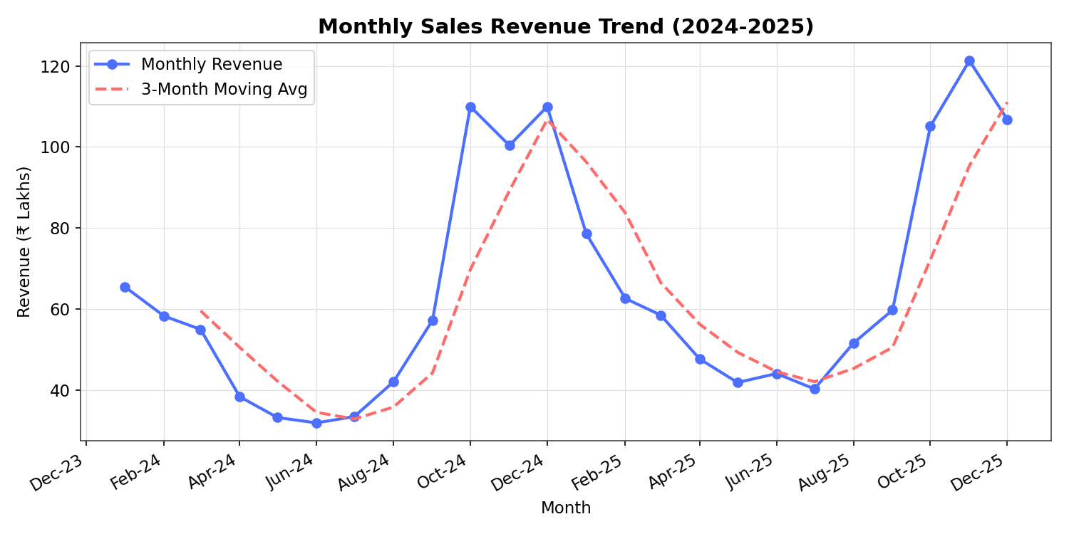
Figure 1: Monthly revenue with 3-month moving average

4.2 Year-over-Year Monthly Comparison
Comparing 2024 and 2025 month-by-month highlights that nearly every month in 2025 outperformed its 2024 counterpart, especially the Oct-Dec festive quarter, indicating strengthening seasonal demand and effective promotions.
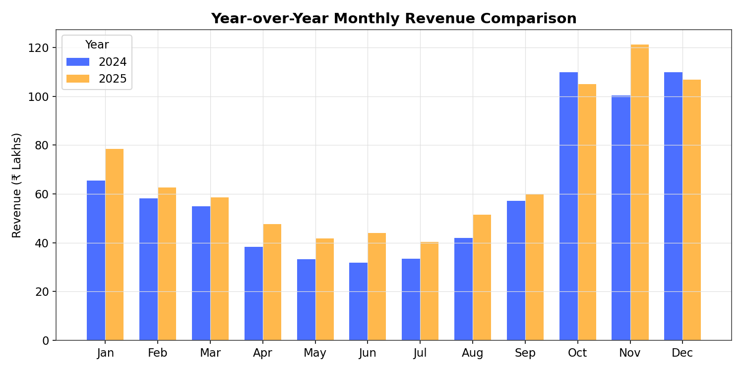
Figure 2: Year-over-year revenue comparison by month

4.3 Revenue by Product Category
Electronics is the dominant revenue driver, contributing over two-thirds of total sales, followed by Home & Kitchen and Clothing. This concentration suggests the business is heavily reliant on high-ticket electronics items.
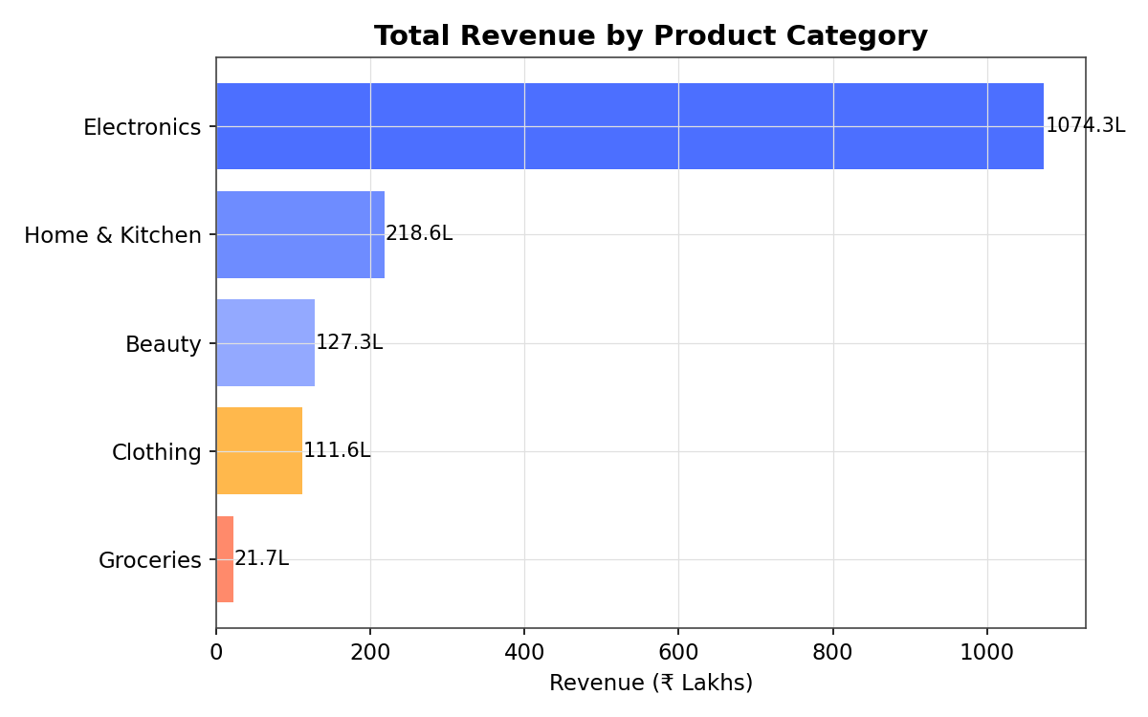
Figure 3: Total revenue by product category

4.4 Regional Performance
The North region leads with a 27.8% revenue share, closely followed by West and East, while South trails slightly. The spread is fairly balanced, indicating a nationally diversified customer base rather than dependence on a single region.
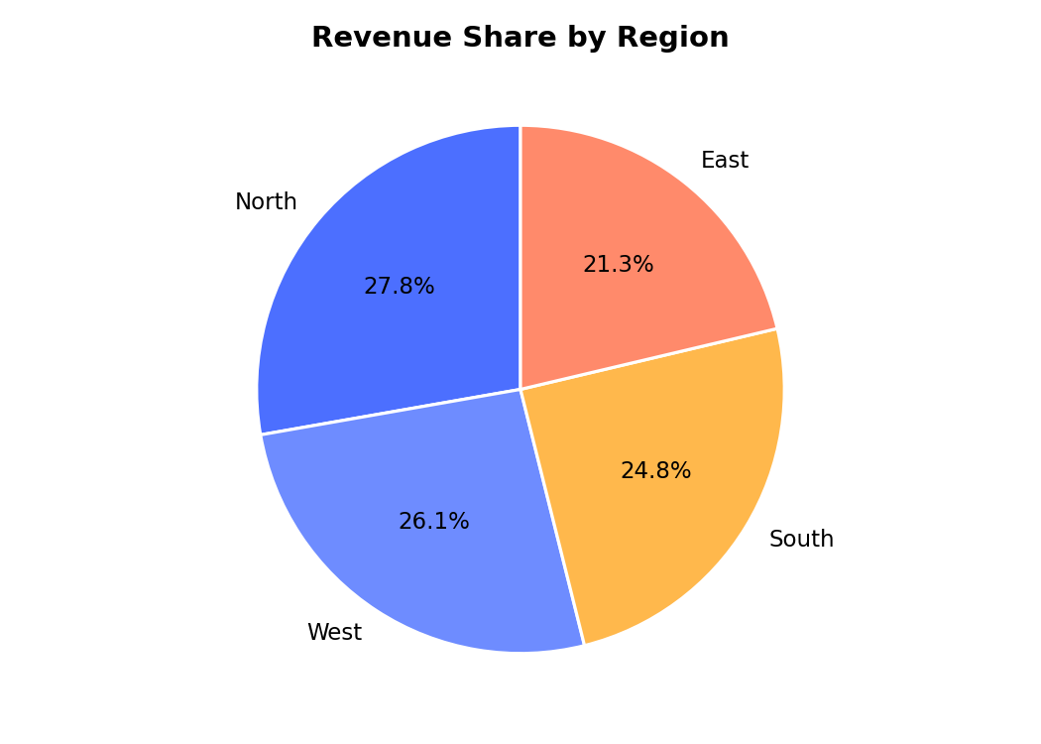
Figure 4: Revenue share by region

4.5 Region × Month Revenue Heatmap
The heatmap makes the festive-season effect visible across every region simultaneously — all four regions darken sharply in Oct-Dec of both years, confirming the seasonality is a nationwide pattern rather than region-specific.
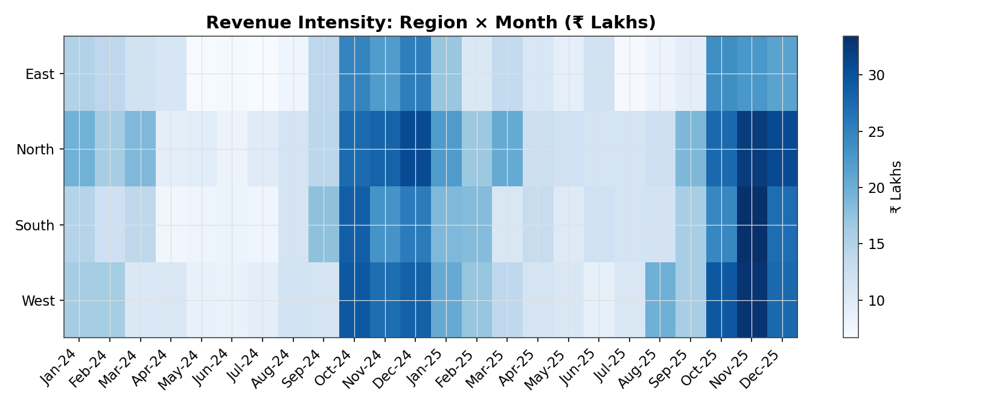
Figure 5: Revenue intensity across regions and months

4.6 Top 10 Products by Revenue
Laptops alone contributed over ₹70 Lakhs, making them the single highest revenue-generating product, followed by Smartphones and Vacuum Cleaners. High-value electronics dominate the top of the list despite lower order volumes than daily-use items.
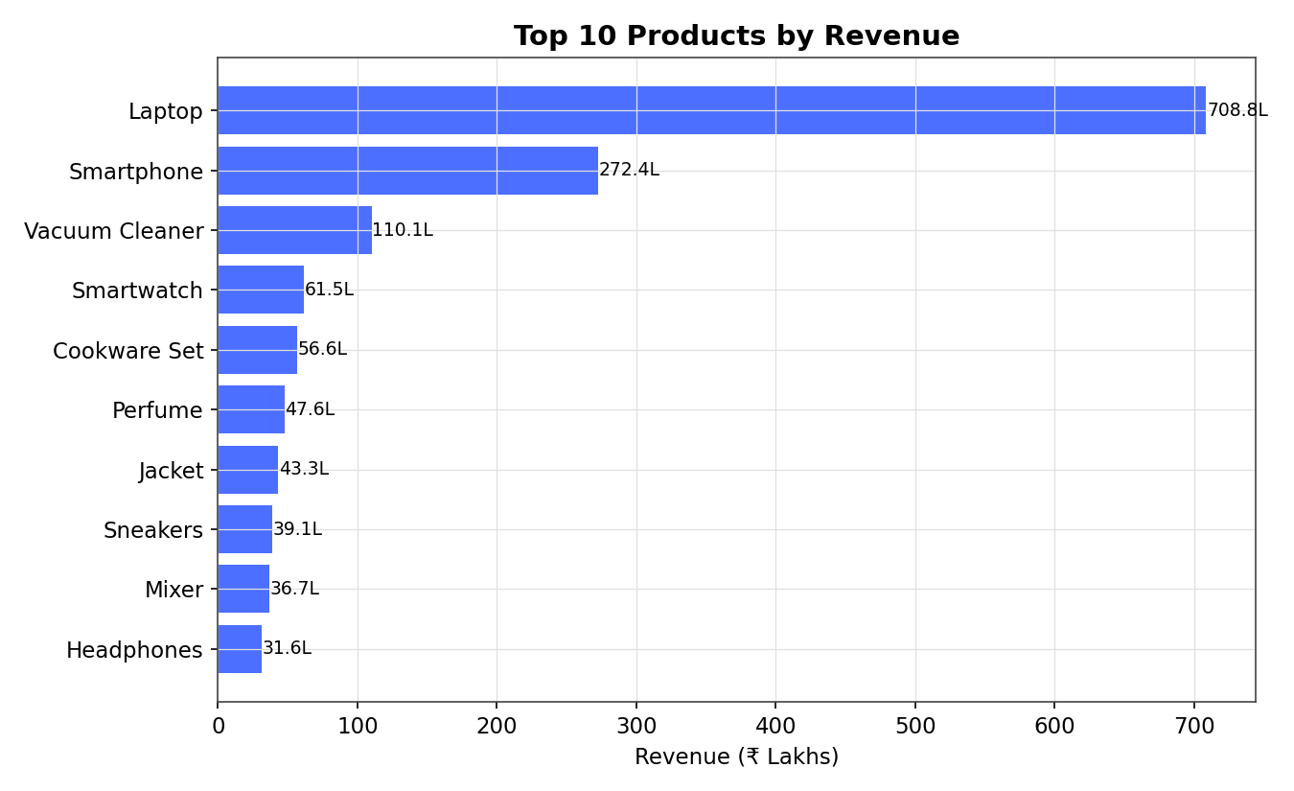
Figure 6: Top 10 products by total revenue

4.7 Day-of-Week Sales Pattern
Weekend sales (Saturday-Sunday, highlighted in red) consistently outperform weekdays, with Sunday recording the highest revenue overall — a pattern useful for scheduling promotions and staffing.
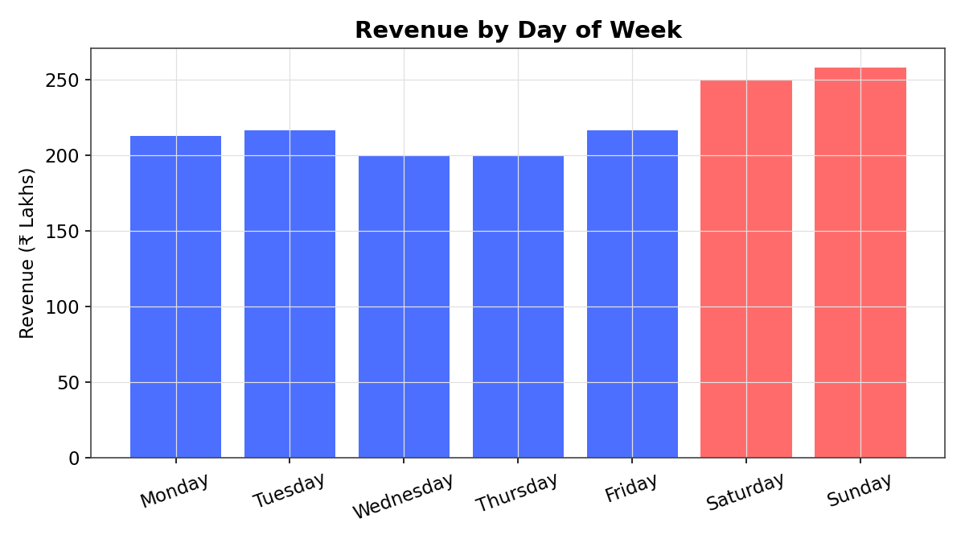
Figure 7: Revenue by day of week

5. Key Insights
- Strong, repeatable seasonality: Oct-Dec festive period generates roughly 2x the revenue of an average month, in both years.
- Healthy year-over-year growth of 11.3%, showing the business is expanding rather than merely holding steady.
- Electronics category and the North region are the two most important levers for revenue — any stock-out or supply issue here has outsized impact.
- Weekend-heavy buying behavior suggests promotional campaigns are more effective when timed for Friday-Sunday.
- June is consistently the weakest month across both years, making it a strong candidate for a mid-year clearance sale to boost off-season revenue.

6. Recommendations
- Increase inventory and marketing spend ahead of October to fully capture the festive demand surge.
- Introduce a targeted June promotional campaign to lift the seasonal low.
- Double down on Electronics assortment and bundle offers, since it drives the majority of revenue.
- Investigate why the South region underperforms relative to others and pilot region-specific offers.
- Shift a larger share of the weekly ad budget toward Friday-Sunday to align with observed peak buying days.

7. Conclusion
This analysis of two years of retail sales data reveals clear, actionable seasonal and regional patterns. Revenue is growing steadily (+11.3% YoY), driven primarily by Electronics and concentrated around festive-season and weekend buying. These insights can directly inform inventory planning, marketing calendars, and regional strategy for the upcoming year.

