E-COMMERCE ORDER MANAGEMENT DATABASE SYSTEM

WEEK 3: SELLER AND INVENTORY MANAGEMENT SYSTEM

CRUD OPERATIONS

1. Create Operation
The Create operation is used to add new records to the database. In the Seller and Inventory Management System, this operation is used to add new seller details and inventory information. It helps the system maintain newly registered sellers and their available product stock.
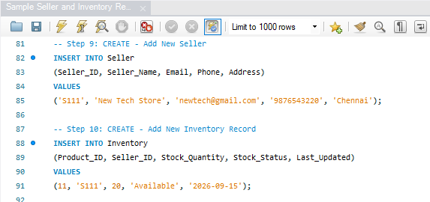

2. Read Operation
The Read operation is used to view and retrieve existing records from the database. It allows the user to display seller details and inventory information. This operation helps in checking the available records and verifying whether the data has been stored correctly.
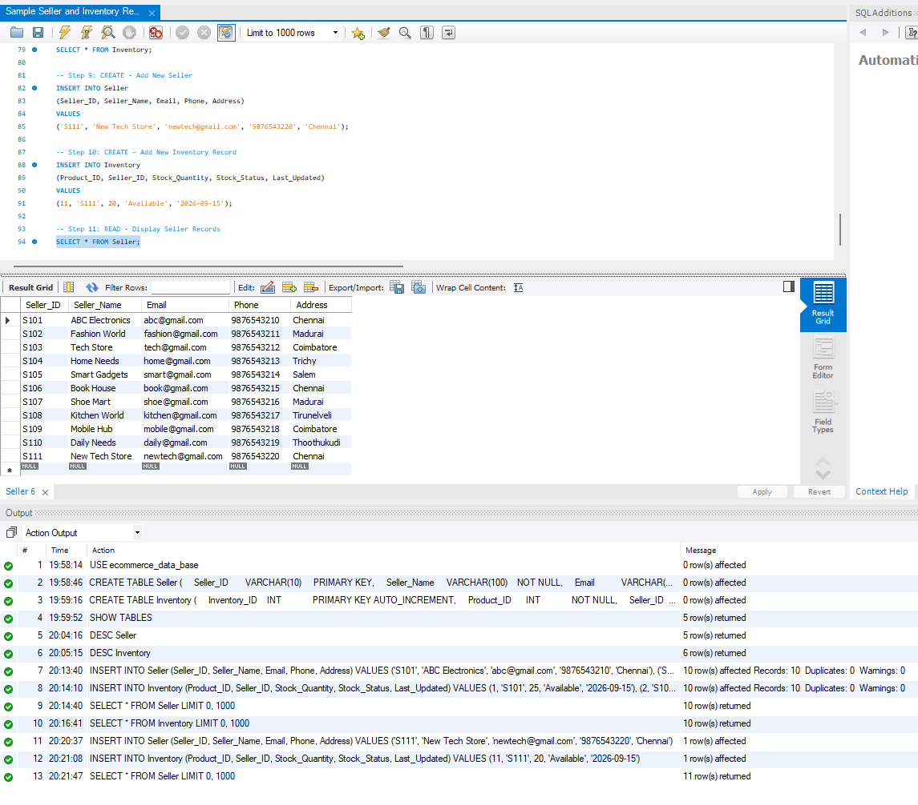

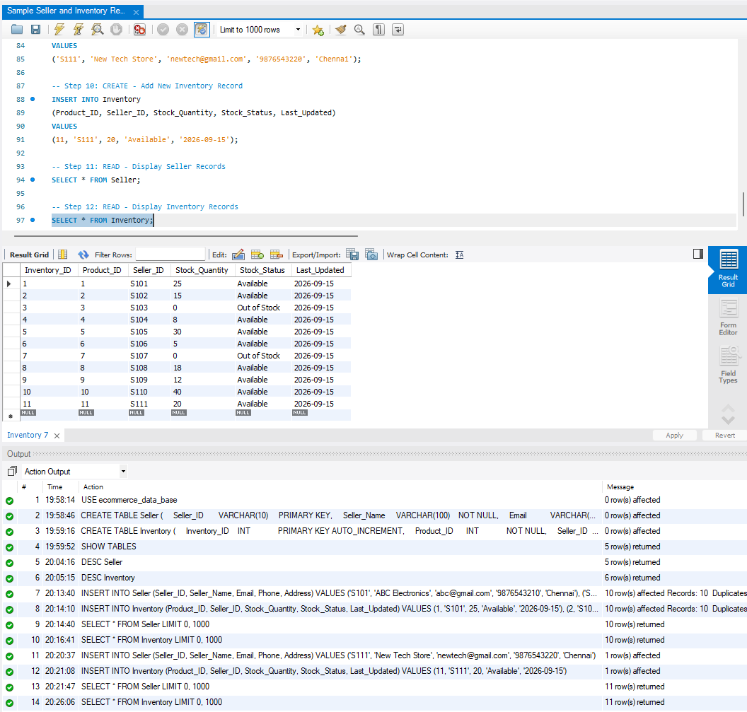

3. Update Operation
The Update operation is used to modify existing records in the database. In this system, seller information such as phone numbers can be updated, and inventory details such as stock quantity, stock status, and last updated date can also be modified.
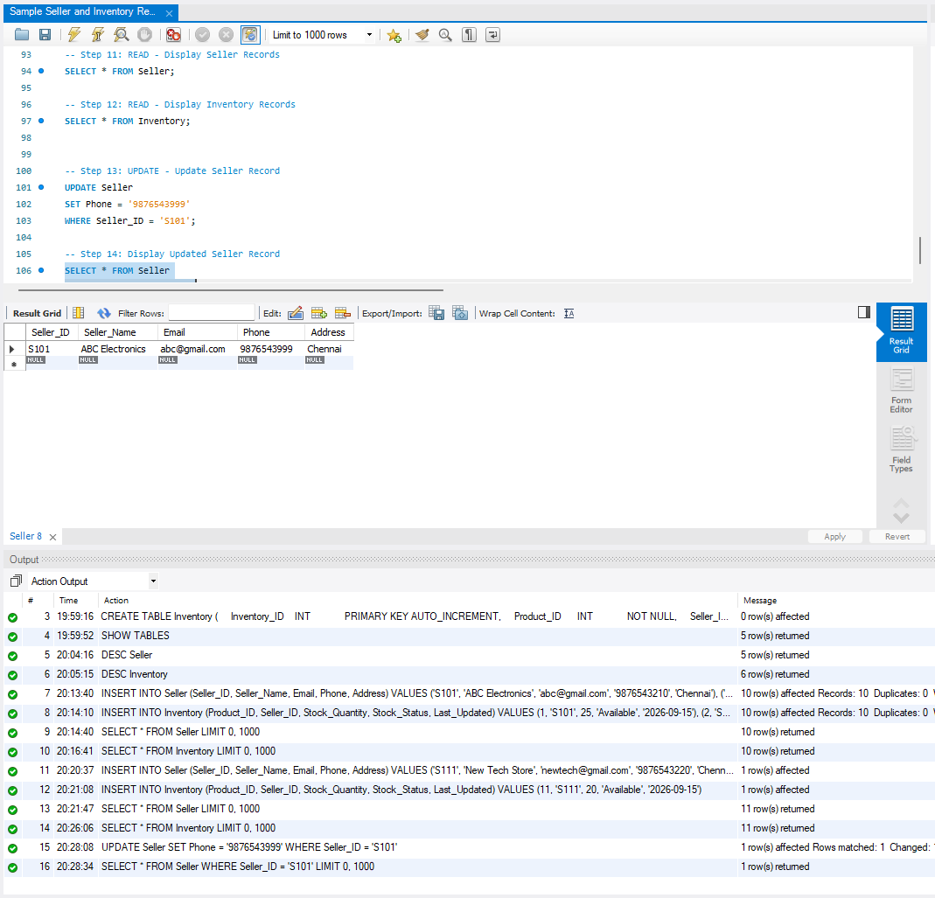

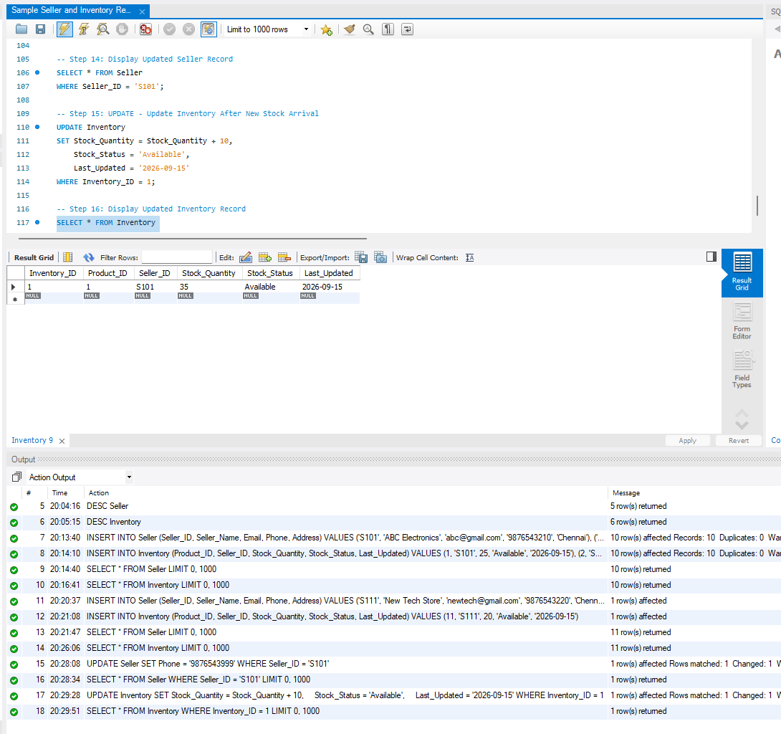

4. Delete Operation
The Delete operation is used to remove unwanted or discontinued records from the database. In the Inventory Management System, this operation can be used to remove an inventory record that is no longer required while maintaining the related seller and product information.
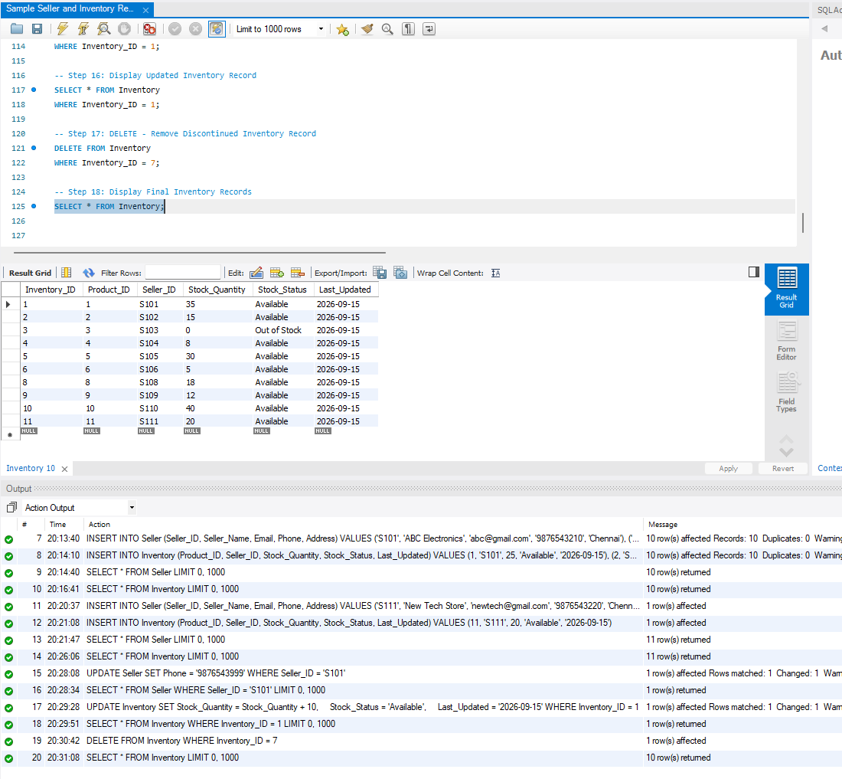

5. CRUD Operation Summary
Operation | Description
Create | Adds new seller and inventory records to the database.
Read | Displays existing seller and inventory records.
Update | Modifies existing seller and inventory information.
Delete | Removes unwanted or discontinued inventory records.

6. Conclusion
The CRUD operations provide the basic functions required to manage seller and inventory information. The Create, Read, Update, and Delete operations help maintain accurate, organized, and up-to-date records in the E-Commerce Order Management Database System.

