## PHASE 1 PROJECT

## Traffic management system

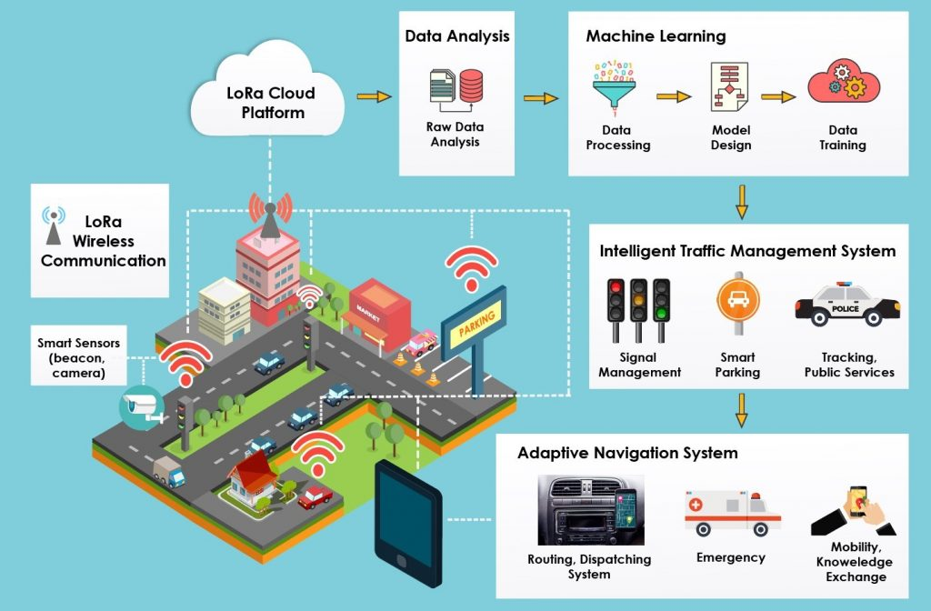

PROJECT DEFINITION:

* Briefly introduce the project.
* The project includes defining objectives, designing the IOT traffic monitoring system, developing the traffic information platform, & integrating them using IOT technology.

ABSTRACT:

An Internet Of Things(IOT)- enabled traffic management system (TMS) is a system that uses a network of interconnected devices to collect and analyze real-time traffic data to improve traffic flow and reduce congestion. IOT-based TMS can be used to manage traffic in a variety of settings, including urban areas, highways, and rural roads.

module 1: Traffic sensing

* Utilizes various IOT sensors, such as cameras, lidar, & infrared sensors, to collect real-time traffic data.
* monitors traffic volume, vehicle speed, and road conditions.
* provides accurate and up-to-date information for traffic management decisions.

module 2: Data processing and analysis

* Collects and processes data from the traffic sensing module.
* analyzes historical and real-time traffic data to identify congestion patterns, traffic bottlenecks, and trends.

module 3: Traffic control

* Integrates with traffic signals, dynamic message signs, and variable speed limit signs.
* Adjusts signal timings and speed limits in real-time based on traffic data and analysis.
* optimizes traffic signal synchronization to reduce wait times flow and improve traffic.

module 4: Communication and connectivity

* Establishes secure and reliable communication channels between IOT devices and the central control system.
* Utilizes wireless communication protocols, such as 5G and MQTT, to transmit data efficiently.

module 5: User interface and information dissemination

* Provides a user-friendly interface for traffic management personal and commuters.
* Displays real-time traffic updates, alternative routes, and estimated travel times.
* Enables two-way communication between traffic management authorities and drivers.

module 6: Emergency Response

* Integrates with emergency services and first responders.
* Automatically clears traffic lanes for emergency vehicles during critical situations.
* Provides real-time updates to emergency personal regarding traffic conditions.

module 7: Scalability and Integration

* Allows for easy addition of new sensors, devices, and data sources as the traffic management system expands.
* Supports integration with other urban systems, such as public transportation and environmental monitoring.

Benefits of IOT-based TMS

1. REAL-TIME DATA COLLECTION AND ALAYSIS.

2. IMPROVED TRAFFIC FLOW.

3. REDUCED CONGESTION.

4. IMPROVED SAFETY.

CONCLUSION:

IOT-enabled TMS systems are a promising new way to improve traffic management. they offer a number of benefits over traditional TMS systems including reduced costs, improved accuracy, and increased flexibility. As the technology continues to develop, we can expect to see more and more cities and municipalities deploy IOTenabled TMS systems.

THANK YOU!