## PHASE 2 PROJECT:

### TRAFFIC MANAGEMENT SYSTEM

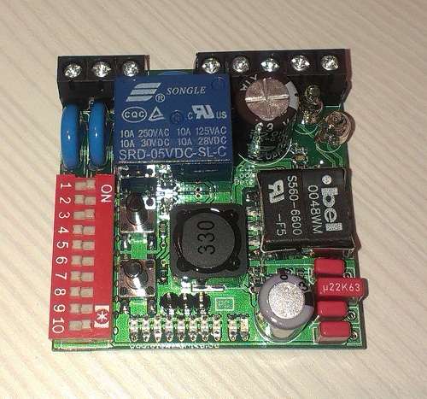

Inductive Loop Detector (ILD) SENSOR

**DEFINITIONS FOR INDUCTIVE LOOP DETECTOR:**

The Inductive Loop Detector (ILD) sensor is one of the most common sensors in traffic management. It is used for collecting traffic flow, vehicle’s occupancy, length, and speed.

**PURPOSE OF INDUCTIVE LOOP DETECTOR:**

It can detect vehicles passing or arriving at a certain point.

**STEPS FOR PROGRAM:**

STEP 1: START THE PROGRAM.

STEP 2: READ DATA FROM INDUCTIVE LOOP DETECTOR (ILD) SENSOR.

STEP 3: INITIALIZE THE SYSTEM AND CONFIGURE SENSOR PATAMETERS.

STEP 4: IDENTIFY THE VEHICLE DETECTION.

STEP 5: IMPLEMENT THE SIGNAL TIMING CONTROL.

STEP 6: ANALYZE TRAFFIC FLOW PATTERNS.

STEP 7: INTEGRATE WITH EMERGENCY VEHICLE HANDLING.

STEP 8: IMPLEMENT ERROR HANDLING ROUTINES TO HANDLE SENSOR FAILURES OR COMMUNICATION ISSUES.

STEP 9: REPEAT THE STEPS 2 TO 8 UNTIL THE DESIRED RESULTS.

STEP 10: STOP THE PROGRAM.

**FLOWCHART FOR INDUCTIVE LOOP DETECTOR SENSOR**

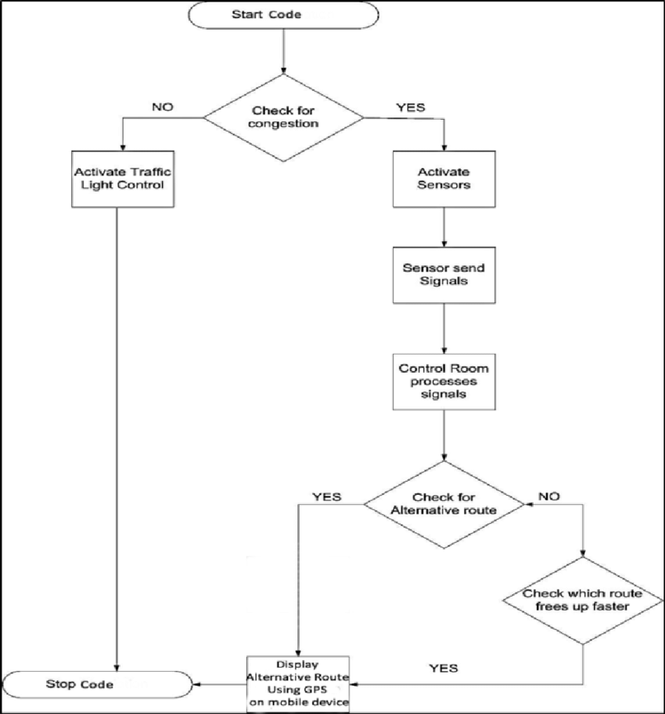

**BLOCK DIAGRAM**

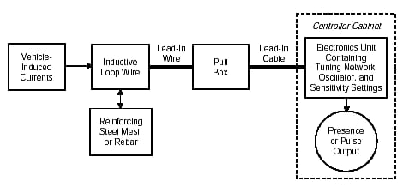

* The inductive-loop system behaves as a tuned electrical circuit in which the loop wire and lead-in cable are the inductive elements.
* When a vehicle passes over the loop or is stopped within the loop.
* The vehicle induces eddy currents in the wire loops, which decrease their inductance.

**CIRCUIT DIAGRAM**

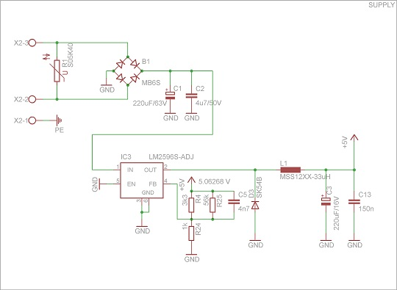

**APPLICATIONS:**

* Controlling traffic signals at intersections to optimize traffic flow.
* Managing entry and exit gates in parking lots or garages.
* Collecting tolls on highways and bridges.
* Monitoring and controlling traffic in areas where traffic flow needs to be managed efficiently.

#### THANK YOU!