**Create a Spring Web Project using Maven**

**CODE :**

**Pom.xml**

<?xml version="1.0" encoding="UTF-8"?>  
<project xmlns="http://maven.apache.org/POM/4.0.0" xmlns:xsi="http://www.w3.org/2001/XMLSchema-instance"  
 xsi:schemaLocation="http://maven.apache.org/POM/4.0.0 https://maven.apache.org/xsd/maven-4.0.0.xsd">  
 <modelVersion>4.0.0</modelVersion>  
 <parent>  
 <groupId>org.springframework.boot</groupId>  
 <artifactId>spring-boot-starter-parent</artifactId>  
 <version>3.5.3</version>  
 <relativePath/>  
 </parent>  
 <groupId>com.cognizant</groupId>  
 <artifactId>spring-learn</artifactId>  
 <version>0.0.1-SNAPSHOT</version>  
 <name>spring-learn</name>  
 <description>Spring web project</description>  
 <url/>  
 <licenses>  
 <license/>  
 </licenses>  
 <developers>  
 <developer/>  
 </developers>  
 <scm>  
 <connection/>  
 <developerConnection/>  
 <tag/>  
 <url/>  
 </scm>  
 <properties>  
 <java.version>17</java.version>  
 </properties>  
 <dependencies>  
 <dependency>  
 <groupId>org.springframework.boot</groupId>  
 <artifactId>spring-boot-starter-web</artifactId>  
 </dependency>  
  
 <dependency>  
 <groupId>org.springframework.boot</groupId>  
 <artifactId>spring-boot-devtools</artifactId>  
 <scope>runtime</scope>  
 <optional>true</optional>  
 </dependency>  
  
 <dependency>  
 <groupId>org.springframework.boot</groupId>  
 <artifactId>spring-boot-starter-test</artifactId>  
 <scope>test</scope>  
 </dependency>  
 <dependency>  
 <groupId>org.mockito</groupId>  
 <artifactId>mockito-inline</artifactId>  
 <version>5.2.0</version>  
 <scope>test</scope>  
 </dependency>  
  
  
  
 <dependency>  
 <groupId>org.springframework</groupId>  
 <artifactId>spring-context</artifactId>  
 </dependency>  
  
 </dependencies>  
  
  
 <build>  
 <plugins>  
 <plugin>  
 <groupId>org.springframework.boot</groupId>  
 <artifactId>spring-boot-maven-plugin</artifactId>  
 </plugin>  
 </plugins>  
 </build>  
  
</project>

**Application.properties**

spring.application.name=spring-learn  
logging.level.com.cognizant=DEBUG  
logging.level.root=INFO

**SpringLearnApplication.java**

package com.cognizant;  
  
import org.slf4j.Logger;  
import org.slf4j.LoggerFactory;  
import org.springframework.boot.SpringApplication;  
import org.springframework.boot.autoconfigure.SpringBootApplication;  
  
@SpringBootApplication  
public class SpringLearnApplication {  
  
 private static final Logger *LOGGER* = LoggerFactory.*getLogger*(SpringLearnApplication.class);  
  
 public static void main(String[] args) {  
 *LOGGER*.info("START");  
 SpringApplication.*run*(SpringLearnApplication.class, args);  
 *LOGGER*.info("END");  
 }  
}

**SpringLearnApplicationTests.java**

package com.cognizant;  
  
import org.junit.jupiter.api.Test;  
import org.springframework.boot.test.context.SpringBootTest;  
  
@SpringBootTest  
class SpringLearnApplicationTests {  
  
 @Test  
 void contextLoads() {  
 }  
}

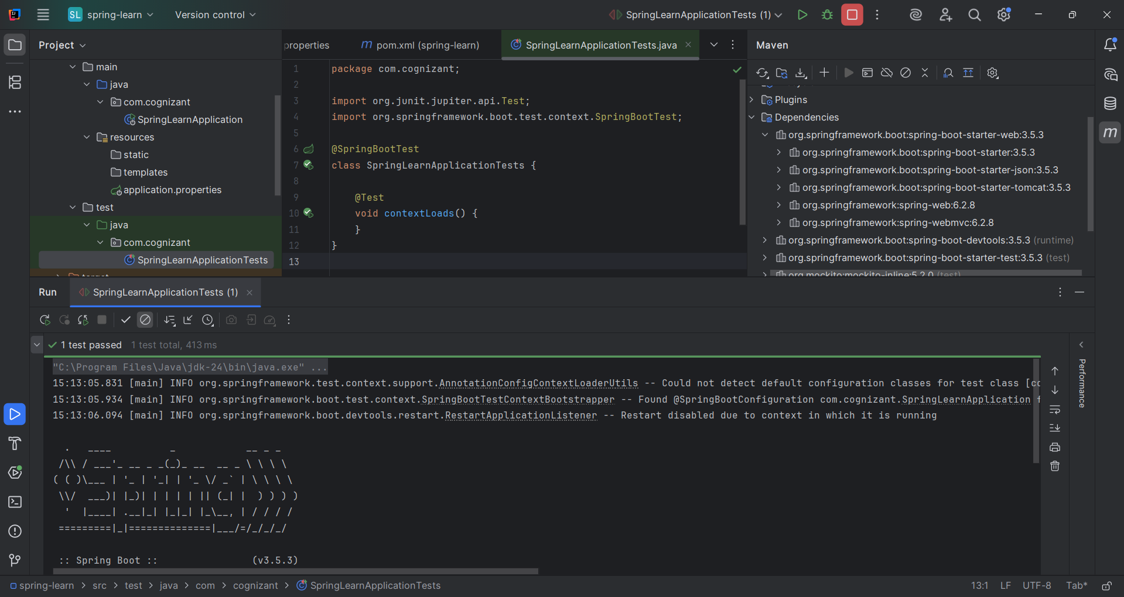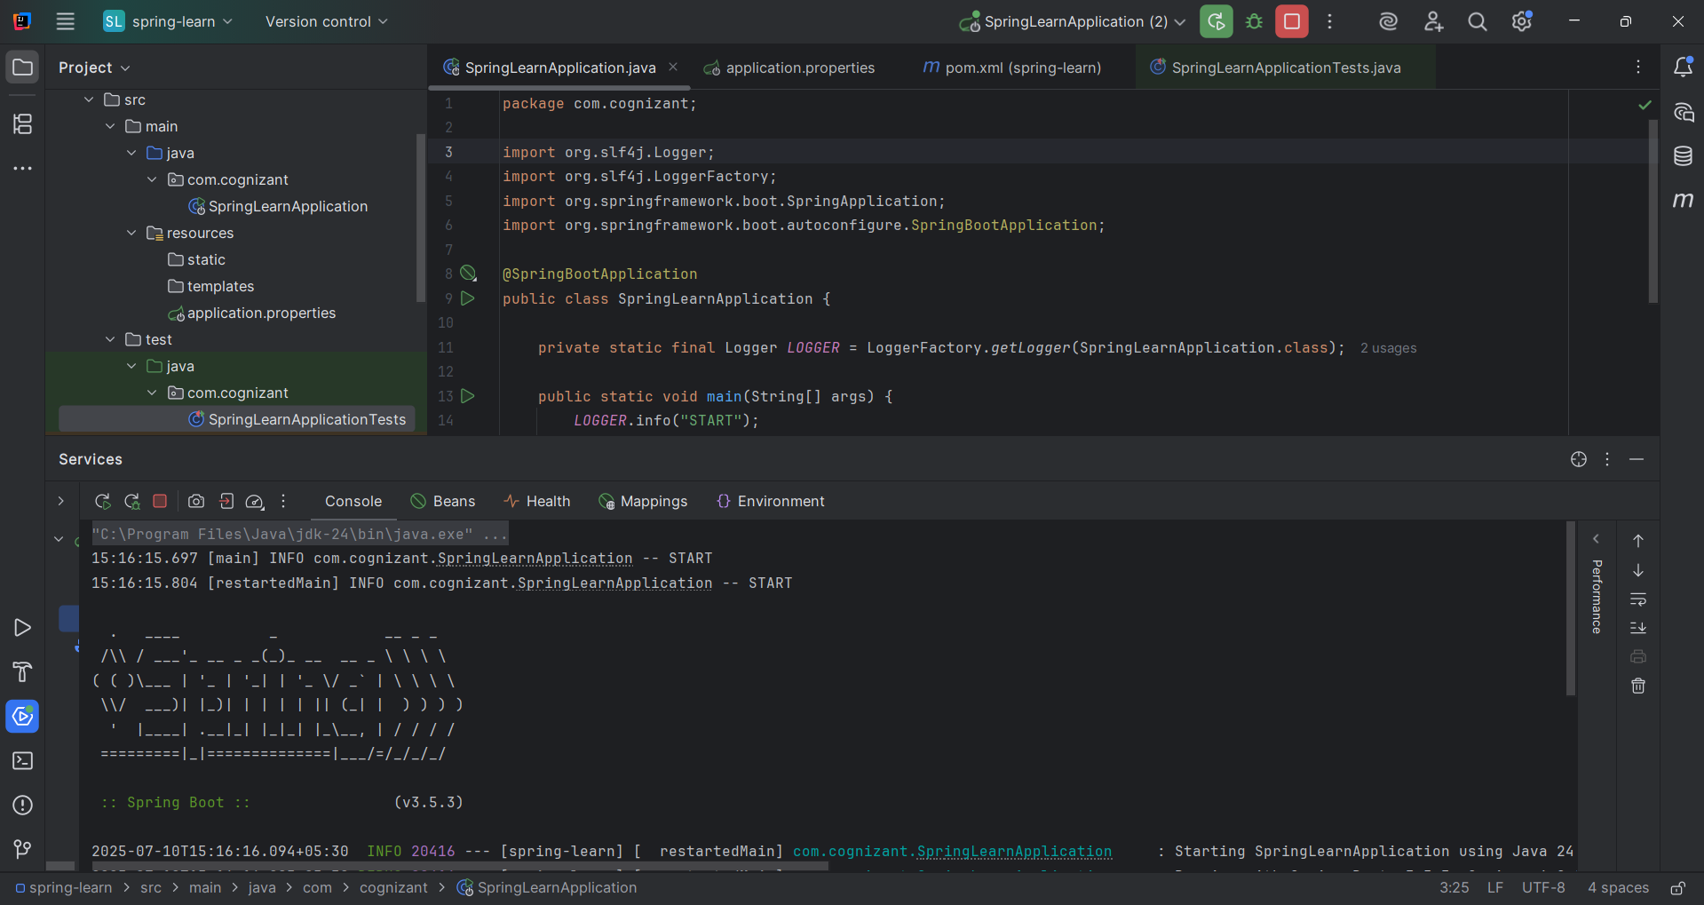**OUTPUT:**