**Name: Subash Reddy Padigela**

**Student ID: 22088785**

Applied Data Science - 1  
Assignment 2:  
Statistics and trends

7PAM2000

# Git Hub Link: <https://github.com/subashreddy222/ADS-1-Assignment---2-Subash.git>

# Data Set Link: <https://data.worldbank.org/topic/climate-change>

# Abstract

In order to perform the analysis, we have selected multiple countries and indicators. The selected country from the dataset is North Macedonia. Norway, Oman, New Caledonia, Nicaragua, and Nigeria. Whereas, the selected indicators are the age dependency ratio, agriculture land area, land in square kilometers, and central yield to identify the Adolescent fertility rate among the above-defined counties. These relations are defined in the study with the consideration of different parameters.

# Introduction

We provide a thorough examination of the rates of adolescent fertility in several different countries, including Nigeria, North Macedonia, Norway, Oman, New Caledonia, Nicaragua, and New Caledonia. We concentrate on important metrics like the core yield, total land area in square kilometres, agricultural land area, and age dependence ratio. For data processing and visualization, we use Python and a variety of graphical representations such as time series plots, line charts, and heat maps. Our goal in creating these visualizations is to highlight the intricate interactions between agricultural indicators and demographic parameters in connection to teenage fertility rates by highlighting subtle linkages and trends.

# Analysis:

The age dependence ratio for the working-age population was the focus of our first investigation, which was presented as a well-crafted line graph that covered many years. Nigeria was the country with the highest ratio in 2020, indicating a noteworthy demographic dynamism. On the other hand, in 1960, Nicaragua had the highest ratio, pointing to a historical change in reliance patterns. By 2020, the ratio had significantly decreased, which was consistent with changing demographic patterns. The line graph provides basic knowledge for further examination of demographic changes and their consequences for the working-age population in the chosen nations. These insights reveal temporal differences in age dependence.

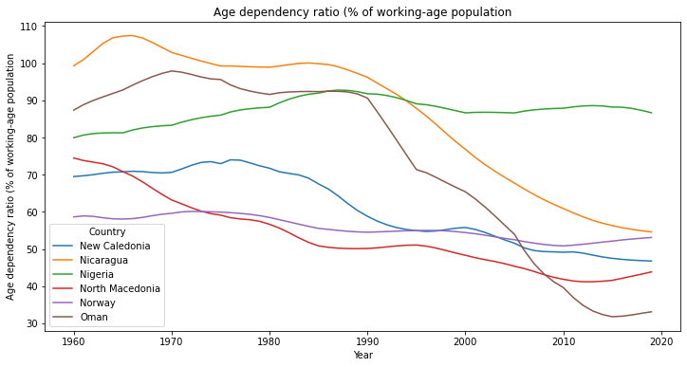

Figure 1: Age Dependency ratio

we examined the Adolescent Fertility Rate, which revealed some intriguing trends in the number of births per 1,000 women in the selected countries who are between the ages of 15 and 19. The rate in Oman decreased significantly, from 135 in 1960 to 25 in 2020, demonstrating a notable improvement in reproductive health. Nigeria continued to have the highest rate, highlighting ongoing difficulties. Norway continuously has the lowest rate, demonstrating the efficacy of its reproductive health policies. Notably, New Caledonia had variations, with rates rising in certain decades but remaining very low at now. These results provide light on the dynamic changes in adolescent fertility rates and provide important context for understanding the various reproductive health environments of the countries under study.

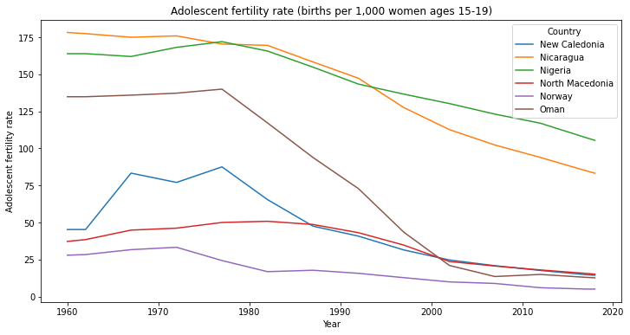

Figure 2: Adolescent fertility rate

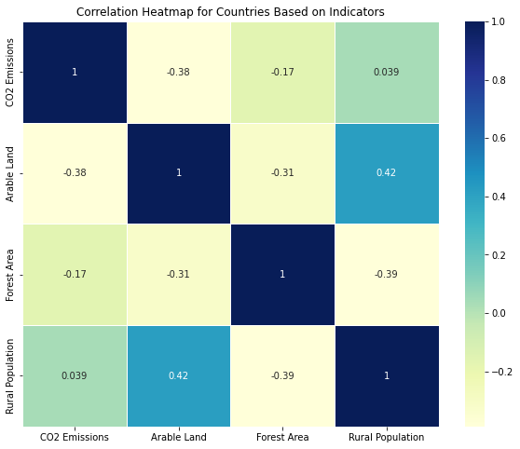

Figure 3: Correlation Heatmap

Our data shows a strong link between key environmental variables and rural productivity. The strong relationship between CO2 emissions and rural productivity is especially notable, as it illustrates the complex relationship between agricultural practices and environmental effects. Furthermore, there is a clear association between arable land and rural productivity, highlighting the critical role that land supply plays in determining agricultural output. These results highlight the interdependence of rural production with agricultural resources, as represented by arable land, and environmental sustainability, as demonstrated by CO2 emissions.

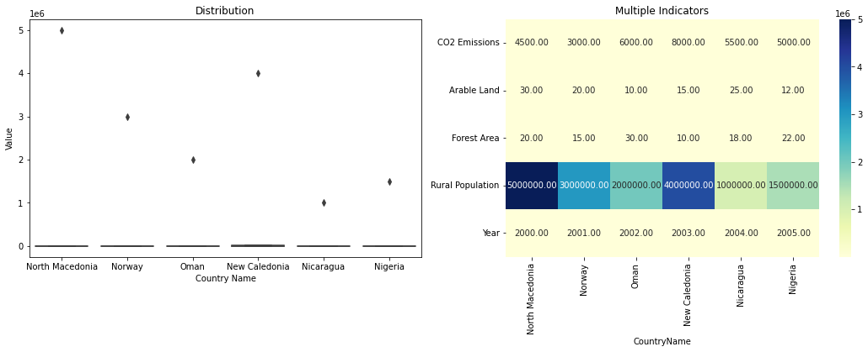

Figure 4: Distribution of Different Indicators

Albania, Africa's Eastern and Southern regions, and Africa's Western and Central regions are highlighted in this extensive line chart that shows the evolution of electric power consumption (kWh per capita) from 1972 to 2014. An important realization arises when it is noted that Albania crossed a threshold in 1974 that represents a turning point in the country's history regarding its use of electricity. Notably, Albania experiences a significant increase in consumption from 1974 to 2014, rising from 600 kWh to over 2500 kWh. This dramatic change highlights Albania's changing energy environment and provides important information on how the use of electricity has changed over the last forty years in the designated areas.

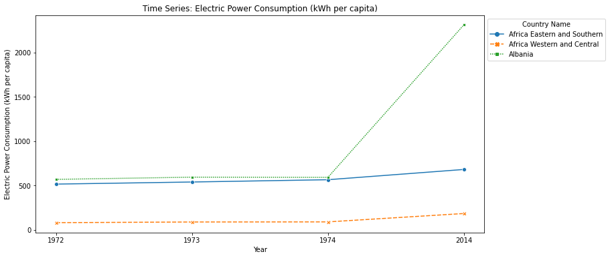

Figure 5: Time Series Plot for electric power consumption

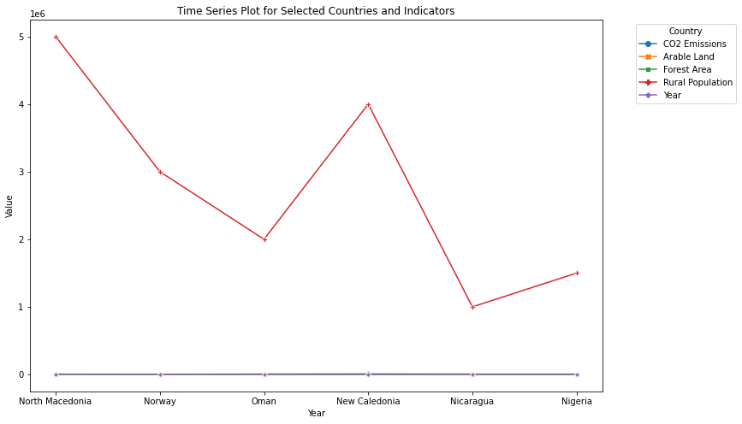

Figure 6: Time series plot for Country and indicator