PRODUCT

create table product(pid int(10),pname varchar(10),price int(10),unitOfMeasurement int(5));

insert into product values(1,'iphone',100000,1);

insert into product values(2,'samsung',80000,1);

insert into product values(3,'moto',15000,1);

insert into product values(4,'lg',15000,1);

insert into product values(5,'nokia',1000,1);

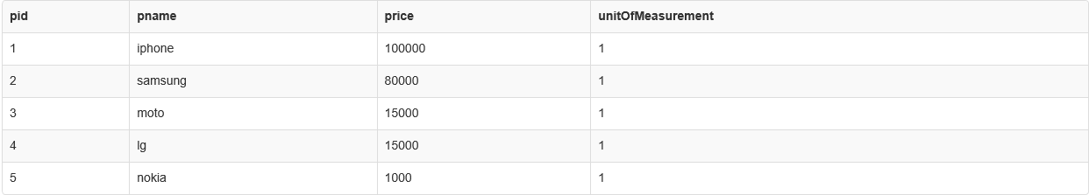

CUSTOMER

create table customer(cid int(10),cname varchar(10),city varchar(10));

insert into customer values(101,'ram','trichy');

insert into customer values(102,'praveen','annanagar');

insert into customer values(103,'hari','madavakkam');

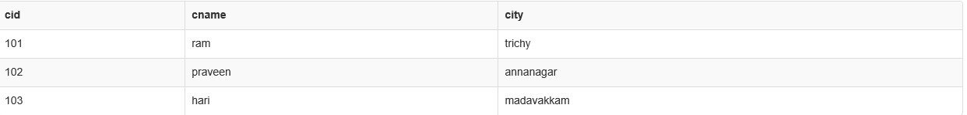

SALES

create table sales(tid int(5),cid int(10),pid int(10),amount int(20));

insert into sales values(1001,101,1,100000);

insert into sales values(1001,101,3,15000);

insert into sales values(1002,102,2,80000);

insert into sales values(1002,102,1,100000

insert into sales values(1001,101,1,100000);

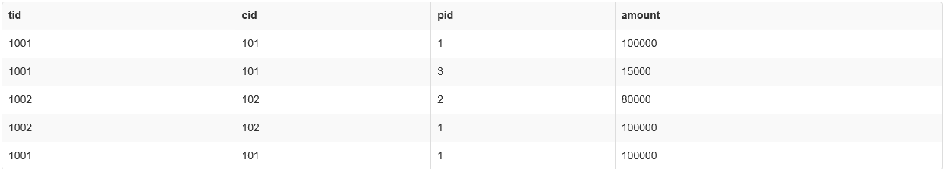

1)Return the Customer details whose has done transactions more than 80000?

Select s.cid,c.cname,c.city,sum(amount) from sales s join customer c on c.cid=s.cid group by cid having sum(amount)>80000;



2)How many no. of times each product is sold?

Select pid,count(pid) as noOfProducts from sales group by pid order by pid;

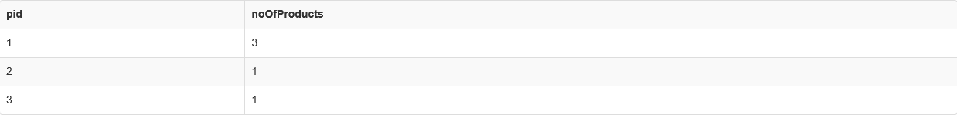

3)Which product is highly sold?

Select pid,max(noOfProducts) from (select pid,count(pid) as noOfProducts from sales group by pid order by pid)as t1;



4)Which phone brand has highest individual transactions?

select pname,s.pid,tid,max(amount) from sales s inner join product p on s.pid=s.pid group by tid;



5)Which branch has sold more products?

select city,max(total) from(select c.city,sum(amount) as total,s.cid from sales s join customer c on c.cid=s.cid group by cid)as t2;

