## **Objectives**

* Explain React components
* Identify the differences between components and JavaScript functions
* Identify the types of components
* Explain class component
* Explain function component
* Define component constructor
* Define render() function

In this hands-on lab, you will learn how to:

* Create a function component
* Apply style to components
* Render a component

## **Prerequisites**

The following is required to complete this hands-on lab:

* Node.js
* NPM
* Visual Studio Code

## **Notes**

Estimated time to complete this lab: **30 minutes.**

Create a react app for Student Management Portal named scorecalculatorapp and create a function component named “CalculateScore” which will accept Name, School, Total and goal in order to calculate the average score of a student and display the same.

1. Create a React project named “scorecalculatorapp” type the following command in terminal of Visual studio:



1. Create a new folder under Src folder with the name “Components”. Add a new file named “CalculateScore.js”
2. Type the following code in CalculateScore.js

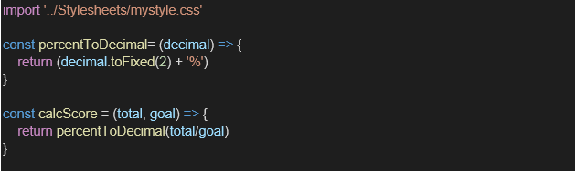

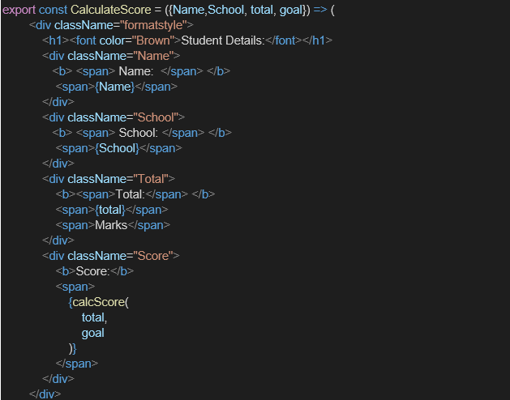

1. Create a Folder named Stylesheets and add a file named “mystyle.css” in order to add some styles to the components:

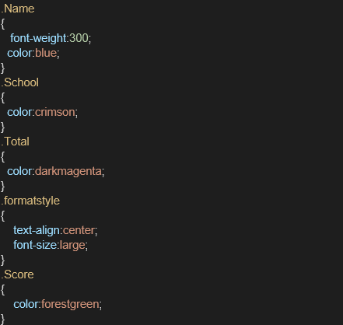

1. Edit the App.js to invoke the CalculateScore functional component as follows:

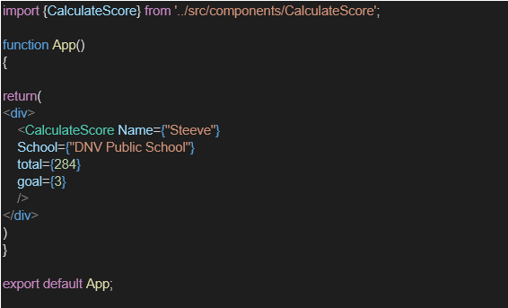

1. In command Prompt, navigate into scorecalculatorapp and execute the code by typing the following command:



1. Open browser and type “localhost:3000” in the address bar:

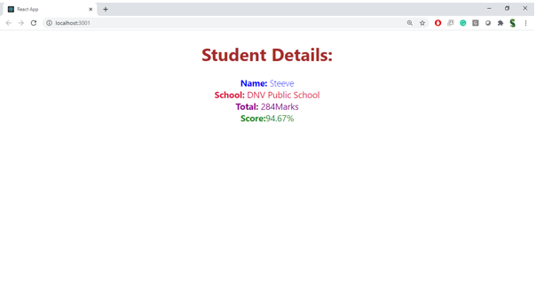

PROGRAM:

import React from 'react';

const CalculateScore = () => {

  const student = {

    name: 'Steeve',

    school: 'DNV Public School',

    marks: [98, 90, 96], // 3 subjects

  };

  const total = student.marks.reduce((acc, mark) => acc + mark, 0);

  const percentage = (total / (student.marks.length * 100)) * 100;

  return (

    <div

      style={{

        display: 'flex',

        justifyContent: 'center',

        alignItems: 'center',

        height: '30vh',

        fontFamily: 'Arial',

        textAlign: 'left',

      }}

    >

      <div>

        <h1 style={{ color: 'brown', textAlign: 'center' }}>Student Details:</h1>

        <p>

          <strong style={{ color: 'blue' }}>Name: </strong>

          <span style={{ color: '#4169E1' }}>{student.name}</span>

        </p>

        <p>

          <strong style={{ color: 'red' }}>School: </strong>

          <span style={{ color: '#DC143C' }}>{student.school}</span>

        </p>

        <p>

          <strong style={{ color: 'purple' }}>Total: </strong>

          <span style={{ color: '#8A2BE2' }}>{total}Marks</span>

        </p>

        <p>

          <strong style={{ color: 'green' }}>Score: </strong>

          <span style={{ color: '#228B22' }}>{percentage.toFixed(2)}%</span>

        </p>

      </div>

    </div>

  );

};

export default CalculateScore;

OUTPUT:

