## **Objectives**

* Explain various ways of conditional rendering
* Explain how to render multiple components
* Define list component
* Explain about keys in React applications
* Explain how to extract components with keys
* Explain React Map, map() function

In this hands-on lab, you will learn how to:

* Implement conditional rendering in React applications

## **Prerequisites**

The following is required to complete this hands-on lab:

* Node.js
* NPM
* Visual Studio Code

## **Notes**

Estimated time to complete this lab: **60 minutes.**

Create a React App named “bloggerapp” in with 3 components.

1. Book Details
2. Blog Details
3. Course Details

Implement this with as many ways possible of Conditional Rendering.

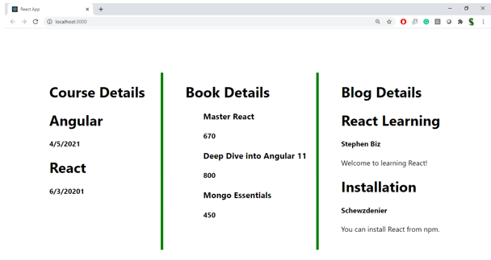

**Hint:**

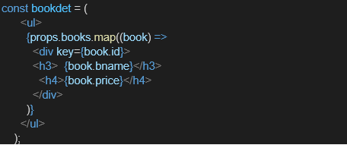

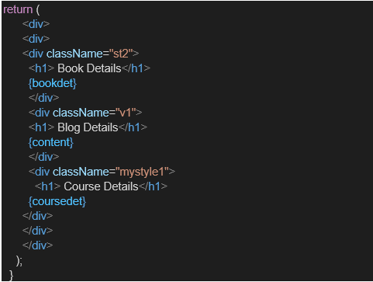

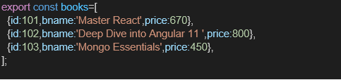

PROGRAM:

import React from 'react';

const books = [

  { title: 'Master React', price: '670' },

  { title: 'Deep Dive into Angular 11', price: '800' },

  { title: 'Mongo Essentials', price: '450' }

];

function BookDetails() {

  return (

    <div className="section">

      <h2>Book Details</h2>

      {books.map((book, index) => (

        <div key={index}>

          <strong>{book.title}</strong>

          <div>{book.price}</div>

        </div>

      ))}

    </div>

  );

}

export default BookDetails;

import React from 'react';

const blogs = [

  {

    title: 'React Learning',

    author: 'Stephen Biz',

    content: 'Welcome to learning React!'

  },

  {

    title: 'Installation',

    author: 'Schewzdenier',

    content: 'You can install React from npm.'

  }

];

function BlogDetails() {

  return (

    <div className="section">

      <h2>Blog Details</h2>

      {blogs.map((blog, index) => (

        <div key={index}>

          <strong>{blog.title}</strong>

          <div><em>{blog.author}</em></div>

          <div>{blog.content}</div>

        </div>

      ))}

    </div>

  );

}

export default BlogDetails;

import React from 'react';

const courses = [

  { name: 'Angular', date: '4/5/2021' },

  { name: 'React', date: '6/3/2021' }

];

function CourseDetails() {

  return (

    <div className="section">

      <h2>Course Details</h2>

      {courses.map((course, index) => (

        <div key={index}>

          <strong>{course.name}</strong>

          <div>{course.date}</div>

        </div>

      ))}

    </div>

  );

}

export default CourseDetails;

OUTPUT:

