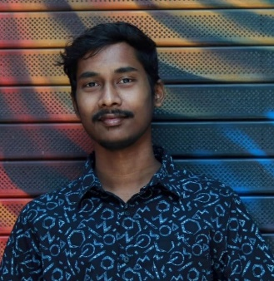 SIVA NAGA SAI SUBASH SAKA

**Ph no- +91 9848108552**

**Mail Id :** [**subashsaka4@gmail.com**](mailto:subashsaka4@gmail.com)

**Linkedin :** [**https://www.linkedin.com/in/subashsaka/**](https://www.linkedin.com/in/subashsaka/)

**Github :** [**https://github.com/subashsaka**](https://github.com/subashsaka)

# OBJECTIVE

Seeking a challenging position in a reputed organization where I can learn new skills, expand my knowledge and leverage my learning’s. To get an opportunity where I can make the best of my potential and contribute to the organization’s growth.

# EDUCATION:

**SATHYABAMA INSTITUTE OF SCIENCE AND TECHNOLOGY,** Chennai B.E (ELECTRONICS AND COMMUNICATION)

YEAR OF PASSING - 2025

MARKS IN CGPA - 8.06(UPTO 6TH SEMESTER)

**GRAVITY JUNIOR COLLEGE,** Visakhapatnam -11 & 12 (State Board)

YEAR OF PASSING - 2021

MARKS IN PERCENTAGE – 79%

**BOON SCHOOL,** Kakinada-10th (CBSE)

YEAR OF PASSING - 2019

MARKS IN PERCENTAGE – 81%

# INTERNSHIPS:

**Externs club,** Chennai — *Full stack web Development.*

PERIOD – 2MONTHS

**Techsnap.in,** Bengaluru — *Figma & Web Development.*

PERIOD - 1 MONTH

**TVS Training & Services**, Chennai — Embedded Systems

PERIOD – 1 week

# SKILLS:

Programming languages: Python, C

Database: SQL, Mongo DB

Design Tools : Figma

Web Development: HTML, CSS, JavaScript, Bootstrap, React, Nodejs, SQL, GitHub

# PROJECTS:

1. Designed a website called “SKILLUP” using Web Development.

Objective: SKILLUP is a website where a user can find the best sources for learning skills.

1. Designed a Frontend portfolio website.

Objective: A website which gives complete profile of a person.

1. Designed a website called “SHOPPERS” using Web Development.

Objective: A website to order grocery items from online using SHOPPERS.

1. Home automation.

Objective: Using ESP8266 wi-fi chip enabled controller and with the help of a smart phone we can able to control electronic devices.

# PERSONAL DETAILS:

* PERMANENT ADDRESS: H-NO:2-99 Rolugunta (village, post, mandal) yetapeta street opposite veera bhadra swami temple andhra pradesh india pincode:531114
* LANGUAGES KNOWN: English (Professional Working Proficiency)

Hindi (Limited Working Proficiency) Telugu (Native Proficiency)

Spanish(Beginner)

* DATE OF BIRTH: 15-06-2004

# STRENGTHS:

* Quick learner, good communication skills, Team management

# DECLARATION:

I hereby declare that all the information furnished above are true and correct to the best of my knowledge.