**PHASE 5 SUBMISSION DOCUMENT**

**Project:** E-COMMERCE APPLICATION USING CLOUD COMPUTING

**E-Commerce Application Project Objective:**

The project's objective for an e-commerce application is to develop a platform that enables businesses to sell their products and services online, and for consumers to purchase goods and services conveniently and securely. The application should be designed to be user-friendly and accessible to businesses of all sizes, and it should offer a wide range of features to help businesses succeed.

**Specific objectives of the e-commerce application may include:**

* Increase sales and revenue for businesses.
* Reduce the cost of selling and marketing products and services.
* Reach new markets and customers.
* Provide a superior customer experience.
* Improve business efficiency and productivity.

The e-commerce application should also be designed to meet the needs of both businesses and consumers. Some specific features that may be included in the application are:

**For businesses:**

* Product catalog management
* Order management
* Payment processing
* Shipping integration
* Customer support
* Marketing and analytics tools

**For consumers**:

* Product search and browsing
* Product reviews and ratings
* Wishlists and shopping carts
* Secure checkout process
* Order tracking and management
* Account management

The e-commerce application should be implemented using a scalable and secure architecture. It should also be designed to be mobile-friendly, so that consumers can use it to shop on their smartphones and tablets.

Overall, the objective of the e-commerce application is to provide a platform that benefits both businesses and consumers. By making it easy for businesses to sell online and for consumers to shop online, the e-commerce application can play a vital role in the digital economy.

**Design Thinking Process for E-commerce Application**

**Empathize**

-User Research:

Conduct in-depth user research to understand the needs, preferences, and pain points of your target audience. This can include surveys, interviews, and user observations.

User Personas:

Create detailed user personas to represent different segments of your audience.

Competitive Analysis:

Analyze existing E-commerce platforms to identify what works well and where there are opportunities for improvement.

**Define**

Problem Statement:

Clearly define the problem you aim to solve with the E-commerce application. For example, "How might we create a more user-friendly and efficient online shopping experience?"

Goals and Objectives:

Set clear project goals and success criteria. Determine what you want to achieve with the application.

**Ideate**

Brainstorming:

Gather a cross-functional team (designers, developers, marketers) for brainstorming sessions. Encourage creative thinking and generate ideas to address the defined problem.

Storyboarding:

Create user journey maps and storyboards to visualize the user experience and potential solutions.

Prototyping:

Develop low-fidelity prototypes of the application's key features and user interface.

**Prototype**

High-Fidelity Prototypes:

Develop interactive, high-fidelity prototypes of the E-commerce application to test and refine the user interface and functionality.

User Testing:

Conduct usability testing with representative users to gather feedback and identify areas for improvement.

**Test**

Usability Testing:

Continue to test the application with real users to identify any issues or pain points. Collect user feedback on the prototype.

Iterate:

Based on user feedback, make iterative improvements to the application's design and features.

**Develop**

Front-end and Back-end Development:

Begin developing the E-commerce application, considering the design and functionality elements refined during the design thinking process.

Agile Development:

Use an agile development approach to allow for flexibility and continuous improvement.

**Test (Again)**

Quality Assurance:

Conduct thorough testing, including unit testing, integration testing, and user acceptance testing, to ensure the application is bug-free and functions as intended.

Performance Testing:

Test the application's performance under various loads to ensure it can handle traffic.

**Deploy**

Deployment Plan:

Prepare a deployment plan, including server setup, database configuration, and deployment to a production environment.

Monitoring and Support:

Implement monitoring tools to track application performance, and provide ongoing support to address any issues that arise post-launch.

**Learn and Iterate**

Data Analytics:

Continuously monitor user behavior, product sales, and user feedback to gather insights.

Iterative Improvements:

Use the data and feedback to make iterative improvements to the application, adding new features and optimizing existing ones.

This design thinking process ensures that the E-commerce application is built with a deep understanding of user needs and continuously evolves to meet those needs effectively. It's a user-centric and iterative approach to application development.

**The development phase for an e-commerce application:**

**Front-end Development:**

UI/UX Design Implementation:

Translate the user interface (UI) and user experience (UX) designs into actual code. This includes creating the visual elements, layout, and interactivity.

Responsive Design:

Ensure that the application is responsive, adapting to different screen sizes and devices for a consistent user experience.

**Back-end Development:**

Server-Side Logic:

Develop the server-side logic that handles data processing, business rules, and interactions with the database.

- Database Development: Create and set up the database structure for product listings, user information, orders, and other relevant data.

- API Development: Build APIs (Application Programming Interfaces) for communication between the front-end and back-end components.

**User Authentication and Authorization**:

- Implement secure user registration and authentication processes to protect user data and privacy.

- Set up authorization mechanisms to control access to specific parts of the application.

**Product Management:**

- Create features for adding, editing, and deleting products in the inventory.

- Implement categorization and tagging for products.

**Search and Navigation:**

- Develop robust search and filtering mechanisms to allow users to find products efficiently.

- Implement smooth navigation and category-based browsing.

**Shopping Cart and Checkout:**

- Design and develop the shopping cart feature, allowing users to add, edit, and remove items.

- Implement a secure and user-friendly checkout process with multiple payment options.

**Order Management:**

- Develop order management features to allow users to track their orders, view order history, and receive order status updates.

- Implement inventory management to track product availability.

**Security Measures:**

- Implement security measures, including encryption (HTTPS), secure coding practices, and protection against common web vulnerabilities.

- Ensure data privacy and protection of sensitive information, such as payment details.

**Payment Integration:**

- Integrate with popular payment gateways (e.g., Stripe, PayPal) to handle financial transactions securely.

- Ensure smooth and reliable payment processing.

**Performance Optimization:**

- Optimize the application for speed and responsiveness to provide a seamless user experience.

- Implement caching, content delivery networks (CDNs), and database indexing for improved performance.

**Scalability Planning:**

- Plan for scalability to handle increasing traffic and user loads. This may involve load balancing, auto-scaling, and resource management.

**Testing and Quality Assurance:**

- Conduct thorough testing, including unit testing, integration testing, and user acceptance testing.

- Identify and resolve any bugs or issues, ensuring the application's reliability.

**Documentation:**

- Document the codebase, APIs, and configuration for future reference and maintenance.

**Deployment:**

- Prepare the application for production deployment.

- Configure servers and hosting environments.

- Deploy the application for public access.

**Post-Launch Support and Maintenance:**

- Provide ongoing support and maintenance to address any issues that may arise after the application is live.

- Regularly update the application to fix bugs, improve performance, and add new features.

The development phase is a complex and critical stage in the creation of an e-commerce application. It requires collaboration between front-end and back-end developers, designers, database administrators, and security experts to ensure a successful and functional application.

**Layout**

The layout of an e-commerce application should be user-friendly and easy to navigate. The main elements of the layout typically include:

* Header:

The header contains the logo of the e-commerce application, as well as links to important pages such as the home page, product catalog, cart, and checkout.

* Navigation:

The navigation bar allows users to browse the product catalog by category or brand.

* Product listing:

The product listing page displays a list of products, along with information such as the product name, price, and image.

* Product detail page:

The product detail page displays more detailed information about a specific product, such as the product description, specifications, and reviews

* Homepage:

Typically displays featured products, promotions, and categories.

* Cart:

The cart page displays the products that the user has added to their cart, as well as the total price.

* Homepage:

Typically displays featured products, promotions, and categories.

* Checkout:

The checkout page allows the user to complete their purchase by entering their shipping and billing information.

* Order History: Access to past orders and order status.

**Features**

E-commerce applications typically offer a variety of features to help businesses sell their products and services online and to help consumers shop conveniently and securely. Some common features include:

* Product catalog management:

Businesses should be able to easily add, edit, and remove products from their catalog. They should also be able to manage product categories, images, and descriptions.

* Order management:

Businesses should be able to track and manage orders from customers. They should be able to see the status of each order, as well as the customer's shipping and billing information.

* Payment processing:

Businesses should be able to accept payments from customers using a variety of payment methods, such as credit cards, debit cards, and PayPal.

* Shipping integration:

Businesses should be able to integrate with shipping carriers to automate the shipping process.

* Customer support:

Businesses should be able to provide customer support to their customers through the e-commerce application. This can be done through live chat, email, or phone support.

* Search and browsing:

Consumers should be able to easily search and browse for products on the e-commerce application. They should be able to filter products by category, brand, price, and other criteria.

* Product reviews and ratings:

Consumers should be able to read and write product reviews and ratings. This can help other consumers make informed purchase decisions.

* Wishlists and shopping carts:

Consumers should be able to create wishlists and shopping carts to save products for later purchase.

* Secure checkout process:

Consumers should be able to checkout securely using a variety of payment methods. They should also be able to see the total cost of their purchase before completing their purchase.

* Order tracking and management:

Consumers should be able to track their orders and manage their account information through the e-commerce application.

**Technical implementation details**

E-commerce applications are typically implemented using a three-tier architecture:

* Presentation tier: The presentation tier is responsible for rendering the user interface and interacting with the user. It is implemented using HTML, CSS, and JavaScript.
* Application tier: The application tier is responsible for handling business logic and processing requests from the presentation tier. It is implemented using a programming language such as Java or Python.
* Database tier: The database tier is responsible for storing and retrieving data. It is implemented using a relational database management system (RDBMS) such as MySQL or PostgreSQL.

**E-commerce applications also typically use a number of third-party libraries and services, such as:**

* Payment processing services such as Stripe or PayPal.
* Shipping integration services such as USPS or FedEx.
* Cloud hosting services such as Amazon Web Services (AWS) or Google Cloud Platform (GCP).

By using a three-tier architecture and third-party libraries and services, e-commerce applications can be developed and deployed quickly and efficiently.

Here are some additional technical considerations for e-commerce applications:

* Security:

Security is of paramount importance for e-commerce applications. All data, including customer information and financial data, must be protected from unauthorized access.

* Scalability:

E-commerce applications must be able to scale to handle a large number of users and transactions. The architecture should be designed to be able to scale up or down as needed.

* Performance:

E-commerce applications must be performant to provide a good user experience. The application should be able to handle a large number of concurrent requests without any significant performance degradation.

By carefully considering the technical requirements, e-commerce applications can be developed and deployed to meet the needs of both businesses and consumers.

**Screenshots or images of the platform's user interface:**

**Home page:**



**User Login page:**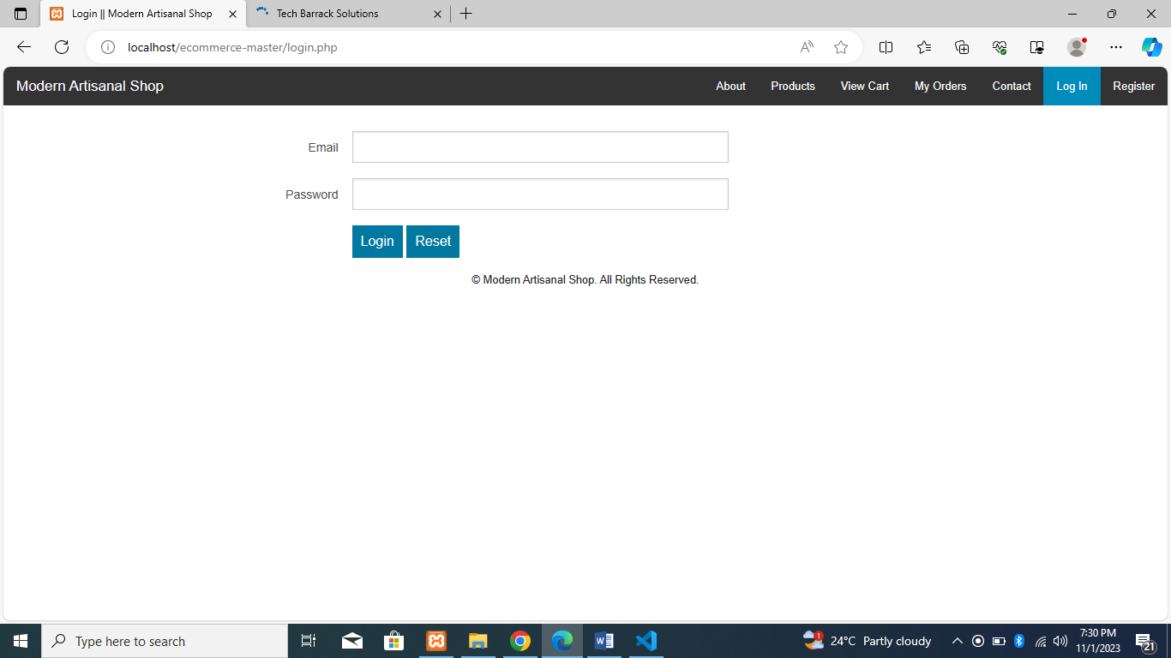

**User Registation page:**

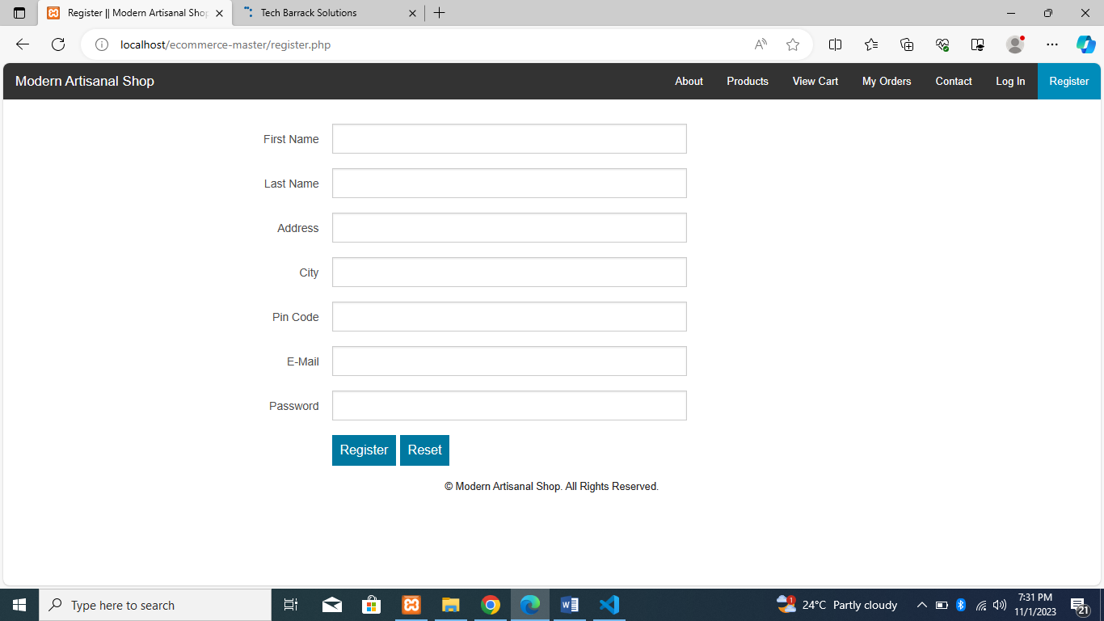

**Products detail:**

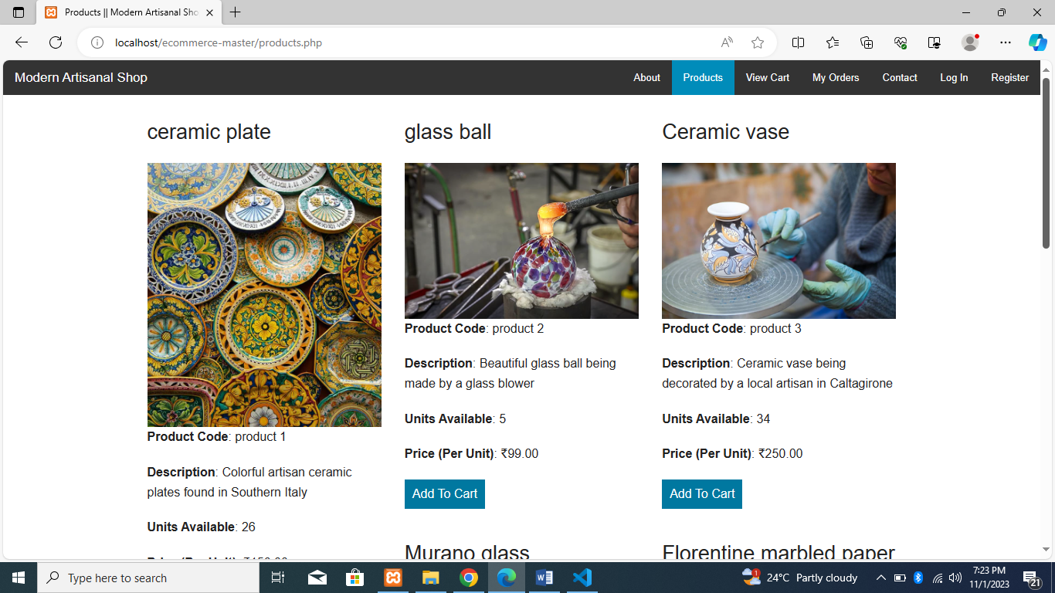

**Cart page:**

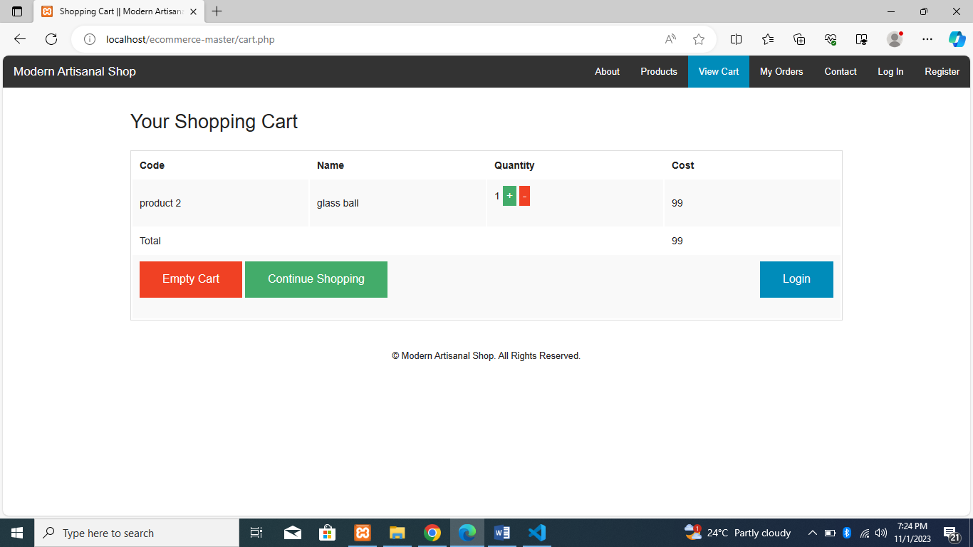

**Orders page:**

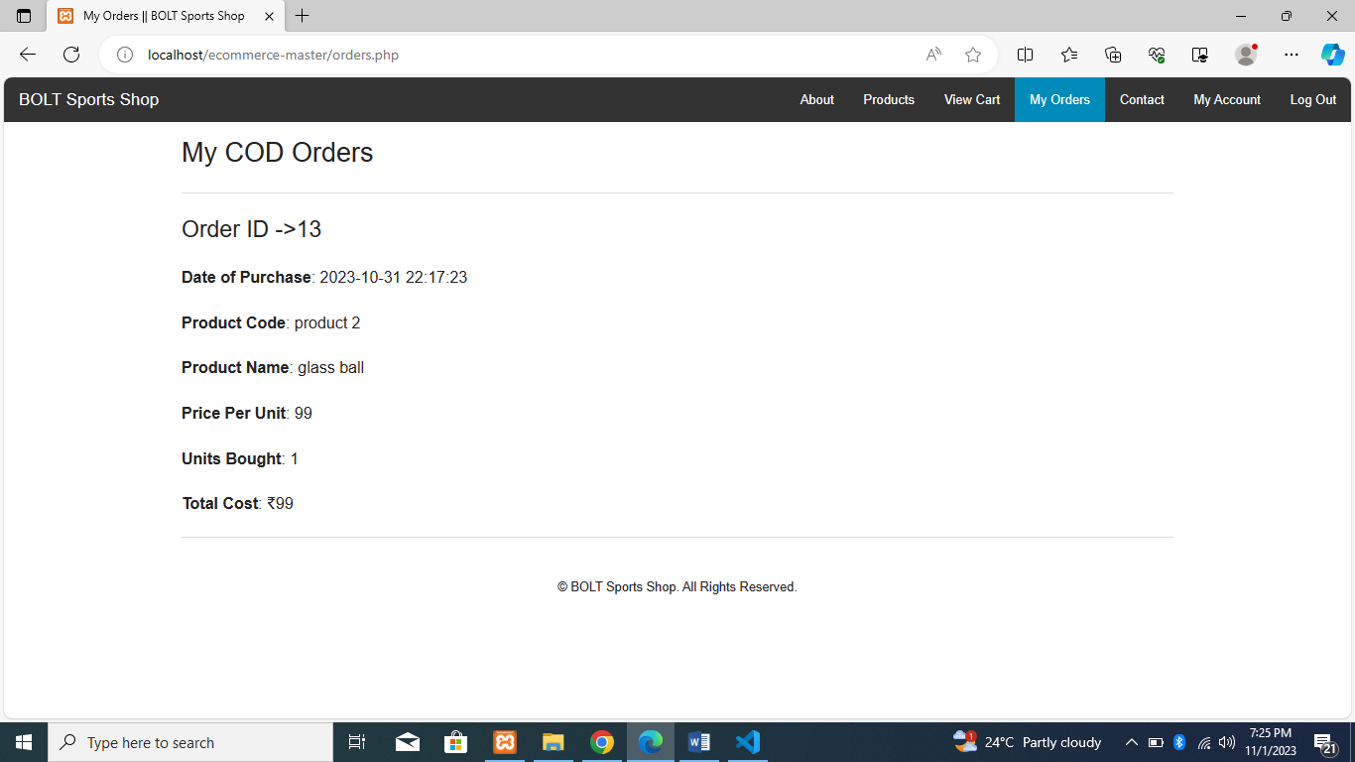

**Contacts page:**

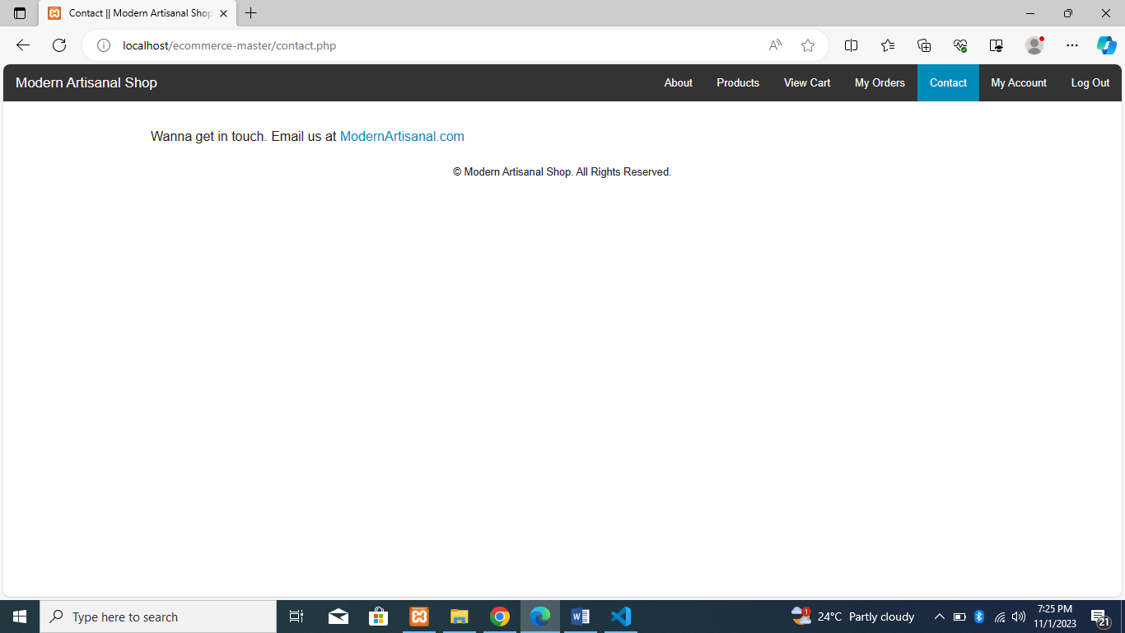

**About page:**

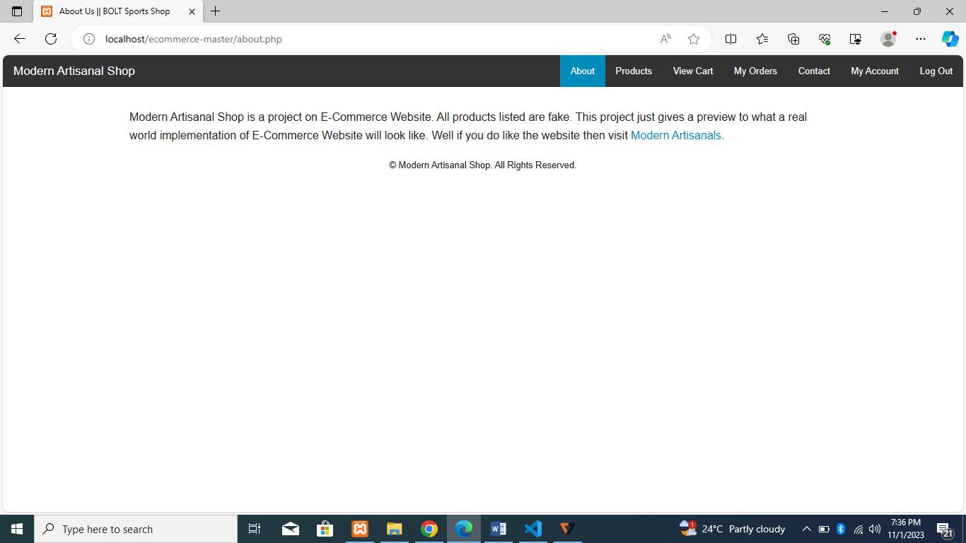

**User Profile :**

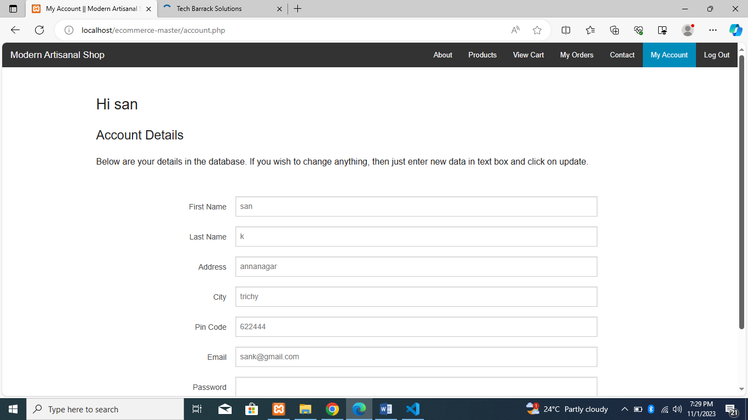

**Conclusion:**

Remember that this is a high-level overview, and the actual design and development of an e-commerce application would require more detailed planning, including database design, API integration, and extensive testing to ensure a secure and reliable platform for both customers and sellers.