Computer Vision Intern Task Report

Name : subash sidgel
gmail : info@subashsigdel.com.np

Introduction
The objective of this task was to develop an object detection model for self-driving cars, using images captured by a front-facing camera. This model aims to identify various objects such as cars, pedestrians, and trucks.

Approach
1. Data Exploration: I began by exploring a self driving car dataset from Roboflow, containing:
- Total Labels: 97,942
- Total Images: 15,000
- Classes: 11 .
- Shape : (195884, 8)
- Classname: ['car', 'pedestrian', 'trafficLight-Red', 'trafficLight-Green', 'trafficLight', 'biker', 'truck', 'trafficLight-GreenLeft', 'trafficLight-RedLeft', 'trafficLight-Yellow', 'trafficLight-YellowLeft']
- LinkofDataset : https://public.roboflow.com/object-detection/self-driving-car)

2. Model Development: Initially, I aimed to use a well-known object detection model called Faster R-CNN with a VGG-16 backbone. So the dataset format for faster RCNN is same as I got in the annotation.csv file. Then I split the data into training and testing. The train folder and test folder contains 200 unique images each and one csv file of the labels or annotations.
Then I made a architecture:
- Define ROI Pooling Convolutional Layer
- setup Vgg-16 model
- define RPN layer
- Classifier layer
- Calculate IoU (Intersection of Union)
- Calculate the rpn for all anchors of all images
- Generate the ground_truth anchors
- Define loss functions
- And Start training
However, I faced challenges during training. To ensure timely delivery, I used another model YOLOv8, which is efficient and well-suited for real-time applications. I fine-tuned this model on my custom dataset focusing on three main classes: cars, trucks, and pedestrians.

3. Evaluation: The model's performance was evaluated using standard metrics:
- The model shows good precision and recall, particularly for detecting cars. However, performance is lower for pedestrians and trucks, indicating room for improvement in these classes.

Visualization
Here are sample predictions from the YOLOv8 model on a few test images. Each image includes bounding boxes and class labels indicating detected objects.
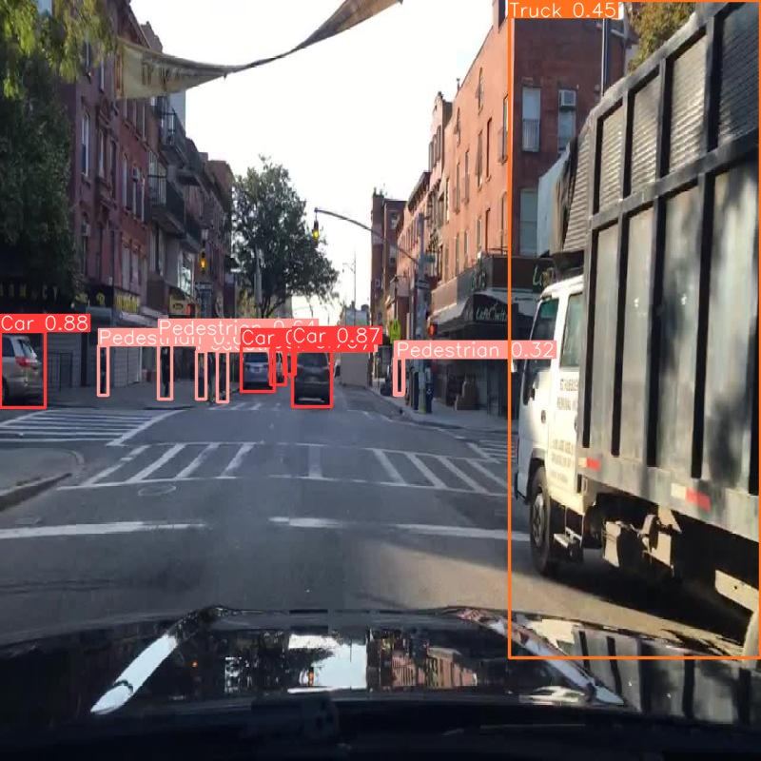
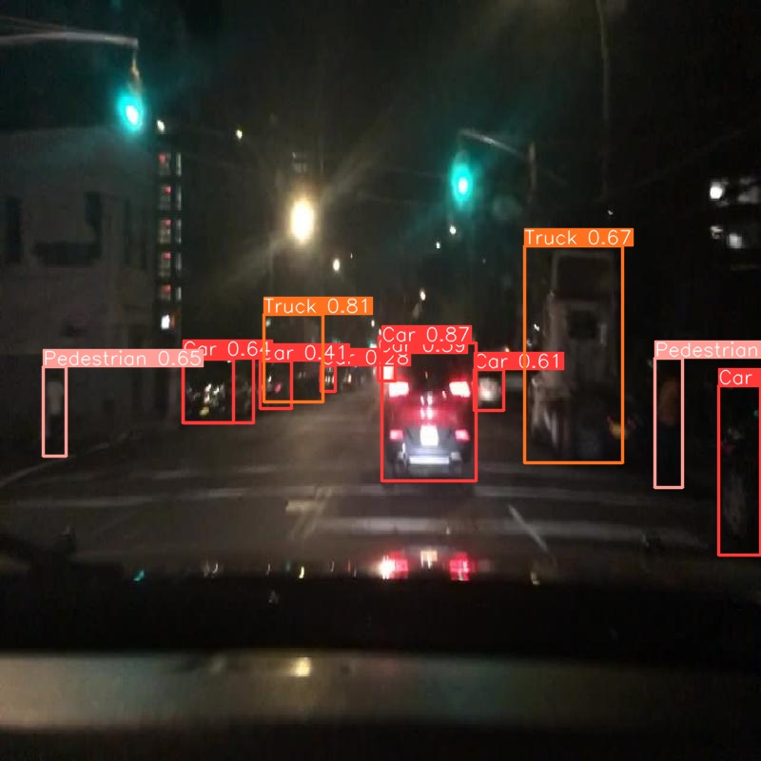

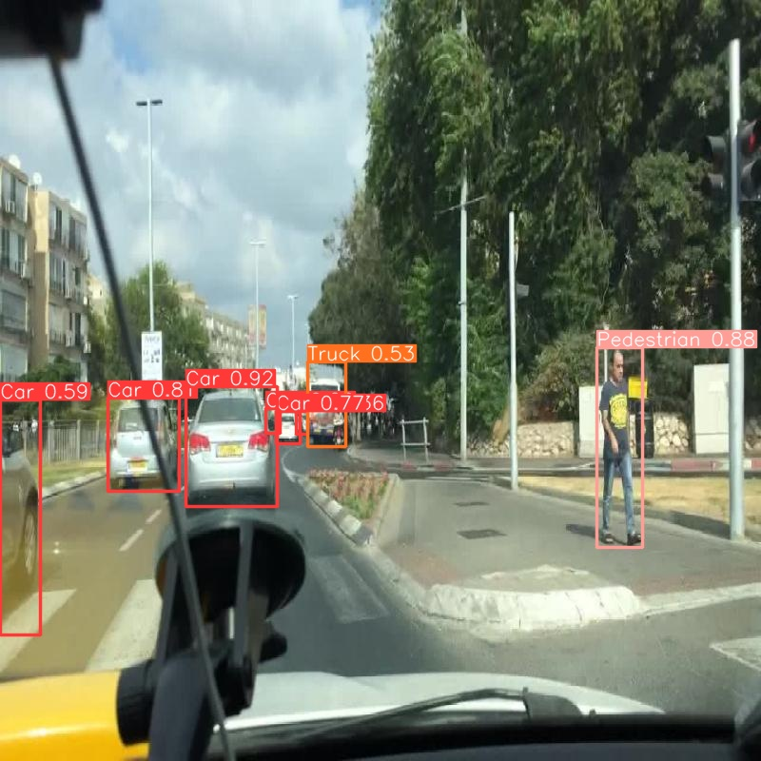

Potential Areas for Improvement
While the initial results are good, especially for car detection, there are several strategies to further enhance the model:
- Hyperparameter Tuning: Adjusting training parameters such as learning rate and batch size to improve performance.
- Data Augmentation: Increasing the diversity of training data through techniques like random cropping and flipping to make the model more robust.
- Model Architecture Adjustments: Exploring other pre-trained models or fine-tuning additional layers could enhance detection accuracy for pedestrians and trucks.

Conclusion
This object detection model for a self-driving car using YOLOv8 due to challenges encountered with Faster R-CNN and VGG-16. The YOLOv8 model demonstrated strong performance in detecting cars but had room for improvement in detecting pedestrians and trucks.

