CSA15 – Cloud Computing and Big Data Analytics

Assignment 1 – CO1: Design, Analyse and Validate a Cloud-Based Solution for Migrating a Legacy University Management System
Field | Details | Field | Details
Student Name | Subash Surya N | Register Number | 1924260164
Department / Section | AI & DS | Academic Year / Semester | 2026-2030
Faculty Name | Dr. R Latha | Nature of Assignment | Individual
Duration | 1 Week | Total Marks | 50

Submission Date: 6/11/2026 Evaluation Date: ____________________
CO1: Apply cloud computing technologies including hardware-software evolution, virtualization, web services, and service models to develop cloud-based solutions.

MARK SHEET (Rubric-based evaluation)
Task | Title | Max | Awarded | Evidence / evaluation focus
1 | Introduce Cloud Computing | 3 |  | Definition; characteristics; deployment models; scenario mapping
2 | Trace Evolution and Hardware Evolution | 3 |  | Timeline; hardware evolution; relevance to university
3 | Analyse Internet Software Evolution | 3 |  | Web/software evolution; SOA; APIs; scenario relevance
4 | Apply Server Virtualization | 5 |  | Hypervisor types; VM/container comparison; consolidation; limitations
5 | Apply Web Services | 4 |  | SOA and SOAP/REST; three university APIs; request/response examples
6 | Analyse IaaS, PaaS and SaaS | 5 |  | Responsibility layers; five-application mapping; comparison; providers
7 | Examine XaaS | 3 |  | Four or more variants; two justified choices; provider risks
8 | Design Cloud Solution Architecture | 5 |  | Labelled diagram; deployment/service models; scaling; security; DR
9 | Hands-on Implementation and Documentation | 4 |  | Running VM/container; PaaS/SaaS; tests; actual screenshots
10 | Evaluate and Recommend Final Solution | 7 |  | Three-way comparison; 3-year costs; risks; phased roadmap
11 | Day-4 Design Challenge | 8 |  | Impact; evaluation; adaptation; evidence-based defence
 | TOTAL | 50 |  | Percentage :

EVIDENCE VERIFICATION CHECKLIST
Tasks | Evidence expected | Status (✓ / P / ✗) | Evaluator note
1-3 | Conceptual explanations, comparisons and relevant illustrations | ✓ | Explanations and relevant scenario mapping documented
4 | Virtualization calculations with stated assumptions and peak-load caution | ✓ | Calculations present; practical capacity validation recommended
5-7 | API examples, service responsibility table and justified XaaS choices | ✓ | Required conceptual evidence documented
8 | Labelled architecture diagram, caption below figure and component justification | ✓ | Architecture documented; sizing assumptions need testing
9 | Actual code, environment details, execution logs, API outputs and screenshots | P | Procedures provided; actual execution evidence not established
10 | Cost assumptions, 3-year totals, risk controls and migration roadmap | ✓ | Estimates and rationale documented
11 | Day-4 changes, 10x load strategy, 99.9% target and 40-college isolation | ✓ | Design analysis documented; practical validation pending

IMPLEMENTATION EVIDENCE CHAIN
Evidence item | Status | Observation
Source code | ✓ | Flask REST API and Dockerfile provided in the proposed implementation
Virtualization | P | Docker container configuration documented; running-container evidence required
PaaS or SaaS | P | Managed web-service deployment procedure described; live deployment not verified
Functional test | P | Expected HTTP 200 response and JSON output documented; actual output required
Failure case | P | HTTP 404 test case documented; actual execution record required
Screenshots | P | Screenshot requirements identified; authentic screenshots need verification
Reproducibility | ✓ | Build commands, run commands, endpoints and expected results specified

OVERALL REMARKS

_______________ | _______________ | _______________
Student Signature | Faculty Signature | Program Director

MANDATORY SUBMISSION EVIDENCE CHECK
✓ = Present in documented answer; P = Partly present; ✗ = Missing / not satisfied
Task | Evidence expected | Status | Evaluator note
1 | Cloud definition, characteristics, deployment models and scenario mapping | ✓ | All conceptual requirements covered
2 | Evolution timeline, hardware development and university relevance | ✓ | Well explained with relevant examples
3 | Internet software evolution, SOA and APIs | ✓ | Clear explanation and scenario relevance
4 | Hypervisors, VM/container comparison and consolidation calculations | ✓ | Calculations included; peak-load limitations discussed
5 | SOAP/REST comparison and three university APIs | ✓ | API methods and request/response examples documented
6 | IaaS/PaaS/SaaS responsibility layers and application mapping | ✓ | All five applications categorized with justification
7 | XaaS variants and two justified selections | ✓ | Six variants explained; DBaaS and DRaaS recommended
8 | Labelled architecture, scaling, security and disaster recovery | ✓ | Design and component justifications documented
9 | Working container, PaaS/SaaS deployment, actual tests and screenshots | P | Code and procedures provided; actual execution evidence requires verification
10 | Three-year cost comparison, risks and migration roadmap | ✓ | Cost assumptions, calculations and recommendations included
11 | Impact analysis, 10x load, 99.9% availability and tenant isolation | ✓ | Changed requirements evaluated; load-test evidence recommended

IMPLEMENTATION EVIDENCE CHAIN (continued)
Evidence item | Status | Observation
Source code | ✓ | Python Flask REST API and Dockerfile documented
Virtualization | P | Docker build and run procedures provided; execution screenshot required
PaaS or SaaS | P | Cloud deployment steps described; actual deployment confirmation required
Functional test | P | HTTP 200 and expected JSON response documented; actual test output required
Failure case | P | HTTP 404 test case included; execution evidence required
Screenshots | P | Required screenshots identified but authenticity and completeness not verified
Reproducibility | ✓ | Installation, configuration, commands and testing steps documented
Interpretation | ✓ | Technical outcomes and implementation limitations explained
Code and report consistency | ✓ | Proposed API, Docker configuration and testing procedure are aligned

SUBMISSION CHECKLIST (Not Separately Marked)
Requirement | Status
All 11 tasks answered | ☒ Yes ☐ Partly ☐ No
Cloud concepts and comparisons explained | ☒ Yes ☐ Partly ☐ No
Virtualization calculations included | ☒ Yes ☐ Partly ☐ No
API examples and service models explained | ☒ Yes ☐ Partly ☐ No
Cloud architecture diagram included | ☒ Yes ☐ Partly ☐ No
Implementation and testing evidence provided | ☐ Yes ☒ Partly ☐ No
Three-year cost analysis and roadmap included | ☒ Yes ☐ Partly ☐ No
Day-4 design challenge completed | ☒ Yes ☐ Partly ☐ No
Figures and screenshots included | ☐ Yes ☒ Partly ☐ No
Table and figure numbering correct | ☐ Yes ☒ Partly ☐ No
Viva recommended | ☒ Yes ☐ No

CSA15 - Cloud Computing and Big Data Analytics: ASSIGNMENT 1
CO1: Apply cloud computing technologies including hardware-software evolution, virtualization, web services, and service models to develop cloud-based solutions.
Assignment Title: Design, Analyse and Validate a Cloud-Based Solution for Migrating a Legacy University Management System (Total Marks - 50)
Duration: 1 week

Scenario - Smart Campus Cloud Migration
A multi-campus university currently runs its Student Information System, Learning Management System, Library System, Exam Portal and Email on ageing physical servers in a single on-premise data centre. Each application has its own dedicated server, which stays idle for most of the year but fails to cope during admissions, result publication and online-exam weeks.
The university's current environment is:
- 12 physical servers, average CPU utilisation of about 15%, with peaks above 95% during admissions and exams
- Approximately 25,000 students and 2,000 staff across 4 campuses
- Applications built as large monolithic programs, with no public interfaces for mobile apps or partner colleges
- High capital expenditure, slow procurement (6-8 weeks per server) and no disaster recovery site
As a cloud consultant, you must study how computing evolved to the cloud model, and then design a cloud-based solution that uses virtualization, web services and an appropriate mix of service models (IaaS, PaaS, SaaS and XaaS) for the university. All recommendations must be justified in terms of cost, scalability, availability and manageability.
Design Challenge: On Day 4, the university announces that it will launch a mobile app and open student-record and fee-payment services to 40 affiliated colleges. Expected load is 10 times the current peak, with a requirement of 99.9% availability and a limited operating budget. Re-evaluate your original design and decide whether it should be retained, modified or redesigned.

TASK 1 - Introduce Cloud Computing and Map It to the Scenario (3 Marks)
Design and propose a cloud computing model for the context of the university's problems.
- Definition of cloud computing and the five essential characteristics (on-demand self-service, broad network access, resource pooling, rapid elasticity, measured service)
- Deployment models (public, private, hybrid, community) and which one suits the university
- Three problems of the current on-premise setup and how each cloud characteristic addresses them
- Benefits and limitations of cloud adoption for the university
Evidence Expected: A clear explanation of cloud characteristics and deployment models, mapped to the university's actual problems.

TASK 2 - Trace the Evolution and Hardware Evolution (3 Marks)
Trace how computing infrastructure evolved to make cloud computing possible.
- A timeline from mainframes, minicomputers and PCs, to client-server, clusters, grid computing, utility computing and cloud
- Hardware evolution: multi-core processors, commodity servers, high-capacity storage, high-speed networking and data centres
- How each stage solved a limitation of the previous one
- Which stage the university's current system corresponds to, with reasons
Evidence Expected: A labelled timeline or diagram, with a justified explanation of how hardware advances enabled the cloud.

TASK 3 - Analyse Internet Software Evolution (3 Marks)
Explain how internet software evolved and why it supports cloud services.
- Evolution from static web pages to dynamic web, Web 2.0, SOA, mashups and cloud-hosted applications
- Role of browsers, HTTP, AJAX and APIs in delivering software over the internet
- Comparison between desktop software, client-server software and web-delivered software
- How this evolution affects the design of the university's applications
Evidence Expected: A comparative explanation of software evolution stages, linked to the university's application design.

TASK 4 - Apply Server Virtualization (5 Marks)
Apply server virtualization to consolidate the university's 12 physical servers.
- Explain how a hypervisor works, and distinguish Type-1 and Type-2 hypervisors, with examples
- Compare full virtualization, para-virtualization, OS-level virtualization (containers) and hardware-assisted virtualization
- Propose which applications should run as virtual machines and which as containers, with reasons
- Calculate the consolidation: with an average utilisation of 15% per server and a target host utilisation of 70%, estimate how many physical hosts are needed (show your assumptions and working)
- Discuss live migration, snapshots and resource over-commitment as benefits, and the risks of virtualization (noisy neighbour, hypervisor failure, security isolation)
Show your calculation. A final number without working will not receive full credit.
Evidence Expected: A justified virtualization plan with a worked consolidation calculation and discussion of benefits and risks.

TASK 5 - Apply Web Services (4 Marks)
Analyse web services to expose the university's functions to other systems.
- Overview of web services and their role in cloud and SOA
- Compare SOAP, WSDL, UDDI and RESTful services (HTTP methods, JSON/XML)
- Identify at least three university functions to expose as web services (for example, result lookup, fee payment, library search) and define the endpoint, method and sample request/response for each
- Justify whether SOAP or REST is more suitable for each function
Evidence Expected: A defined set of web services with sample request/response formats and a justified choice of SOAP or REST.

TASK 6 - Analyse the Service Models: IaaS, PaaS and SaaS (5 Marks)
Analyse which service model fits each university application.
- Define IaaS, PaaS and SaaS, and show who manages which layer (hardware to application) in each model
- Categorise the five university applications (SIS, LMS, Library, Exam Portal, Email) into IaaS, PaaS or SaaS, with reasons
- Compare the models on control, cost, scalability, maintenance effort and vendor lock-in
- Give one real provider example for each model
Present your categorisation in a table, but explain the reasoning behind each decision. A table alone is not sufficient.
Evidence Expected: A reasoned mapping of applications to service models, supported by a layer-wise responsibility comparison.

TASK 7 - Examine XaaS (3 Marks)
Examine the broader XaaS (Anything-as-a-Service) concept for the university.
- Explain XaaS and describe at least four variants (for example DaaS, BaaS/MBaaS, FaaS, DBaaS, Security-as-a-Service, Disaster-Recovery-as-a-Service)
- Select two XaaS offerings that would benefit the university, and justify them
- Discuss the risks of over-reliance on multiple 'as-a-Service' providers
Evidence Expected: An analysis of XaaS variants, with justified selection of two offerings for the university.

TASK 8 - Design the Cloud Solution Architecture (5 Marks)
Bloom's Level: Level 6 - Create | Action verbs: Design, Construct, Propose
Create a complete cloud architecture for the university by combining virtualization, web services and service models.
- An architecture diagram showing users, load balancer, web/application tier, database tier, storage, API layer and DR region
- The deployment model and the service model chosen for each component
- How elasticity (auto-scaling) will handle admissions and exam peaks
- Basic security and availability measures (access control, encryption, backup, multi-zone deployment)
Evidence Expected: A labelled architecture diagram with written justification for each component and design decision.

TASK 9 - Hands-on Implementation and Documentation (4 Marks)
Implement a small proof-of-concept of your design using a free-tier cloud account or a local virtualization tool.
- Create a virtual machine or container (using AWS/Azure/GCP free tier, VirtualBox, or Docker) and host a simple web page or REST API for one university function
- Deploy a SaaS or PaaS component (for example a cloud-hosted database, a serverless function or a static site)
- Test the web service with a client (browser, Postman or curl) and record the output
- Provide screenshots, configuration steps and any issues faced
Evidence Expected: Annotated screenshots and clear, reproducible steps showing that the proof-of-concept works.

TASK 10 - Evaluate and Recommend the Final Solution (7 Marks)
Evaluate your design and recommend the final cloud solution for the university.
- Compare on-premise, IaaS-based and PaaS/SaaS-based options on cost (CapEx vs OpEx), scalability, availability, security and effort
- Estimate a simple 3-year cost comparison using stated assumptions
- Identify the main risks (vendor lock-in, data privacy, downtime, skills gap) and give mitigation steps
- Provide your final recommendation and a short migration roadmap (which application moves first, and why)
Your recommendation must be supported by the analysis in the previous tasks. Choosing a popular cloud provider without justification is not sufficient.
Evidence Expected: A technically justified recommendation, supported by a cost comparison, risk analysis and migration roadmap.

DAY-4 DESIGN CHALLENGE - TASK 11 - Re-evaluate and Adapt the Design (8 Marks)
Changed Requirement: The university will now launch a mobile app and open student-record and fee-payment services to 40 affiliated colleges. Expected load is 10 times the current peak, availability must be 99.9%, and the operating budget is limited.
Re-evaluate your original design in response to these changed conditions. You may retain, modify or redesign your original solution.
Impact Analysis - 2 Marks. Discuss:
- What has changed from the original problem
- Which original assumptions (load, users, availability, cost) are affected
- Why the web services and APIs now become critical
- How multi-tenant access by 40 colleges affects security and isolation
Evidence Expected: A clear analysis of how the changed requirements affect the original cloud design.
Evaluation of the Original Design - 2 Marks. Discuss:
- Whether the chosen service models and virtualization plan can handle a 10x load
- Whether auto-scaling and the single-region deployment are sufficient for 99.9% availability (about 8.76 hours of downtime allowed per year)
- Whether cost remains acceptable under the new load
- Whether another service model or XaaS offering would give better overall results
Evidence Expected: A technically supported evaluation of the original design under the new conditions.
Adaptation or Redesign - 2 Marks. Discuss:
- Decide whether to retain, modify or redesign the solution
- Describe the revised architecture (for example API gateway, container orchestration, serverless components, multi-zone deployment or a hybrid model)
- Explain what changed in the service model mix and in the virtualization approach
- If you retain the original design, give sufficient technical justification for why no change is required
Evidence Expected: An appropriate design response to the changed requirement, with clear technical reasoning.
Evidence-Based Defence - 2 Marks. Discuss:
- Capacity and availability calculations
- Cost comparison between the original and the revised design
- Security and multi-tenancy considerations
- Trade-offs such as vendor lock-in, complexity and migration effort
Evidence Expected: A well-supported final decision that follows logically from the analysis.

MARK DISTRIBUTION
Task | Title | Bloom's Level | Marks
Task 1 | Cloud Computing - Introduction & Characteristics | L2 - Understand | 3
Task 2 | Evolution & Hardware Evolution | L2 - Understand | 3
Task 3 | Internet Software Evolution | L2 - Understand | 3
Task 4 | Server Virtualization | L3 - Apply | 5
Task 5 | Web Services | L3 - Apply | 4
Task 6 | Service Models: IaaS, PaaS, SaaS | L4 - Analyze | 5
Task 7 | XaaS | L4 - Analyze | 3
Task 8 | Design the Cloud Solution Architecture | L6 - Create | 5
Task 9 | Hands-on Implementation & Documentation | L3 - Apply | 4
Task 10 | Evaluate & Recommend the Final Solution | L5 - Evaluate | 7
Task 11 | Day-4 Design Challenge | L4 / L5 / L6 | 8
 | TOTAL |  | 50

TASK 1 - Introduce Cloud Computing and Map It to the Scenario (3 Marks)
Required: definition and the five essential characteristics; deployment models and the best fit; three current problems and how each cloud characteristic addresses them; benefits and limitations.

• Definition
Cloud computing is a model for enabling ubiquitous, convenient, on-demand network access to a shared pool of configurable computing resources (servers, storage, networks, platforms, applications and services) that can be rapidly provisioned and released with minimal management effort or provider interaction (NIST SP 800-145). In simple terms, computing is consumed as a utility: the university rents capacity over the network, pays for what it uses and no longer owns or operates the underlying hardware.

• The five essential characteristics
Characteristic | Meaning | What it means for the university
On-demand self-service | A user provisions compute, storage or services through a portal or API with no human interaction with the provider | IT staff launch a server in minutes, not after a 6-8 week purchase cycle
Broad network access | Services are available over the network through standard mechanisms (browser, mobile, API) | Students and staff on 4 campuses, and later the mobile app, reach services from anywhere
Resource pooling | The provider serves many tenants from a shared, virtualized pool and assigns resources dynamically | The university stops owning 12 mostly idle machines and draws from a much larger shared pool
Rapid elasticity | Capacity scales out and in quickly, often automatically | Extra capacity appears during admissions, results and exam weeks and is released afterwards
Measured service | Usage is metered and billed (per hour, per request, per GB) and can be monitored | Each department can be charged for real consumption; cost follows usage

• Deployment models and the best fit
Model | Description | Pros | Cons
Public cloud | Operated by a provider (AWS, Azure, GCP) and shared by many customers | No CapEx, near-unlimited elasticity, wide reach | Less control; data-residency and privacy concerns
Private cloud | Dedicated to one organisation, on-premise or hosted | Maximum control and compliance | High CapEx, limited elasticity, needs skilled staff
Hybrid cloud | Private/on-premise plus public cloud connected together | Sensitive data stays local while peaks burst to public cloud | Integration and networking complexity
Community cloud | Shared by organisations with common needs (e.g. a consortium of colleges) | Shared cost and common compliance | Limited scale and few providers
Recommended model: public cloud, with a hybrid element during migration (and possibly a community-cloud arrangement for the 40 affiliated colleges later). Reasons:
- The workload is highly bursty (15% average, 95% peak). Only a large public pool can absorb such peaks economically.
- The university has no capital budget for a private cloud and no second data centre for disaster recovery.
- Student records are sensitive, so the database of record can stay in an in-country cloud region (or on-premise in early phases), which is exactly what hybrid allows.
- Public cloud regions in India help meet data-localisation expectations.

• Three problems of the current setup and how cloud characteristics solve them
 | Current problem | Evidence in the scenario | Cloud characteristic | How it helps
 | Capacity fails at peaks, yet servers idle for most of the year | 15% average vs 95% peak | Rapid elasticity and resource pooling | Auto-scaling adds instances during admissions or exams and removes them afterwards; idle capacity is no longer stranded inside the university
 | Slow, costly procurement and large CapEx | 6-8 weeks per server; ageing hardware | On-demand self-service and measured service | Resources appear in minutes and are paid as operating expense per hour of use
 | No public interface for mobile or partners; single site with no DR | Monolithic applications; one data centre | Broad network access (plus provider multi-region infrastructure) | Functions are exposed through APIs over standard protocols; replication to a second region gives disaster recovery

• Benefits and limitations of cloud adoption
Benefits: conversion of CapEx to OpEx; pay-per-use that matches the bursty load; fast scaling; built-in redundancy and DR options; quicker delivery of new services (mobile app, partner APIs); less hardware administration so staff can focus on academic IT; access to managed services (databases, monitoring, security tooling).
Limitations and risks: vendor lock-in; recurring cost that can grow unnoticed without governance; dependence on internet connectivity; data privacy and regulatory concerns (student data, DPDP Act 2023); shared-responsibility security misconfiguration; skills gap in the current IT team; latency to a distant region; need to refactor monolithic applications to exploit the cloud fully.
Conclusion of Task 1: every major problem of the university (bursty demand, slow procurement, no DR, no interfaces) maps directly onto a cloud characteristic, and a public/hybrid model is the best fit.

TASK 2 - Trace the Evolution and Hardware Evolution (3 Marks)
Required: timeline from mainframes to cloud; hardware evolution; how each stage solved the limitation of the previous one; which stage the university's current system corresponds to.

• Timeline of computing infrastructure
Figure 1: Evolution of computing infrastructure from mainframes to cloud computing (top to bottom)
Stage | Period | Key idea
Mainframe | 1950s-60s | Central, time-shared, very costly
Minicomputer | 1960s-70s | Cheaper departmental machines
Personal computer | 1980s | Individual, standalone computing
Client-server | Late 1980s-90s | Servers plus PC clients over a LAN
Cluster | 1990s | Many commodity machines act as one
Grid | Late 1990s-2000s | Distributed resources shared across sites
Utility computing | Early 2000s | Metered pay-per-use
Cloud computing | 2006 onwards | Self-service, elastic, virtualized, API-driven
The university's present system sits at stage 4 (client-server).

• How each stage solved the limitation of the previous one
Stage | Key characteristic | Limitation it removed | New limitation it created
Mainframe | Centralised, time-shared, dumb terminals | - | Extremely expensive; single point of failure
Minicomputer | Smaller, cheaper departmental machines | Cost and exclusivity of mainframes | Islands of computing with weak sharing
Personal computer | Individual ownership and local software | Dependence on central access and queues | Scattered data, no central control or collaboration
Client-server | Dedicated servers (database, file, application) serve many clients over LANs | Data silos and poor sharing between PCs | One server per application, poor utilisation, scaling only by buying hardware
Cluster computing | Commodity machines linked to act as one system | Capacity ceiling and single-server failure | Confined to one site and one organisation
Grid computing | Geographically distributed resources shared across organisations | Limited capacity inside one site | Complex middleware, batch-oriented, hard for business use
Utility computing | Metered pay-per-use computing like electricity | Up-front investment | Needed virtualization and automation to be flexible
Cloud computing | Virtualized, self-service, elastic, measured services via APIs | Fixed capacity, slow provisioning, high CapEx | Governance, security, lock-in and cost-control challenges

• Hardware evolution that made the cloud possible
Hardware advance | What changed | Contribution to cloud
Multi-core processors | Performance growth moved from clock speed to many cores per chip, with hardware virtualization support (Intel VT-x, AMD-V) | Dozens of VMs run efficiently on one host
Commodity (x86) servers | Standard, inexpensive servers replaced proprietary systems | Providers build huge fleets cheaply and tolerate failures through software redundancy
High-capacity, low-cost storage | Falling cost per GB; SSD/NVMe; distributed storage | Object storage and cheap backups at massive scale
High-speed networking | 1 GbE to 10/40/100 GbE, broadband and fibre, software-defined networking | Remote consumption becomes practical; data centres link to each other and to users
Modern data centres | Purpose-built facilities with efficient power and cooling, automation and multiple regions | Economies of scale, high availability, global reach
Virtualization and management software | Hypervisors and orchestration | Abstract hardware so it can be pooled, sliced and moved
Together, these advances gave cheap compute, cheap storage and fast networking; virtualization then turned them into a flexible, shareable utility.

• Where the university's current system sits
The current environment corresponds to the client-server stage: one application per dedicated physical server in a single data centre. Reasons:
- Each application (SIS, LMS, Library, Exam Portal, Email) runs on its own server, the classic client-server pattern.
- There is no virtualization or resource pooling, which explains the 15% average utilisation.
- Capacity is bought as hardware (6-8 week procurement, CapEx) instead of rented on demand.
- Applications are monolithic with no public interfaces, typical of pre-web-services client-server systems.
- There is no multi-site redundancy, so none of the resilience of cluster, grid or cloud systems.
Relevance to the university: the migration is the logical next step in this evolution. Pooling (cluster and grid ideas), metering (utility computing) and virtualization together give the university what each earlier stage lacked.

TASK 3 - Analyse Internet Software Evolution (3 Marks)
Required: evolution from static web to cloud-hosted applications; role of browsers, HTTP, AJAX and APIs; comparison of desktop, client-server and web-delivered software; effect on the design of the university's applications.

• Evolution of internet software
Stage | Era | Description | Significance for the cloud
Static web (Web 1.0) | 1990s | Read-only HTML pages served over HTTP | Universal access through a browser and URLs
Dynamic web | Late 1990s | Server-side scripting (CGI, PHP, ASP, JSP) and databases generate pages on demand | Made web applications (admission forms, result lookup) possible
Web 2.0 | Mid-2000s | User-generated content, rich interaction, AJAX, social platforms | The browser became an application platform
Service-Oriented Architecture (SOA) | 2000s | Loosely coupled, reusable services with standard interfaces (SOAP/WSDL, later REST) | Introduced the idea of consuming functions as network services
Mashups | 2000s | New applications combine data and functions from several web APIs | Showed the value of public APIs and composable services
Cloud-hosted applications | 2006 onwards | Applications and platforms hosted in elastic data centres and delivered over the internet (SaaS, PaaS) | Software consumed as a service; scaling and operations handled by the provider

• Role of key technologies
- Browsers: a universal, installation-free client. Any device with a browser becomes a client, which supports broad network access.
- HTTP/HTTPS: the standard request-response protocol on which web services, REST APIs and load balancers depend; HTTPS adds encryption.
- AJAX (Asynchronous JavaScript and XML/JSON): lets a page fetch data in the background without reloading, giving desktop-like interactivity while the server exposes data endpoints.
- APIs: well-defined interfaces (usually REST/JSON) through which one program uses another's functions. They enable mobile apps, partner integration and mashups, and are the glue of cloud architectures.

• Desktop vs client-server vs web-delivered software
Aspect | Desktop software | Client-server software | Web-delivered (cloud) software
Where it runs | Entirely on the user's PC | Client on PC, logic and data on a server | Mostly on provider servers; browser or thin client
Installation and updates | Per machine, manual | Client install and version matching needed | None or automatic; one central version
Data location | Local files | Central server database | Central, replicated cloud storage
Collaboration | Poor | Moderate, inside the network | Strong, from anywhere
Scalability | None (per PC) | Limited by the server purchased | Elastic, scales with demand
Access | One device | Typically inside the LAN/VPN | Any device with internet
Maintenance cost | High (many devices) | Medium | Low for the user; handled by provider
Integration | Hard | Proprietary protocols | Open APIs (REST/SOAP)

• Effect on the design of the university's applications
- Move from monolith to services. Split the SIS, LMS and Exam Portal into modules (authentication, results, fees, course content) that scale independently.
- API-first design. Every important function is available through a REST API so the web portal, the mobile app and partner colleges all use the same interface.
- Browser-based clients. Staff and students use a browser or mobile app, removing client installation on campus PCs.
- Stateless, horizontally scalable components, with sessions and files in shared stores, so extra instances can be added during peaks.
- Standard protocols and security. HTTPS, token-based authentication (OAuth2/JWT) and single sign-on across all applications.
- Consume existing services (SaaS email, payment-gateway APIs) instead of building everything in-house, following the SOA and mashup idea.
The software evolution explains why the university's monolithic, interface-less applications cannot serve a mobile app or 40 colleges, and what the redesign must look like.

TASK 4 - Apply Server Virtualization (5 Marks)
Required: how a hypervisor works and Type-1 vs Type-2 with examples; comparison of full, para, OS-level (containers) and hardware-assisted virtualization; which applications run as VMs and which as containers; consolidation calculation with assumptions; live migration, snapshots, over-commitment, and the risks.

• How a hypervisor works
A hypervisor (virtual machine monitor) is a thin software layer that sits between the physical hardware and the operating systems. It (a) divides CPU cores, memory, disk and network into virtual resources, (b) presents each virtual machine (VM) with its own virtual hardware so that the guest OS believes it owns a real machine, (c) schedules the VMs on the physical CPUs, and (d) keeps VMs isolated from one another so a crash or compromise in one does not directly affect the others. With hardware support (Intel VT-x / AMD-V), privileged guest instructions are trapped or executed safely by the CPU, so overhead is small (typically 2-10%).

• Type-1 vs Type-2 hypervisors
Aspect | Type-1 (bare-metal) | Type-2 (hosted)
Where it runs | Directly on the hardware | As an application on a host OS
Performance | Near native; low overhead | Lower, because requests pass through the host OS
Typical use | Production data centres and clouds | Developer laptops, testing, learning
Security and stability | Smaller attack surface, enterprise management features | Depends on the host OS; larger attack surface
Examples | VMware ESXi, Microsoft Hyper-V, KVM (Linux), Xen, Proxmox VE | Oracle VirtualBox, VMware Workstation, Parallels
Suitability for the university | Used for the consolidated production hosts | Used only for staff training and the Task 9 proof of concept

• Comparison of virtualization techniques
Technique | How it works | Guest OS modified? | Overhead and isolation | Example
Full virtualization | Hypervisor emulates complete hardware (using binary translation or hardware assist), so unmodified guest OSes run | No | Moderate overhead; strong isolation | VMware ESXi, KVM, VirtualBox
Para-virtualization | Guest OS is modified to make hypercalls to the hypervisor instead of executing privileged instructions | Yes | Low overhead; good isolation; limited OS support | Xen PV, virtio drivers
Hardware-assisted virtualization | CPU extensions (VT-x, AMD-V, EPT/NPT, IOMMU) let the CPU itself run guests safely | No | Lowest overhead for full VMs; now the standard foundation | KVM, Hyper-V on modern CPUs
OS-level virtualization (containers) | Many isolated user-space instances share one host kernel using namespaces and cgroups; no guest kernel | No guest kernel | Very low overhead, starts in seconds, lighter isolation because the kernel is shared | Docker, Kubernetes, LXC
In practice, modern platforms combine them: KVM or Hyper-V uses hardware-assisted full virtualization with para-virtual drivers, and containers run on top of those VMs.

• Which applications run as VMs and which as containers
Application | Proposed form | Reason
Database servers (SIS, LMS, Library, Exam DB) | VMs (later managed DBaaS) | Stateful, I/O-sensitive, need strong isolation and snapshots; easy live migration
SIS (legacy monolith) | VM at first | Legacy code expects a full OS; lift-and-shift without rewriting; later split into containerised services
Email server | VM (then SaaS) | Complex stateful legacy product with its own OS dependencies
Exam Portal web/API tier | Containers | Stateless, must scale from a few to many instances within minutes during exam week
LMS web tier (e.g. Moodle) | Containers | Stateless PHP/Python front ends behind a load balancer; files in shared object storage
Library system web tier and search | Containers | Lightweight, low and predictable load, easy to deploy and update
API gateway, authentication, reporting jobs | Containers | Small, frequently updated, independently scaled services
Rule applied: stateful or legacy workloads go in VMs; stateless, scalable or frequently released workloads go in containers.

• Consolidation calculation
Assumptions
- All 12 existing servers have the same capacity; call one server's full capacity 100 units.
- Average utilisation is 15%, so each server delivers 15 units of useful work on average.
- A new virtualization host has the same capacity as an old server (100 units). This is deliberately conservative; modern servers are usually faster.
- Target host utilisation is 70% (leaving 30% headroom for spikes, migration and failover), so usable capacity per host = 70 units.
- Hypervisor and management overhead is taken as 10%.
- The sizing is for average load; peak load is treated separately in step 6.
Step 1 Average total workload = 12 servers x 15 units = 180 units
Step 2 Add 10% hypervisor overhead = 180 x 1.10 = 198 units
Step 3 Usable capacity per host = 100 x 70% = 70 units
Step 4 Hosts required = 198 / 70 = 2.83 -> 3 hosts (round up)
Step 5 Add one spare host (N+1) for failover and maintenance = 4 hosts
Step 6 Peak check (worst case, all apps at 95% together):
12 x 95 = 1140 units; x 1.10 = 1254 units
1254 / 70 = 17.9 -> about 18 same-size hosts
Result
Item | Value
Physical hosts needed for average load | 3
Recommended with N+1 high availability | 4 hosts
Consolidation ratio | 12 : 4 = 3 : 1 (a 67% reduction in physical machines)
Average utilisation of the 4 hosts | 198 / (4 x 100) = 49.5%, and 66% if one host fails (198 / 300), still under 70%
If new hosts are 2x more powerful | 198 / 140 = 1.41, so 2 hosts, or 3 with N+1
Peak-load caution. The 4-host cluster covers normal operation, but a worst-case peak needs about 18 same-size hosts. Buying that on-premise would recreate the idle-capacity problem. In practice only one or two applications peak at the same time (the SIS during admissions, the Exam Portal during exams), so the real peak is lower than the worst case, but it still exceeds 4 hosts. The remaining burst capacity should therefore come from cloud elasticity, which is the core argument for the cloud design in later tasks. The figures above should be validated with real monitoring data (CPU, memory, disk I/O and network, not CPU alone) before final purchase or reservation.

• Benefits of virtualization
- Live migration: a running VM moves from one host to another with almost no downtime (e.g. vMotion, KVM live migration), so hosts can be patched or repaired without stopping the Exam Portal.
- Snapshots: a point-in-time image of a VM lets staff roll back a failed upgrade or restore after corruption in minutes, and makes cloning test environments easy.
- Resource over-commitment: the hypervisor can allocate more virtual CPUs or memory than physically exist (for example 3:1 vCPU to core), because VMs rarely peak together. This raises utilisation, but should be limited for memory and for production databases.
- Further benefits: hardware independence, faster provisioning from templates, lower power and space costs, and simpler backup and DR.

• Risks and limitations of virtualization
Risk | Explanation | Mitigation
Noisy neighbour | One VM (for example the Exam Portal) consumes CPU, memory or disk I/O and degrades others on the same host | Resource limits and reservations, separate clusters or hosts for critical workloads, I/O quotas, monitoring
Hypervisor or host failure | Many VMs fail together when a host or the hypervisor fails (a larger blast radius) | N+1 clustering with automatic restart (HA), live migration, spreading replicas across hosts and zones
Security isolation | A hypervisor or container escape vulnerability could expose other tenants; containers share a kernel | Patch promptly, minimise hypervisor attack surface, network segmentation, run sensitive databases in VMs, hardened and non-root containers
Over-commitment risk | Memory over-commit causes swapping and slowdowns at peak | Conservative ratios, memory reservation for databases
VM sprawl and licensing | Easy creation leads to unmanaged VMs and licence costs | Governance, tagging, lifecycle policy
Skills and management complexity | Needs new operational skills | Training, automation, managed services
Conclusion of Task 4: virtualization consolidates 12 physical servers into 4 hosts (3 plus one spare), saves about two-thirds of the hardware, and prepares the workloads to move to the cloud, but it cannot by itself absorb 95% peaks.

TASK 5 - Apply Web Services (4 Marks)
Required: overview of web services and SOA; comparison of SOAP, WSDL, UDDI and REST; at least three university functions exposed as web services with endpoint, method and sample request/response; SOAP vs REST justification for each.

• Web services and their role in cloud and SOA
A web service is a software function made available over a network using standard web protocols (HTTP) and data formats (XML or JSON) so that different programs, written in different languages and running on different platforms, can use it. In Service-Oriented Architecture (SOA), an application is built from loosely coupled services that have published contracts. In the cloud, web services are the way every component is controlled (cloud provider APIs) and consumed (SaaS APIs), and they are what allows the mobile app and partner colleges to use the university's functions without access to its internal systems.

• SOAP, WSDL, UDDI and REST compared
Aspect | SOAP | WSDL | UDDI | REST
What it is | A protocol for exchanging structured XML messages | An XML document describing a SOAP service (operations, messages, endpoints) | A registry for publishing and discovering services | An architectural style using plain HTTP and resources
Data format | XML only (envelope, header, body) | XML | XML | JSON (most common), XML, text
Transport | HTTP, SMTP, others | - | - | HTTP/HTTPS
Operations | Custom operations in the message | Defines them | Lists services | Standard HTTP methods: GET, POST, PUT, PATCH, DELETE on URLs
Contract | Strict, formal (WSDL) | Is the contract | Directory of contracts | Loose; documented with OpenAPI/Swagger
State | Can be stateful | - | - | Stateless
Caching | Not natively cacheable | - | - | Cacheable (GET)
Security | WS-Security, WS-Transaction support built in | - | - | HTTPS, OAuth2, JWT, API keys
Weight and speed | Heavy, slower | - | - | Lightweight, fast, mobile-friendly
Status today | Used in banking, legacy enterprise | Still used with SOAP | Practically obsolete | Dominant for cloud and mobile APIs

• University functions exposed as web services
All endpoints are under the base URL https://api.university.example/v1, use HTTPS, and require an OAuth2 bearer token that carries the caller's role and college (tenant) identity.

Service A - Result lookup
Item | Detail
Endpoint | GET /students/{studentId}/results?semester=2026-ODD
Method | GET (read-only, cacheable)
Request:
GET /v1/students/21CS1045/results?semester=2026-ODD HTTP/1.1
Host: api.university.example
Authorization: Bearer <token>
Accept: application/json
Response (HTTP 200):
{
"studentId": "21CS1045",
"semester": "2026-ODD",
"courses": [
{"code": "CSA15", "title": "Cloud Computing and Big Data Analytics", "grade": "A", "credits": 4},
{"code": "CSA11", "title": "Database Systems", "grade": "B+", "credits": 4}
],
"sgpa": 8.6,
"status": "PASS"
}
Error case: 404 Not Found with {"error": "RESULT_NOT_PUBLISHED"} when results are not yet released.

Service B - Fee payment
Item | Detail
Endpoint | POST /fees/payments (status: GET /fees/payments/{paymentId})
Method | POST (creates a payment record; protected by an Idempotency-Key header so retries never charge twice)
Request:
POST /v1/fees/payments HTTP/1.1
Authorization: Bearer <token>
Content-Type: application/json
Idempotency-Key: 7d2f6c1a-9b34-4e0e-8d11-5a1f0c2b9e77
{"studentId": "21CS1045", "feeType": "TUITION", "term": "2026-ODD", "amount": 45000.00, "currency": "INR", "method": "UPI"}
Response (HTTP 201 Created):
{
"paymentId": "PAY-20261030-000871",
"status": "PENDING_CONFIRMATION",
"amount": 45000.00,
"currency": "INR",
"gatewayRedirectUrl": "https://pay.gateway.example/session/abc123"
}
Error cases: 400 for an invalid amount, 409 for a duplicate payment, 402 if the gateway declines.

Service C - Library catalogue search
Item | Detail
Endpoint | GET /library/books?title=cloud&author=&page=1&size=10
Method | GET (public or low-privilege, cacheable)
Request:
GET /v1/library/books?title=cloud&page=1&size=2 HTTP/1.1
Host: api.university.example
Accept: application/json
Response (HTTP 200):
{
"total": 14,
"page": 1,
"items": [
{"isbn": "9780134770017", "title": "Cloud Computing: Concepts, Technology and Architecture", "available": 3, "campus": "Main"},
{"isbn": "9781119031970", "title": "Cloud Computing Bible", "available": 0, "campus": "North"}
]
}

• SOAP or REST for each function
Function | Choice | Justification
Result lookup | REST | Read-only, very high volume at result time, benefits from HTTP caching and CDN; JSON is light for mobile apps; no complex transaction semantics.
Library search | REST | Simple, public, search-style queries with URL parameters; easy for partner colleges and mobile apps to consume; cacheable.
Fee payment | REST for the public API; SOAP only if the bank requires it behind the gateway | The mobile app and 40 colleges need a light, stateless interface secured with OAuth2/HTTPS and idempotency keys. SOAP's WS-Security and formal contract would be justified only for the back-end link to a legacy bank or payment system that exposes SOAP, where a small adapter service can translate REST to SOAP.
SOAP remains the better fit where a formal WSDL contract, WS-Security message-level signing or WS-AtomicTransaction is mandatory; for the university's mobile and partner use cases REST is clearly more suitable, which is why the API layer in Task 8 is REST-based.

TASK 6 - Analyse the Service Models: IaaS, PaaS and SaaS (5 Marks)
Required: definitions and who manages which layer; categorisation of SIS, LMS, Library, Exam Portal and Email with reasons (table plus explanation); comparison on control, cost, scalability, maintenance effort and lock-in; one real provider for each model.

• Definitions
- Infrastructure as a Service (IaaS): the provider supplies virtualized compute, storage and networking on demand. The customer installs and manages the operating system, middleware, runtime, data and applications. Example use: renting virtual machines.
- Platform as a Service (PaaS): the provider also manages the operating system, middleware and runtime and gives a ready platform to deploy code. The customer manages only the application and its data. Example use: deploying a web app or container without managing servers.
- Software as a Service (SaaS): the provider delivers a complete application over the internet. The customer only configures it and manages users and content.

• Who manages which layer
Layer (bottom to top) | On-premise (today) | IaaS | PaaS | SaaS
Data centre, power, cooling, network | University | Provider | Provider | Provider
Physical servers and storage | University | Provider | Provider | Provider
Virtualization / hypervisor | University | Provider | Provider | Provider
Operating system | University | University | Provider | Provider
Middleware and runtime | University | University | Provider | Provider
Application | University | University | University | Provider
Data and user configuration | University | University | University | University (content and access)
Security of the above | University | Shared (the university secures what it manages) | Shared | Mostly provider; the university manages identities and data classification

• Categorisation of the five university applications
Table 1: Target service model for each application
Application | Chosen model | Main reason
Student Information System (SIS) | IaaS (VMs plus managed database), planned later move to PaaS | Heavily customised legacy monolith that holds the most sensitive data and must be migrated with minimum code change
Learning Management System (LMS) | PaaS (containerised Moodle-type LMS on a managed app platform) | Needs plugins and integration with the SIS, but not OS-level control; traffic is bursty
Library System | SaaS (hosted library management service) | Standard, low-differentiation function with small and steady load
Exam Portal | PaaS (containers or serverless with auto-scaling) | Custom, spiky workload that must scale quickly in exam weeks and then scale back
Email | SaaS (cloud email and collaboration suite) | Commodity service; running a mail server gives no advantage; SaaS offers high availability and spam/security tooling
Reasoning for each decision (a table alone is not sufficient)
- SIS - IaaS. The SIS is the system of record for 27,000 users, and it is a large monolith written without cloud in mind. A PaaS would force code changes, because it limits the OS, libraries and runtime versions, and SaaS would require replacing the system and migrating years of customised workflows. IaaS allows a lift-and-shift of the existing VMs with the same software stack, full control of security and data residency, and snapshot-based rollback. Because only the application and OS are managed by the university, the cost is moderate. As the SIS is later split into services (Task 10 roadmap), parts of it can move to PaaS and the database to DBaaS (Task 7).
- LMS - PaaS. An LMS is largely a standard product, but the university integrates it with the SIS (course enrolment, grades) and uses plugins. Hosting it on a managed platform removes OS patching and runtime administration while keeping code and plugin control. Stateless web containers can scale at assignment-deadline and exam times, and files go to object storage. A fully SaaS LMS would cut effort further but at a higher licence cost and with less integration freedom.
- Library - SaaS. Library cataloguing, circulation and search follow standard international practices (MARC, Z39.50, SIP2). There is little to customise, and the load is light and predictable. A SaaS product removes all infrastructure work, offers regular updates, and exposes a standard API that can feed the university's catalogue-search service (Task 5).
- Exam Portal - PaaS. This is the clearest case of unpredictable bursts. The portal is custom code that must handle thousands of simultaneous candidates for a few days. PaaS gives automatic scaling, built-in load balancing, blue-green deployment and health checks without managing servers. The university keeps control of exam logic and question data (important for integrity) without administering infrastructure.
- Email - SaaS. Email is a commodity. SaaS suites include spam filtering, 99.9%+ availability SLAs, storage, mobile access and collaboration tools, and education editions are free or low cost for many institutions. Self-hosting gives neither a security nor a cost advantage and consumes scarce staff time.
Note: Task 4 describes the interim consolidation of the existing servers onto four virtualized hosts (VMs and containers). Task 6 describes the target state after migration. The two are consistent: the VM and container plan is the stepping stone to IaaS and PaaS.

• Comparison of the models
Criterion | On-premise | IaaS | PaaS | SaaS
Control | Full | High (OS and above) | Medium (app and data) | Low (configuration only)
Upfront cost | Very high (CapEx) | None | None | None
Running cost | Fixed, includes idle capacity | Pay per use; risk of paying for idle VMs | Pay per use; usually efficient for variable load | Per user or per subscription; predictable
Scalability | Limited by purchased hardware | High, but VMs need configuration and take minutes | Very high and mostly automatic | Provider-managed; limited by plan
Maintenance effort | Highest | High (patching, OS, middleware) | Low (code only) | Lowest
Time to deploy | Weeks to months | Minutes to hours | Minutes | Immediate
Vendor lock-in | None, but locked to own hardware | Low to medium (VM images are portable) | Medium to high (provider-specific services) | High (data and workflows tied to the product)
Best fit | - | Legacy and custom stacks | Custom web apps and APIs | Standard business functions

• One real provider example for each model
Model | Provider example(s)
IaaS | Amazon EC2 (AWS), Microsoft Azure Virtual Machines, Google Compute Engine
PaaS | Azure App Service, Google App Engine / Cloud Run, AWS Elastic Beanstalk
SaaS | Google Workspace for Education, Microsoft 365, Salesforce

TASK 7 - Examine XaaS (3 Marks)
Required: explain XaaS and at least four variants; select two offerings with justification; discuss the risks of over-reliance on many as-a-Service providers.

• What is XaaS?
XaaS (Anything-as-a-Service, or Everything-as-a-Service) is the generalisation of the IaaS/PaaS/SaaS idea: any IT capability, from a database or a desktop to security or disaster recovery, can be delivered over the network as a metered, subscription-based service. The university stops building and operating each capability itself and instead consumes it with an SLA and a price per unit of use.

• XaaS variants
Variant | What the provider delivers | How it could help the university
DaaS (Desktop as a Service) | Virtual desktops streamed to any device | Computer labs and remote students use virtual desktops with licensed software, reducing lab PC refresh cost
BaaS / MBaaS (Backend / Mobile Backend as a Service) | Ready backend features for apps: authentication, push notifications, storage, APIs | Speeds up the mobile app launched on Day 4 without building every backend feature
FaaS (Function as a Service / serverless) | Event-driven functions billed per execution | Result-publication notifications, PDF hall-ticket generation, and fee-receipt processing that run only when triggered
DBaaS (Database as a Service) | Managed relational or NoSQL databases with patching, backup, replication and failover | Hosts the SIS and exam databases with automatic backup and multi-zone replicas
SECaaS (Security as a Service) | Managed identity, firewall, WAF, DDoS protection, SIEM | Protects public APIs and student data
DRaaS (Disaster Recovery as a Service) | Replication and failover of servers and data to the provider's site | Gives the university the disaster-recovery site it does not have today

• Two selected offerings and justification
Selection 1: DBaaS.
- The SIS and Exam Portal databases are the most valuable and most failure-sensitive assets. Today the university must manage patches, backups and replication on ageing servers.
- DBaaS provides automated backups, point-in-time recovery, multi-zone failover and read replicas for result-day read spikes, so the database is no longer the weakest link.
- It reduces the skills gap (no full-time DBA effort for routine tasks) and supports the 99.9% availability target.
- It keeps standard engines (PostgreSQL or MySQL), which limits lock-in.
Selection 2: DRaaS.
- The scenario explicitly states that there is no disaster-recovery site. Building a second data centre would cost more than the entire annual operating budget of the migrated system.
- DRaaS replicates VMs and data to a second region continuously and bills mainly for storage until a failover is invoked, so cost is low during normal operation.
- It gives defined recovery objectives (for example RPO of 15 minutes and RTO of 1-4 hours) that can be tested, which is a direct improvement over the current situation of no recovery capability.
(BaaS and FaaS are strong candidates for the Day-4 mobile app and are revisited in Task 11.)

• Risks of over-reliance on multiple as-a-Service providers
Risk | Explanation | Mitigation
Vendor lock-in | Proprietary APIs and data formats make leaving costly | Prefer open standards and portable engines, keep exports and exit clauses, use containers
Cascading or hidden dependency failures | An outage at one provider (identity, DNS, payment gateway) can take down several services | Map dependencies, multi-zone design, graceful degradation, status monitoring
Integration and governance complexity | Many contracts, consoles and APIs; inconsistent security models | Central identity (single sign-on), API gateway, cloud governance team
Cost sprawl | Many small subscriptions and usage charges grow unnoticed | Budgets and alerts, tagging, quarterly review, reserved capacity
Data privacy and compliance | Student data spread across providers and countries | Data-processing agreements, in-country regions, encryption with university-held keys
SLA mismatch | Individual 99.9% SLAs multiply to a lower combined availability | Calculate composite availability, add redundancy
Provider failure or change | Price rises, product retirement, insolvency | Contract terms, regular backups outside the provider, exit plan
Skills and support | Staff must understand many services | Training and a small number of strategic providers
A simple illustration of the SLA risk: three serial services each at 99.9% give a combined availability of 0.999 x 0.999 x 0.999 = 99.7%, about 26 hours of downtime a year instead of 8.76 hours. The university should therefore choose a small number of strategic providers and design redundancy deliberately.

TASK 8 - Design the Cloud Solution Architecture (5 Marks)
Required: labelled architecture diagram (users, load balancer, web/application tier, database tier, storage, API layer, DR region); deployment and service model per component; auto-scaling for admissions and exam peaks; security and availability measures.

• Architecture diagram
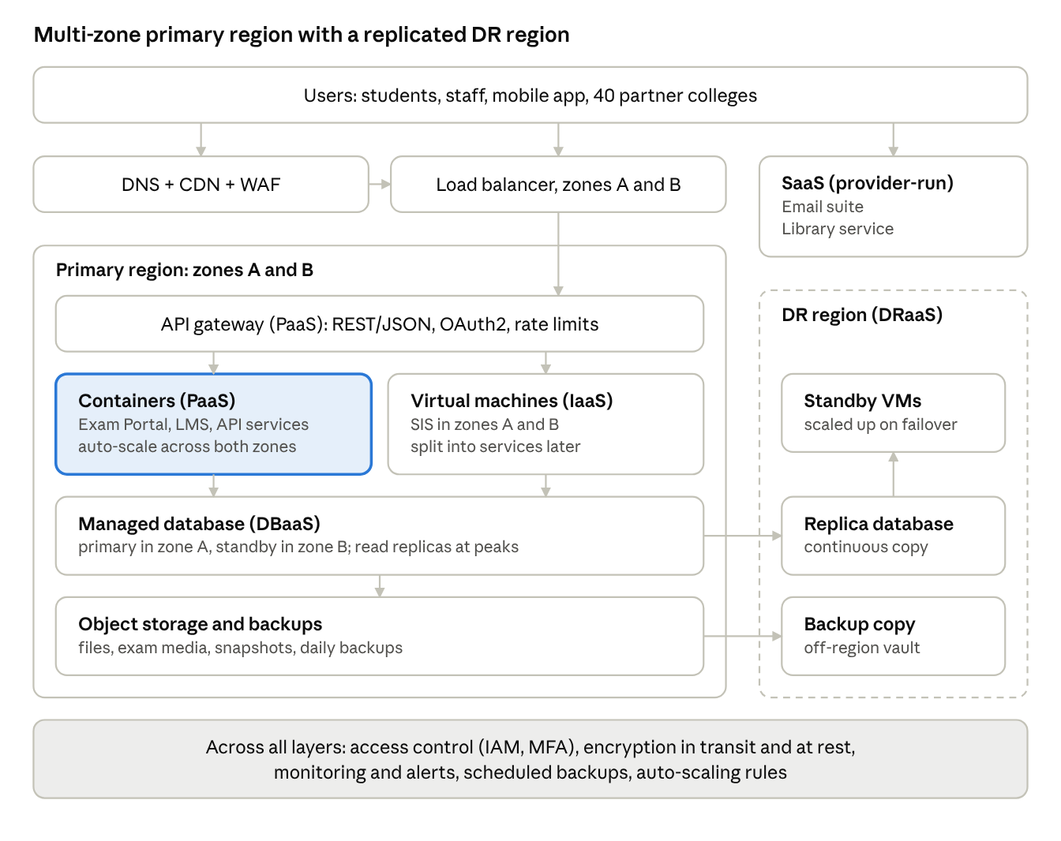
cloud architecture - primary region, DR region, SaaS
Figure 2: Proposed cloud architecture for the Smart Campus solution. Traffic flows from users through DNS/CDN/WAF and the load balancer to the API gateway, then to containers (PaaS) and virtual machines (IaaS), which use a managed database and object storage. Data is replicated to a warm-standby DR region. Email and Library are consumed as SaaS.

• Components, deployment model, service model and justification
Component | Deployment model | Service model | Justification
Users and clients (browser, mobile app, partner systems) | - | - | Broad network access; all clients use the same HTTPS APIs
DNS, CDN and WAF | Public cloud | PaaS / SECaaS | The CDN caches static content and result pages near users, cutting origin load; the WAF blocks injection attacks and abusive traffic
Load balancer | Public cloud | IaaS/PaaS (managed) | Spreads requests across instances in two zones and removes unhealthy instances automatically, supporting availability
API gateway | Public cloud | PaaS | One controlled entry point: authentication, throttling per college, request logging, versioning
Web/application tier: Exam Portal, LMS, API services | Public cloud | PaaS (containers) | Stateless, scales automatically for exam and deadline peaks, no OS administration
Web/application tier: SIS | Public cloud (hybrid during migration) | IaaS (VMs) | Legacy monolith migrated with minimal change; full control for data-sensitive logic
Database tier | Public cloud, in-country region | DBaaS (XaaS) | Managed backup, patching, failover and read replicas for the most critical data
Object storage and backups | Public cloud | IaaS storage | Durable, cheap storage for documents, exam media and backups; replicated automatically
Email and Library | Public cloud (provider-run) | SaaS | Commodity applications with no infrastructure to manage
DR region | Public cloud (second region) | DRaaS (XaaS) | Warm standby with replicated data to meet recovery objectives affordably
Security and monitoring layer | Cross-cutting | Shared / SECaaS | Central identity, encryption and alerting across all tiers
Overall deployment model: public cloud with a hybrid transition phase, in which unmigrated systems continue on the four consolidated on-premise hosts from Task 4 and connect over a VPN.

• Elasticity: handling admissions and exam peaks
- Horizontal auto-scaling of the stateless tier. Container instances are added when average CPU stays above about 60% for a few minutes (or when request count per instance exceeds a set limit) and removed when it falls below about 30%. A minimum of two instances (one per zone) keeps the service always available; a maximum cap prevents runaway cost.
- Scheduled scaling. Admissions, result publication and exam dates are known in advance, so capacity is raised before the event (pre-warming) instead of waiting for load to arrive.
- Caching and CDN. Result pages, course materials and library searches are cached, so the origin serves only a fraction of requests on result day.
- Database scaling. Read replicas absorb read-heavy traffic (result lookup); connection pooling and a queue protect the primary from write bursts (fee payments).
- Queue-based decoupling. Heavy tasks (PDF hall tickets, notifications, receipt generation) go on a queue and are handled by workers, so interactive requests stay fast.
- Cost guardrails. Budget alerts and scaling limits ensure elasticity does not become unlimited spending.
The SIS on VMs scales more slowly (a new VM takes minutes), so its read-heavy paths (results, profiles) are served through the cached API layer, and the SIS is the first candidate for refactoring into containers.

• Security and availability measures
Area | Measures
Access control | Single sign-on with MFA for staff; role-based access control (student, faculty, admin); least-privilege cloud roles; OAuth2 tokens for APIs with per-college scopes
Network security | Private subnets for databases and VMs; security groups allowing only required ports; WAF and DDoS protection at the edge; VPN or private link to the campuses
Encryption | TLS 1.2 or higher in transit; AES-256 at rest for storage and databases, with university-controlled keys
Backup | Daily full and frequent incremental backups, point-in-time recovery for the database, immutable copies in the DR region, restore tests every quarter
Multi-zone deployment | Load balancer, containers and database standby spread over two availability zones, so loss of one zone does not stop service
Disaster recovery | Warm standby in a second region with continuous data replication; target recovery point of about 15 minutes and recovery time of 1-4 hours (assumed targets to be validated by DR drills)
Monitoring and audit | Central logs, metrics and alerts; audit trails of administrator actions; vulnerability scanning and a patching schedule
Compliance | Student data kept in an Indian region where required; data-processing agreement with the provider; retention policy aligned with the DPDP Act 2023

• Key design decisions and reasons
- Mixed service models rather than a single model: each application sits at the highest level of abstraction it can tolerate (SaaS for commodity, PaaS for custom elastic apps, IaaS for legacy), minimising administration effort.
- API-first layer: one gateway decouples clients from internal systems and enables the mobile app and partner access.
- Managed data services: DBaaS and DRaaS give high availability without a large operations team.
- Two zones plus a DR region: protects against component, zone and region failures at different costs.

TASK 9 - Hands-on Implementation and Documentation (4 Marks)
Required: create a VM or container hosting a simple web page or REST API for one university function; deploy a SaaS or PaaS component; test with a client and record output; provide screenshots, configuration steps and issues faced.
Important note on evidence. This section gives complete, reproducible code, commands and the output you should expect. I cannot run Docker or a cloud account from this chat, and I will not invent screenshots or fake terminal output. After you run the steps on your own machine, paste your real screenshots into the placeholders in section 9.7 and replace the 'expected' outputs with your actual ones. Real evidence is what the evaluator will check.

• Proof-of-concept scope
Item | Choice
University function | Result lookup (Service A from Task 5)
Technology | Python 3 Flask REST API packaged as a Docker container
Virtualization part (IaaS-style) | Docker container on a local machine (or on a free-tier VM)
PaaS part | The same container image deployed to a managed container platform (Google Cloud Run or Render free tier)
Test client | curl and Postman (or a browser)
Success criteria | HTTP 200 with JSON for a valid student; HTTP 404 with JSON error for an unknown student; health endpoint returns 200

• Project files
Create a folder result-api with the following three files.
app.py
from flask import Flask, jsonify
app = Flask(__name__)
# Demo data only - a real system would read from the managed database
RESULTS = {
'21CS1045': {
'studentId': '21CS1045',
'semester': '2026-ODD',
'courses': [
{'code': 'CSA15', 'grade': 'A', 'credits': 4},
{'code': 'CSA11', 'grade': 'B+', 'credits': 4},
],
'sgpa': 8.6,
}
}
@app.route('/health')
def health():
return jsonify(status='ok'), 200
@app.route('/api/v1/students/<student_id>/results')
def get_results(student_id):
data = RESULTS.get(student_id)
if data is None:
return jsonify(error='RESULT_NOT_FOUND', studentId=student_id), 404
return jsonify(data), 200
if __name__ == '__main__':
app.run(host='0.0.0.0', port=5000)
requirements.txt
flask==3.0.3
gunicorn==22.0.0
Dockerfile
FROM python:3.12-slim
WORKDIR /app
COPY requirements.txt .
RUN pip install --no-cache-dir -r requirements.txt
COPY app.py .
ENV PORT=5000
EXPOSE 5000
CMD gunicorn --bind 0.0.0.0:${PORT} app:app
The PORT variable lets the same image run locally (port 5000) and on PaaS platforms that inject their own port.

• Step A - Build and run the container (virtualization)
- Install Docker Desktop (or Docker Engine on Linux/VirtualBox Ubuntu VM) and confirm with docker --version.
- Build the image: docker build -t uni-result-api:1.0 .
- Run it: docker run -d --name result-api -p 8080:5000 uni-result-api:1.0
- Confirm it is running: docker ps (the container should show status Up and ports 8080 to 5000).
- Check logs: docker logs result-api.
- Observe resource use: docker stats --no-stream result-api (this shows the light footprint of a container compared with a VM).

• Step B - Test the web service
Test | Command | Expected result
Health check | curl -i http://localhost:8080/health | HTTP/1.1 200 OK and body {"status":"ok"}
Functional test (valid student) | curl -i http://localhost:8080/api/v1/students/21CS1045/results | HTTP/1.1 200 OK, Content-Type: application/json, body containing studentId 21CS1045, two courses and sgpa 8.6
Failure case (unknown student) | curl -i http://localhost:8080/api/v1/students/99XX9999/results | HTTP/1.1 404 NOT FOUND and body {"error":"RESULT_NOT_FOUND","studentId":"99XX9999"}
Postman | New GET request to the same URLs | Same status codes; screenshot the Status, Time and Body panes
Expected body for the valid student (key order may differ because Flask sorts keys):
{"courses":[{"code":"CSA15","credits":4,"grade":"A"},{"code":"CSA11","credits":4,"grade":"B+"}],"semester":"2026-ODD","sgpa":8.6,"studentId":"21CS1045"}

• Step C - Deploy as PaaS
Option 1: Google Cloud Run (managed container platform)
- Create a Google Cloud account and project, enable billing and the Cloud Run and Cloud Build APIs (a free tier exists; check the current limits and set a budget alert).
- Install and sign in with the gcloud CLI: gcloud auth login and gcloud config set project <PROJECT_ID>.
- From the result-api folder run: gcloud run deploy result-api --source . --region asia-south1 --allow-unauthenticated
- Note the service URL printed at the end (for example https://result-api-xxxxx-el.a.run.app).
- Repeat the three curl tests using that URL instead of localhost.
- Open the Cloud Run console to show revisions, request count and the autoscaling setting (minimum 0 and maximum instances).
Option 2: Render or similar (free web service from a Git repository)
- Push the three files to a GitHub repository.
- In Render, create a new Web Service from that repository and choose the Docker runtime.
- Deploy, note the public URL, and repeat the curl tests.
Option 3 (SaaS/static component): publish a one-page HTML result-search form on GitHub Pages or Netlify that calls the PaaS API with fetch(). If the browser blocks the call, enable CORS in Flask with the flask-cors package; this is a realistic issue worth documenting.
Free-tier limits and prices change, so verify them on the provider's page before you start, and delete the service after the demonstration to avoid charges.

• Issues you may face and fixes (replace with your own)
Possible issue | Likely cause | Fix
docker: command not found or daemon not running | Docker not installed or not started | Start Docker Desktop; on Linux run sudo systemctl start docker
port is already allocated | Port 8080 in use | Use another host port, e.g. -p 8081:5000
Container exits at once | Syntax error in app.py or missing dependency | Run docker logs result-api and fix the error
Connection refused from curl | Wrong host port mapping | Check docker ps and map the host port correctly
Cloud Run deploy fails with port error | App listening on a fixed port | Use the PORT variable as in the Dockerfile above
Browser shows CORS error on the static page | API does not send CORS headers | Add flask-cors and allow the page's origin
Unexpected charges | Resources left running | Set a budget alert and delete the service after testing

• Evidence checklist (to be completed with your real screenshots)
No. | Screenshot to insert | What it must show | Status
S1 | Project files | Folder with app.py, requirements.txt, Dockerfile | To be captured
S2 | docker build | Successful build with image tag | To be captured
S3 | docker ps and docker stats | Running container, ports, CPU/memory | To be captured
S4 | curl valid request | HTTP 200 and JSON body | To be captured
S5 | curl invalid request | HTTP 404 and JSON error | To be captured
S6 | Postman | Request URL, status 200, response time and body | To be captured
S7 | PaaS console | Deployed service, URL, region and scaling setting | To be captured
S8 | Public URL test | Same tests against the cloud URL | To be captured
Insert your screenshots below this table, label each as Figure 3, Figure 4 and so on with a one-line annotation, and keep the numbering consistent with the figures above.
Reference output (for comparison only; replace with your own captures)
The app.py, requirements.txt and Dockerfile above were checked on 30 October 2026 by running app.py under gunicorn 22.0.0 with Flask 3.0.3 on Linux (Python virtual environment, port 8080) and testing it with curl. All three tests returned the results below, so the code and the expected outputs in Step B are consistent. The Docker image build and the PaaS deployment could not be checked in that environment (Docker Hub was not reachable), so screenshots S2, S3, S7 and S8 must come from your own machine and cloud account.
Test 1: curl -i http://localhost:8080/health
HTTP/1.1 200 OK
Content-Type: application/json
Content-Length: 16

{"status":"ok"}
Test 2: curl -i http://localhost:8080/api/v1/students/21CS1045/results
HTTP/1.1 200 OK
Content-Type: application/json
Content-Length: 153

{"courses":[{"code":"CSA15","credits":4,"grade":"A"},{"code":"CSA11","credits":4,"grade":"B+"}],"semester":"2026-ODD","sgpa":8.6,"studentId":"21CS1045"}
Test 3: curl -i http://localhost:8080/api/v1/students/99XX9999/results
HTTP/1.1 404 NOT FOUND
Content-Type: application/json
Content-Length: 52

{"error":"RESULT_NOT_FOUND","studentId":"99XX9999"}
Your own run will also show Server and Date headers; the Date will differ.
Screenshot frames: paste each real screenshot over its frame and keep the caption below it.
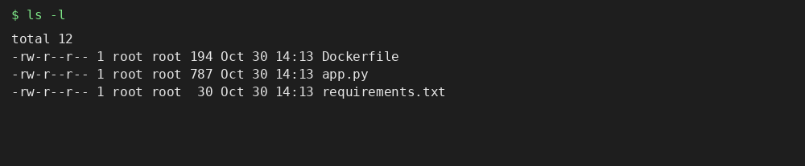
Figure 3: Project folder with app.py, requirements.txt and Dockerfile.
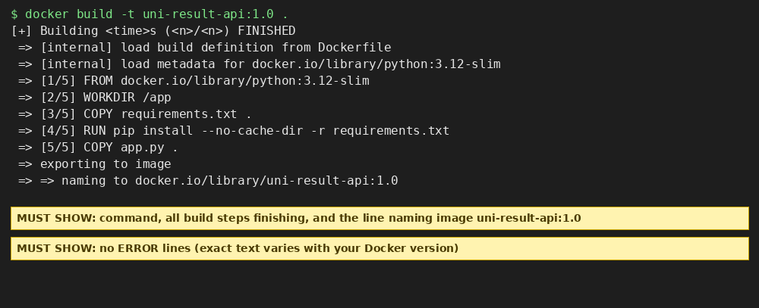
Figure 4: docker build completes and tags the image uni-result-api:1.0.
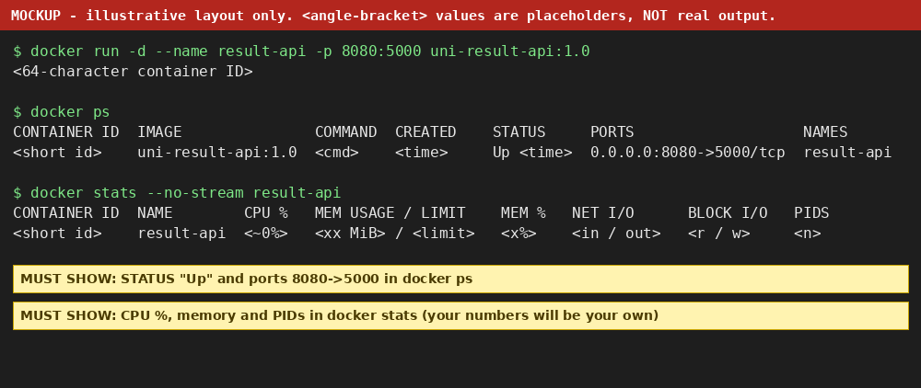
Figure 5: docker ps and docker stats show the running container, port mapping, CPU and memory.
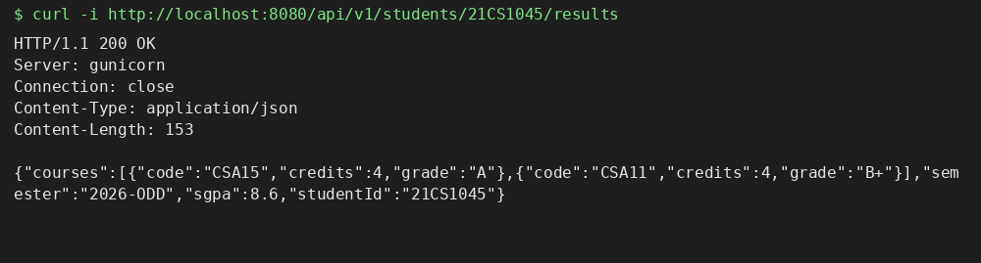
Figure 6: curl on a valid student returns HTTP 200 and the JSON result.
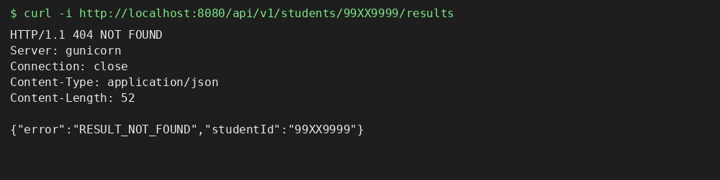
Figure 7: curl on an unknown student returns HTTP 404 and the JSON error.
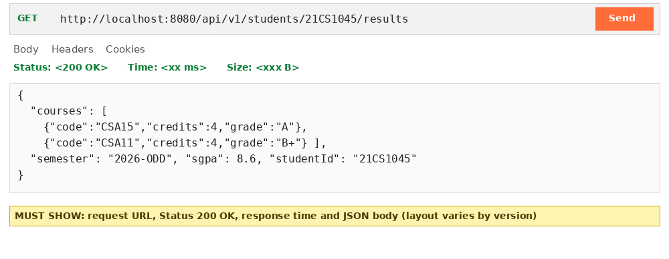
Figure 8: Postman GET request showing status 200, response time and body.
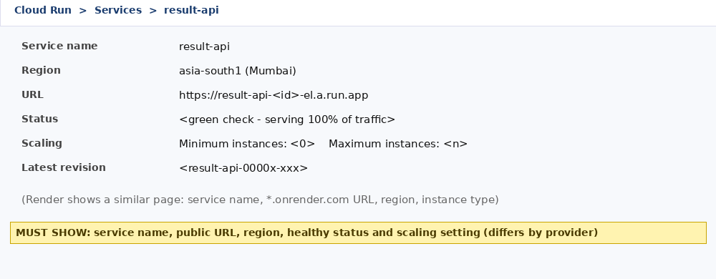
Figure 9: PaaS console showing the deployed service, URL, region and scaling setting.
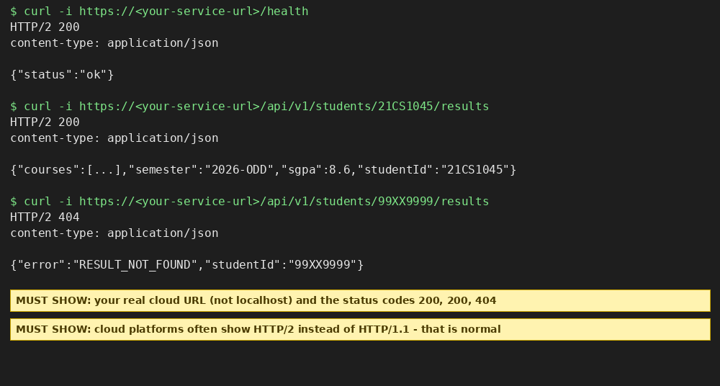
Figure 10: The same tests run against the public cloud URL.
Interpretation (complete after running): container start-up in seconds, a small memory footprint and a one-command PaaS deployment demonstrate the virtualization and PaaS benefits discussed in Tasks 4 and 6. Limitations to state honestly: demo data is in memory (no database), there is no authentication or HTTPS inside the container (the platform terminates HTTPS), and a single instance proves function, not scale.

TASK 10 - Evaluate and Recommend the Final Solution (7 Marks)
Required: compare on-premise, IaaS-based and PaaS/SaaS-based options on cost, scalability, availability, security and effort; 3-year cost estimate with stated assumptions; risks and mitigations; final recommendation with a migration roadmap.

• Comparison of the three options
Criterion | Option 1: On-premise refresh | Option 2: IaaS-based (lift and shift) | Option 3: PaaS/SaaS-led mix (with IaaS for SIS)
Cost model | High CapEx up front, fixed running cost | OpEx; no hardware purchase, but 24x7 VMs and OS/middleware effort | OpEx; mostly pay-per-use and subscriptions
Scalability | Fixed; peaks still exceed capacity; 6-8 weeks to add servers | Good; VMs added in minutes but scaling needs configuration | Very good; platform auto-scaling and provider-managed SaaS
Availability | Single site, no DR; hardware failures hit users | Multi-zone possible; DR must be built and managed by the university | Multi-zone and DRaaS built in; provider SLAs (typically 99.9%+)
Security | Full control, but patching and physical security depend on a small team | Shared responsibility; the university patches OS and middleware | Provider handles most platform security; the university manages identity and data
Management effort | Highest (hardware, OS, applications) | High (OS, middleware, applications) | Lowest (applications and data only)
Migration effort | None, but replacement of 12 servers | Low to medium (re-host) | Medium (some refactoring and data migration)
Lock-in | Low | Low to medium | Medium
Weighted decision matrix (scores 1 = poor to 5 = excellent; weights reflect the brief's emphasis on cost, scalability, availability and manageability; scores are the author's judgement):
Criterion | Weight | On-premise | IaaS | PaaS/SaaS mix
Cost (3-year) | 25% | 2 | 3 | 4
Scalability | 20% | 1 | 4 | 5
Availability | 20% | 2 | 4 | 4
Security and compliance | 15% | 4 | 4 | 4
Manageability | 20% | 1 | 3 | 5
Weighted score | 100% | 1.9 | 3.55 | 4.4
Example working for the PaaS/SaaS mix: 0.25x4 + 0.20x5 + 0.20x4 + 0.15x4 + 0.20x5 = 1.00 + 1.00 + 0.80 + 0.60 + 1.00 = 4.4.

• Three-year cost comparison (illustrative, in Indian rupees; 1 lakh = 100,000)
Assumptions
- On-premise: replace the 12 ageing servers at ₹6.0 lakh each (₹72 lakh CapEx). Yearly running cost: power, cooling and space ₹10 lakh; annual maintenance contract at 10% of hardware ₹7.2 lakh; 3 system administrators ₹15 lakh; software and backup licences ₹5 lakh. This option has no DR site (building one would add roughly ₹40 lakh and is excluded).
- IaaS: 16 reserved VMs at ₹6,000 per month; auto-scaling burst capacity ₹8 lakh per year; storage, backup and DR replication ₹6 lakh; network, CDN and WAF ₹3 lakh; 2 administrators ₹10 lakh; licences ₹5 lakh. One-time migration ₹12 lakh.
- PaaS/SaaS mix: container platform ₹8 lakh; managed database ₹6 lakh; SIS VMs ₹4 lakh; SaaS (email and library) ₹5 lakh; DRaaS and backup ₹4 lakh; edge services and monitoring ₹3 lakh; 1.5 administrators ₹7.5 lakh; licences ₹2 lakh. One-time migration and partial refactoring ₹20 lakh.
- Prices are held constant for 3 years; no discount, tax or inflation is applied; cloud figures include education-pricing assumptions and must be re-quoted from real provider calculators. The estimate accuracy is about plus or minus 20%.
- Price cross-check (30 October 2026): a 2 vCPU, 8 GiB virtual machine (AWS m5.large) in the Mumbai region lists at USD 0.101 per hour on demand, about USD 74 per month, which is roughly ₹6,000-6,500 per month at an assumed ₹82-88 per USD (exchange rate not verified). The ₹6,000 per VM-month assumption is therefore consistent, and reserved or committed pricing would normally be lower.
- Price cross-check: Google Cloud Run request-based list prices are USD 0.000024 per vCPU-second, USD 0.0000025 per GiB-second and USD 0.40 per million requests, with a monthly free tier of 180,000 vCPU-seconds, 360,000 GiB-seconds and 2 million requests. Mumbai (asia-south1) is a Tier 1 region. This supports the low container-platform figures used for the proof of concept; the ₹8 lakh per year line is an estimate for the full production load.
- Price cross-check: Google Workspace for Education Fundamentals is free for qualifying institutions, while the paid editions (Standard, Teaching and Learning, Plus) are quoted by Google sales. The ₹5 lakh SaaS line (email and library) therefore mainly covers the library SaaS subscription and any paid email add-ons, and should be confirmed by vendor quotes.
- Not verified against published prices and still the author's assumptions: managed database, DRaaS and backup, library SaaS subscription, staff salaries, and one-time migration costs. Sources: cloud.google.com/run/pricing; doit.com/compute/spot/ap-south-1/m5.large; edu.google.com Workspace for Education editions page.
Cost item (₹ lakh) | Year 0 (CapEx / migration) | Year 1 | Year 2 | Year 3 | 3-year total
Option 1: On-premise | 72.0 | 37.2 | 37.2 | 37.2 | 183.6
Option 2: IaaS | 12.0 | 43.5 | 43.5 | 43.5 | 142.6
Option 3: PaaS/SaaS mix | 20.0 | 39.5 | 39.5 | 39.5 | 138.5
Working: Option 1 = 72 + 3 x (10 + 7.2 + 15 + 5) = 72 + 3 x 37.2 = 183.6. Option 2 yearly = 11.52 (16 x 6,000 x 12) + 8 + 6 + 3 + 10 + 5 = 43.52; total = 12 + 3 x 43.52 = 142.6. Option 3 yearly = 8 + 6 + 4 + 5 + 4 + 3 + 7.5 + 2 = 39.5; total = 20 + 3 x 39.5 = 138.5.
Reading the result: Option 3 is about ₹45 lakh (25%) cheaper than the on-premise refresh and also adds DR and elasticity, which Option 1 lacks. The gap between Options 2 and 3 is small (about 3%) and within estimation error, so the case for Option 3 rests mainly on scalability, availability and reduced management effort rather than on cost alone.

• Main risks and mitigation
Risk | Description | Mitigation
Vendor lock-in | Proprietary PaaS features and SaaS data formats make exit costly | Containers and standard engines (PostgreSQL/MySQL), open APIs, regular exports, documented exit plan, avoid exclusive proprietary services for core logic
Data privacy and compliance | Student and fee data under the DPDP Act and affiliation rules | In-country region, encryption with university-held keys, data-processing agreement, role-based access, audit logs, data classification
Downtime during or after migration | Cut-over errors; provider outage | Phased migration, parallel run, rollback plan, multi-zone deployment, DRaaS, cut-over outside admission and exam periods
Skills gap | Staff are experienced with physical servers, not cloud | Provider training and certification, a small cloud team, use of managed services, a partner for the first phase
Cost overrun | Autoscaling or forgotten resources increase the bill | Budgets and alerts, scaling caps, tagging, monthly cost review, reserved capacity for the baseline
Performance or latency | Distance to the region, VPN limits | Use a nearby Indian region, CDN, caching, adequate campus bandwidth
Change resistance | Departments fear loss of control | Communication, pilot with Email first, clear service levels

• Final recommendation
Adopt Option 3: a PaaS/SaaS-led mix on a public cloud in an Indian region, with the SIS initially re-hosted on IaaS VMs and a managed database, a warm-standby DR region, and a transitional hybrid link to the on-premise hosts. Application mapping: Email and Library as SaaS; Exam Portal and LMS as PaaS containers; SIS on IaaS with DBaaS, then progressively refactored.
Why this follows from the earlier tasks: the workload is bursty (Task 1 and Task 4 show peaks far above what 4 hosts can hold); applications are monolithic and need APIs (Tasks 3 and 5); each application has a natural service model (Task 6); DBaaS and DRaaS close the data-safety and DR gaps (Task 7); and the architecture in Task 8 delivers these in a controlled way.
Provider selection (not by popularity). Shortlist two or three providers and decide by these criteria: an in-country region with at least two zones and a second region for DR; managed container and database services; education pricing; published SLAs (99.9% or higher); data-export and exit terms; support in India; and compatibility with the skills the team can acquire. Confirm with a one-week proof of concept (as in Task 9) and a priced quotation before signing.

• Migration roadmap
Phase | Timing (approx.) | What moves | Why this order | Exit gate
0. Foundation | Months 0-1 | Cloud account structure, identity/SSO, VPN, budgets, security baseline, staff training | Everything else depends on identity, network and governance | Landing zone reviewed; budget alerts active
1. Email | Months 1-2 | Mailboxes to the SaaS email suite | Lowest risk and quick win; builds confidence and the identity foundation | Users migrated; mail flow verified
2. Library | Month 2-3 | Catalogue and circulation to SaaS | Small, self-contained, low risk | Search and circulation verified; catalogue API live
3. Exam Portal | Months 3-5 | Containerise and deploy on PaaS with auto-scaling | Largest pain point (failures at exams); highest benefit; stateless and easy to scale; must be done before the next exam cycle | Load test at the target concurrent users; rollback tested
4. LMS | Months 5-7 | Containerised LMS on PaaS with managed database and object storage | Moderate complexity; integrates with SIS and identity | Course data migrated; integration tests passed
5. SIS and databases | Months 7-12 | Re-host SIS on VMs, move to DBaaS, enable multi-zone and DR; expose APIs | Most critical and most complex, so moved last, outside admissions and result periods | Parallel run completed; DR failover drill passed
6. Decommission and optimise | Months 12-15 | Retire old servers, tune costs, start refactoring SIS modules | Release hardware cost and capture savings | Old servers retired; cost review done
The roadmap is a plan with assumed timings; actual dates should align with the academic calendar.

DAY-4 DESIGN CHALLENGE

TASK 11 - Re-evaluate and Adapt the Design (8 Marks)
Changed requirement: the university launches a mobile app and opens student-record and fee-payment services to 40 affiliated colleges. Expected load is 10 times the current peak, availability must be 99.9%, and the operating budget is limited. Re-evaluate the original design (Tasks 1-10) and decide whether to retain, modify or redesign it.
Decision in one line: MODIFY. The cloud foundation (public cloud, API-first, DBaaS, DRaaS, multi-zone) stays, but the SIS tier, the data layer, the API layer and the service-model mix must change substantially to carry 10 times the load at 99.9% availability within a limited budget. A full redesign is not needed; retaining the design unchanged would fail on scalability and cost.

• Impact Analysis (2 Marks)
What has changed
Aspect | Original problem | Changed requirement
Users | About 27,000 (25,000 students + 2,000 staff) on 4 campuses | Also the mobile app users and the staff and students of 40 affiliated colleges (an unknown but much larger population, accessing from the public internet)
Access pattern | Browser-based, mostly campus network, internal | Mobile app and partner systems calling APIs 24x7 from anywhere
Peak load | Peaks above 95% of 12 servers, a few weeks a year | 10 times the current peak
Availability | Not formally defined; no DR | 99.9% (about 8.76 hours of downtime per year, or about 43 minutes per month)
Budget | Replace CapEx with OpEx | Limited operating budget, so cost must grow far slower than load
Tenancy | One institution | 40 colleges plus the university as separate tenants
Original assumptions that are now affected
- Load: the Task 4 and Task 8 sizing assumed one institution's peaks; it did not include partner colleges or mobile polling.
- Users: user count, concurrency and geographic spread all increase.
- Availability: Task 8 targeted resilience but never committed to a measured SLO; 99.9% is now a contractual-style target that includes the university's own components and its dependencies.
- Cost: the Task 10 estimate (₹39.5 lakh per year) assumed the original load and no external customers.
- Security: the original design assumed a trusted internal user base; partner access widens the attack surface.
Why web services and APIs now become critical
- The mobile app and 40 colleges cannot use the university's web screens; they need stable, documented, versioned APIs (result lookup, student record, fee payment).
- The API layer becomes the single controlled front door: authentication, per-college quotas, throttling, monitoring and billing happen there.
- APIs decouple clients from the internal systems, so the SIS can be refactored and scaled without breaking the app or partners.
- A stateless REST API can be cached and scaled horizontally, which is the main lever for handling 10 times the load.
How multi-tenant access by 40 colleges affects security and isolation
- Each college must see only its own students and fee records. A tenant identifier must be carried in every token and enforced in every query (row-level security or schema-per-tenant), because a single missing filter would leak data between colleges.
- Authorisation must be per-college role-based (college admin, registrar, student), with scoped OAuth2 tokens and short expiry.
- A noisy tenant (for example one college running a bulk download) must not degrade others, so per-tenant rate limits and quotas are required.
- Fee data raises payment-security needs (PCI DSS scope is reduced by using a hosted payment gateway rather than handling card data).
- Audit logging per tenant, and the ability to export or delete a college's data, are needed for compliance with the DPDP Act 2023 and contractual terms.

• Evaluation of the Original Design (2 Marks)
(a) Can the chosen service models and virtualization plan handle 10 times the load?
Current worst-case peak = 12 servers x 95% = 11.4 server-equivalents (1,140 units)
10 x peak = 11,400 units
Add 10% virtualization overhead = 11,400 x 1.10 = 12,540 units
Hosts at 70% target utilisation = 12,540 / 70 = 179 -> about 180 original-sized hosts
On-premise this would mean about 180 servers (roughly ₹1,080 lakh at ₹6 lakh each), which is impossible for the university, so elasticity is mandatory.
Component | Can it handle 10x? | Reason
Containers on PaaS (Exam Portal, LMS, APIs) | Yes, with tuning | Stateless and horizontally scalable; limits are the platform quotas, the database and cold-start time, all adjustable
SIS on VMs (IaaS) | No | A VM takes minutes to add; the monolith cannot scale its components separately; scaling it 10x multiplies cost; it is also the main target of partner API calls
Managed database | Partly | Read replicas can serve result and record queries, but a single primary will become a bottleneck for fee-payment writes at 10x
SaaS (Email, Library) | Yes | Provider-scaled; but partner colleges are not necessarily users of the university's email or library
API gateway | Yes, if quotas are raised and tenant throttling added | Original design had one gateway but no per-tenant policy
(b) Are auto-scaling and the single-region active deployment sufficient for 99.9%?
99.9% allows 0.001 x 8,760 hours = 8.76 hours of downtime a year. Availability of components in series multiplies:
Single-zone, single-region stack (assumed component SLAs):
load balancer 99.99% x app tier 99.9% x database 99.9%
= 0.9999 x 0.999 x 0.999 = 0.9979 -> 99.79% -> about 18.4 h downtime/year (FAILS 99.9%)
Original Task 8 design (two zones + managed multi-zone database + CDN/WAF 99.99%):
app tier, two independent zones at 99.9% each: 1 - (0.001 x 0.001) = 99.9999%
load balancer 99.99% x database (multi-zone) 99.95% x edge 99.99%
= 0.9999 x 0.999999 x 0.9995 x 0.9999 = about 0.9993 -> 99.93% -> about 6.1 h downtime/year (MEETS 99.9%, thin margin)
The component SLA values are assumptions used to illustrate the method and must be replaced with the chosen provider's published figures. Findings:
- Auto-scaling protects against load, not against failure; it does nothing if a zone or the database fails. Multi-zone design is what delivers availability.
- The original multi-zone design meets 99.9% on paper, but with only about 2.7 hours of margin. A region-level outage (rare) would consume 1-4 hours of the assumed DR recovery time, and a failed or late scale-out during an exam would also count as downtime.
- The fee-payment flow depends on an external payment gateway, whose own availability is outside the university's control (if it is 99.9%, the end-to-end fee flow cannot exceed about 99.83%). The design must degrade gracefully, for example by queueing payment confirmations.
- Therefore the original design is adequate for failures but not yet for 10x load and tenant isolation; it needs a bigger safety margin and a database that scales for writes.
(c) Does cost remain acceptable?
If the original design were simply scaled 10x on the load-driven items (container platform ₹8, managed database ₹6, SIS VMs ₹4, edge services ₹3 lakh = ₹21 lakh per year; the other ₹18.5 lakh is fixed):
Scaled cost = 21 x 10 + 18.5 = ₹228.5 lakh per year (vs ₹39.5 lakh originally, about 5.8 times)
3-year total (original design scaled) = 3 x 228.5 = ₹685.5 lakh, before migration costs
This exceeds even the original on-premise 3-year cost (₹183.6 lakh) by far and breaks the limited-budget condition. Cost does not remain acceptable without design changes.
(d) Would another service model or XaaS offering give better results?
Yes. Services priced per request and managed by the provider fit the new pattern of many small API calls much better than always-on VMs:
Offering | Benefit for the Day-4 requirement
Container orchestration (managed Kubernetes or serverless containers) | Faster and finer-grained scaling than VMs; efficient packing of many small services
FaaS (serverless functions) | Pay only per execution for bursty jobs: receipts, notifications, result-publication fan-out
BaaS / MBaaS | Ready authentication, push notifications and mobile backend features speed up the app and reduce custom code
Managed cache (in-memory) and CDN | Absorb most read traffic (results, library search, static content)
Message queue | Smooths fee-payment write bursts and protects the database
SECaaS (managed WAF, DDoS, identity) | Required protection for a public API used by 40 colleges
DBaaS with read replicas and tenant partitioning | Keeps the database from becoming the bottleneck

• Adaptation or Redesign (2 Marks)
Decision: modify (evolve) the original design. The following are retained: public cloud in an Indian region; SaaS for Email and Library; DBaaS; DRaaS; multi-zone deployment; the API-first principle. The following change.
Revised architecture
- Edge and API layer: CDN and WAF in front; a managed API gateway with OAuth2/OIDC, per-college tenant identification, rate limits, quotas, API versioning and usage reporting. The mobile app and the colleges use only this layer.
- Application tier: the SIS is split into services (student record, results, fee payment, authentication), packaged as containers on managed orchestration, deployed active-active across three availability zones, with horizontal auto-scaling on CPU and request rate. The remaining SIS legacy modules stay on VMs behind an adapter until refactored.
- Serverless components (FaaS): receipts, SMS/email/push notifications, report generation and result-publication fan-out run as functions triggered by events from a message queue.
- Caching: a managed in-memory cache plus CDN for read-heavy endpoints (results, student profile, library search), with short, safe expiry.
- Data tier: multi-zone managed database with read replicas and tenant-aware partitioning; writes (fee payments) go through a queue with idempotency keys so retries are safe; object storage for documents.
- Resilience and DR: deploy across three zones for headroom; warm-standby DR region retained and upgraded to automated failover with drills twice a year; health checks and circuit breakers; graceful degradation (for example, show cached results and queue payments if the gateway is slow).
- Hybrid element: the on-premise hosts are decommissioned after migration instead of retained, apart from a short parallel-run period.
- Observability and cost control: central monitoring, SLO dashboards (availability and latency), per-tenant usage metering and budget alerts.
Change in the service-model mix
Layer | Original design | Revised design
SIS | IaaS (VMs) | PaaS containers for refactored services; small IaaS footprint for legacy modules only
Exam Portal, LMS | PaaS containers | PaaS containers on orchestration (unchanged in model, upgraded in scaling)
Mobile backend | Not present | MBaaS / BaaS (authentication, push)
Event processing | Not present | FaaS + queue
Database | DBaaS | DBaaS with replicas and tenant partitioning
Security | Cloud-native controls | SECaaS (managed WAF, DDoS, identity governance) added
Email, Library | SaaS | SaaS (unchanged)
Change in the virtualization approach: the plan shifts from 'VMs for stateful and containers for stateless' towards containers as the default unit with orchestration (scheduling, self-healing, rolling updates), while VMs remain only for legacy components and the managed database is provider-run. Containers start in seconds, which suits sudden load, and pack more tightly than VMs, which lowers cost.

• Evidence-Based Defence (2 Marks)
(a) Capacity and availability calculations
Worst-case 10x requirement = 12,540 units (about 180 original-sized hosts)
CDN and cache absorb about 60% of read traffic (assumption, to be measured)
-> 12,540 x (1 - 0.60) = 5,016 units
Modern containers on current hardware are about twice as efficient per host (assumption)
-> 5,016 / 2 = 2,508 original-host units
Hosts at 70% target utilisation = 2,508 / 70 = about 36 original-sized hosts
-> about 18 modern hosts' worth of capacity at peak only, scaled up for a few weeks and then back to baseline
Headroom: N+1 across three zones means each zone can lose one third and the others still carry the load at under 100%.

Revised availability (assumed SLAs; replace with the provider's published figures):
edge CDN/WAF 99.99% x API gateway 99.99% x app tier (3 zones) 99.9999% x multi-zone DB 99.95% x cache/queue 99.99%
= 0.9999 x 0.9999 x 0.999999 x 0.9995 x 0.9999 = about 0.9992 -> 99.92% (about 7.0 h downtime/year)
Design target (SLO) for the university's own components: 99.9% with an internal alert at 99.95%.
The external payment gateway is excluded from the SLO and handled with queues and retries.
Note: the calculation is limited by assumed SLAs and assumed cache and efficiency factors. A 10x load test (for example with k6, JMeter or Locust) and a zone-failure drill are required before go-live to confirm these numbers.
(b) Cost comparison, original design vs revised design (₹ lakh per year, assumed figures)
Cost item | Original design | Original scaled 10x (no change) | Revised design
Container platform / orchestration (baseline + burst) | 8.0 | 80.0 | 14.0
FaaS (receipts, notifications) | - | - | 2.0
API gateway and MBaaS | - | - | 4.0
Managed database (multi-zone, replicas) | 6.0 | 60.0 | 11.0
SIS VMs | 4.0 | 40.0 | 5.0
Cache, CDN, WAF and edge | 3.0 | 30.0 | 6.0
SaaS (email, library) | 5.0 | 5.0 | 5.0
DRaaS and backup | 4.0 | 4.0 | 6.0
Security and monitoring (SECaaS) | - | - | 3.0
Operations staff | 7.5 | 7.5 | 10.0
Licences | 2.0 | 2.0 | 2.0
Total per year | 39.5 | 228.5 (see Evaluation, part c) | 68.0
Note on the 'scaled 10x' column: the load-driven items listed in 11.2(c) total ₹21 lakh and become ₹210 lakh; the table shows the same items scaled item by item (80 + 60 + 40 + 30 = 210) plus the fixed ₹18.5 lakh, giving ₹228.5 lakh.
- Revised 3-year cost = one-time migration/refactoring of ₹15 lakh (assumed, in addition to Task 10 phases) + 3 x 68.0 = ₹219 lakh, against ₹685.5 lakh for scaling the original unchanged, a saving of about 68%.
- Load grows 10x but cost grows only about 1.7x (68.0 / 39.5), because of caching, serverless pricing, auto-scaling only at peaks and tighter packing.
- The extra ₹28.5 lakh per year (68.0 - 39.5) spread over 40 colleges is about ₹0.71 lakh (₹71,000) per college per year. A service fee of about ₹1.5 lakh per college (assumed, to be negotiated) would raise ₹60 lakh a year and cover most of the revised running cost, which supports the limited-budget condition.
(c) Security and multi-tenancy considerations
Concern | Control
Tenant isolation | Tenant ID in every OAuth2 token and enforced in code and database (row-level security); separate schema or database for any large college that needs stronger isolation; automated cross-tenant access tests
Authentication and authorisation | OIDC single sign-on, short-lived tokens, per-college roles and scopes, MFA for administrators
Abuse and noisy neighbours | Per-tenant rate limits and quotas at the gateway; WAF; DDoS protection; separate scaling limits per tenant
Data protection | Encryption in transit and at rest; tenant-level key options; masking of sensitive fields in logs; hosted payment gateway so card data never touches the university
Audit and compliance | Per-tenant audit logs, retention policy, data export and deletion procedure, DPDP Act 2023 alignment, contracts with each college
Recovery | Per-tenant restore capability from backups, tested restores
(d) Trade-offs: vendor lock-in, complexity and migration effort
Trade-off | Effect of the revised design | How it is managed
Vendor lock-in | Higher: FaaS, MBaaS and managed services use provider-specific features | Containers and standard APIs for core logic; PostgreSQL/MySQL-compatible database; keep business logic outside proprietary functions; documented exit plan
Operational complexity | Higher: orchestration, queues, caching, three zones and many services to monitor | Managed services rather than self-run; automation and infrastructure-as-code; dashboards and runbooks; training
Migration and refactoring effort | Medium to high: SIS must be split into services | Strangler pattern: move one capability at a time behind the API gateway, starting with read-only result lookup; keep legacy VMs until each module is replaced
Cost predictability | Usage-based billing can vary | Budgets, alerts, scaling caps, reserved capacity for the baseline, per-tenant metering
Skills | New skills needed (containers, DevOps, API security) | Provider training, a small platform team, a managed-services partner for the first year
Final defence. The original design is retained in its foundations (public cloud, API-first, multi-zone, managed database, DR region, SaaS for commodity applications) but is modified because (1) a 10x load cannot be carried by VM-based SIS scaling or a single write database, (2) availability of 99.9% leaves only about 2.7 hours of margin in the original design and needs three-zone active-active deployment, caching and queues, (3) naive scaling would cost about ₹685 lakh over three years while the revised design costs about ₹219 lakh and can be partly recovered through college service fees, and (4) multi-tenant API access requires an API gateway with tenant-level security and quotas. The cost of this decision is higher complexity and some lock-in, which are accepted and mitigated as shown above.

