**timing 120 jenkins setup chapter 342**

**In project path save the file as “runner.bat”, the content should be = mvn cln test**

**Double click the .bat file to execute your test**

**How to configure, trigger, and schedule your build in jenkins**

**1).** Download Jenkins from google’ LTS download for windows

**2).** From the location where u have ur Jenkins.war file, open a command prompt and type

Java -jar Jenkins.war, when u run for the first time, u will get an encrypted key which needs to be copied and kept for later use, I have kept it below. Finally ul get a message Jenkins is up and running

Now login to Jenkins in ur local system with url

**Localhost:8080, local system but in organization dev team gives url, uid, & pwd**

As soon as u login, it asks u to enter the encrypted key

Then install all default plugins. Fill in the registration form and use the username & pwd to login

To configure , click **on Manage Jenkins 🡪 Global tool configuration 🡪**

**JDK installation, provide the JAVA_HOME** path same as env variables

**NOTE**: Don’t install automatically

**Maven Installation** : provide the MAVEN_HOME path and click on Save

**Now goto Manage Plugins** and under Available tab search for

1). Maven Integration is needed to run mvn builds thru jenkins and

2). html publisher , after test execution to publish ur html reports, testng or extent reports to Jenkins build.

Restart after installation.

Now goto Dashboard, clickon New Item, enter item name, SELECT Maven project or Freestyle project and OK

**Under Source Code Management tab** , under Build in the Root POM provide the pom.xml path

Under Goals and Options provide clean test

Add post build action , publish html reports, provide the reports folder path from ur project/IntelliJ

In Index page(s) use *.html

Report title enter as EXTENT REPORT

**APPLY & Save**

**Now on dashboard** u shuld be able to see ur configured build, u can trigger it by clicking on Build scheduled icon , u can see the progress in the Build executor status bar , click on Build now button.

Check the progress under Console Output u can see mvn test being called, Running Test Suite

Recording Test Results

Under your Project tab, u can see the EXTENT reports

For the reports to be displayed properly, u need to add a flag as below

Java -Dhudson.model.DirectoryBrowserSupport.CSP=”” -jar jenkins.war

Once again login to ur Jenkins ui and rerun ur build, u can see the results on the Project tab and also under Extent reports tab.

Goto Project, goto Configure, Under Source Code Management, under Build Triggers, select Build Periodically and click on ? at the right hand side , below ul see syntax to cron, u can see the different options to schedule ur build 5 ***** is for every minute build

CHAPTER 355 Page Factories - Configuring Jenkins and sending Automated Emails

**While starting Jenkins, need to run below** For the reports to be displayed properly, u need to add a flag as below

Java -Dhudson.model.DirectoryBrowserSupport.CSP=”” -jar jenkins.war

Now login to Jenkins in ur local system with url

**Localhost:8080, local system but in organization dev team gives url, uid, & pwd**

**On Dashboard , New Item, New Maven Project , then OK**

**In the Configure tab,** under BUILD, Root POM , provide POM path

**Goals and Options** clean test

**Under Post Steps,** select Publish HTML Reports

HTML Directory to Archiever = Provide the report path

Index page(s) = extent.html

Report title = Extent Report

Click on Save

On Dashboard, click on **BUILD NOW**

**Under Console Output,** u can see the results

ON Dashboard, under Extent Reports

Copy the entire path to be sent in email

Under CustomListeners inframework

In ISuiteListener, in OnFinish method, enter

In message body of the email, copy and paste the exten report after the portnumber/job/

Once again build and run, u should receive the email in ur report

**Chapter 314 Jenkins build generation**

**2121dfb8400a49c3aa6ff7b1c3016e21 jenkins password**

**Jenkins initial setup is required. An admin user has been created and a password generated.**

**Please use the following password to proceed to installation:**

**2121dfb8400a49c3aa6ff7b1c3016e21**

**This may also be found at: C:\Users\Subhash\.jenkins\secrets\initialAdminPassword**

**Enter localhost:8080 in url and continue as below**

[**Sign in [Jenkins]**](http://localhost:8080/login?from=%2F)

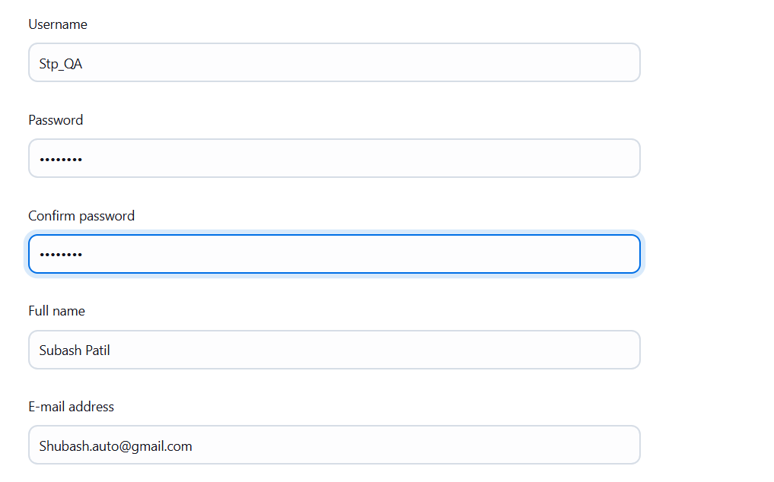

**Stp@1234**

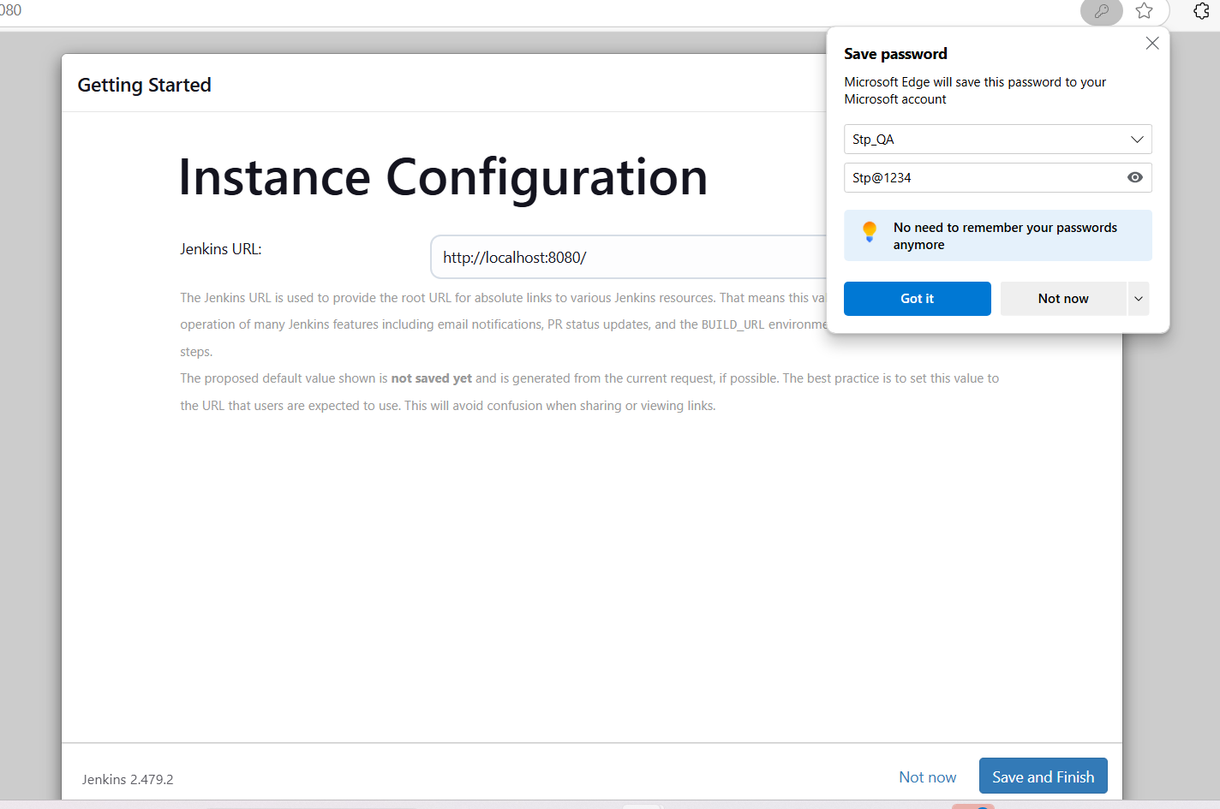

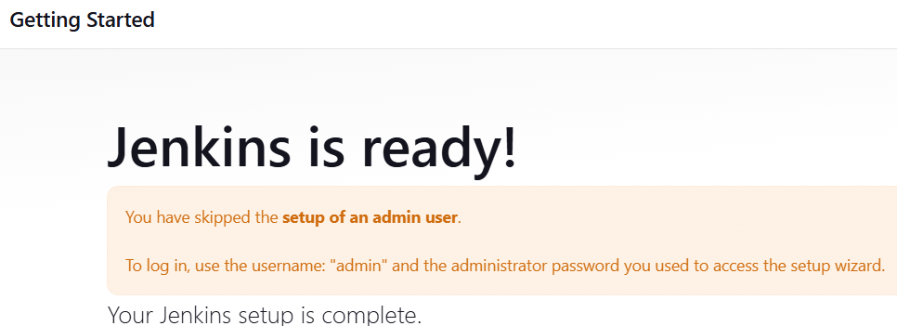

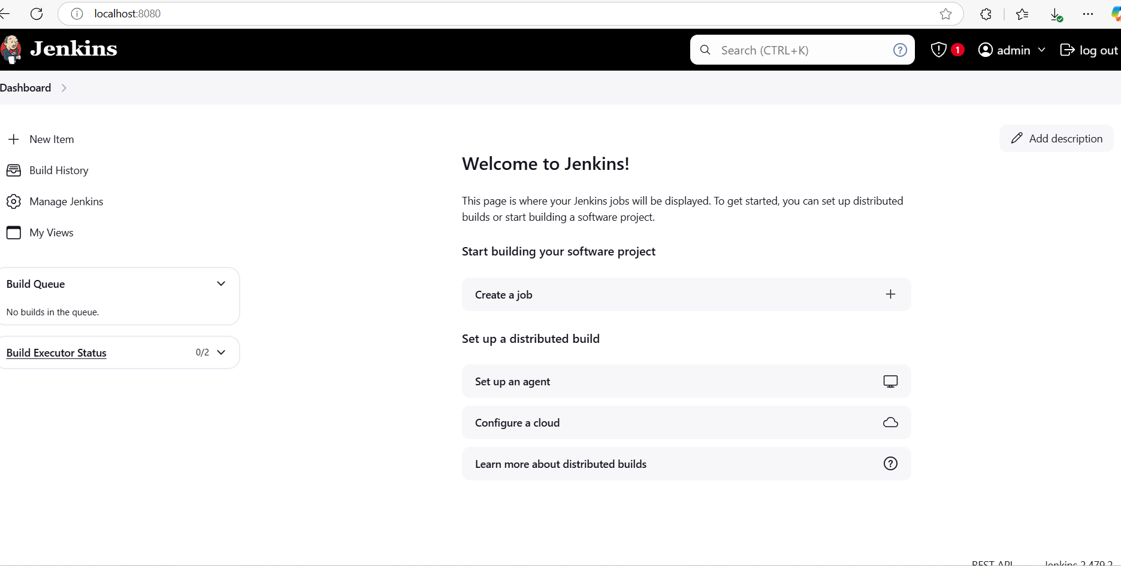

**Manage Jenkins**