<https://www.youtube.com/watch?v=m558zwIM-bU>

**How to Handle Stale Element Exception in Selenium with Java**

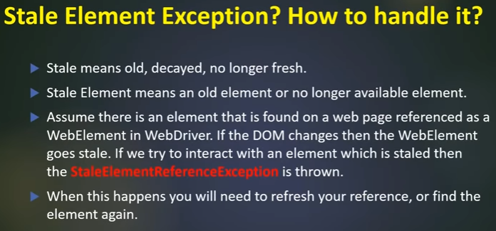

StaleElementReferenceException

Whenever we are navigating btwn pages, the new Ajax calls will be sent to the server, in that case the elements will become stale, so now u have to reidentify the elements and perform action.

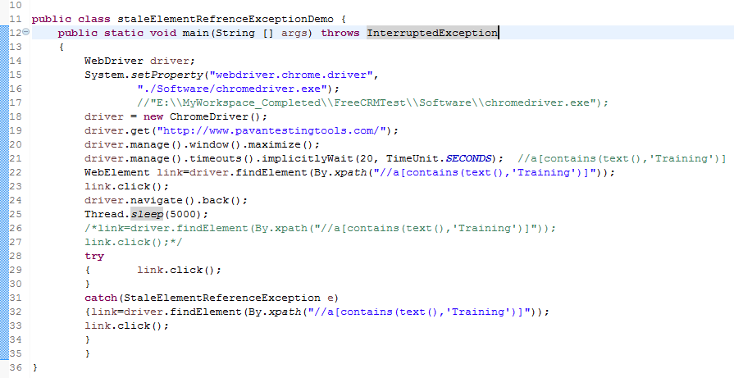

STEPS TO Reproduce a Stale Element

**public** **class** staleElementRefrenceExceptionDemo2 {

**public** **static** **void** main(String [] args) **throws** InterruptedException

{

WebDriver driver;

System.*setProperty*("webdriver.chrome.driver",

"./Software/chromedriver.exe");

driver = **new** ChromeDriver();

driver.manage().window().maximize();

driver.get("https://www.freecrm.com/index.html");

driver.manage().timeouts().implicitlyWait(20, TimeUnit.***SECONDS***); //a[contains(text(),'Training')]

WebElement login=driver.findElement(By.*xpath*("//span[contains(text(),'Log In')]"));

login.click();

Thread.*sleep*(2000);

WebElement userName=driver.findElement(By.*xpath*("//input[@placeholder='E-mail address']"));

userName.sendKeys("subashtpatil@gmail.com");

WebElement pwd= driver.findElement(By.*xpath*("//input[@placeholder='Password']"));

pwd.sendKeys("test@123");

driver.navigate().refresh();

Thread.*sleep*(2000);

**try** {

userName.sendKeys("subashtpatil@gmail.com");

pwd.sendKeys("test@123");

**throw** **new** StaleElementReferenceException(**null**, **null**);

}

**catch**(StaleElementReferenceException e){

/*userName=driver.findElement(By.xpath("//input[@placeholder='E-mail address']"));

userName.sendKeys("subashtpatil@gmail.com");

pwd= driver.findElement(By.xpath("//input[@placeholder='Password']"));

pwd.sendKeys("test@123");

driver.findElement(By.xpath("//div[@class='ui fluid large blue submit button']")).click();*/

e.printStackTrace();

}

}

}

