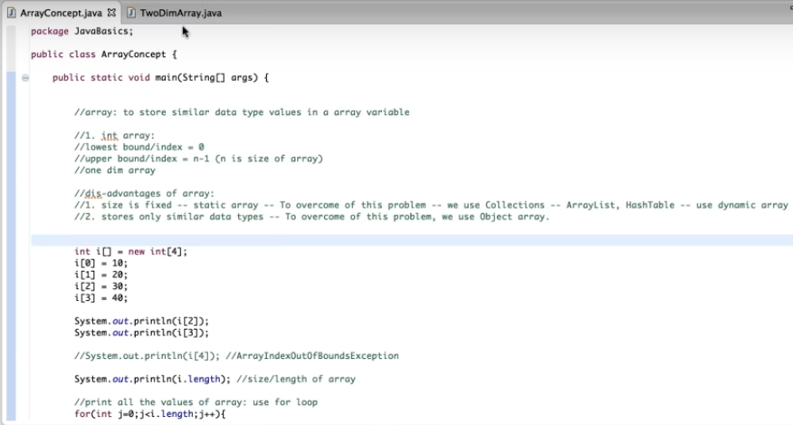

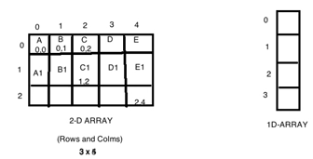

**package** Arrays;

**public** **class** Twodimensionalarray {

**public** **static** **void** main(String[] args) {

String x[][]= **new** String [3][5];

System.***out***.println(x.length); // total no of rows = 3

System.***out***.println(x[0].length); //total no of columns in 0th row =5

System.***out***.println(x[1].length); //total no of columns in 1st row =5

//initializing or assigning valueS

//1st row

x[0][0]="A";

x[0][1]="B";

x[0][2]="C";

x[0][3]="D";

x[0][4]="E";

//2nd row

x[1][0]="A1";

x[1][1]="B1";

x[1][2]="C1";

x[1][3]="D1";

x[1][4]="E1";

//3rd row

x[2][0]="A2";

x[2][1]="B2";

x[2][2]="C2";

x[2][3]="D2";

x[2][4]="E2";

System.***out***.println(x[1][2]);

System.***out***.println(x[2][2]);

System.***out***.println(x[0][4]);

//print all the values of 2 dimensional array

//row=0, col = 0 to 4

//row=1, col = 0 to 4

//row=2, col = 0 to 4

**for**(**int** row=0; row<=x.length; row++) {

**for**(**int** col=0; col<=x[0].length; col++) {

System.***out***.println(x[row][col]);

}

}

}

}