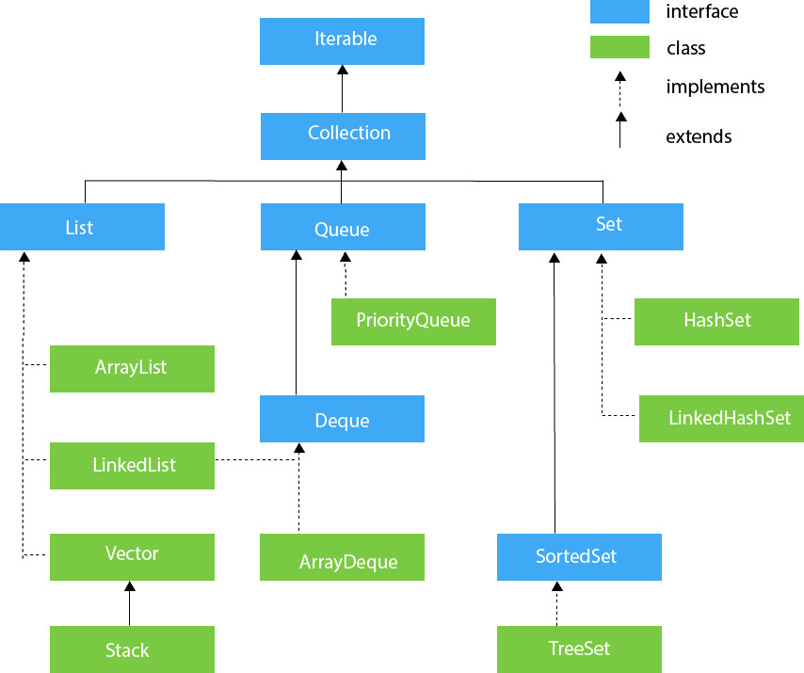

 Operations such as searching, sorting, insertion, manipulation, deletion, etc, can easily be performed by Java Collections.

In computer science, a data structure is a particular way of organising data in a computer so that it can be used efficiently. Searching a particular book from millions of books on Amazon or sorting through the endless choice of mobile phones on the basis of price are all done with low cost and low complexity algorithms, which work on structured data.

Earlier, all these data structures were written in C or C++ and had to be created every time in order to store data. Java came up with a solution that provided an API in the java.util package. This contains classes and interfaces which implement all these data structures, are ready to be used and make work easy for the coder.

In looking further to find how Java implements the structuring of data, I came across the Java Collection framework. This provides the architecture to store and manipulate a group of objects. Operations like searching, sorting, insertion, deletion and manipulation are all performed using the collection framework.

Now lets carefully analyse each data structure and look at how these are implemented by Collection. The Java Collection framework provides many interfaces (Set, List, Queue, Deque, etc) and classes (ArrayList, Vector, LinkedList, HashSet, LinkedHashSet, TreeSet, etc).

**Hierarchy of Collection Framework**

Collection Map

/ / \ \ |

/ / \ \ |

Set List Queue Dequeue SortedMap

/

/

SortedSet

**Core Interfaces in Collections**

Note that this diagram only shows core interfaces.

**Collection :** Root interface with basic methods like add(), remove(),

contains(), isEmpty(), addAll(), ... etc.

[**Set**](https://www.geeksforgeeks.org/set-in-java/) **:** Doesn't allow duplicates. Example implementations of Set

interface are HashSet (Hashing based) and TreeSet (balanced

BST based). Note that TreeSet implements **SortedSet**.

[**List**](https://www.geeksforgeeks.org/list-interface-java-examples/) **:** Can contain duplicates and elements are ordered. Example

implementations are LinkedList (linked list based) and

[ArrayList](https://www.geeksforgeeks.org/array-vs-arraylist-in-java/) (dynamic array based)

[**Queue**](https://www.geeksforgeeks.org/queue-interface-java/) **:** Typically order elements in FIFO order except exceptions

like PriorityQueue.

[**Deque**](https://www.geeksforgeeks.org/deque-interface-java-example/) **:** Elements can be inserted and removed at both ends. Allows

both LIFO and FIFO.

[**Map**](https://www.geeksforgeeks.org/map-interface-java-examples/) **:** Contains Key value pairs. Doesn't allow duplicates. Example

implementation are [HashMap](http://www.geeksforgeeks.org/java-util-hashmap-in-java/) and TreeMap.

[TreeMap](https://www.geeksforgeeks.org/treemap-in-java/) implements **SortedMap**.

The difference between Set and Map interface is that in Set we

have only keys, whereas in Map, we have key, value pairs.

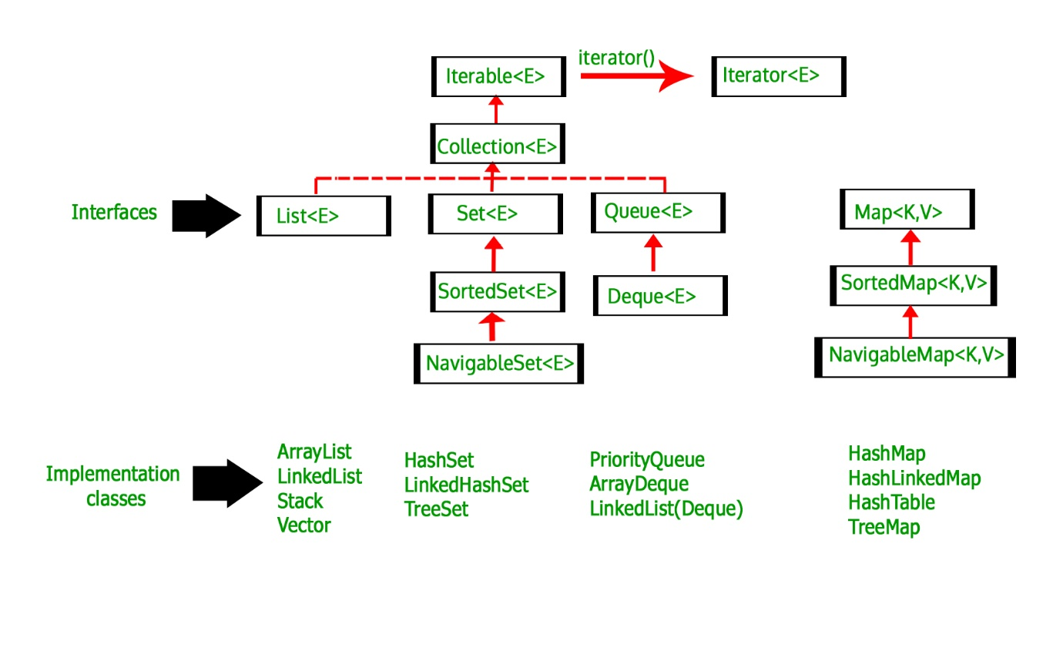

Collections in Java

1. [Java Collection Framework](https://www.javatpoint.com/collections-in-java)
2. [Hierarchy of Collection Framework](https://www.javatpoint.com/collections-in-java#collectionhierarchy)
3. [Collection interface](https://www.javatpoint.com/collections-in-java#collectionmethods)
4. [Iterator interface](https://www.javatpoint.com/collections-in-java#collectioniterator)

The **Collection in Java** is a framework that provides an architecture to store and manipulate the group of objects.

Java Collections can achieve all the operations that you perform on a data such as searching, sorting, insertion, manipulation, and deletion.

Java Collection means a single unit of objects. Java Collection framework provides many interfaces (Set, List, Queue, Deque) and classes ([ArrayList](https://www.javatpoint.com/java-arraylist), Vector, [LinkedList](https://www.javatpoint.com/java-linkedlist), [PriorityQueue](https://www.javatpoint.com/java-priorityqueue), HashSet, LinkedHashSet, TreeSet).

What is Collection in Java

A Collection represents a single unit of objects, i.e., a group.

What is a framework in Java

* It provides readymade architecture.
* It represents a set of classes and interfaces.
* It is optional.

What is Collection framework

The Collection framework represents a unified architecture for storing and manipulating a group of objects. It has:

1. Interfaces and its implementations, i.e., classes
2. Algorithm

Do You Know?

* What are the two ways to iterate the elements of a collection?
* What is the difference between ArrayList and LinkedList classes in collection framework?
* What is the difference between ArrayList and Vector classes in collection framework?
* What is the difference between HashSet and HashMap classes in collection framework?
* What is the difference between HashMap and Hashtable class?
* What is the difference between Iterator and Enumeration interface in collection framework?
* How can we sort the elements of an object? What is the difference between Comparable and Comparator interfaces?
* What does the hashcode() method?
* What is the difference between Java collection and Java collections?

Hierarchy of Collection Framework

Let us see the hierarchy of Collection framework. The **java.util** package contains all the [classes](https://www.javatpoint.com/object-and-class-in-java) and [interfaces](https://www.javatpoint.com/interface-in-java) for the Collection framework.



Methods of Collection interface

There are many methods declared in the Collection interface. They are as follows:

|  |  |  |
| --- | --- | --- |
| **No.** | **Method** | **Description** |
| 1 | public boolean add(E e) | It is used to insert an element in this collection. |
| 2 | public boolean addAll(Collection<? extends E> c) | It is used to insert the specified collection elements in the invoking collection. |
| 3 | public boolean remove(Object element) | It is used to delete an element from the collection. |
| 4 | public boolean removeAll(Collection<?> c) | It is used to delete all the elements of the specified collection from the invoking collection. |
| 5 | default boolean removeIf(Predicate<? super E> filter) | It is used to delete all the elements of the collection that satisfy the specified predicate. |
| 6 | public boolean retainAll(Collection<?> c) | It is used to delete all the elements of invoking collection except the specified collection. |
| 7 | public int size() | It returns the total number of elements in the collection. |
| 8 | public void clear() | It removes the total number of elements from the collection. |
| 9 | public boolean contains(Object element) | It is used to search an element. |
| 10 | public boolean containsAll(Collection<?> c) | It is used to search the specified collection in the collection. |
| 11 | public Iterator iterator() | It returns an iterator. |
| 12 | public Object[] toArray() | It converts collection into array. |
| 13 | public <T> T[] toArray(T[] a) | It converts collection into array. Here, the runtime type of the returned array is that of the specified array. |
| 14 | public boolean isEmpty() | It checks if collection is empty. |
| 15 | default Stream<E> parallelStream() | It returns a possibly parallel Stream with the collection as its source. |
| 16 | default Stream<E> stream() | It returns a sequential Stream with the collection as its source. |
| 17 | default Spliterator<E> spliterator() | It generates a Spliterator over the specified elements in the collection. |
| 18 | public boolean equals(Object element) | It matches two collections. |
| 19 | public int hashCode() | It returns the hash code number of the collection. |