CONCATINATION OPERATOR

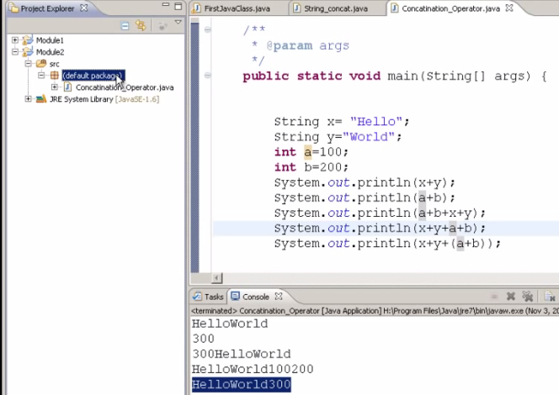

WHILE LOOPS

Disadvantage of While loops ; if the condition is not given, it will enter into an infinite loop.

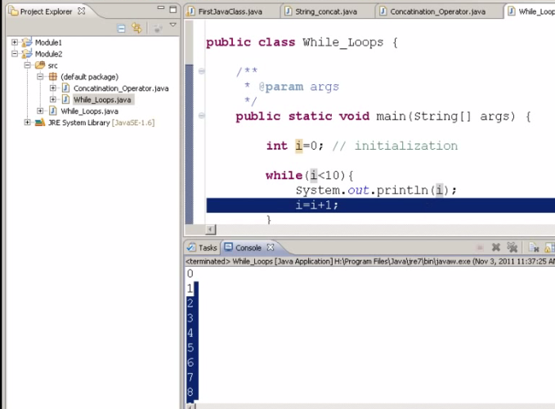

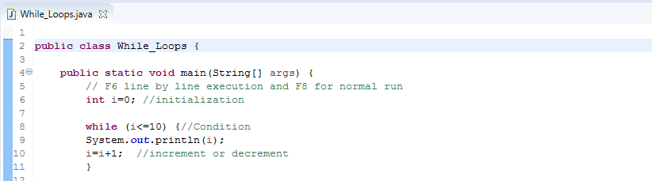

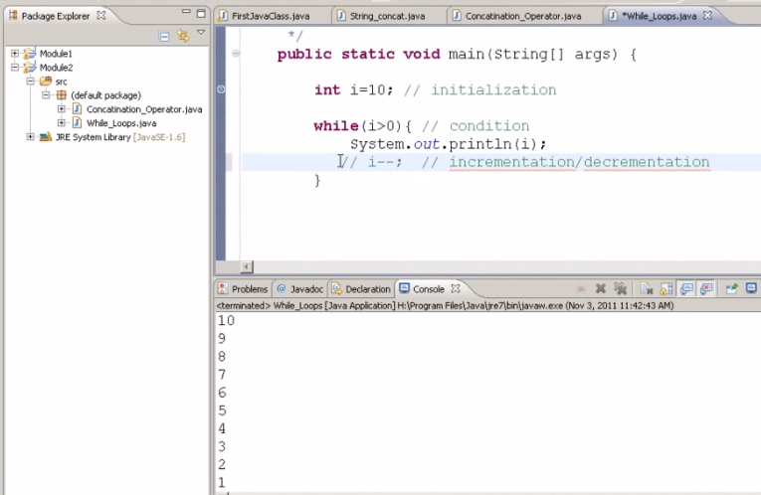

DEBUG MODE: Press F6 for step by step execution and F8 for normal execution.

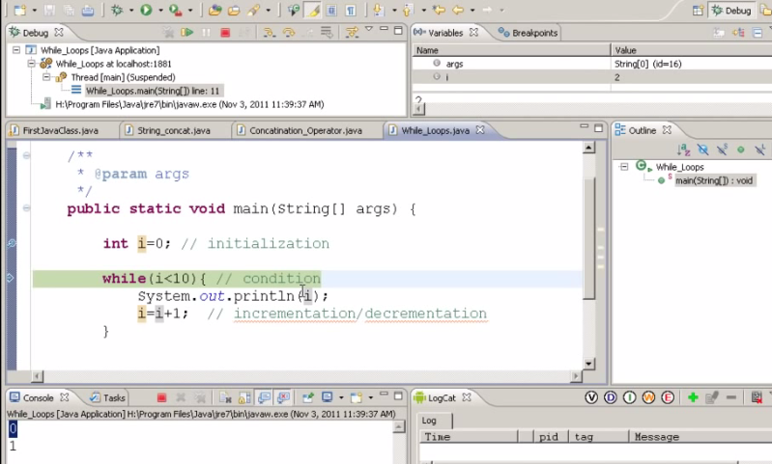

FOR LOOP

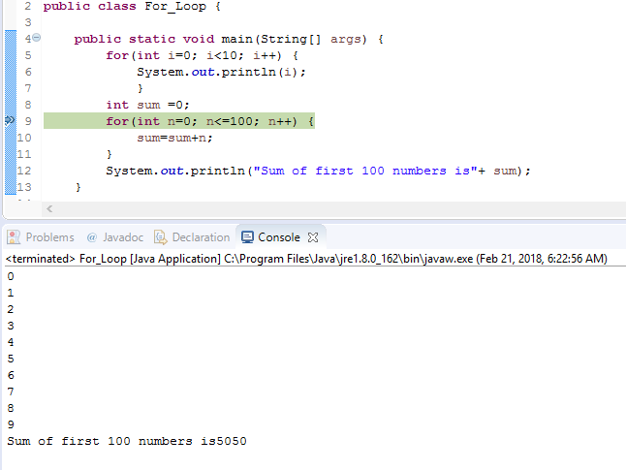

ARRAYS: Drawback of array is that you have to give the maximum size of the array if it is an array of type string. Int, char, string or char arrays can hold only respective data types. An array is only for particular data type but cannot hold any other data types or cross data types.

Declaring different types of arrays:4





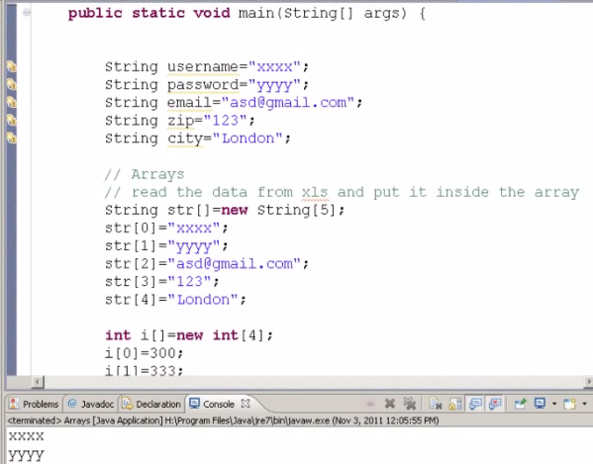

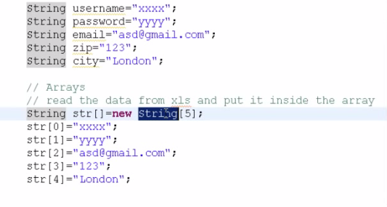



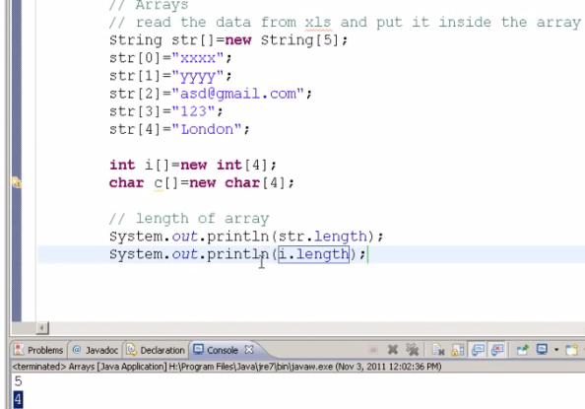

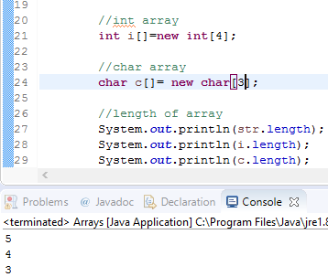

Printing the contents of an array;

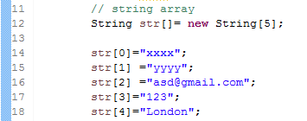

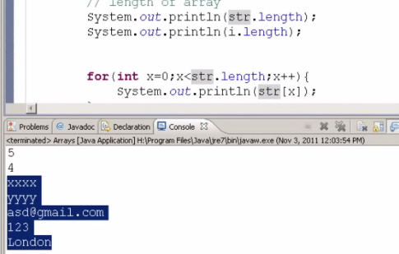

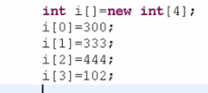

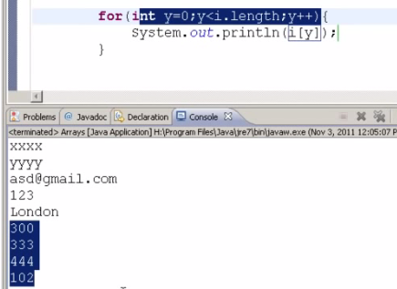

FOR LOOP IN REVERSE ORDER

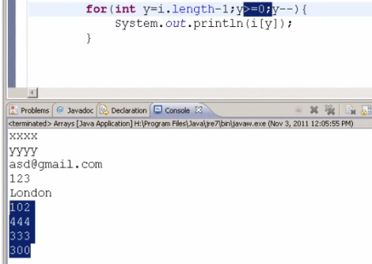

33.30 timing in video

TWO DIMENSIONAL ARRAYS

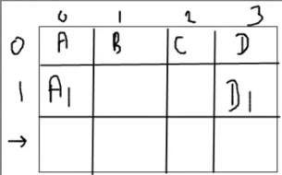

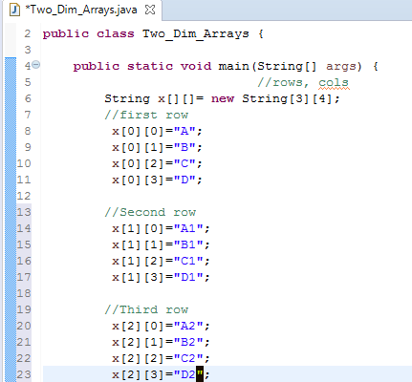

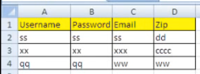 In selenium we read data from an excel file using 2-dimensional array.

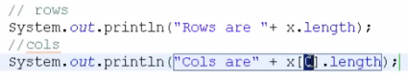



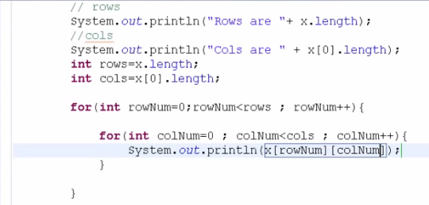



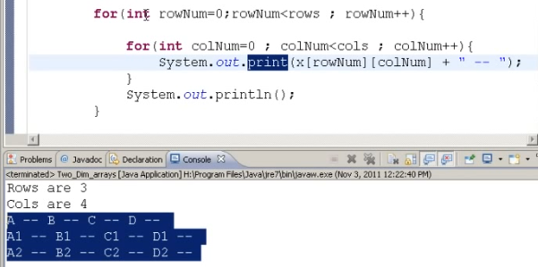

Since all arrays hold only respective data types, we need to create an array which can hold all types of data in a single array.

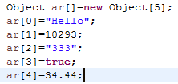

FUNCTIONS: When below function is executed only the main function gets executed and not the testme function. Main function is the one in which control comes for the first time as below. We cannot write a function within another function. All functions need to be parallel to each other. The order of execution is in a serial order. If you press Ctrl+Spacebar, it displays the list of all functions in the script.

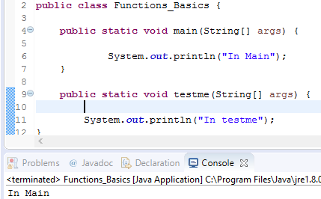

Below is the way how you call a function in a Main function

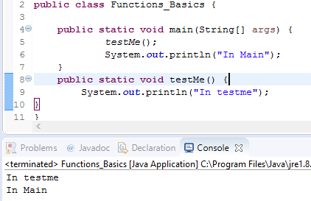

A function can be called any number of times as below and order of execution is in sequential order

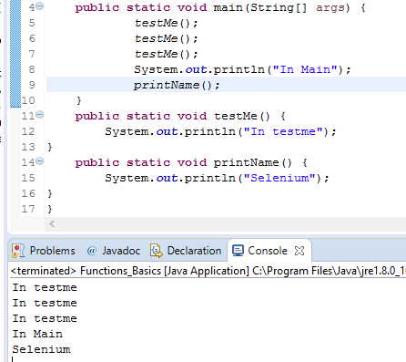

YOU Can Pass any number of values inside a function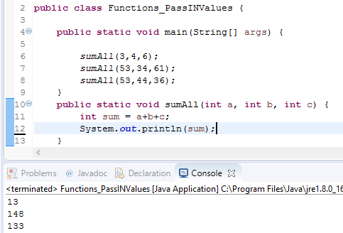

In the 2nd sumAll function the first argument is of type String so it will be calling the 2nd SumAll function. The life of the Local variable is only specific to the function in which it is declared.

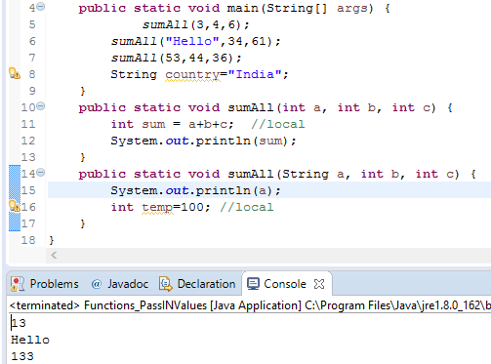

Void is the return type which means (nothing is returned if void is mentioned) if it is not specified as int or string etc.

A function can accept any number of arguments but can return only one value. You have to mention the return type in place of void as seen below

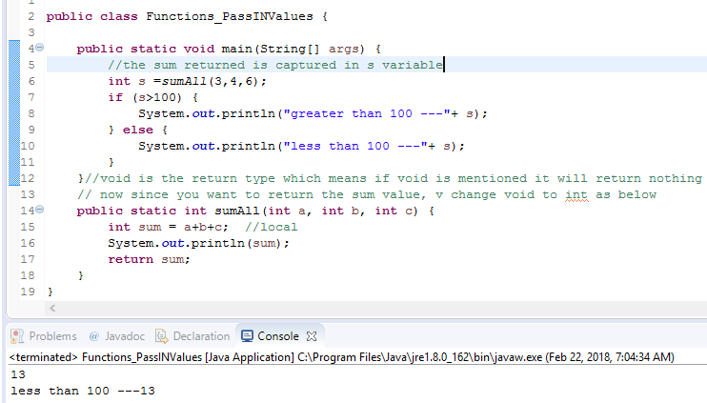

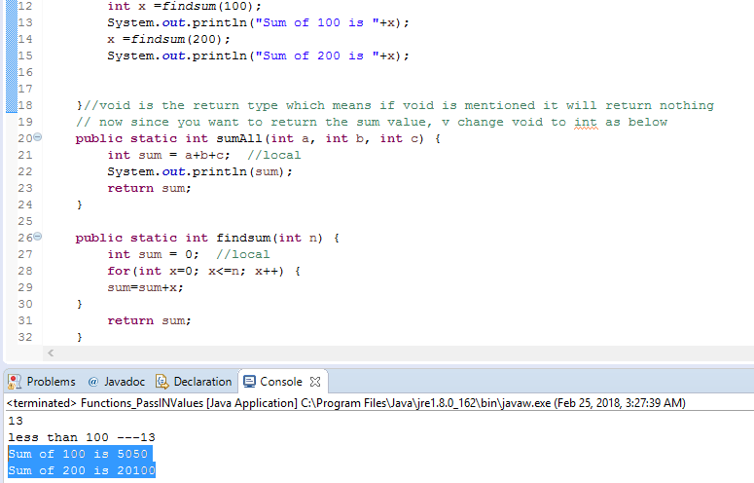

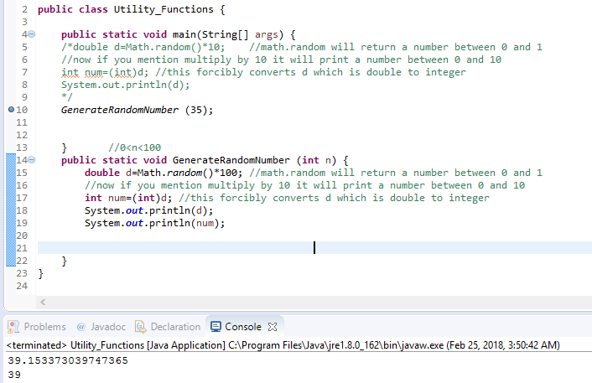

How to write a function

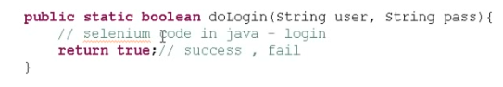

OBJECT ARRAYS: Object is an inbuilt class in Java. Object arr[] is an array which can hold all (different) types of data in a single array.

