<https://www.qtpselenium.com/selenium-training>

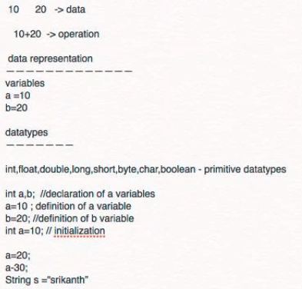

Method name should always start with a lowercase letter

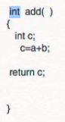return type is int 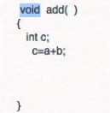 void means I am not returning anything

STATIC AND Nonstatic functions

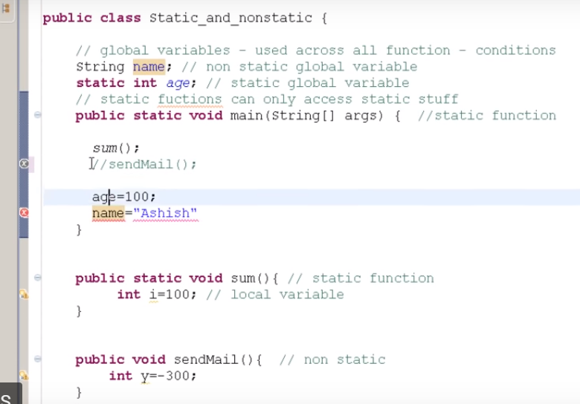

Creating a class called Car

