45 years now, until how long will i be able to apply for canada and after applying what is the duration for the process.

it is okay if not employed for what period.

edu 21

we 15

age 1

wife 5

ielts 7778 24

saskatchewan 60

20

12

<https://www.youtube.com/watch?v=RYd_hagCiVk>

<https://www.youtube.com/watch?v=7tndaxgk1E8>

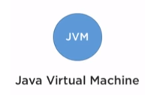JVM Java Virtual machine is virtually present in your s/w or h/w system. It helps to execute the Java code in your device. It has no physical presence in the system. It provides an environment for the code execution.

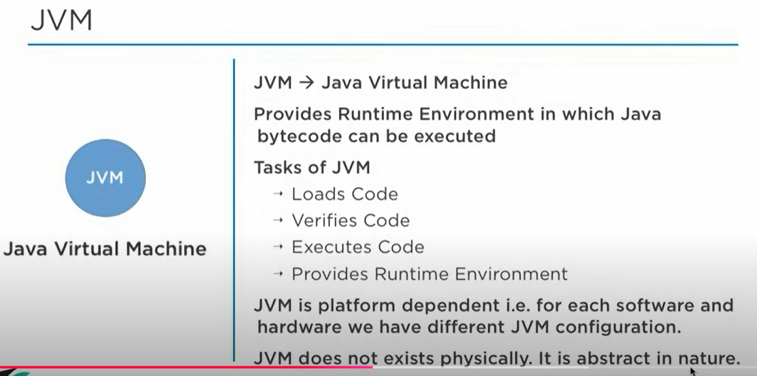

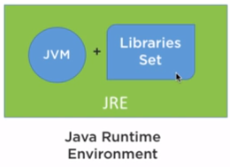

JRE: Java Runtime Environment: It is a combination of JVM and a few libraries set. In addition to the JVM we have libraries set. These are the library set that JVM requires for code execution during the runtime. JRE helps you to run the code in your device. 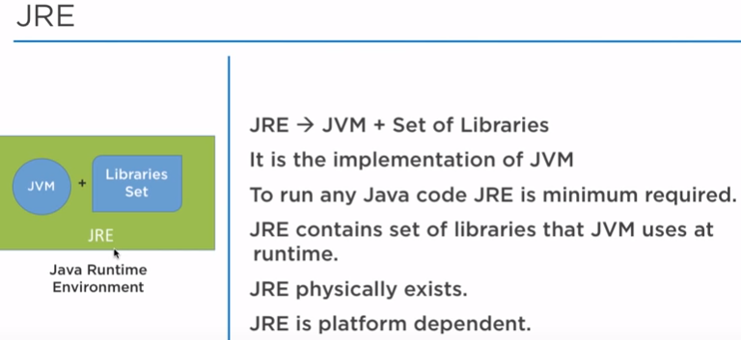

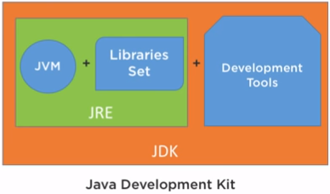

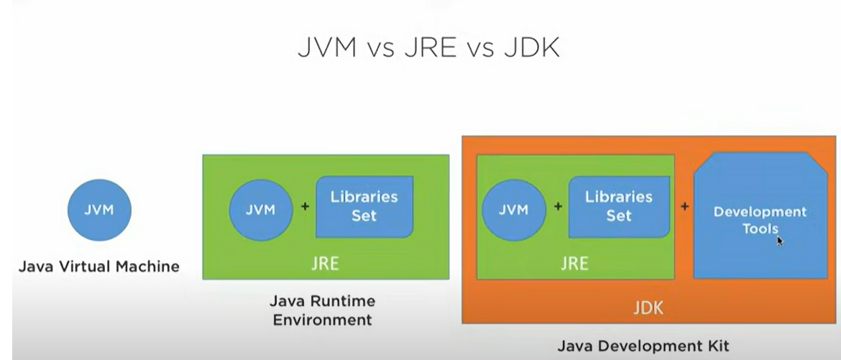

JDK: Java Development Kit: JDK contains the JRE in which we have the JVM+ libraries set, also in addition to JRE in case of JDK we have the development tools. JRE only helps to run the code but to develop some application or write some programs you need the development tools such as the debugger, compiler, executer and so on. So all these are actually present inside the development tools. So the JDK helps you to develop some Java applications.

