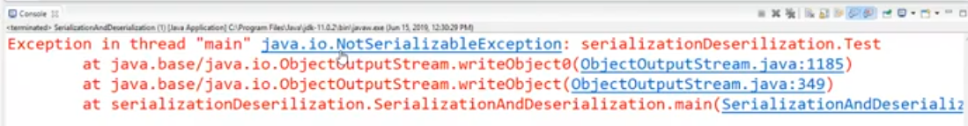

Because we have not implemented the Serializable class as seen below

