Java String

In [Java](https://www.javatpoint.com/java-tutorial), string is basically an object that represents sequence of char values. An [array](https://www.javatpoint.com/array-in-java) of characters works same as Java string. For example:

1. **char**[] ch={'j','a','v','a','t','p','o','i','n','t'};
2. String s=**new** String(ch);

is same as:

1. String s="javatpoint";

**Java String** class provides a lot of methods to perform operations on strings such as compare(), concat(), equals(), split(), length(), replace(), compareTo(), intern(), substring() etc.

The java.lang.String class implements *Serializable*, *Comparable* and *CharSequence* [interfaces](https://www.javatpoint.com/interface-in-java).

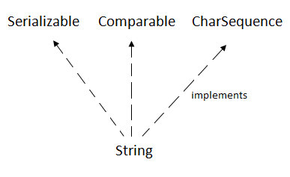

CharSequence Interface

The CharSequence interface is used to represent the sequence of characters. String, [StringBuffer](https://www.javatpoint.com/StringBuffer-class) and [StringBuilder](https://www.javatpoint.com/StringBuilder-class) classes implement it. It means, we can create strings in java by using these three classes.

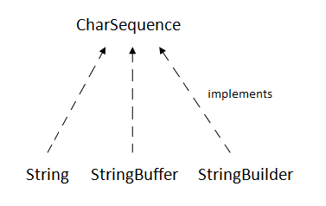

The Java String is immutable which means it cannot be changed. Whenever we change any string, a new instance is created. For mutable strings, you can use StringBuffer and StringBuilder classes.

We will discuss immutable string later. Let's first understand what is String in Java and how to create the String object.

What is String in java

Generally, String is a sequence of characters. But in Java, string is an object that represents a sequence of characters. The java.lang.String class is used to create a string object.

How to create a string object?

There are two ways to create String object:

1. By string literal
2. By new keyword

1) String Literal

Java String literal is created by using double quotes. For Example:

1. String s="welcome";

Each time you create a string literal, the JVM checks the "string constant pool" first. If the string already exists in the pool, a reference to the pooled instance is returned. If the string doesn't exist in the pool, a new string instance is created and placed in the pool. For example:

1. String s1="Welcome";
2. String s2="Welcome";//It doesn't create a new instance

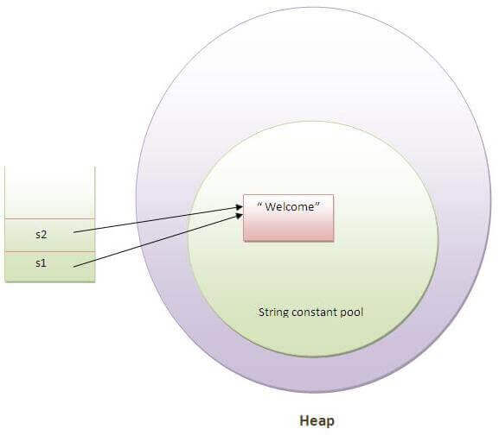

In the above example, only one object will be created. Firstly, JVM will not find any string object with the value "Welcome" in string constant pool, that is why it will create a new object. After that it will find the string with the value "Welcome" in the pool, it will not create a new object but will return the reference to the same instance.

Note: String objects are stored in a special memory area known as the "string constant pool".

Why Java uses the concept of String literal?

To make Java more memory efficient (because no new objects are created if it exists already in the string constant pool).

2) By new keyword

1. String s=**new** String("Welcome");//creates two objects and one reference variable

In such case, [JVM](https://www.javatpoint.com/jvm-java-virtual-machine) will create a new string object in normal (non-pool) heap memory, and the literal "Welcome" will be placed in the string constant pool. The variable s will refer to the object in a heap (non-pool).

Java String Example

1. **public** **class** StringExample{
2. **public** **static** **void** main(String args[]){
3. String s1="java";//creating string by java string literal
4. **char** ch[]={'s','t','r','i','n','g','s'};
5. String s2=**new** String(ch);//converting char array to string
6. String s3=**new** String("example");//creating java string by new keyword
7. System.out.println(s1);
8. System.out.println(s2);
9. System.out.println(s3);
10. }}

[**Test it Now**](http://www.javatpoint.com/opr/test.jsp?filename=StringExample)

java

strings

example

Java String contains() method example

1. **class** ContainsExample{
2. **public** **static** **void** main(String args[]){
3. String name="what do you know about me";
4. System.out.println(name.contains("do you know"));
5. System.out.println(name.contains("about"));
6. System.out.println(name.contains("hello"));
7. }}

[**Test it Now**](http://www.javatpoint.com/opr/test.jsp?filename=ContainsExample)

true

true

false

Java String contains() Method Example 2

The contains() method searches case sensitive char sequence. If the argument is not case sensitive, it returns false. Let's see an example below.

1. **public** **class** ContainsExample2 {
2. **public** **static** **void** main(String[] args) {
3. String str = "Hello Javatpoint readers";
4. **boolean** isContains = str.contains("Javatpoint");
5. System.out.println(isContains);
6. // Case Sensitive
7. System.out.println(str.contains("javatpoint")); // false
8. }
9. }

true

false

Java String contains() Method Example 3

The contains() method is helpful to find a char-sequence in the string. We can use it in control structure to produce search based result. Let us see an example below.

1. **public** **class** ContainsExample3 {
2. **public** **static** **void** main(String[] args) {
3. String str = "To learn Java visit Javatpoint.com";
4. **if**(str.contains("Javatpoint.com")) {
5. System.out.println("This string contains javatpoint.com");
6. }**else**
7. System.out.println("Result not found");
8. }
9. }

Output:

This string contains javatpoint.com