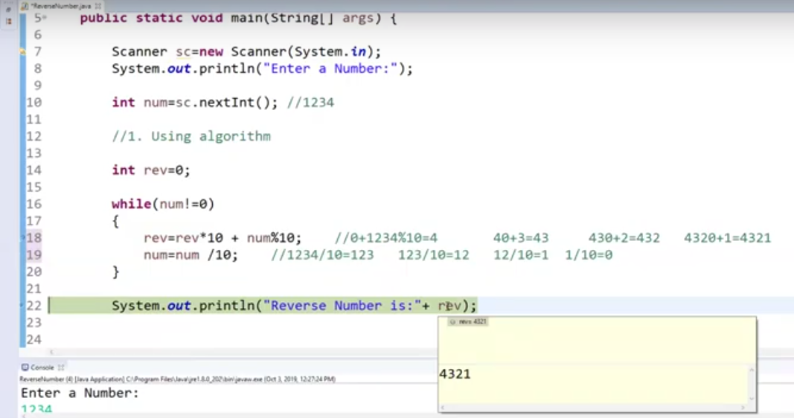

**public** **class** ReverseANumber_2 {

**public** **static** **void** main(String[] args) {

@SuppressWarnings("resource")

Scanner s = **new** Scanner(System.***in***);

System.***out***.println("Enter the number to be reversed");

**int** num = s.nextInt();

// Using StringBuffer class

StringBuffer sb = **new** StringBuffer(String.*valueOf*(num));

StringBuffer rev = sb.reverse();

System.***out***.println("The reversed number is " + rev);

}

}/*

Enter the number to be reversed

1234

The reversed number is 4321*/

**public** **class** ReverseANumber_1 {

**public** **static** **void** main(String[] args) {

Scanner s = **new** Scanner(System.***in***);

System.***out***.println("Enter the number to be reversed");

**int** num = s.nextInt();

**int** rev = 0;

**while** (num != 0) {

rev = rev * 10 + num % 10;

num = num / 10;

}

System.***out***.println("The reversed number is " + rev);

}

}

/*Enter the number to be reversed

4321

The reversed number is 1234*/

**public** **class** ReverseANumber_3 {

**public** **static** **void** main(String[] args) {

@SuppressWarnings("resource")

Scanner s = **new** Scanner(System.***in***);

System.***out***.println("Enter the number to be reversed");

**int** num = s.nextInt();

StringBuilder sbl= **new** StringBuilder();

sbl.append(num);

StringBuilder rev= sbl.reverse();

System.***out***.println("The reversed number is " + rev);

}

}

/*Enter the number to be reversed

4321

The reversed number is 1234*/