This is to check the configurations file

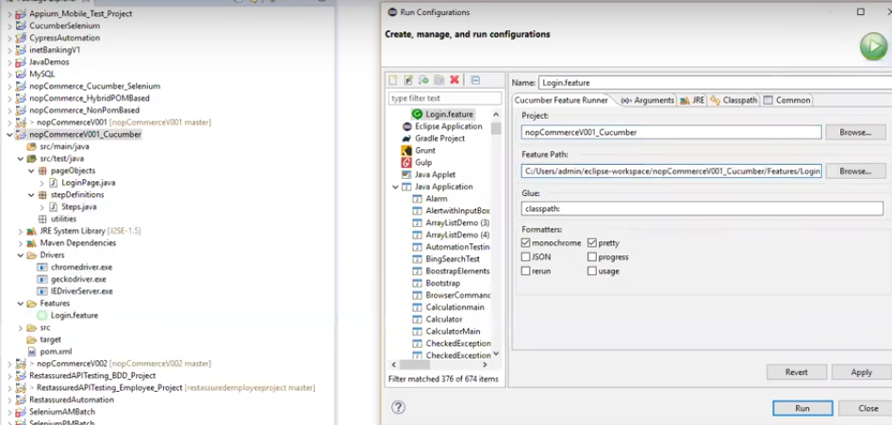

java.lang.NoSuchMethodError: org.testng.remote.AbstractRemoteTestNG.addListener

I also had the same issue. I tried the below solution and it worked for me like a charm. The Solution was:

Adding the TestNG Library into the project. Steps are:

1. Right Click on the Project
2. Build Path
3. Configure Build Path
4. Libraries (Tab)
5. Go to "Add Library" and click the button.
6. Add the 'TestNG' Library and click Ok/Next.
7. TestNG Library will be added to your project.

Try Running again, it will work.

[ERROR] No compiler is provided in this environment. Perhaps you are running on a JRE rather than a JDK?

ANSWER

On your Eclipse IDE, go into **Window** > **Preferences** > **Java** > **Installed JREs** > and check your **installed JREs**. You should have an entry with a JDK there.

