PATTERNED CONCRETE
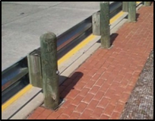
Relative Installation Cost | High
Life Cycle Cost | Low
Maintenance/Repair Cost | High
Effective Longevity | High
Installation | Difficult
Repair | Difficult
Maintenance | Moderate
Retrofit | Difficult

Description: Standard or minor concrete using color additive and stamped or imprinted pattern.

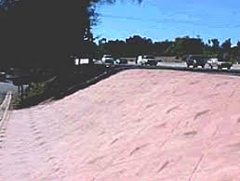
Applications:
- Guardrail
- Median cable barrier
- Gore
- Median
- Slope/embankment

Considerations:
- High aesthetic appeal
- High life cycle costs
- Requires leave-out area at ground penetrations
- Good for use in urban/high visibility locations
- Can be used in most climate conditions

Limitations
- Difficult to use at guardrail/median barrier locations
- Difficult/costly repairs to match color and pattern
- Not generally applicable for retrofit applications

Common Problems:

- Some damage noted with snow removal equipment due to highly textured concrete pattern

