ASPHALT COMPOSITE
Relative Installation Cost | Low
Life cycle Cost | Low
Maintenance/Repair Cost | Low
Effective Longevity | High
Installation | Easy
Repair | Easy
Maintenance | Easy
Retrofit | Easy
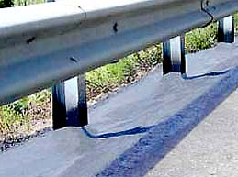

Description: Single-step, seamless, cold spray applied asphalt emulsion reinforced with fiberglass strands.
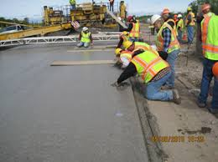
Applications:
- Guardrail
- Sign Posts
- Gore/Median
- Mow Edge
- Median Cable Barrier

Considerations:
- Flexible & solid
- Installed using typical maintenance equipment/practices
- Low life-cycle costs
- Low cost and easy installation and repairs.
- Seamless installation to reduce vegetation encroachment at seams
- Does not require leave out at ground penetrations

Limitations
- Requires installation temperature >50°

Common Problems:

