RUBBER WEED MAT
Relative Installation Cost | Moderate
Life Cycle Cost | Low
Maintenance/Repair Cost | Low
Effective Longevity | High
Installation | Easy
Repair | Easy
Maintenance | Easy
Retrofit | Easy
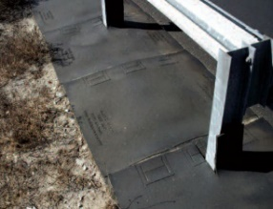

Description: Mats consisting of recycled rubber tires adhered together with a resin. Cutouts are often provided for post placement.

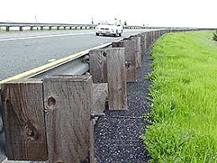
Applications:
- Guardrail
- Sign Post
- Median Cable Barrier

Considerations:
- Does not require leave out at ground penetrations
- No staking/anchoring is required
- Easily replaced
- Different colors available

Limitations
- Potential joint separation if not installed/sealed properly
- Slow installation process

Common Problems:

- Subject to damage from wind, mowers, snow removal equipment damage, joint separation and UV degradation

