ROCK/GRAVEL MULCH
Relative Installation Cost | Low
Life Cycle Cost | Low
Maintenance/Repair Cost | Low
Effective Longevity | Moderate
Installation | Easy
Repair | Easy
Maintenance | Easy
Retrofit | Easy
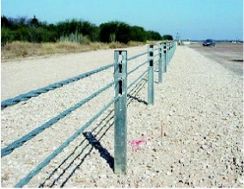

Description: Graded, crushed rock placed on geosynthetic fabric (herbicide or non-herbicide treated)

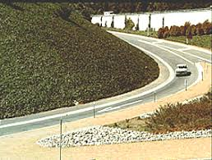
Applications:
- Guardrail
- Sign Post
- Gore/Median
- Slope/Embankment
- Mow Edge
- Pavement Edge
- Median Cable Barrier

Considerations:
- Does not require leave out at ground penetrations
- Low cost treatment
- Can be used in most climate conditions
- Low tech process – standard maintenance equipment required

Limitations
- May not be applicable in areas with snow removal equipment and snow storage

Common Problems:

- Displacement by errant vehicles and maintenance equipment
- Requires removal of wind-blown dirt/debris

