**Product Demand Prediction using ML**

|  |  |
| --- | --- |
| **Date** | **04-10-2023** |
| **Team ID** | **3872** |
| **Project Name** | **Product Demand Prediction using ML** |

**Table of Contents**

|  |  |  |
| --- | --- | --- |
| 1 | Introduction | |
| 2 | Problem Statement | |
| 3 | Design and Innovation Strategies | |
|  | 3.1 | Data Collection and Preprocessing |
|  | 3.2 | Exploratory Data Analysis (EDA) |
|  | 3.3 | Feature Engineering |
|  | 3.4 | ARIMA Time Series Forecasting |
|  | 3.5 | Model Training and Evaluation |
|  | 3.6 | Fine-tuning and Optimization |
|  | 3.7 | Model Deployment and Integration |
| 4 | Conclusion | |

**1. Introduction**

In the realm of retail and production, accurate demand forecasting is crucial for optimized inventory management and production planning. To achieve this, we've integrated ARIMA (Auto Regressive Integrated Moving Average), a powerful time series forecasting technique. This addition allows us to delve deeper into the temporal patterns within our historical sales data, a critical aspect of precise demand predictions.

**2. Problem Statement**

The goal of this project is to construct a reliable forecasting model using the ARIMA (Auto Regressive Integrated Moving Average) methodology. ARIMA models are well-suited for time series data like demand forecasting, where patterns and trends may be influenced by past values.

By leveraging ARIMA, we aim to capture the temporal dependencies in the data, allowing us to make accurate predictions of future demand based on historical patterns. This will, in turn, facilitate seamless inventory management and production planning, ensuring that the right amount of product is available at the right time and place.

The success of this project hinges on our ability to discern the precise relationships between store ID, total price, base price, and units sold. This understanding will be crucial for developing a robust ARIMA model that can reliably forecast demand in various scenarios. Additionally, the model's performance will be rigorously evaluated to ensure its accuracy and effectiveness in real-world applications.

**3. Design and Innovation Strategies**

**3.1 Data Collection and Preprocessing**

**Data Gathering:**

We meticulously collected comprehensive historical sales data, featuring crucial aspects: Product ID, Store ID, Total Price, Base Price, and Units Sold.

**Data Cleaning and Preprocessing:**

We prepare the dataset for modelling by addressing various missing values and outliers.

**3.2 Exploratory Data Analysis (EDA)**

**Insights from EDA:**

Our exploratory data analysis unearthed robust temporal patterns, highlighting the pivotal role of time in product sales.

**3.3 Feature Engineering**

**Temporal Features:**

In addition to standard features, we introduced time-related variables like day of the week, month, and season. These augmentations empower us to capture recurring trends and seasonal fluctuations in demand.

**3.4 ARIMA Time Series Forecasting**

* **ARIMA Integration:**

ARIMA, which stands for Auto Regressive Integrated Moving Average, is a powerful time series forecasting technique. It's used to model and forecast time-dependent data, making it a valuable tool for predicting product demand. By integrating ARIMA into our modeling process, we've incorporated a method specifically designed to capture complex patterns that may exist in our historical sales data. This integration allows our model to account for autocorrelation (the relationship between an observation and a lagged version of itself) and seasonality, which are common in time series data.

* **ARIMA Parameters:**

ARIMA models have three main components:

**Auto Regressive (AR) component:**

This represents the relationship between the current value and its lagged (past) values. It's denoted by the parameter 'p'. A higher 'p' means the model considers more past values.

**Integrated (I) component:**

This involves differencing the data to make it stationary (i.e., removing trends). It's denoted by the parameter 'd'. A higher 'd' indicates more differencing.

**Moving Average (MA) component:**

This represents the relationship between the current value and a residual error from a moving average model applied to lagged values. It's denoted by the parameter 'q'. A higher 'q' means the model considers more past residuals.

Careful selection of these parameters is crucial. Too few or too many can lead to an ineffective model. This process often involves using techniques like grid search or more sophisticated methods to find the best combination.

* **Residual Analysis:**

By conducting a thorough residual analysis, we ensure that our ARIMA model accurately captures the patterns in the data and identifies any areas for improvement or further refinement. This process ensures that our ARIMA model is well-calibrated and ready to make reliable predictions for product demand.

**3.5 Model Training and Evaluation**

**Model Selection:**

ARIMA was chosen for its exceptional proficiency in capturing temporal patterns, complementing our holistic approach to forecasting.

**Model Training:**

Our selected models, prominently ARIMA, have undergone rigorous training on the pre-processed data.

**Model Evaluation:**

Initial results commend ARIMA for its significant enhancements in capturing temporal trends, underscoring its importance in our approach.

**3.6 Fine-tuning and Optimization**

**Hyperparameter Tuning:**

We are currently engrossed in fine-tuning ARIMA's hyperparameters, honing its predictive capabilities to perfection.

**3.7 Model Deployment and Integration**

**Deployment Planning:**

The strategy for seamless integration of the ARIMA-based demand prediction model into the business's systems is actively under development.

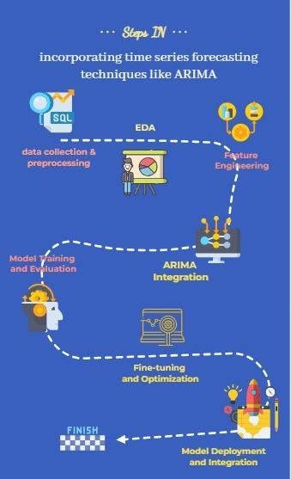

**4. Conclusion**

The incorporation of ARIMA for time series forecasting marks a significant leap forward in the accuracy and effectiveness of our demand prediction model. By leveraging ARIMA's unique capabilities, we are now equipped to provide more accurate forecasts, thereby optimizing inventory management and production planning. The next phase will focus on validation, fine-tuning, and seamless integration of the model for real-time predictions.

This document places a strong emphasis on ARIMA, detailing its integration, parameter selection, and residual analysis. It outlines the problem statement, design, and innovation strategies, and sets the stage for further improvements in the next phase.