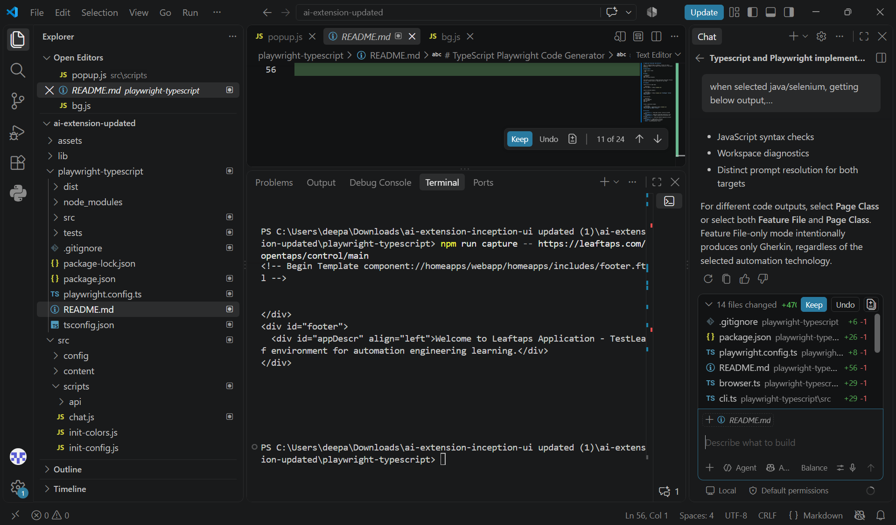
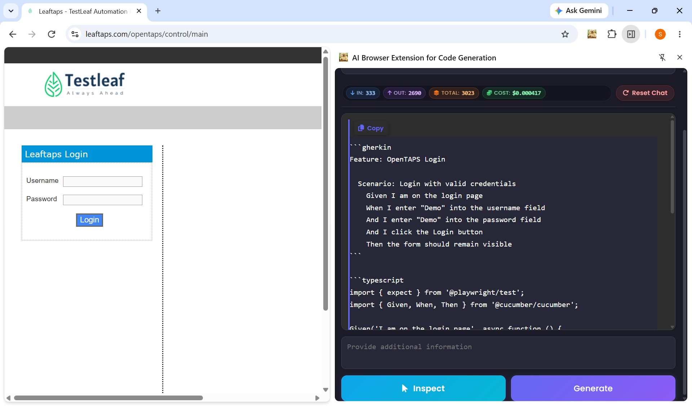

As if like Java +Selenium , the application is implemented with typescript + Playwright as well.

```gherkin
Feature: OpenTAPS Login

Scenario: Login with valid credentials
Given I am on the login page
When I enter "Demo" into the username field
And I enter "Demo" into the password field
And I click the Login button
Then the form should remain visible
```

```typescript
import { expect } from '@playwright/test';
import { Given, When, Then } from '@cucumber/cucumber';

Given('I am on the login page', async function () {
await this.page.goto('https://leaftaps.com/opentaps/control/main');
await expect(this.page.locator('#username')).toBeVisible();
});

When('I enter {string} into the username field', async function (value) {
await this.page.locator('#username').fill(value);
});

When('I enter {string} into the password field', async function (value) {
await this.page.locator('#password').fill(value);
});

When('I click the Login button', async function () {
await this.page.locator('input.decorativeSubmit').click();
});

Then('the form should remain visible', async function () {
await expect(this.page.locator('form#login')).toBeVisible();
});
```

