Integrate the Jira with this existing codebase

Activity: Integrate the AI Agent with Jira by adding a "Connect Jira" feature that allows users to establish a connection using their Jira Base URL, Email ID, and Jira API Token. Once the connection is successfully established, retrieve and populate the available Jira user stories within the application. Ensure the implementation follows the existing project architecture, UI design, and coding standards while maintaining compatibility with the current functionality.

1. Implement the UI Changes
2. Then Implement the Connectivity

Connect Jira button is implemented
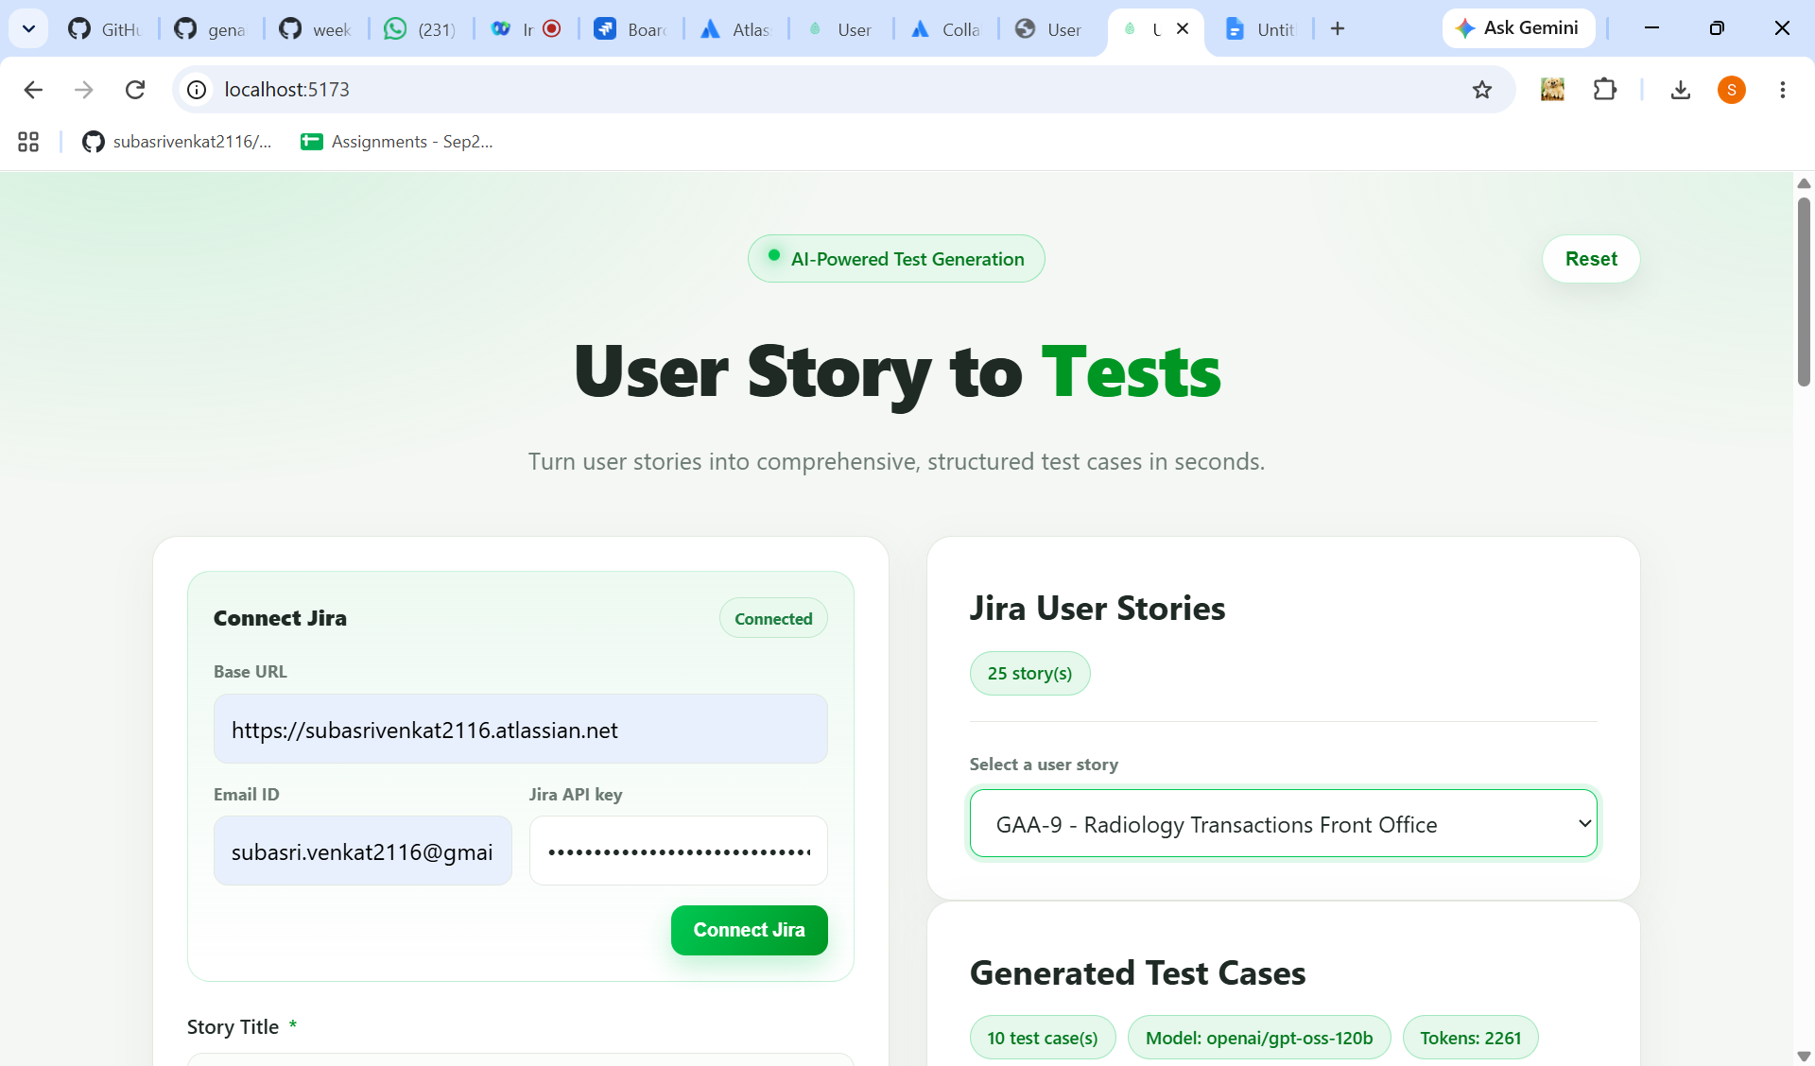

Userstories are fetched and displayed in the dropdown
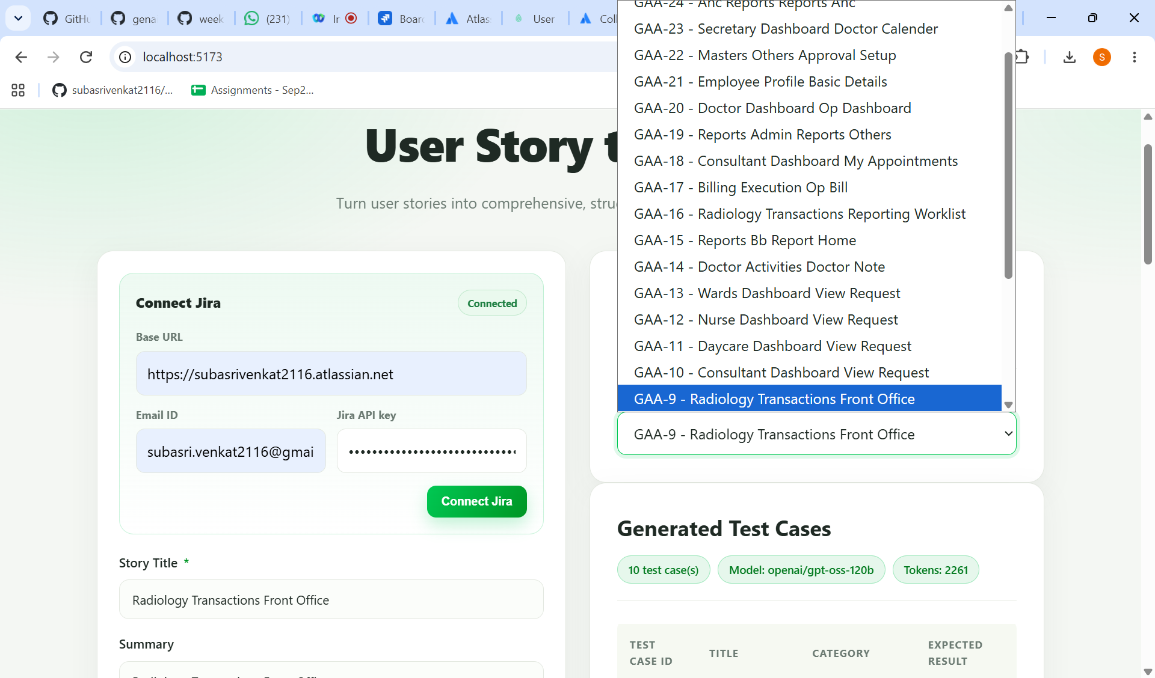
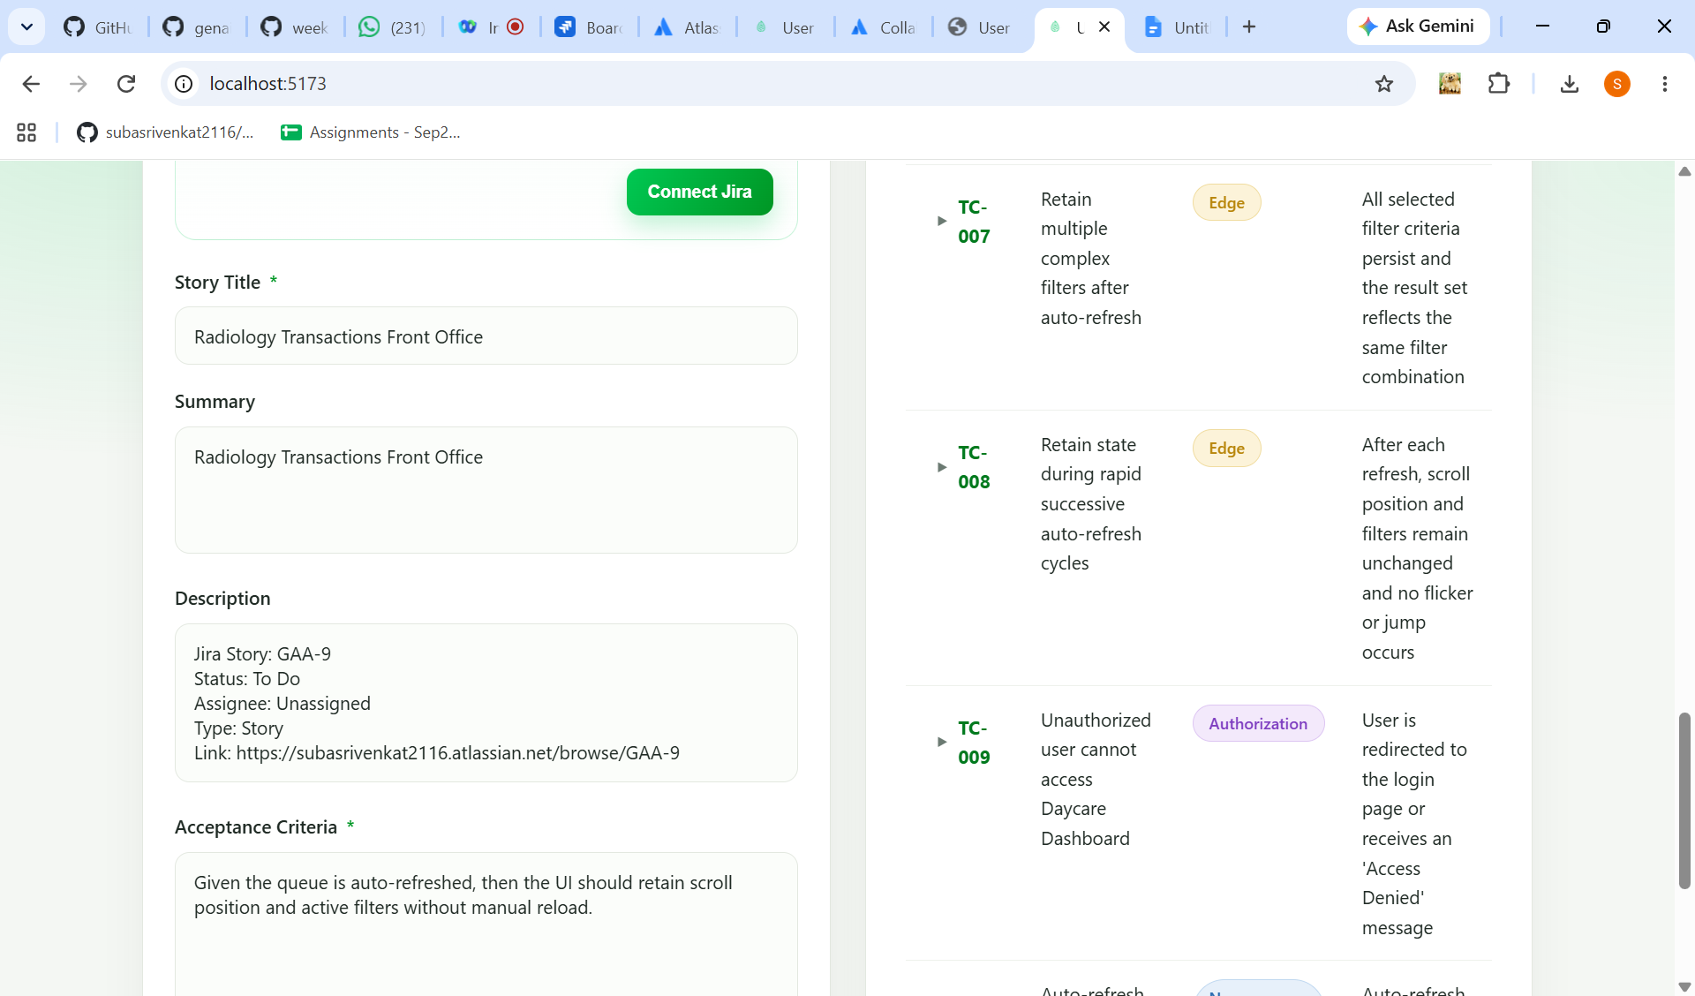
Testcases generated successfully
