# Brainstorm

**TIP**

Add customizable tags to sticky notes to make it easier to find, browse, organize, and categorize important ideas as themes within your mural.

**TIP**

You can select a sticky note and hit the pencil [switch to sketch] icon to start drawing!

**TIP**

Participants can use their cursors to point at where sticky notes should go on the grid. The facilitator can confirm the spot by using the laser pointer holding the **H key** on the keyboard.

### Before you collaborate

A little bit of preparation goes a long way with this session. Here’s what you need to do to get going.

**10 minutes**

**1**

### Define your problem statement

What problem are you trying to solve? Frame your problem as a How Might We statement. This will be the focus of your brainstorm.

**5 minutes**

**PROBLEM**

Fasion allows individuals to express their personality,creativity,and identity through clothing, helping people feel confident and unique. Product counterfeiting is one of the biggest challenges facing fashion brands today whom want to grow and expand their business in international markets.

**2**

### Brainstorm

Write down any ideas that come to mind that address your problem statement.

**10 minutes**

**3**

### Group ideas

Take turns sharing your ideas while clustering similar or related notes as you go. Once all sticky notes have been grouped, give each cluster a sentence-like label. If a cluster is bigger than six sticky notes, try and see if you and break it up into smaller sub-groups.

**20 minutes**

**4**

### Prioritize

Your team should all be on the same page about what's important moving forward. Place your ideas on this grid to determine which ideas are important and which are feasible.

**20 minutes**

### After you collaborate

You can export the mural as an image or pdf to share with members of your company who might find it helpful.

**Quick add-ons**

# & idea prioritization

Use this template in your own brainstorming sessions so your team can unleash their imagination and start shaping concepts even if you're not sitting in the same room.

**10 minutes** to prepare

**1 hour** to collaborate

**2-8 people** recommended

**A Team gathering**

Define who should participate in the session and send an invite. Share relevant information or pre-work ahead.

**B Set the goal**

Think about the problem you'll be focusing on solving in the brainstorming session.

**C Learn how to use the facilitation tools**

Use the Facilitation Superpowers to run a happy and productive session.

[**Open article**](https://support.mural.co/en/articles/2113740-facilitation-superpowers)

#### Key rules of brainstorming

To run an smooth and productive session

**Person 1**

It’s best to becreative while brainstorming the clothing brand name ideas.

Fun should become an integral part of the process at it’s the start of the new journey for the brand its team.

**Person 2**

A method of design teams use to generate ideas to solve clearly defined design problems.

Provide inventory information online.

**Person 3**

Send out promotions via SMS in available in store.

Optimize for we websites for local searches , Host events.

**Person 4**

Make sure our fasion brand is unique.

Make it easy to follow our fasion brand on social medioa purchases.

Share knowledge and experiences in your existing community. Send them regular messages, e-mails, letters and let them know the latest trends in the fashion industry. Start posting about products, offers/discounts, the latest collections, etc., on your social media profiles and let potential customers reach you.

The profitability of textile **+**

businesses in India varies, but the denim garment industry, designer saree manufacturing, garment wholesaling, and tailored upholstery services are among the most profitable

A method of design teams use to generate ideas to solve clearly defined design

It’s best to becreative while brainstorming the clothing brand name ideas.

**A Share the mural**

**Share a view link** to the mural with stakeholders to keep them in the loop about the outcomes of the session.

**B Export the mural**

Export a copy of the mural as a PNG or PDF to attach to emails, include in slides, or save in your drive.

#### Keep moving forward

**Strategy blueprint**

Define the components of a new idea or strategy.

[**Open the template**](https://app.mural.co/template/e95f612a-f72a-4772-bc48-545aaa04e0c9/984865a6-0a96-4472-a48d-47639307b3ca)

**Customer experience journey map**

Stay in topic.

Defer judgment.

Encourage wild ideas.

Listen to others.

#### Importance

If each of these tasks could get

problems.

Understand customer needs, motivations, and

obstacles for an experience.

[**Open the template**](https://app.mural.co/template/b7114010-3a67-4d63-a51d-6f2cedc9633f/c1b465ab-57af-4624-8faf-ebb312edc0eb)

Go for volume. If possible, be visual.

done without any difficulty or cost, which would have the most positive impact?

**Strengths, weaknesses, opportunities & threats**

Identify strengths, weaknesses, opportunities, and threats (SWOT) to develop a plan.

Optimize for we websites for local searches , Host events.

|  |  |
| --- | --- |
|  |  |
|  |  |

[**Open the template**](https://app.mural.co/template/6a062671-89ee-4b76-9409-2603d8b098be/ca270343-1d54-4952-9d8c-fbc303ffd0f2)

[**Share template feedback**](https://muralco.typeform.com/to/CiqaHVat?typeform-source=app.mural.co)

Facebook Business page link : https:// [www.facebook.com/profile.php?id=](http://www.facebook.com/profile.php?id) 61552447250030&mibextid=ZbWKwL

Website Link : https:// subasurya3360.wixsite.com/mysite

**-**

#### - Feasibility

Regardless of their importance, which tasks are more feasible than others? (Cost, time, effort, complexity, etc.)

Instagram Business page Link : [https://www.instagram.](http://www.instagram.com/)com/ team_1 wears/?utm_source= qr&igshid= OGIxMTE0OTdkZA%3D%3D

## +

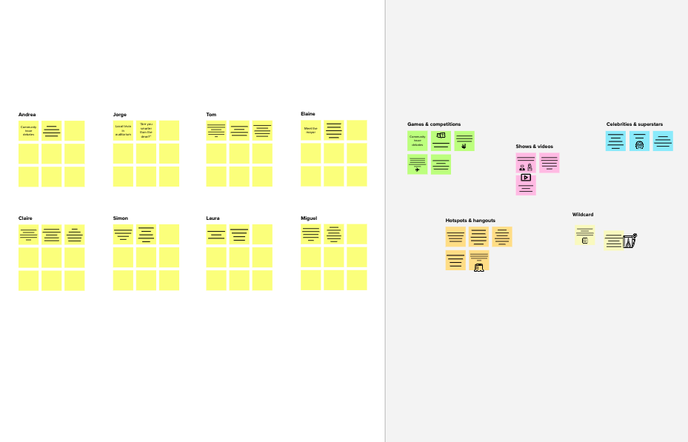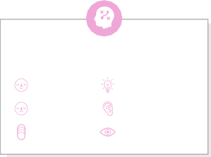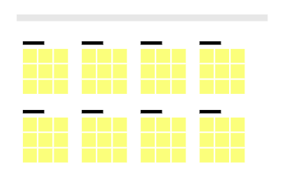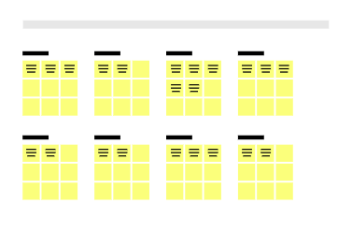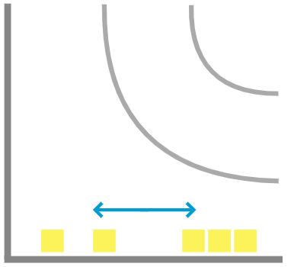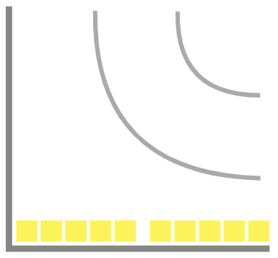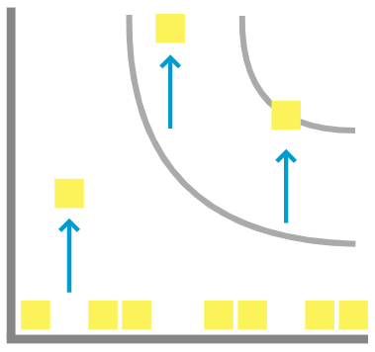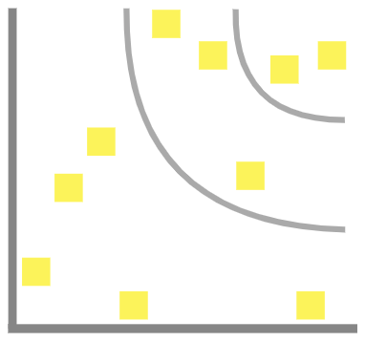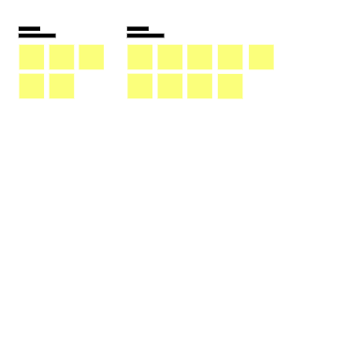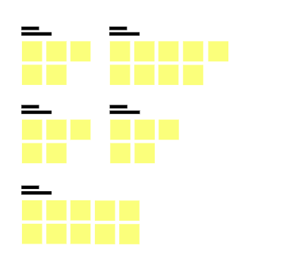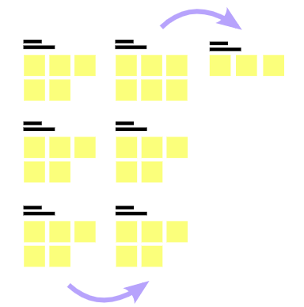

**Template**

**Need some inspiration?**

See a finished version of this template to kickstart your work.

[**Open example**](https://app.mural.co/template/e5a93b7b-49f2-48c9-afd7-a635d860eba6/93f1b98d-b2d2-4695-8e85-7e9c0d2fd9b9)