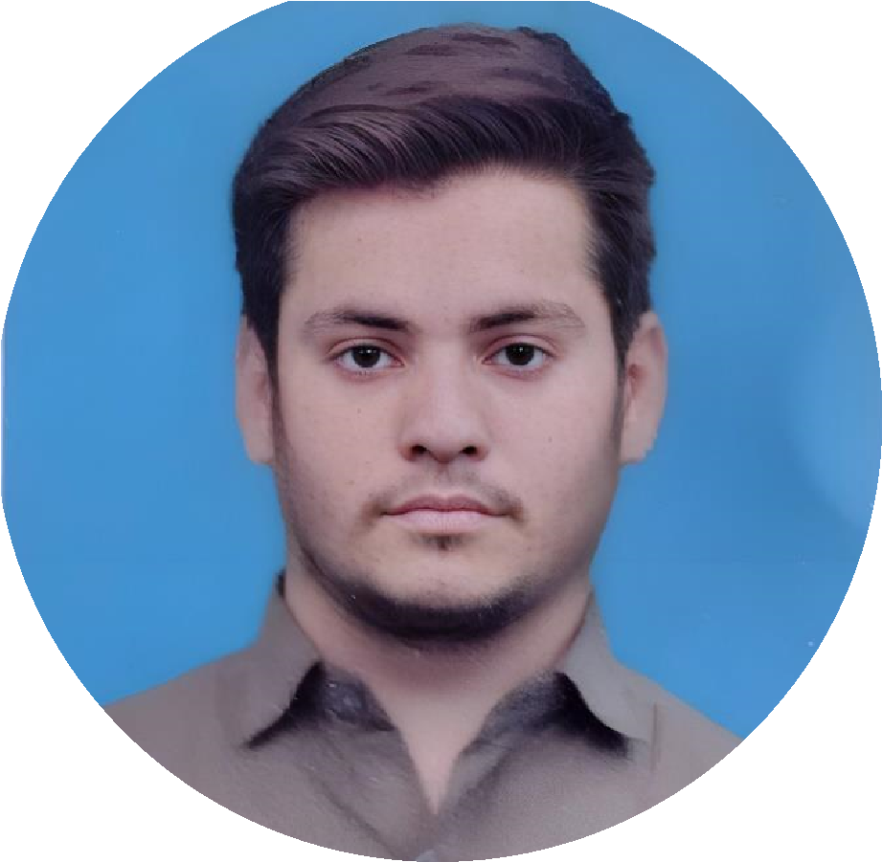

**MUHAMMAD SHOIAB**

**KHAN**

**ABOUT ME**

To secure a

responsible position in

your organization where the

company can utilize my abilities to

the maximum and I can grow

professionally as well as functionally

as same time

**EDUCATION**

**MATRIC**

Grade: A

Percentage:

79

%

Board: Karachi

Passing Year: 2019

**INTERMEDIATE**

Grade: A

Percentage:

7

%

6

Board: Karachi

Passing Year: 20

21

**GRADUATION**

BSCS (Continue)

University: Federal Urdu University Of

Arts Science And Technology

**EXPERIENCE**

**FIRST**

**COMPANY**

The Karachi Traders

(

Public Relation Officer)

**CONTACT**

**SKILLS**

Shoaib.amin998@gmail.com

+923

171034800

House no.3, Street no. 16, Sector 4/F

Mujahid Colony Orangi Town

Karachi.

WEB

DEVELOPMENT

MS OFFICE



ENGLISH (BASIC)

PASHTO

URDU

**LANGUAGES**

WORDPRESS