**Part 1: Module coupling and cohesion**

**Module coupling: code extract and explanation**

**Example 1: Common Environment Coupling**

When two software modules access the same data area, this is known as **common environment coupling**. The game state is managed by the globally defined intialMatrix in the setPiece and gameOverCheck functions.

In the setPiece function, it uses the intialMatrix to check if the current slot is occupied. The function moves the disc to the next available slot by continuously calling itself and adjusting the row if the slot is already occupied. In order to decide where to put the disc, the setPiece function accesses the global variable initialMatrix.

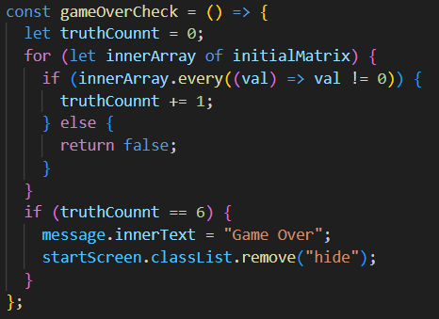

To determine whether the game is over if every row is filled, the gameOverCheck function uses initialMatrix. InitialMatrix is used by both functions to control the game state. Both functions use and change the same data, the initialMatrix, which has an impact on how the game starts and finishes.

**Example 2: Control Coupling**

**Control coupling** is shown here as fillBox function communicated information to the setPiece function for explicit purpose of influencing the latter module’s execution.

In the fillBox function, it passes parameters startCount and colValue to the setPiece function.

The startCount and colValue parameters are then passed to the setPiece function, which utilizes them to determine the disc's placement. By indicating which row to start from and which column the disc should be placed in, the data passed by the fillBox function affects the setPiece function. By sending information, the fillBox function controls what the setPiece function does, demonstrating control coupling.

**Module cohesion: code extract and explanation**

**Example 1: Logical Cohesion**

By checking the win condition in various directions but distinct operations, the winCheck function demonstrates **logical cohesion** in its tasks. Instead of concentrating on a single task, it combines related tasks to determine whether the game is won. With a focus on checking the win condition in multiple directions and logically grouping these operations together, the winCheck function is very cohesive because all its tasks are directly related to determining whether the game is won.

This function verifies the win condition in the row, column, and diagonal directions. Since they all work toward determining whether a player has won, these operations are related. They carry out different tasks, though. To handle each direction, the function invokes three distinct helper functions.

**Example 2: Functional Cohesion**

**Functional cohesion** is shown by the verifyArray function. When all of the tasks carried out by a software module work together to perform a single function, this is known as function cohesion. Because every operation in the function is connected to a single task checking for a win condition in a sequence it is extremely cohesive.

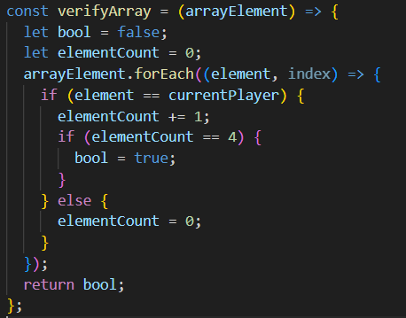

This function decides if each array contains the current player's four consecutive discs. Its primary goal is to confirm that the requirements for winning are fulfilled. The verifyArray function only checks to see if the array contains four consecutive values; it doesn't worry about other game-related tasks.