**Exp. No.: 4 Create UDF in PIG**

# Step-by-step installation of Apache Pig on Hadoop cluster on Ubuntu Pre-requisite:

* Ubuntu 16.04 or higher version running (I have installed Ubuntu on Oracle VM (Virtual Machine) VirtualBox),
* Run Hadoop on ubuntu (I have installed Hadoop 3.2.1 on Ubuntu 16.04). You may refer to my blog “How to install Hadoop installation” click [here](https://medium.com/mlearning-ai/installation-of-apache-hadoop-3-2-1-on-ubuntu-67073ce208d7) for Hadoop installation).

# Pig installation steps

**Step 1:** Login into Ubuntu

**Step 2**: Go to <https://pig.apache.org/releases.html> and copy the path of the latest version of pig that you want to install. Run the following comment to download Apache Pig in Ubuntu:

$ wget <https://dlcdn.apache.org/pig/pig-0.16.0/pig-0.16.0.tar.gz>

**Step 3**: To untar pig-0.16.0.tar.gz file run the following command:

$ tar xvzf pig-0.16.0.tar.gz

**Step 4:** To create a pig folder and move pig-0.16.0 to the pig folder, execute the following command:

$ sudo mv /home/hadoop/pig-0.16.0 /home/hadoop/pig

**Step 5:** Now open the .bashrc file to edit the path and variables/settings for pig. Run the following command:

$ sudo nano .bashrc

Add the below given to .bashrc file at the end and save the file.

#PIG settingsexport PIG_HOME=/home/hdoop/pigexport PATH=$PATH:$PIG_HOME/binexport PIG_CLASSPATH=$PIG_HOME/conf:$HADOOP_INSTALL/etc/hadoop/export PIG_CONF_DIR=$PIG_HOME/confexport JAVA_HOME=/usr/lib/jvm/java-8- openjdkamd64export PIG_CLASSPATH=$PIG_CONF_DIR:$PATH#PIG setting ends

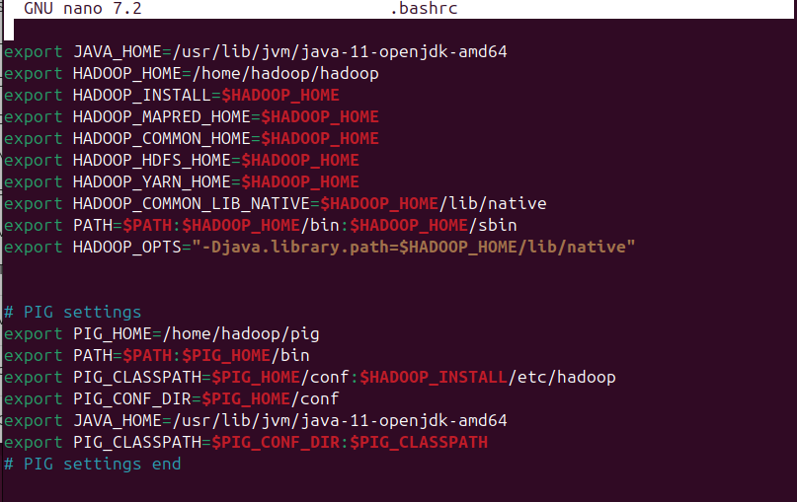

**Step 6:** Run the following command to make the changes effective in the .bashrc file:

$ source .bashrc

**Step 7:** To start all Hadoop daemons, navigate to the hadoop-3.2.1/sbin folder and run the following commands:

$ ./start-dfs.sh$ ./start-yarn$ jps

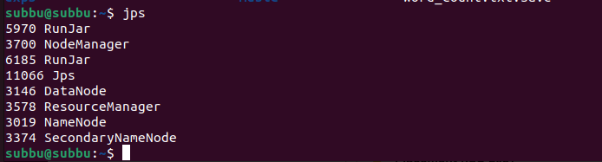

**Step 8:** Now you can launch pig by executing the following command: $ pig

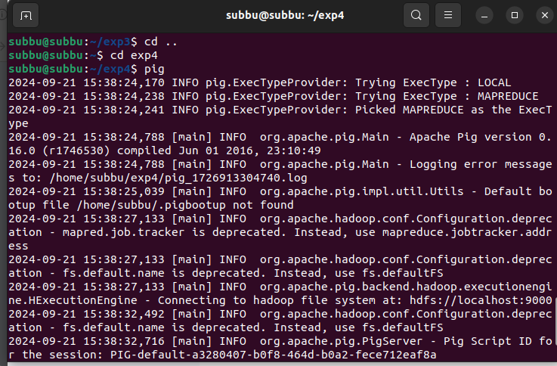

**Step 9:** Now you are in pig and can perform your desired tasks on pig. You can come out of the pig by the quit command:

> quit;

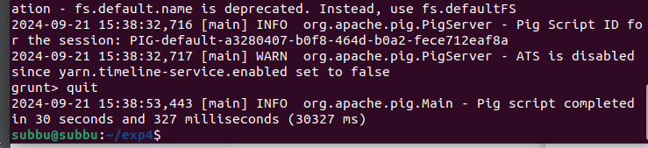

# Aim :

**CREATE USER DEFINED FUNCTION(UDF)**

To create User Define Function in Apache Pig and execute it on map reduce.

# PROCEDURE:

**Create a sample text file** hadoop@Ubuntu:~/Documents$ nano sample.txt Paste the below content to sample.txt

1,John 2,Jane 3,Joe 4,Emma

hadoop@Ubuntu:~/Documents$ hadoop fs -put sample.txt /home/hadoop/piginput/

# Create PIG File

hadoop@Ubuntu:~/Documents$ nano demo_pig.pig

# paste the below the content to demo_pig.pig

-- Load the data from HDFS

data = LOAD '/home/hadoop/piginput/sample.txt' USING PigStorage(',') AS (id:int>

-- Dump the data to check if it was loaded correctly DUMP data;

# the above file

hadoop@Ubuntu:~/Documents$ pig demo_pig.pig

# Run

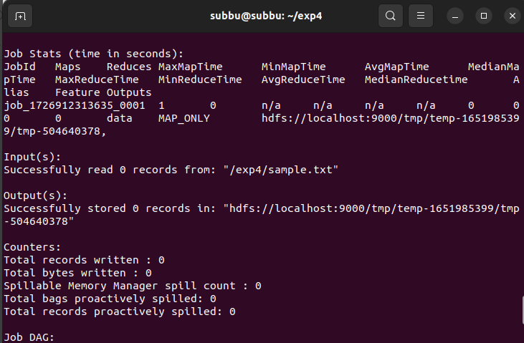

**Create udf file an save as uppercase_udf.py**

uppercase_udf.py

def uppercase(text): return text.upper() if name == " main ":

import sys for line in sys.stdin:

line = line.strip() result = uppercase(line) print(result)

**Create the udfs folder on hadoop**

**hadoop@Ubuntu:~/Documents$ hadoop fs -mkdir /home/hadoop/udfs put the upppercase_udf.py in to the abv folder**

**hadoop@Ubuntu:~/Documents$ hdfs dfs -put uppercase_udf.py /home/hadoop/udfs/**

**hadoop@Ubuntu:~/Documents$ nano udf_example.pig copy and paste the below content on udf_example.pig**

-- Register the Python UDF script

REGISTER 'hdfs:///home/hadoop/udfs/uppercase_udf.py' USING jython AS udf;

-- Load some data

data = LOAD 'hdfs:///home/hadoop/sample.txt' AS (text:chararray);

-- Use the Python UDF

uppercased_data = FOREACH data GENERATE udf.uppercase(text) AS uppercase_text;

-- Store the result

STORE uppercased_data INTO 'hdfs:///home/hadoop/pig_output_data';

# place sample.txt file on hadoop

hadoop@Ubuntu:~/Documents$ hadoop fs -put sample.txt /home/hadoop/

# To Run the pig file

hadoop@Ubuntu:~/Documents$ pig -f udf_example.pig

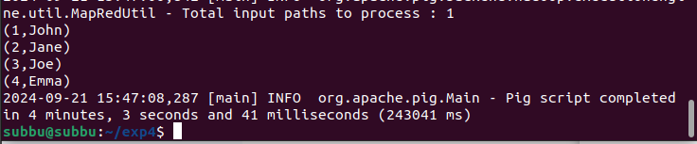

**--------------------------------------------------------------------------------------------------------------**

# To check the output file is created

hadoop@Ubuntu:~/Documents$ hdfs dfs -ls /home/hadoop/pig_output_data Found 2 items

If you need to examine the files in the output folder, use:

**To view the output**

**hadoop@Ubuntu:~/Documents$ hdfs dfs -cat /home/hadoop/pig_output_data/part-m00000**

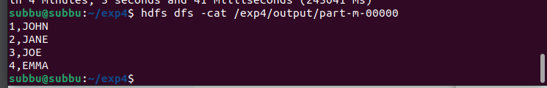

**Result:**

Thus the program to create User Define Function in Apache Pig and execute it on map reduce has been done successfully.