JDBC
What is JDBC?
- JDBC is Java application programming interface that allows the Java programmers to access database management system from Java code.
- It was developed by JavaSoft, a subsidiary of Sun Microsystems.
- It uses Java API that enables Java programs to execute SQL statements.
- JDBC makes it possible to write a single database application that can run on different platforms and interact with different DBMSs.
- JDBC provides methods for querying and updating the data in Relational Database Management system such as SQL, Oracle etc.
- Java application programming interface provides a mechanism for dynamically loading the correct Java packages and drivers and registering them with the JDBC Driver Manager which is used as a connection factory for creating JDBC connections which supports creating and executing statements such as SQL INSERT, UPDATE and DELETE.
- Driver Manager is the backbone of the jdbc architecture.
- Java Database Connectivity is similar to Open Database Connectivity (ODBC) which is used for accessing and managing database, but the difference is that JDBC is designed specifically for Java programs, whereas ODBC doesn’t depends on any language.

ODBC:
- ODBC (Open Database Connectivity) is a standard C programming language middleware API for accessing database management systems (DBMS).
- The designers of ODBC aimed to make it independent of database systems and operating systems; an application written using ODBC can be ported to other platforms.
- ODBC accomplishes DBMS independence by using an ODBC driver as a translation layer between the application and the DBMS.
- ODBC was originally developed by Microsoft during the early 1990s

What is a JDBC driver?
- The JDBC API defines the Java interfaces and classes that programmers use to connect to databases and send queries.
- A JDBC driver (third party vendors provides) implements these interfaces and classes for a particular DBMS vendor.
- A Java program that uses the JDBC API loads the specified driver for a particular DBMS before it actually connects to a database.
- The JDBC DriverManager class then sends all JDBC API calls to the loaded driver.

The four types of JDBC drivers are:
JDBC-ODBC Bridge plus ODBC driver also called Type 1.
Translates JDBC API calls into Microsoft Open Database Connectivity (ODBC) calls that are then passed to the ODBC driver. The ODBC binary code must be loaded on every client computer that uses this type of driver.
Native-API, partly Java driver, also called Type 2.
Converts JDBC API calls into DBMS-specific client API calls. Like the bridge driver, this type of driver requires that some binary code be loaded on each client computer.

JDBC-Net, pure Java driver, also called Type 3.
Sends JDBC API calls to a middle-tier net server that translates the calls into the DBMS-specific network protocol. The translated calls are then sent to a particular DBMS.
Native-protocol, pure Java driver, also called Type 4.
Converts JDBC API calls directly into the DBMS-specific network protocol without a middle tier. This allows the client applications to connect directly to the database server

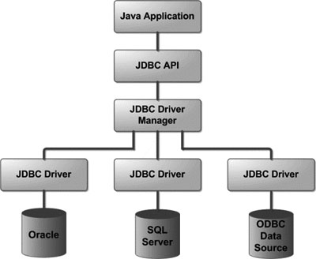
The following table describes the interfaces, classes, and exceptions that make up the JDBC API. In the table, interfaces belonging to the javax.sql package.

Interface/class/exception |  | Description
Interfaces:
java.sql.Connection |  | Interface used to establish a connection to a database. SQL statements run within the context of a connection.
java.sql.DatabaseMetaData |  | Interface used to return information about the database.
java.sql.Driver |  | Interface used to locate the driver for a particular database management system.
java.sql.PreparedStatement |  | Interface used to send precompiled SQL statements to the database server and obtain results.
java.sql.ResultSet |  | Interface used to process the results returned from executing an SQL statement.
java.sql.ResultSetMetaData |  | Interface used to return information about the columns in a ResultSet object.
java.sql.Statement |  | Interface used to send static SQL statements to the database server and obtain results.
javax.sql.ConnectionEventListener |  | Receives events that a PooledConnection object generates.
javax.sql.ConnectionPoolDataSource |  | Factory for PooledConnection objects. A ConnectionPoolDataSource object is usually registered with a JNDI service.
javax.sql.DataSource |  | A factory for Connection objects. A DataSource object is usually registered with a JNDI service provider.
javax.sql.PooledConnection |  | A PooledConnection object represents a physical connection to a data source.
Classes:
 | java.sql.Date | Subclass of java.util.Date used for the SQL DATE data type.
 | java.lang.DriverManager | Class used to manage a set of JDBC drivers.
 | java.sql.DriverPropertyInfo | Class used to discover and supply properties to a connection.
 | java.sql.Time | Subclass of java.util.Date used for the SQL TIME data type.
 | java.sql.TimeStamp | Subclass of java.util.Date used for the SQL TIMESTAMP data type.
 | java.sql.Types | Class used to define constants that are used to identify standard SQL data types, such as CHAR, INTEGER, and DECIMAL.
 | java.sql.String | Class used to identify text data types such as CHAR.
Exception classes:
 | java.sql.SQLException | Exception that provides information about a database error.
 | java.sql.SQLWarning | Exception that provides information about a database warning.

Driver Manager Class:
public class DriverManager extends Object
The basic service for managing a set of JDBC drivers.

- The JDBC Driver Manager is a very important class that defines objects which connect Java applications to a JDBC driver.
- The main responsibility of JDBC database driver is to load all the drivers found in the system properly as well as to select the most appropriate driver from opening a connection to a database.
- The Driver Manager also helps to select the most appropriate driver from the previously loaded drivers when a new open database is connected.
- This class is mainly useful for the simple application, the most frequently used method of this class is DriverManager.getConnetion(). We can know by the name of the method that this method establishes a connection to a database.
- The DriverManager class maintains the list of the Driver classes. Each driver has to be get registered in the DriverManager class by calling the method DriverManager.registerDriver().
- The driver is loaded by calling the Class.forName() method.
- This class has many methods. Some of the commonly used methods are given below:

deregisterDriver(Driver driver) : It drops the driver from the list of drivers registered in the DriverManager class.
registerDriver(Driver driver) : It registers the driver with the DriverManager class.
getConnection(String url) : It tries to establish the connection to a given database URL.
getConnection(String url, Sting user, String password) : It tries to establish the connection to a given database URL.
getConnection(String url, Properties info) : It tries to establish the connection to a given database URL.
getDriver(String url) : It attempts to locate the driver by the given string.
getDrivers() : It retrieves the enumeration of the drivers which has been registered with the DriverManager class.

We can load the driver and register with driver in two ways:
1.Class.forName():
- The most common approach to register a driver is to use Java's Class.forName() method to dynamically load the driver's class file into memory, which automatically registers it.
- This method is preferable because it allows you to make the driver registration configurable and portable.
- The following example uses Class.forName( ) to register the Oracle driver:
try {
Class.forName("oracle.jdbc.driver.OracleDriver");
}
catch(ClassNotFoundException ex) {
System.out.println("Error: unable to load driver class!");
System.exit(1);
}
import java.sql.*;
class HybridConnection
{
public static void main(String a[]) throws Exception
{
Class.forName("oracle.jdbc.driver.OracleDriver");
System.out.println("driver is loaded");
String cs="jdbc:oracle:thin:@localhost:1521: tns-name ";
Connection con=DriverManager.getConnection(cs,"scott","tiger");
System.out.println("jdbc client connected to oracle server");
con.close();
System.out.println("connection is closed");
}
}

import java.sql.*;
class HybridConnection
{
public static void main(String a[]) throws Exception
{
String driver="sun.jdbc.odbc.JdbcOdbcDriver";
String cs="jdbc:odbc:dsn-name";
Class.forName(driver);
System.out.printf("driver is loaded");
Connection con=DriverManager.getConnection(cs,"hr","hr");
System.out.println("jdbc client connected to oracle server");
con.close();
System.out.println("connection is closed");
}
}

2.DriverManager.registerDriver():
- The second approach you can use to register a driver is to use the staticDriverManager.registerDriver() method.
- You should use the registerDriver() method if you are using a non-JDK compliant JVM, such as the one provided by Microsoft.
- The following example uses registerDriver() to register the Oracle driver:
try {
Driver myDriver = new oracle.jdbc.driver.OracleDriver();
DriverManager.registerDriver( myDriver );
}
catch(ClassNotFoundException ex) {
System.out.println("Error: unable to load driver class!");
System.exit(1);
}
import java.sql.*;
class HybridConnection{
public static void main(String a[]) throws Exception
{
try {
Driver myDriver = new oracle.jdbc.driver.OracleDriver();
DriverManager.registerDriver( myDriver );
}
catch(Exception ex)
{
System.out.println("Error: unable to load driver class!");
System.exit(1);
}
System.out.println("driver is loaded");
String cs="jdbc:oracle:thin:@localhost:1521:tns-name";
Connection con=DriverManager.getConnection(cs,"scott","tiger");
System.out.println("jdbc client connected to oracle server");
con.close();
System.out.println("connection is closed");
}}

import java.sql.*;
class HybridConnection{
public static void main(String a[]) throws Exception
{
try {
Driver myDriver = new sun.jdbc.odbc.JdbcOdbcDriver();
DriverManager.registerDriver( myDriver );
}
catch(Exception ex)
{
System.out.println("Error: unable to load driver class!");
System.exit(1);
}
System.out.println("driver is loaded");
String cs="jdbc:odbc:dsn-name";
Connection con=DriverManager.getConnection(cs,"hr","hr");
System.out.println("jdbc client connected to oracle server");
con.close();
System.out.println("connection is closed");
}}

Setting DSN(Data Source Name) for type1 driver:

Start → control panel → Administrative Tools → Data Sources(ODBC) → click on SystemDSN tab → click on Add button → choose Microsoft ODBC for Oracle → click on Finish → give DSN name in Data Source Name column → click on ok → now u can work with type1 driver.

Setting TNS (Transparent Network Substrate) classpath to work with type4 driver:
Set the classpath for below string in system environment variables area
C:\oraclexe\app\oracle\product\10.2.0\server\jdbc\lib\ojdbc14.jar;

Finding TNS name in the System:

C:\oraclexe\app\oracle\product\10.2.0\server\NETWORK\ADMIN → open tnsnames.ora file using text editor → SERVICE_NAME is your TNS name
(Or)
Start → control panel → Administrative Tools → Data Sources(ODBC) → click on SystemDSN tab → click on Add button → choose Oracle in XE → click on Finish → click on TNS name drop down box arrow → see the name probably (XE) for Xpress Edition.

Generic connection using Properties Object:
A Properties object holds a set of keyword-value pairs. It's used to pass driver properties to the driver during a call to the getConnection() method.
DriverManager.getConnection(String url, Properties info);

import java.util.Properties;
import java.sql.DriverManager;
import java.sql.Connection;
import java.io.FileInputStream;
class GenericConnection
{
public static void main(String[] args) throws Exception
{
Properties p=new Properties();
p.load(new FileInputStream("db.proparties"));
String d=p.getProperty("driver");
String cs=p.getProperty("url");
Class.forName(d);
Connection con=DriverManager.getConnection(cs,p);
System.out.println("Connected");
con.close();

}
}
Db.proparties:
driver=oracle.jdbc.driver.OracleDriver
url=jdbc:oracle:thin:@localhost:1521:xe
user=hr
password=hr

JDBC-ODBC Bridge (type1):
- The JDBC-ODBC Bridge allows applications written in the Java programming language to use the JDBC API with many existing ODBC drivers.
- The Bridge is itself a driver based on JDBC technology ("JDBC driver") that is defined in the class sun.jdbc.odbc.JdbcOdbcDriver. The Bridge defines the JDBC sub-protocol ODBC.
- Oracle does not support the JDBC-ODBC Bridge. Oracle recommends that you use JDBC drivers provided by the vendor of your database instead of the JDBC-ODBC Bridge.
- In a Type 1 driver, a JDBC bridge is used to access ODBC drivers installed on each client machine.
- Using ODBC requires configuring on your system a Data Source Name (DSN) that represents the target database.
- When Java first came out, this was a useful driver because most databases only supported ODBC access but now this type of driver is recommended only for experimental use or when no other alternative is available.

Why use ODBC at all?
- The ideal is "Pure Java": no native code, no platform dependent features.
- But you may need to begin your development effort right away, without waiting for your DBMS to offer a Java-only JDBC driver.
- Partly native drivers, such as the JDBC-ODBC Bridge, let you create programs that easily adapt to Pure Java drivers as they become available.

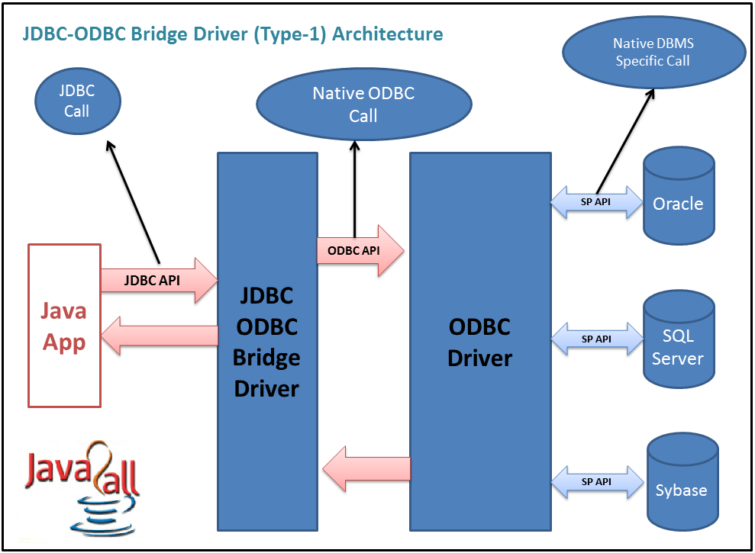
Advantage:
(1) Connect to almost any database on any system, for which ODBC driver is installed.
(2) Its an easy for installation as well as easy (simplest) to use as compare the all other driver.

Disadvantage:
(1) The ODBC Driver needs to be installed on the client machine.
(2) It’s not a purely platform independent because its use ODBC which is depends on native libraries of the operating system on client machine.
(3) Not suitable for applets because the ODBC driver needs to be installed on the client machine.

The Bridge Implementation
The Bridge is implemented in Java and uses Java native methods to call ODBC.

Installation
- The Bridge is installed automatically with the JDK, as package sun.jdbc.odbc.
- See your ODBC driver vendor for information on installing and configuring ODBC.
- No special configuration is required for the Bridge.
- See your database vendor for client installation and configuration information.

Using the Bridge
- The Bridge is used by opening a JDBC connection using a URL with the odbc subprotocol.
- Before a connection can be established, the bridge driver class, sun.jdbc.odbc.JdbcOdbcDriver, must either be added to the java.lang.System property named jdbc.drivers, or it must be explicitly loaded using the Java class loader.
- Explicit loading is done with the following line of code:
Class.forName("sun.jdbc.odbc.JdbcOdbcDriver");
- When loaded, the ODBC driver (like all good JDBC drivers) creates an instance of itself and registers this with the JDBC driver manager.

What Is the JDBC URL Supported by the Bridge?
The Bridge driver uses the odbc subprotocol. URLs for this subprotocol are of the form:
Jdbc:odbc:<data-source-name>[<attribute-name>=<attribute-value>]*

For example:
jdbc:odbc:sybase
jdbc:odbc:mydb;UID=me;PWD=secret

Type 2: JDBC-Native API:
- In a Type 2 driver, JDBC API calls are converted into native C/C++ API calls which are unique to the database.
- These drivers typically provided by the database vendors and used in the same manner as the JDBC-ODBC Bridge, the vendor-specific driver must be installed on each client machine.
- If we change the Database we have to change the native API as it is specific to a database and they are mostly obsolete now but you may realize some speed increase with a Type 2 driver, because it eliminates ODBC's overhead.

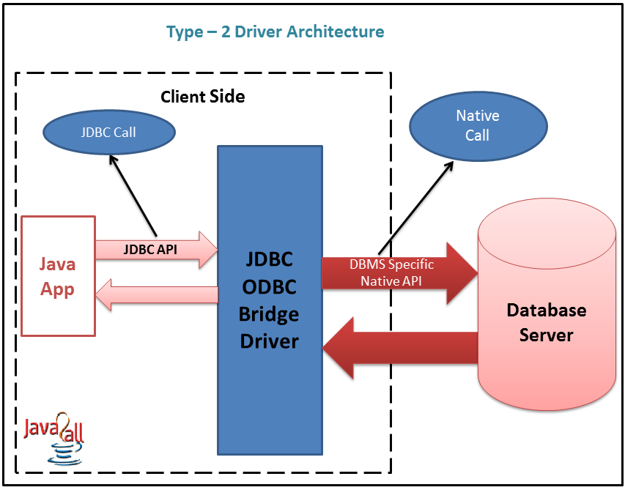
Advantage:
- There is no implantation of JDBC-ODBC Bridge so it’s faster than a type 1 driver; hence the performance is better as compare the type 1 driver (JDBC-ODBC Bridge).

Disadvantage:
- On the client machine require the extra installation because this driver uses the vendor client libraries.
- The Client side software needed so cannot use such type of driver in the web-based application.
- Not all databases have the client side library.
- This driver supports all JAVA applications except applets.

Type 3: JDBC-Net pure Java:
- In a Type 3 driver, a three-tier approach is used to accessing databases.
- The JDBC clients use standard network sockets to communicate with a middleware application server.
- The socket information is then translated by the middleware application server into the call format required by the DBMS, and forwarded to the database server.
- This kind of driver is extremely flexible, since it requires no code installed on the client and a single driver can actually provide access to multiple databases.
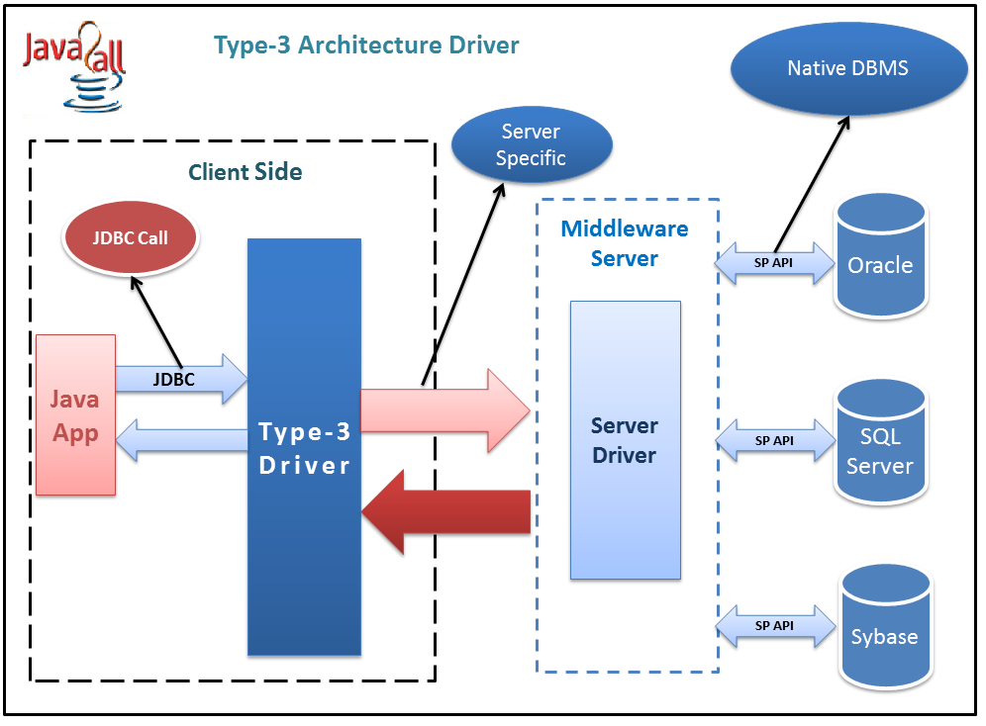
Advantage:
- There is no need for the vendor database library on the client machine because the middleware is database independent and it communicates with client.
- Type 3 driver can be used in any web application as well as on internet also because there is no any software require at client side.
- A single driver can handle any database at client side so there is no need a separate driver for each database.
- The middleware server can also provide the typical services such as connections, auditing, load balancing, logging etc.
Disadvantage:
- An Extra layer added, may be time consuming.
- At the middleware develop the database specific coding, may be increase complexity.

Type 4: 100% pure Java:
- In a Type 4 driver, a pure Java-based driver that communicates directly with vendor's database through socket connection.
- This is the highest performance driver available for the database and is usually provided by the vendor itself.
- This kind of driver is extremely flexible; you don't need to install special software on the client or server.

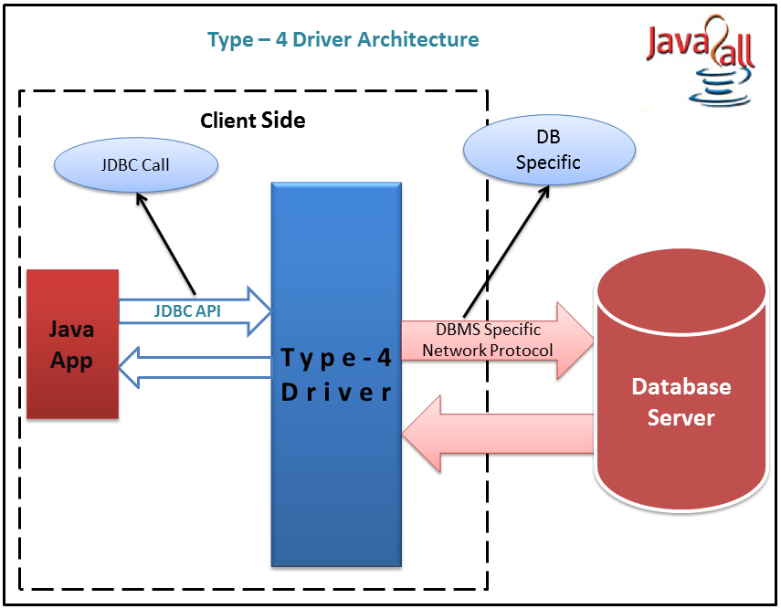
Advantage:
- It’s a 100% pure JAVA Driver so it’s a platform independence.
- No translation or middleware layers are used so consider as a faster than other drivers.
- The all process of the application-to-database connection can manage by JVM so the debugging is also managed easily.
Disadvantage:
- There is a separate driver needed for each database at the client side.
- Drivers are Database dependent, as different database vendors use different network protocols.

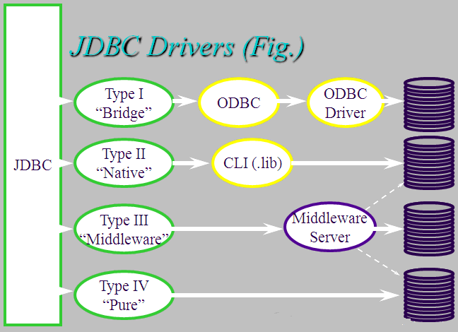
Database URL Formulation:
- After you've loaded the driver, you can establish a connection using the DriverManager.getConnection() method.
- For easy reference, let me list the three overloaded DriverManager.getConnection() methods:
getConnection(String url)
getConnection(String url, Properties prop)
getConnection(String url, String user, String password)
- Here each form requires a database URL. A database URL is an address that points to your database.
- Formulating a database URL is where most of the problems associated with establishing a connection occur.

Following table lists down popular JDBC driver names and database URL.
RDBMS | JDBC driver name | URL format
MySQL | com.mysql.jdbc.Driver | jdbc:mysql://hostname/ databaseName
ORACLE | oracle.jdbc.driver.OracleDriver | jdbc:oracle:thin:@hostname:port Number:databaseName
DB2 | COM.ibm.db2.jdbc.net.DB2Driver | jdbc:db2:hostname:port Number/databaseName
Sybase | com.sybase.jdbc.SybDriver | jdbc:sybase:Tds:hostname: port Number/databaseName
All the green highlighted part in URL format is static and you need to change only remaining part as per your database setup.

JDBC - Statements
- Once a connection is obtained we can interact with the database.
- The JDBC Statement, CallableStatement, and PreparedStatement interfaces define the methods and properties that enable you to send SQL or PL/SQL commands and receive data from your database.
- They also define methods that help bridge data type differences between Java and SQL data types used in a database.

Following table provides a summary of each interface's purpose to understand how do you decide which interface to use?

Interfaces | Recommended Use
Statement | Use for general-purpose access to your database.  Useful when you are using static SQL statements at runtime.  The Statement interface cannot accept parameters.
PreparedStatement | Use when you plan to use the SQL statements many times.  The PreparedStatement interface accepts input parameters at runtime.
CallableStatement | Use when you want to access database stored procedures.  The CallableStatement interface can also accept runtime input parameters.
Statement Interface:
- The Statement interface is used for to execute a static query.
- It’s a very simple and easy so it also calls a “Simple Statement”.
- The statement interface has several methods for execute the SQL statements and also get the appropriate result as per the query sent to the database.

Some of the most common methods are as given below
Method | Description
void close() | This method frees an object of type Statement from database and other JDBC resources.
boolean execute(String s) | This method executes the SQL statement specified by s. The getResultSet() method is used to retrieve the result.
ResultSet getResultet() | This method retrieves the ResultSet that is generated by the execute() method.
ResultSet executeQuery(String s) | This method is used to execute the SQL statement specified by s and returns the object of type ResultSet.
int getMaxRows() | This method returns the maximum number of rows those are generated by the executeQuery() method.
Int executeUpdate(String s) | This method executes the SQL statement specified by s. The SQL statement may be a SQL insert, update and delete statement.
int[] executeBatch() | Submits a batch of commands to the database for execution and if all commands execute successfully, returns an array of update counts.

Creating Statement Object:
- Before you can use a Statement object to execute a SQL statement, you need to create one using the Connection object's createStatement( ) method, as in the following example:

Statement stmt = null;
try {
stmt = conn.createStatement( );
. . .
}
catch (SQLException e) {
. . .
}
finally {
. . .
}
Once you've created a Statement object, you can then use it to execute a SQL statement with one of its three execute methods.

boolean execute(String SQL) :
- Returns a boolean value of false if a query will be executed; otherwise, it returns true.
- Use this method to execute SQL DDL statements or when you need to use truly dynamic SQL.

import java.sql.Connection;
import java.sql.DriverManager;
import java.sql.Statement;
public class Main
{
static boolean result;
public static void main(String[] argv) throws Exception
{

String driver="sun.jdbc.odbc.JdbcOdbcDriver";
String cs="jdbc:odbc:mydsn";
Class.forName(driver);
System.out.println("driver is loaded");
Connection con=DriverManager.getConnection(cs,"hr","hr");
System.out.println("jdbc client connected to oracle server");
Statement stmt = con.createStatement();
System.out.println("---------"+stmt);
System.out.println("Hello...............");
result=stmt.execute("drop table emps");
System.out.println(result);
if(result)
System.out.println("failed in droping a table ");
else
System.out.println("table deleted”);

}
}

int executeUpdate(String SQL) :
- Returns the numbers of rows affected by the execution of the SQL statement.
- Use this method to execute SQL statements for which you expect to get a number of rows affected - for example, an INSERT, UPDATE, or DELETE statement.

import java.sql.Connection;
import java.sql.DriverManager;
import java.sql.Statement;
public class Main
{
static int i;
public static void main(String[] argv) throws Exception
{

String driver="sun.jdbc.odbc.JdbcOdbcDriver";
String cs="jdbc:odbc:mydsn";
Class.forName(driver);
System.out.println("driver is loaded");
Connection con=DriverManager.getConnection(cs,"hr","hr");
System.out.println("jdbc client connected to oracle server");
Statement stmt = con.createStatement();
System.out.println("---------"+stmt);
System.out.println("Hello...............");
i=stmt.executeUpdate("insert into emps values(1001,'naresh',50000)");
System.out.println("number of rows updated :"+i);

}
}

ResultSet executeQuery(String SQL) :
- Returns a ResultSet object.
- Use this method when you expect to get a result set, as you would with a SELECT statement.
- A ResultSet object maintains a cursor pointing to its current row of data. Initially the cursor is positioned before the first row. The next method moves the cursor to the next row, and because it returns false when there are no more rows in the ResultSet object, it can be used in a while loop to iterate through the result set.
- A default ResultSet object is not updatable and has a cursor that moves forward only. Thus, you can iterate through it only once and only from the first row to the last row.

boolean | next() : Moves the cursor forward one row from its current position.

import java.sql.*;
import java.util.Properties;
import java.io.FileInputStream;
import java.io.FileNotFoundException;
import java.io.IOException;
class ColumnDetails
{
public static String tab="\t";
public static String dtab="\t\t";
public static void main(String args[]) throws SQLException, FileNotFoundException,ClassNotFoundException,IOException
{
Properties p=null;
Connection con=null;
Statement st=null;
ResultSet rs=null;
p=new Properties();
p.load(new FileInputStream("db.proparties"));

String d=p.getProperty("driver");
Class.forName(d);
String cs=p.getProperty("url");
con=DriverManager.getConnection(cs,p);
st=con.createStatement();
rs=st.executeQuery("select *from emps");
ResultSetMetaData rsmd=rs.getMetaData();
int a=rsmd.getColumnCount();
System.out.println("Number of columns :"+a);
for(int i=1;i<=a;i++)
{
System.out.print(tab+rsmd.getColumnName(i)+tab);
}
System.out.println("\n-----------------------------------------------");
while(rs.next())
{
System.out.print("\n"+rs.getRow()+")\t"+rs.getInt(1)+"\t"+rs.getString(2)+"\t"+"\t"+rs.getFloat(3));
}
rs.close();
st.close();
con.close();
}
}

boolean execute()
Executes the SQL statement in this PreparedStatement object, which may be any kind of SQL statement.

ResultSet executeQuery()
Executes the SQL query in this PreparedStatement object and returns the ResultSet object generated by the query.

int executeUpdate()
Executes the SQL statement in this PreparedStatement object, which must be an SQL INSERT, UPDATE or DELETE statement; or an SQL statement that returns nothing, such as a DDL statement.

executeUpdate() -> database UPDATE statements
executeQuery() -> database QUERY statements
execute() -> anything that comes in

What are the differences between executeQuery(…), executeUpdate(…) and execute(…) methods?
- Where executeQuery() can be used to execute selection group sql queries to fetch the data from database.
- When we use selection group sql query with executeQuery() then JVM will send that sql query to the database engine, database engine will execute it, by this database engine(DBE) will fetch the data from database and send back to the java application.
- Java is a purely object oriented technology. That’s why the jdbc application will maintain the fetched data from database, in the form of an object at heap memory, called as ResultSet object.
public ResultSet executeQuery(String sqlquery)

- Where executeUpdate() can be used to execute updation group sql query to update the database. When we provide updation group sql query as a parameter to executeUpdate(), then JVM will send that sql query to DBE, here DBE will execute it and perform updations on the database, by this DBE will identify the number of records got updated value called as “records updated count” and return back to the java application.
public int executeUpdate(String sqlquery)

- Where execute() can be used to execute either selection group sql queries or updation group queries.
- When we use selection group sql query with the execute() then we will get ResultSet object at heap memory with the fetched data. But execute() will return “true” as a Boolean value.
- When we use updation group sql query with execute() then we will get “ records updated count value” at jdbc application. But execute() will return “false” as a Boolean value.
public boolean execute(String sqlquery)

Closing Statement Obeject:
- Just as you close a Connection objects to save database resources, for the same reason you should also close the Statement object.
- A simple call to the close() method will do the job.
- If you close the Connection object first it will close the Statement object as well.
- However, you should always explicitly close the Statement object to ensure proper cleanup.
Statement stmt = null;
try {
stmt = conn.createStatement( );
. . .
}
finally {
stmt.close();
}

Void addBatch(String sql)
Adds the given SQL command to the current list of commands for this Statement object.

int[] executeBatch()
Submits a batch of commands to the database for execution and if all commands execute successfully, returns an array of update counts.

import java.sql.Connection;
import java.sql.DriverManager;
import java.sql.Statement;
class ExecuteBatch
{
public static void main(String[] argv) throws Exception
{
String driver="sun.jdbc.odbc.JdbcOdbcDriver";
String cs="jdbc:odbc:mydsn";
Class.forName(driver);
System.out.println("driver is loaded");
Connection con=DriverManager.getConnection(cs,"hr","hr");
System.out.println("jdbc client connected to oracle server");
Statement stmt = con.createStatement();
Employee e=new Employee();
for (int i=0;i<3;i++)
{
String query = "insert into emps (eno,ename,esal) values("+e.getNumber(i)+",'"+e.getName(i)+"',"+e.getSalary(i)+")";
stmt.addBatch(query);
System.out.println(query +(i+1)+"\t added");
}
System.out.println("batch added");
stmt.executeBatch();
stmt.close();
con.close();
}
}

class Employee
{
int eno[]={1003,1004,1005};
String ename[]={"ram","robert","rahim"};
float esal[]={10000,20000,30000};

int getNumber(int i)
{
return eno[i];
}
String getName(int i)
{
return ename[i];
}
float getSalary(int i)
{
return esal[i];
}
}

JDBC Connection to Microsoft Excel
Introduction
In this article we will describe how a Java program connects to a Microsoft Excel sheet and retrieves the data from the sheet. And this connection is made with the JdbcOdbc bridge driver API provided by the SQL package in Java. You have to perform some steps to make the connection with an Excel sheet.
Step 1: First create the workbook (Excel sheet); if your Excel sheet is already created then there is no need to create it again.
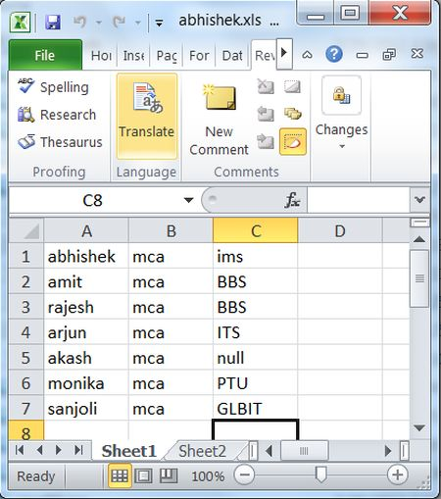
Step 2: To start, we need to setup the local ODBC connection. So select Administrative Tools inControl Pannel .
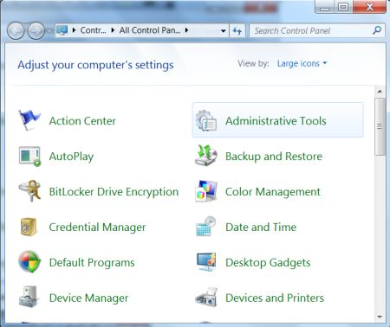
Step 3: Select Data Source (ODBC) option.
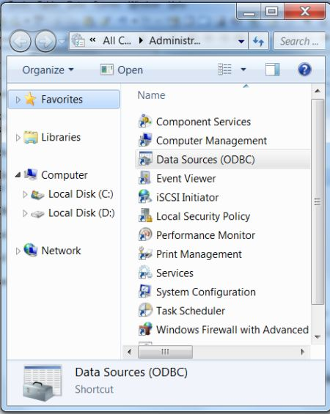
Step 5: Select System DSN and click on the Add tab.
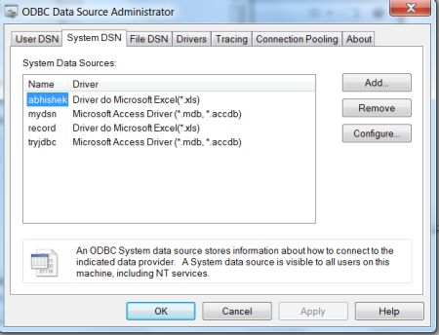
Step 6: Select the driver named as Driver do Microsoft Excel(*.xls) from the list.
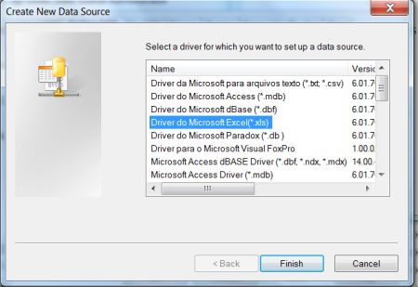
Step 7: Give the data source name and select your work book.
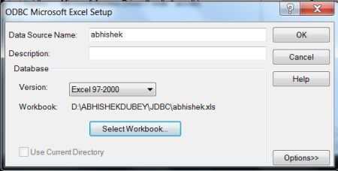
Step 8: Click on the selectworkbook tab and then click ok.
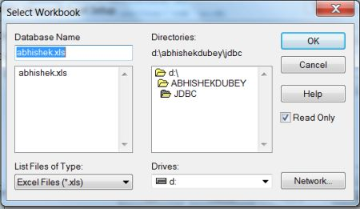
So now your DSN is created.
Program:

import java.sql.*;
public class ExcelConnection
{
public static void main(String[] args)
{
try
{
Class.forName("sun.jdbc.odbc.JdbcOdbcDriver");
Connection con = DriverManager.getConnection("jdbc:odbc:sree");
Statement st = con.createStatement();
ResultSet rs = st.executeQuery("Select * from [Sheet1$]");
ResultSetMetaData rsmd = rs.getMetaData();
int numberOfColumns = rsmd.getColumnCount();
while (rs.next())
{
for (int i = 1; i <= numberOfColumns; i++)
{
if (i >1)
{
System.out.print("\t ");
}
String columnValue = rs.getString(i);
System.out.print(columnValue);
}
System.out.println("");
}
st.close();
con.close();
} catch (Exception ex)
{
System.err.print("Exception: ");
System.err.println(ex.getMessage());
}
}
}

Interface PreparedStatement:
public interface PreparedStatement extends Statement
- Sometimes it is more convenient to use a PreparedStatement object for sending SQL statements to the database.
- This special type of statement is derived from the more general class, Statement that you already know.
- If you want to execute a Statement object many times, it normally reduces execution time to use a PreparedStatement object instead.
- The main feature of a PreparedStatement object is that, unlike a Statement object, it is given an SQL statement when it is created.
- The advantage to this is that in most cases, this SQL statement is sent to the DBMS right away, where it is compiled.
- As a result, the PreparedStatement object contains not just an SQL statement, but an SQL statement that has been precompiled.
- This means that when the PreparedStatement is executed, the DBMS can just run the PreparedStatement SQL statement without having to compile it first.
- Although PreparedStatement objects can be used for SQL statements with no parameters, you probably use them most often for SQL statements that take parameters.
- The advantage of using SQL statements that take parameters is that you can use the same statement and supply it with different values each time you execute it.
- Creating a PreparedStatement Object As with Statement objects, you create PreparedStatement objects with a Connection method.
- Using our open connection con from previous examples, you might write code such as the following to create a PreparedStatement object that takes two input parameters:

PreparedStatement updateSales = con.prepareStatement( "UPDATE COFFEES SET SALES = ? WHERE COF_NAME LIKE ?");

- The variable updateSales now contains the SQL statement, "UPDATE COFFEES SET SALES =? WHERE COF_NAME LIKE?” which has also, in most cases, been sent to the DBMS and been precompiled.
- Supplying Values for PreparedStatement Parameters, you need to supply values to be used in place of the question mark placeholders (if there are any) before you can execute a PreparedStatement object.
- You do this by calling one of the setXXX methods defined in the PreparedStatement class.
- If the value you want to substitute for a question mark is a Java int, you call the method setInt.
- If the value you want to substitute for a question mark is a Java String, you call the method setString , and so on.
- In general, there is a setXXX method for each primitive type declared in the Java programming language.
- setXXX Using the PreparedStatement object updateSales from the previous example, the following line of code sets the first question mark placeholder to a Java int with a value of 75:
updateSales.setInt(1, 75);
- setXXX The first argument given to a setXXX method indicates which question mark placeholder is to be set, and the second argument indicates the value to which it is to be set. The next example sets the second placeholder parameter to the string "Colombian ":
updateSales.setString(2, "Colombian");
- setXXX After these values have been set for its two input parameters, the SQL statement in updateSales is the equivalent to the SQL statement in the String object updateString that was used in the previous update example. Therefore, the following two code fragments accomplish the same thing:

Code Fragment 1:
String updateString = "UPDATE COFFEES SET SALES = 75 " +"WHERE COF_NAME LIKE 'Colombian'";
stmt.executeUpdate(updateString);

Code Fragment 2:

PreparedStatement updateSales = con.prepareStatement("UPDATE COFFEES SET SALES = ? WHERE COF_NAME LIKE ? ");
updateSales.setInt(1, 75);
updateSales.setString(2, "Colombian");
updateSales.executeUpdate():

- The method executeUpdate was used to execute both the Statement stmt and the PreparedStatement updateSales.
- Notice, however, that no argument is supplied to executeUpdate when it is used to execute updateSales .
- This is true because updateSales already contains the SQL statement to be executed.
- Looking at these examples, you might wonder why you would choose to use a PreparedStatement object with parameters instead of just a simple statement, since the simple statement involves fewer steps.
- If you were going to update the SALES column only once or twice, then there would be no need to use an SQL statement with input parameters.
- If you will be updating often, on the other hand, it might be much easier to use a PreparedStatement object, especially in situations where you can use for loop or while loop to set a parameter to a succession of values.
- Once a parameter has been set with a value, it retains that value until it is reset to another value, or the method clearParameters is called.
- Using the PreparedStatement object updateSales , the following code fragment illustrates reusing a prepared statement after resetting the value of one of its parameters and leaving the other one the same:
updateSales.setInt(1, 100);
updateSales.setString(2, "French_Roast");
updateSales.executeUpdate();
// changes SALES column of French Roast row to 100
updateSales.setString(2, "Espresso");
updateSales.executeUpdate();
(Changes SALES column of Espresso row to 100 (the first parameter stayed 100, and the second parameter was reset to "Espresso")

import java.sql.*;
public class PreparedStatementExample
{
public static void main(String[] args) throws Exception
{
Class.forName("sun.jdbc.odbc.JdbcOdbcDriver");
Connection con = DriverManager.getConnection("jdbc:odbc:mydsn","hr","hr");
PreparedStatement updateemp = con.prepareStatement("insert into emps values(?,?,?)");
updateemp.setInt(1,1006);
updateemp.setString(2,"Roshan");
updateemp.setFloat(3, 30000);
updateemp.executeUpdate();
Statement stmt = con.createStatement();
String query = "select * from emps";
ResultSet rs = stmt.executeQuery(query);
System.out.println("eno eName esal");
while (rs.next())
{
int eno = rs.getInt("eno");
String ename = rs.getString("ename");
Float esal = rs.getFloat("esal");
System.out.println(eno + " " + ename+" "+esal);
}
}
}

import java.sql.*;
public class TwicePreparedStatement
{
public static void main(String[] args)
{
System.out.println("Twice use prepared statement example!\n");
Connection con = null;
PreparedStatement prest;
try
{
Class.forName("sun.jdbc.odbc.JdbcOdbcDriver");
con = DriverManager.getConnection("jdbc:odbc:mydsn","hr","hr");
try
{
String sql = "SELECT * FROM emps WHERE eno = ?";
prest = con.prepareStatement(sql);
prest.setInt(1,1003);
ResultSet rs1 = prest.executeQuery();
System.out.println("employee details of 1003 are :");
while (rs1.next())
{
int eno = rs1.getInt(1);
String ename = rs1.getString(2);
float esal=rs1.getFloat(3);
System.out.println(eno + "\t " + ename +"\t"+esal);
}
prest.setInt(1,1005);
ResultSet rs2 = prest.executeQuery();
System.out.println("employee details of 1005 are :");
while (rs2.next())
{
int eno = rs2.getInt(1);
String ename = rs2.getString(2);
float esal=rs2.getFloat(3);
System.out.println(eno + "\t " + ename +"\t"+esal);
}
}
catch (SQLException s){
System.out.println("SQL statement is not executed!");
}
}
catch (Exception e){
e.printStackTrace();
}
}
}

Interface Connection:
A connection (session) with a specific database. SQL statements are executed and results are returned within the context of a connection.

Note: When configuring a Connection, JDBC applications should use the appropriate Connection method such as setAutoCommit or setTransactionIsolation. Applications should not invoke SQL commands directly to change the connection's configuration when there is a JDBC method available. By default a Connection object is in auto-commit mode, which means that it automatically commits changes after executing each statement. If auto-commit mode has been disabled, the method commit must be called explicitly in order to commit changes; otherwise, database changes will not be saved.

The following are the ways to obtain a Connection object of the database:-
1. DriverManager.getConnection(String URL)
2. DriveManager.getConnection(String URL,String Username, String Password)
3. DriverManager.getConnection (String URL, java.util.Properties props)
4. Driver.connect(String URL, java.util.Properties props)

- With a java.sql.Connection object, you can create three alternate Statement objects.
- A Statement object is used for the further dialogue with the database.
- A Connection object has alternative methods to create a java.sql.Statement object, which can be used to perform a full written SQL statement to a database for a desired pre-selected action.
- A Connection object has also alternative methods to create a java.sql.PreparedStatementobject, which can be used to perform a parameter based SQL statement to a database for a desired pre-selected action.
- A Connection object has also alternative methods to create a java.sql.CallableStatementobject, which is mainly used to send a SQL statement to execute a Stored Procedure in a database.
- A java.sql.Connection object has many methods to control transactions. How to handle the transaction will be explained later in this JDBC learning.

The CallableStatement Objects:
public interface CallableStatement extends PreparedStatement

- The interface used to execute SQL stored procedures.
- The JDBC API provides a stored procedure SQL escape syntax that allows stored procedures to be called in a standard way for all RDBMSs.
- This escape syntax has one form that includes a result parameter and one that does not.
- If used, the result parameter must be registered as an OUT parameter.
- The other parameters can be used for input, output or both.
- Parameters are referred to sequentially, by number, with the first parameter being 1.
{?= call <procedure-name>[<arg1>,<arg2>, ...]}
{call <procedure-name>[<arg1>,<arg2>, ...]}

- IN parameter values are set using the set methods inherited from PreparedStatement.
- The type of all OUT parameters must be registered prior to executing the stored procedure; their values are retrieved after execution via the get methods provided here.
- A CallableStatement can return one ResultSet object or multiple ResultSet objects.
- Multiple ResultSet objects are handled using operations inherited from Statement.

creating ‘simple’ table in datatbase:
sql> create table simple(num number(5));
table created;

creating stored procedure to insert data into ‘simple’ table:
sql>CREATE OR REPLACE PROCEDURE insertnumber(no number)
sql>IS
sql>BEGIN
sql>insert into simple(num) values(no);
sql>END;
sql>/
procedure created successfully.

Inserting number into ‘simple’ table through ‘insertnumber’ procedure using prepareCall():

import java.sql.*;
class CallableStatementExample
{
public static void main(String[] args) throws Exception
{
CallableStatement CState=null;
String driver="sun.jdbc.odbc.JdbcOdbcDriver";
String cs="jdbc:odbc:mydsn";
Class.forName(driver);
System.out.printf("driver is loaded");
Connection con=DriverManager.getConnection(cs,"hr","hr");
System.out.println("jdbc client connected to oracle server");
String StoreProc = "{call insertnumber(?)}";
CState= con.prepareCall(StoreProc);
CState.setInt(1, 250);
CState.executeUpdate();
System.out.println("Record is inserted into DBUSER table!");

}
}

Creation of student table:
SQL> create table student(num number(5), name varchar2(20));
Table created.
SQL> commit;
Commit complete.

Inserting records into student table:

SQL> insert into student values(1001,'ram');
1 row created.
SQL> insert into student values(1002,'robert');
1 row created.
SQL> insert into student values(1003,'rahim');
1 row created.
SQL> commit;
Commit complete.

cheking records of student table:

SQL> select *from student;

NUM NAME
---------- --------------------
1001 ram
1002 robert
1003 rahim

Creating stored procedure using IN and OUT parameters to retrieve the name of a particular record no:

SQL> create or replace procedure getName(no in number, nm out varchar2)
2 is
3 begin
4 select name
5 into nm
6 from student
7 where num=no;
8 end;
9 /

Procedure created.

Executing the above stored procedure from sql prompt :

SQL> set server out on;
SP2-0158: unknown SET option "server"
SQL> set serverout on;
SQL> declare
2 names varchar2(20);
3 begin
4 getName(1001,names);
5 dbms_output.put_line(names);
6 end;
7 /
ram

PL/SQL procedure successfully completed.

Example program using IN and OUT parameters prepareCall ():

import java.sql.*;
class CallableStatementExample
{
public static void main(String[] args) throws Exception
{
CallableStatement CState=null;
String driver="sun.jdbc.odbc.JdbcOdbcDriver";
String cs="jdbc:odbc:mydsn";
Class.forName(driver);
System.out.printf("driver is loaded");
Connection con=DriverManager.getConnection(cs,"hr","hr");
System.out.println("jdbc client connected to oracle server");
String StoreProc = "{call getName(?,?)}";
CState= con.prepareCall(StoreProc);
CState.setInt(1, 1001);
CState.registerOutParameter(2, Types.VARCHAR);
CState.execute();
String name = CState.getString(2);
System.out.println("the name is :"+name);
}
}

Stored Procedure:
A stored procedure in Oracle database. Later, calls it via JDBC.

CREATE OR REPLACE PROCEDURE addNewEmp (
no IN number,
name IN varchar2,
sal IN number )
iS
BEGIN
INSERT INTO emps(eno,ename,esal) VALUES (no,name,sal);
END;
/

import java.sql.*;
class CallableStatementExample
{
public static void main(String[] args) throws Exception
{
CallableStatement CState=null;
String driver="sun.jdbc.odbc.JdbcOdbcDriver";
String cs="jdbc:odbc:mydsn";
Class.forName(driver);
System.out.printf("driver is loaded");
Connection con=DriverManager.getConnection(cs,"hr","hr");
System.out.println("jdbc client connected to oracle server");
String StoreProc = "{call addNewEmp(?,?,?)}";
CState= con.prepareCall(StoreProc);
CState.setInt(1, 1002);
CState.setString(2, "divya");
CState.setFloat(3, 25000);
CState.executeUpdate();
System.out.println("Record is inserted into DBUSER table!");

}
}

Write a java program which illustrates the concept of function?
stored procedure:
create or replace function StuFun (a in number, b in number, n1 out number) return number
as
n2 number;
begin
n1:=a*b;
n2:=a+b;
return (n2);
end;
/

FunctionConcept.java:

import java.sql.*;
import java.io.*;
class FunConcept
{
public static void main (String [] args)
{
try
{
DriverManager.registerDriver (new oracle.jdbc.driver.OracleDriver ());
System.out.println ("DRIVERS LOADED...");
Connection con=DriverManager.getConnection ("jdbc:oracle:thin:@localhost:1521:
BudDinu","scott","tiger");
System.out.println ("CONNECTION OBTAINED...");
DataInputStream dis=new DataInputStream (System.in);
System.out.println ("ENTER FIRST NUMBER : ");
String s1=dis.readLine ();
System.out.println ("ENTER SECOND NUMBER : ");
String s2=dis.readLine ();
int n1=Integer.parseInt (s1);
int n2=Integer.parseInt (s2);
CallableStatement cs=con.prepareCall ("{?=call ArthFun (?,?,?)}");
cs.setInt (2, n1);
cs.setInt (3, n2);
cs.registerOutParameter (1, Types.INTEGER);
cs.registerOutParameter (4, Types.INTEGER);
cs.execute ();
int res=cs.getInt (1);
int res1=cs.getInt (4);
System.out.println ("SUM OF THE NUMBERS : "+res);
System.out.println ("MULTIPLICATION OF THE NUMBERS : "+res1);
}
catch (Exception e)
{
e.printStackTrace ();
}
}// main
}// FunConcept

ResultSet:
public interface ResultSet

- A table of data representing a database result set, which is usually generated by executing a statement that queries the database.
- A ResultSet object maintains a cursor pointing to its current row of data.
- Initially the cursor is positioned before the first row.
- The next method moves the cursor to the next row, and because it returns false when there are no more rows in the ResultSet object, it can be used in a while loop to iterate through the result set.
- A default ResultSet object is not updatable and has a cursor that moves forward only.
- Thus, you can iterate through it only once and only from the first row to the last row.
- It is possible to produce ResultSet objects that are scrollable and/or updatable.
- The ResultSet interface provides getter methods (getBoolean, getLong, and so on) for retrieving column values from the current row.
- Values can be retrieved using either the index number of the column or the name of the column.
- In general, using the column index will be more efficient. Columns are numbered from 1.
- For maximum portability, result set columns within each row should be read in left-to-right order, and each column should be read only once.
- For the getter methods, a JDBC driver attempts to convert the underlying data to the Java type specified in the getter method and returns a suitable Java value.

The methods of the ResultSet interface can be broken down into three categories:
Navigational methods: used to move the cursor around.
Get methods: used to view the data in the columns of the current row being pointed to by the cursor.
Update methods: used to update the data in the columns of the current row. The updates can then be updated in the underlying database as well.

Type of ResultSet:
The possible RSType are given below, If you do not specify any ResultSet type, you will automatically get one that is TYPE_FORWARD_ONLY.

Type | Description
ResultSet.TYPE_FORWARD_ONLY | The cursor can only move forward in the result set.
ResultSet.TYPE_SCROLL_INSENSITIVE | The cursor can scroll forwards and backwards, and the result set is not sensitive to changes made by others to the database that occur after the result set was created.
ResultSet.TYPE_SCROLL_SENSITIVE. | The cursor can scroll forwards and backwards, and the result set is sensitive to changes made by others to the database that occur after the result set was created.

Concurrency of ResultSet:
The possible RSConcurrency are given below, if you do not specify any Concurrency type, you will automatically get one that is CONCUR_READ_ONLY.

Concurrency | Description
ResultSet.CONCUR_READ_ONLY | Creates a read-only result set. This is the default
ResultSet.CONCUR_UPDATABLE | Creates an updateable result set.

Navigating a Result Set:
There are several methods in the ResultSet interface that involve moving the cursor, including:
Methods & Description
public void beforeFirst() throws SQLException | Moves the cursor to just before the first row
public void afterLast() throws SQLException | Moves the cursor to just after the last row
public boolean first() throws SQLException | Moves the cursor to the first row
public void last() throws SQLException | Moves the cursor to the last row.
public boolean absolute(int row) throws SQLException | Moves the cursor to the specified row
public boolean relative(int row) throws SQLException | Moves the cursor the given number of rows forward or backwards from where it currently is pointing.
public boolean previous() throws SQLException | Moves the cursor to the previous row. This method returns false if the previous row is off the result set
public boolean next() throws SQLException | Moves the cursor to the next row. This method returns false if there are no more rows in the result set
public int getRow() throws SQLException | Returns the row number that the cursor is pointing to.
public void moveToInsertRow() throws SQLException | Moves the cursor to a special row in the result set that can be used to insert a new row into the database. The current cursor location is remembered.
public void moveToCurrentRow() throws SQLException | Moves the cursor back to the current row if the cursor is currently at the insert row; otherwise, this method does nothing

Viewing a Result Set:
The ResultSet interface contains dozens of methods for getting the data of the current row.

There is a get method for each of the possible data types, and each get method has two versions:
- One that takes in a column name.
- One that takes in a column index.

For example, if the column you are interested in viewing contains an int, you need to use one of the getInt() methods of ResultSet:

Methods | Description
public int getInt(String columnName) throws SQLException | Returns the int in the current row in the column named columnName
public int getInt(int columnIndex) throws SQLException | Returns the int in the current row in the specified column index. The column index starts at 1, meaning the first column of a row is 1; the second column of a row is 2, and so on.

Updating a Result Set:
The ResultSet interface contains a collection of update methods for updating the data of a result set.

As with the get methods, there are two update methods for each data type:
- One that takes in a column name.
- One that takes in a column index.
For example, to update a String column of the current row of a result set, you would use one of the following updateString() methods:

Methods | Description
public void updateString(int columnIndex, String s) throws SQLException | Changes the String in the specified column to the value of s.
public void updateString(String columnName, String s) throws SQLException | Similar to the previous method, except that the column is specified by its name instead of its index.

- The default ResultSet object is not updateable therefore the cursor moves only forward from the first row to the last row only once. It is possible to make ResultSet object that is updateable and acrollable.
- To make such type of ResultSet object you need to write the following code.
Statement stmt = con.createStatement(
ResultSet.TYPE_SCROLL_INSENSITIVE,
ResultSet.CONCUR_UPDATABLE);
ResultSet rs = stmt.executeQuery("SELECT * FROM Student");

resultSet.first();
// Setting the updating String
resultSet.updateString("Name", "vnay");
// Updating the first row
resultSet.updateRow();

An Example given below illustrates the above explanations, At first create database named student and then create a table student in the student database as
SQL> CREATE TABLE students ( RollNo number(9),Name varchar2(20),Course varchar(25), Address varchar(30));

Then insert the value into it as
INSERT INTO students VALUES(1, 'Ram', 'B.Tech', 'Delhi') ;
INSERT INTO students VALUES(2, 'Syam', 'M.Tech', 'Mumbai') ;

import java.sql.Connection;
import java.sql.DriverManager;
import java.sql.ResultSet;
import java.sql.SQLException;
import java.sql.Statement;
class JDBCResultSetExample
{
public static void main(String[] args) throws Exception
{
// Loading the driver
Class.forName("sun.jdbc.odbc.JdbcOdbcDriver");
Connection con = DriverManager.getConnection("jdbc:odbc:mydsn", "hr","hr");
System.out.println("Connection created Successfully");
Statement statement = con.createStatement(ResultSet.TYPE_SCROLL_INSENSITIVE,ResultSet.CONCUR_UPDATABLE);
String query = "SELECT * FROM students";
// executing a query string and storing it into the resultSet object
ResultSet resultSet = statement.executeQuery(query);
System.out.println("Before Updating....................\n");
while (resultSet.next())
{
// Printing results to the console
System.out.println("Roll No- " + resultSet.getInt("RollNo")+ ", Name- " + resultSet.getString("Name")+ ", Course- " + resultSet.getString("Course")+ ", Address- " + resultSet.getString("Address"));
}
// setting the row to we have to update
resultSet.first();
// Setting the updating String
resultSet.updateString("Name", "raghu");
// Updating the first row
resultSet.updateRow();
resultSet.previous();
System.out.println("\n\n After Updatig.......................\n");
while (resultSet.next())
{
// Printing results to the console
System.out.println("Roll No- " + resultSet.getInt("RollNo")+ ", Name- " + resultSet.getString("Name")+ ", Course- " + resultSet.getString("Course")+ ", Address- " + resultSet.getString("Address"));
}
con.close();
}
}

import java.sql.Connection;
import java.sql.DriverManager;
import java.sql.ResultSet;
import java.sql.SQLException;
import java.sql.Statement;
class JDBCResultSetExample
{
public static void main(String[] args) throws Exception
{
// Loading the driver
Class.forName("sun.jdbc.odbc.JdbcOdbcDriver");
Connection con = DriverManager.getConnection("jdbc:odbc:mydsn", "hr","hr");
System.out.println("Connection created Successfully");
Statement statement = con.createStatement(ResultSet.TYPE_SCROLL_INSENSITIVE,ResultSet.CONCUR_UPDATABLE);
String query = "SELECT * FROM students";
// executing a query string and storing it into the resultSet object
ResultSet rs = statement.executeQuery(query);
// Get cursor position
int pos = rs.getRow(); // 0
System.out.println(pos);
boolean b = rs.isBeforeFirst(); // true
System.out.println(b);

// Move cursor to the first row
rs.next();

// Get cursor position
pos = rs.getRow(); // 1
b = rs.isFirst(); // true
System.out.println(pos);
System.out.println(b);

// Move cursor to the last row
rs.last();
// Get cursor position
pos = rs.getRow();
System.out.println(pos);
b = rs.isLast(); // true

// Move cursor past last row
rs.afterLast();

// Get cursor position
pos = rs.getRow();
b = rs.isAfterLast(); // true
System.out.println(b);
rs.close();
statement.close();
con.close();
}

}

ResultSetMetaData:
public interface ResultSetMetaData

- The simple meaning of metadata is data about data.
- There are two metadata available in the JDBC API
  - ResultSetMetaData
  - DatabaseMetaData.
ResultSetMetaData
- It is used to make descriptive information about ResultSet object, like; number of columns, name of columns and dataype of columns.
- It does not provide any information regarding database and how many rows are available in the ResultSet object. Whether ResultSet is read only, updatable or scrollable.
- First we have to create object of ResultSetMetadata by calling getMetaData() method from ResultSet object.
ResultSetMetaData rsmd=res.getMeataData();
- The following are common methods in ResultSetMetadata interface -
int getColumnCount()
String getColumnName()
int getColumnType()
String getTableName()

import java.sql.*;
import java.io.*;
public class ResultSetMetaDataExample
{

public static void main(String[] args) throws Exception
{
Class.forName("sun.jdbc.odbc.JdbcOdbcDriver");
Connection con = DriverManager.getConnection("jdbc:odbc:mydsn","hr","hr");
ResultSetMetaDataExample obj=new ResultSetMetaDataExample();
BufferedReader br=new BufferedReader(new InputStreamReader(System.in));
String choice="";
System.out.println("Enter table name to display records using ResultSetMeataData interface :");
String name=br.readLine();
String columnHeading="";
Statement stmt=con.createStatement();
ResultSet res=stmt.executeQuery("select *from "+name.trim());
if(res.next())
{
ResultSetMetaData rsmd=res.getMetaData();
int columnCount=rsmd.getColumnCount();
for (int i = 1; i<= columnCount; i++)
{
System.out.println("NAME: " + rsmd.getColumnName(i) + "\t\t " + "TYPE: " + rsmd.getColumnTypeName(i));
}
}
}
}

DatabaseMetaData:

A java.sql.Connection object contains a method to retrieve metadata from the database:
Method | Description
DatabaseMetaData  getMetaData() | Retrieves a DatabaseMetaData object that contains metadata about the database to which this Connection object represents a connection.  The metadata includes information about the database's tables, its supported SQL grammar, its stored procedures, the capabilities of this connection, and so on.

Information about Database:
import java.sql.*;
class Dbmd
{
public static void main(String args[])
{
try
{
Class.forName("oracle.jdbc.driver.OracleDriver");
Connection con=DriverManager.getConnection("jdbc:oracle:thin:@localhost:1521:xe","hr","hr");
DatabaseMetaData dbmd=con.getMetaData();
System.out.println("Driver Name: "+dbmd.getDriverName());
System.out.println("Driver Version: "+dbmd.getDriverVersion());
System.out.println("UserName: "+dbmd.getUserName());
System.out.println("Database Product Name: "+dbmd.getDatabaseProductName());
System.out.println("Database Product Version: "+dbmd.getDatabaseProductVersion());
con.close();
}catch(Exception e){ System.out.println(e);}
}
}

ResultSet getTables(String catalog, String schemaPattern, String tableNamePattern, String[] types)

Catalog: Retrieves a description of the tables available in the given catalog. The database catalog of a database instance consists of metadata in which definitions of database objects such as base tables, views (virtual tables), synonyms, value ranges, indexes, users, and user groups are stored

Schema: Database design(schema) is the process of producing a detailed data model of a database. This logical data model contains all the needed logical and physical design choices and physical storage parameters needed to generate a design in a Data Definition Language, which can then be used to create a database. A fully attributed data model contains detailed attributes for each entity.

Table Design Patterns:
Pattern Name | Relative Column Count | Relative Row Count | Type | Notes
Reference | Small | Small | Permanent | Use single-column character primary key.
Small Master | Small | Small | Permanent | Use single-column character primary key.
Large Master | Large | Large | Permanent | Use integer auto-assigned primary key
Transactions | n/a | n/a | Transient | Describes interactions between things, like a customer purchase of an item or a student's enrollment in a class. Use integer auto-assigned primary key
Cross Reference | n/a | n/a | Permanent | Describes relationships between master entries, such as an item's price group or a teacher's department. Use multi-column primary keys.

Types of Database Management Systems:
- Define hierarchical databases.
- Define network databases.
- Define relational databases.
- Define object-oriented databases.

Types of DBMS: Hierarchical Databases
There are four structural types of database management systems: hierarchical, network, relational, and object-oriented.
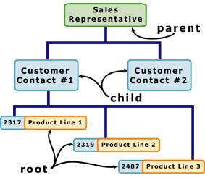
- Hierarchical Databases (DBMS), commonly used on mainframe computers, have been around for a long time.
- It is one of the oldest methods of organizing and storing data and it is still used by some organizations for making travel reservations.
- A hierarchical database is organized in pyramid fashion, like the branches of a tree extending downwards.
- Related fields or records are grouped together so that there are higher-level records and lower-level records, just like the parents in a family tree sit above the subordinated children.
- Based on this analogy, the parent record at the top of the pyramid is called the root record.
- A child record always has only one parent record to which it is linked, just like in a normal family tree.
- In contrast, a parent record may have more than one child record linked to it.
- Hierarchical databases work by moving from the top down.
- A record search is conducted by starting at the top of the pyramid and working down through the tree from parent to child until the appropriate child record is found.
- Furthermore, each child can also be a parent with children underneath it.

Types of DBMS: Network Databases
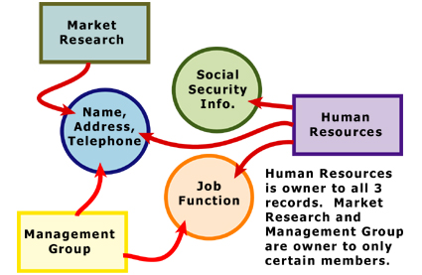
- Network databases are similar to hierarchical databases by also having a hierarchical structure. There are a few key differences, however.
- Instead of looking like an upside-down tree, a network database looks more like a cobweb or interconnected network of records.
- In network databases, children are called members and parents are called owners.
- The most important difference is that each child or member can have more than one parent (or owner).
- Like hierarchical databases, network databases are principally used on mainframe computers.
- Since more connections can be made between different types of data, network databases are considered more flexible.

Types of DBMS: Relational Databases
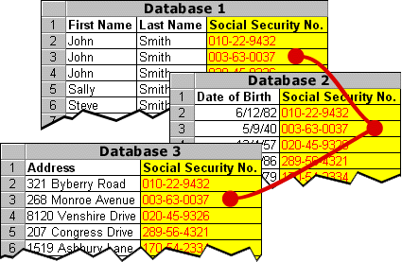
- In relational databases, the relationship between data files is relational, not hierarchical.
- Hierarchical and network databases require the user to pass down through a hierarchy in order to access needed data.
- Relational databases connect data in different files by using common data elements or a key field.
- Data in relational databases is stored in different tables, each having a key field that uniquely identifies each row.
- Relational databases are more flexible than either the hierarchical or network database structures. In relational databases, tables or files filled with data are called relations, tuples designates a row or record, and columns are referred to as attributes or fields.
- Relational databases work on the principle that each table has a key field that uniquely identifies each row, and that these key fields can be used to connect one table of data to another.
- Thus, one table might have a row consisting of a customer account number as the key field along with address and telephone number.
- The customer account number in this table could be linked to another table of data that also includes customer account number (a key field), but in this case, contains information about product returns, including an item number (another key field).
- This key field can be linked to another table that contains item numbers and other product information such as production location, color, quality control person, and other data.
- Therefore, using this database, customer information can be linked to specific product information.
- The relational database has become quite popular for two major reasons.

Types of DBMS: Object-oriented Databases (OODBMS)
- Able to handle many new data types, including graphics, photographs, audio, and video, object-oriented databases represent a significant advance over their other database cousins.
- Hierarchical and network databases are all designed to handle structured data; that is, data that fits nicely into fields, rows, and columns.
- They are useful for handling small snippets of information such as names, addresses, zip codes, product numbers, and any kind of statistic or number you can think of.
- On the other hand, an object-oriented database can be used to store data from a variety of media sources, such as photographs and text, and produce work, as output, in a multimedia format.
- Object-oriented databases use small, reusable chunks of software called objects.
- The objects themselves are stored in the object-oriented database. Each object consists of two elements:
1) A piece of data (e.g., sound, video, text, or graphics)
2) The instructions, or software programs called methods, for what to do with the data.
- Part two of this definition requires a little more explanation.
- The instructions contained within the object are used to do something with the data in the object.
- For example, test scores would be within the object as would the instructions for calculating average test score.

SQL> create table imgtable(name varchar2(50), photo BLOB);
Table created.
SQL> commit;
Commit complete.

How to store a text file into database:(using char stream)

/*SQL> create table filetable(id number(7), name CLOB);
Table created.
SQL> commit;
Commit complete.
*/

import java.io.*;
import java.sql.*;

public class StoreFile
{
public static void main(String[] args)
{
try
{
Class.forName("oracle.jdbc.driver.OracleDriver");
Connection con=DriverManager.getConnection("jdbc:oracle:thin:@localhost:1521:xe","hr","hr");
PreparedStatement ps=con.prepareStatement("insert into filetable values(?,?)");
File f=new File("F:/myfile.txt");
FileReader fr=new FileReader(f);
ps.setInt(1,101);
ps.setCharacterStream(2,fr,(int)f.length());
int i=ps.executeUpdate();
System.out.println(i+" records affected");
con.close();
}catch (Exception e) {e.printStackTrace();}
}
}

How to store a text file into database:(using byte stream)

import java.io.*;
import java.sql.*;

public class StoreFile
{
public static void main(String[] args)
{
try
{
Class.forName("oracle.jdbc.driver.OracleDriver");
Connection con=DriverManager.getConnection("jdbc:oracle:thin:@localhost:1521:xe","hr","hr");
PreparedStatement ps=con.prepareStatement("insert into filetable values(?,?)");
File f=new File("F:/myfile.txt");
FileInputStream s=new FileInputStream(f);
ps.setInt(1,101);
ps.setBinaryStream(2,s,(int)f.length());
int i=ps.executeUpdate();
System.out.println(i+" records affected");
con.close();
}catch (Exception e) {e.printStackTrace();}
}
}

How to retrieve a text file from database:

import java.io.*;
import java.sql.*;
public class RetrieveFile
{
public static void main(String[] args)
{
try
{
Class.forName("oracle.jdbc.driver.OracleDriver");
Connection con=DriverManager.getConnection("jdbc:oracle:thin:@localhost:1521:xe","hr","hr");
PreparedStatement ps=con.prepareStatement("select * from filetable");
ResultSet rs=ps.executeQuery();
rs.next();//now on 1st row
Clob c=rs.getClob(2); //if file is not there leads to CE:
Reader r=c.getCharacterStream();
FileWriter fw=new FileWriter("f:/retrivefile.txt");
int i;
while((i=r.read())!=-1)
fw.write((char)i);
fw.close();
con.close();
System.out.println("success");
}catch (Exception e) {e.printStackTrace(); }
}
}

SQL> select dbms_lob.getlength(name) from filetable;

DBMS_LOB.GETLENGTH(NAME)
------------------------
56
112
How to store a image file into database:(using byte stream)

import java.sql.*;
import java.io.*;
public class InsertImage
{
public static void main(String[] args)
{
try
{
Class.forName("oracle.jdbc.driver.OracleDriver");
Connection con=DriverManager.getConnection("jdbc:oracle:thin:@localhost:1521:xe","hr","hr");
PreparedStatement ps=con.prepareStatement("insert into imgtable values(?,?)");
FileInputStream fin=new FileInputStream("D:\\cutie.jpg");
ps.setString(1,"cutie");
ps.setBinaryStream(2,fin,fin.available());
int i=ps.executeUpdate();
System.out.println(i+" records affected");
con.close();
}catch (Exception e) {e.printStackTrace();}
}
}

How to retrieve a image file from database:

import java.sql.*;
import java.io.*;
public class RetrieveImage
{
public static void main(String[] args)
{
try{
Class.forName("oracle.jdbc.driver.OracleDriver");
Connection con=DriverManager.getConnection(
"jdbc:oracle:thin:@localhost:1521:xe","hr","hr");

PreparedStatement ps=con.prepareStatement("select * from imgtable");
ResultSet rs=ps.executeQuery();
rs.next();//now on 1st row

Blob b=rs.getBlob(2);
byte barr[]=new byte[(int)b.length()];//an array is created but contains no data
barr=b.getBytes(1,(int)b.length());

FileOutputStream fout=new FileOutputStream("d:\\sonoo.jpg");
fout.write(barr);

fout.close();
System.out.println("ok");

con.close();

}catch (Exception e) {e.printStackTrace(); }
}
}

SQL> select *from imgtable
2 ;
SP2-0678: Column or attribute type can not be displayed by SQL*Plus
SQL> select dbms_lob.getlength(photo) from imgtable;

DBMS_LOB.GETLENGTH(PHOTO)
-------------------------
30594

ResourceBundle used to include proparties file dynamically
import java.sql.*;
import java.util.*;
class LoginCheck
{
public static void main(String[] args) throws SQLException,ClassNotFoundException
{
Connection con = null;
ResultSet rs = null;
ResourceBundle rb = ResourceBundle.getBundle("dbdriver");
String driver = rb.getString("driver");
String url = rb.getString("url");
String scmusername= rb.getString("username");
String scmpsd = rb.getString("password");
Class.forName(driver);
con=DriverManager.getConnection(url,scmusername,scmpsd);
Statement stmt = con.createStatement();
Scanner sc =new Scanner(System.in);
System.out.println("enter username");
String uname = sc.nextLine();
System.out.println("enter password");
String upwd = sc.nextLine();
String sql= " select userid from login where username='"+uname+"' and password ='"+upwd+"'";
rs = stmt.executeQuery(sql);
if(rs.next())
{
System.out.println("login success");
}
else
{
System.out.println("login fail");
}
}
}

connection pooling works in Java and JDBC
- JDBC Connection pooling is similar to any other object pooling. Connection pooling is very useful for any application which uses database as backend.
- Database connection is very expensive to create over network, for this we need to create a network connection, then initializing a database, creating a session, doing transaction and then after closing the connection, this take more time, therefore application becomes slower.
- The valuable database resources such as memory, cursors, locks, temporary tables all tends to increase on numbers of concurrent connections.
- The transaction profile for Web applications, probably the most common application in use today, is that of a large number of users performing short, discrete database operations.
- These applications usually perform work centered on creating a web page that will be sent back to the user's browser.
- Transactions are generally short-lived, and user sessions are often limited in time.
- A connection pool operates by performing the work of creating connections ahead of time, In the case of a JDBC connection pool; a pool of Connection objects is created at the time the application server (or some other server) starts.
- These objects are then managed by a pool manager that disperses connections as they are requested by clients and returns them to the pool when it determines the client is finished with the Connection object.
- When the connection pool server starts, it creates a predetermined number of Connection objects. A client application would then perform a JNDI lookup to retrieve a reference to a DataSource object that implements the ConnectionPoolDataSource interface.
- When the client application requests a connetion from the ConnetionPoolDataSource, the data source implementation would retrieve a physical connection to the client application. theConnectionPoolDataSource would return a Connection object that implemented thePooledConnection interface.
- In connection pooling, we creates limited numbers of connection objects pools at a time, such as 10 connections, 50 connections, 100 connections etc. This depends upon the capacity of the database that how much connections it can handle at a time. If any request comes we allocate a connection object to it. When it completed their work then it releases the connection object and this object is added into the pool.
.
MainClaz:
import java.sql.*;

public class MainClaz
{
public static void main(String[] args)
{
try
{
Class.forName("sun.jdbc.odbc.JdbcOdbcDriver");
} catch (Exception E) {
System.out.println("Unable to load a driver " );
}
try
{
JDBCConnectionPooling connectionPooling = new JDBCConnectionPooling("jdbc:odbc:mydsn", "hr", "hr");
Connection[] connArr = new Connection[10];
for (int i = 0; i < connArr.length; i++)
{
connArr[i] = connectionPooling.connectionCheck();
System.out.println("Checking Connections..." + connArr[i]);
System.out.println("Connections Available... "+ connectionPooling.availableCount());
}
} catch (SQLException sqle) {
System.out.println(sqle.toString());
} catch (Exception e) {
System.out.println(e.toString());
}
}
}

JDBCConnectionPooling:
import java.util.*;
import java.sql.*;

public class JDBCConnectionPooling implements Runnable
{
int initialConnections = 5;
Vector connectionsAvailable = new Vector();
Vector connectionsUsed = new Vector();

String connectionUrl ;
String userName;
String userPassword ;
public JDBCConnectionPooling(String url,String userName, String userPass) throws SQLException
{
try
{
this.connectionUrl = url;
this.userName = userName;
this.userPassword = userPass;
Class.forName("sun.jdbd.odbc.JdbcOdbcDriver");
for (int count = 0; count < initialConnections; count++)
{
connectionsAvailable.addElement(getConnection());
}
} catch (ClassNotFoundException e) {
System.out.println(e.toString());
}
}
private Connection getConnection() throws SQLException
{
return DriverManager.getConnection(connectionUrl, userName,userPassword);
}
public synchronized Connection connectionCheck() throws SQLException
{
Connection newConnection = null;
if (connectionsAvailable.size() == 0)
{
// creating a new Connection
newConnection = getConnection();
// adding Connection to used list
connectionsUsed.addElement(newConnection);
}
else
{
newConnection = (Connection) connectionsAvailable.lastElement();
connectionsAvailable.removeElement(newConnection);
connectionsUsed.addElement(newConnection);
}
return newConnection;
}

public int availableCount()
{
return connectionsAvailable.size();
}
public void run()
{
try {
while (true) {
synchronized (this) {
while (connectionsAvailable.size() > initialConnections) {
Connection connection = (Connection) connectionsAvailable.lastElement();
connectionsAvailable.removeElement(connection);
connection.close();
}
}
}
} catch (SQLException sqle) {
sqle.printStackTrace();
} catch (Exception e) {
e.printStackTrace();
}
}
}

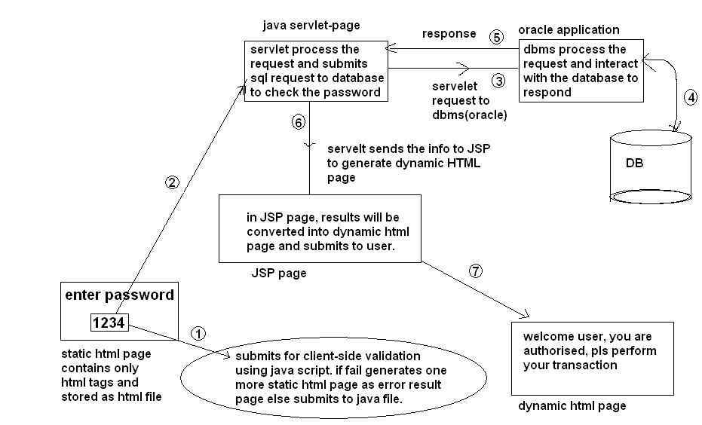

How to install apache software:
http://www.youtube.com/watch?v=WSKHqREbhAI

how to install edit plus(and set preferences to run java program):
http://www.youtube.com/watch?v=a_iH917NGQc

how to install java and set environment variables
http://www.youtube.com/watch?v=U73ml74coYs

how to install oracle 9i:
http://www.youtube.com/watch?v=skXBw4sDxL4
how to install oracle 10g on windows xp:
http://www.youtube.com/watch?v=qP5U2pepwp0
how to install oracle 10g on windows7:
http://www.youtube.com/watch?v=VkX9AnlgMFs

Running a SQL Script in the Oracle 10g Database
Download the script from SamePage Support.
Rename the script which you just downloaded with a simple name, such as "A.sql"
Go to "Start" menu and go to the "Oracle Database 10g Express Edition" Folder
Select "Run SQL Command Line"
Now you must connect the SQL command line to the database which your instance of SamePage uses
Type "connect USERNAME." USERNAME is the name of the user , which in the default case is "samepage". If you are using a different USERNAME please enter that instead of "samepage". Then press enter.
The command line will prompt you for a password. Type the database password and press enter. The default password is "samepage," but if you have changed it, please enter that password now."
The command line should display the response "Connected."
If you have any doubt that you are connected with the right username, type "show user" and the command line should give you back your username.
Type "@C:/PATH/FILENAME.sql" and press enter. Remember to type the entire path. In this case, you should have renamed the filename to "A.sql" per instruction 2. Make sure that you know what the correct path is to the file A.sql. You can find the path by right clicking on "A.sql" and then selecting "Properties". In the Properties pop-up window, look at the "Location" attribute. This is the path to the file.
You should see a bunch of different processes in the command line window, and when they complete, you will be back to the "SQL>" prompt. Please close the command line. You are finished with running the script.

import java.sql.Connection;
import java.sql.DriverManager;
import java.sql.Statement;
import java.sql.ResultSet;
import java.util.Scanner;
class EmployeeInfo
{
static Connection con = null;
static Statement stmt = null;
static Scanner sc = null;
public static void main(String[] argv) throws Exception
{
int ch;
Class.forName("sun.jdbc.odbc.JdbcOdbcDriver");
System.out.println("driver is loaded");
con=DriverManager.getConnection("jdbc:odbc:priya","hr","hr");
System.out.println("jdbc client connected to oracle server");
stmt = con.createStatement();

while(true)
{
System.out.println("1.insert employee");
System.out.println("2.delete employee");
System.out.println("3.display employee");
System.out.println("4.exit");

System.out.println("Enter ur choice : ");
sc = new Scanner(System.in);
ch = sc.nextInt();

switch(ch)
{
case 1 : EmployeeInfo.insert();
break;
case 2 : EmployeeInfo.delete();
break;
case 3 : EmployeeInfo.display();
break;
case 4 : stmt.close();
con.close();
System.exit(1);
default : System.out.println("invalid choice");
}
}
}
static void insert() throws Exception
{
System.out.println("Enter emp details : ");
System.out.print("Enter emp no : ");
int empno = sc.nextInt();
System.out.print("Enter emp name : ");
String ename = sc.next();
System.out.print("Enter emp salary : ");
double esal = sc.nextDouble();
int res = 0;

res = stmt.executeUpdate("insert into empl values("+empno+",'"+ename+"',"+esal+")");
if(res==1)
System.out.println(empno+" inserted successfully");
else
System.out.println("failed in insertion...");
}
static void delete() throws Exception
{
System.out.print("Enter emp no to be deleted : ");
int empno = sc.nextInt();
int res = 0;
res = stmt.executeUpdate("delete from empl where eno = "+empno);
if(res ==1 )
System.out.println("employee "+empno+" deleted successfully");
else
System.out.println(empno+" does not exist...");
}
static void display() throws Exception
{
ResultSet rs = null;
System.out.print("Enter emp no to display : ");
int empno = sc.nextInt();

rs = stmt.executeQuery("select *from empl where eno ="+empno);
if(rs.next())
System.out.println("eno : "+rs.getInt(1)+"\nename : "+rs.getString(2)+"\nesal : "+rs.getDouble(3));
else
{
System.out.println(empno+" doesn't exist");
}
}
}

