Servlets
- Java Servlets is a web technology for Java.
- Servlet is an API that provides many interfaces and classes to write your applications.
- Servlet is an interface that must be implemented for creating any servlet.
- Servlet is a class that extends the capabilities of the servers and responds to the incoming request. It can respond to any type of requests.
- Servlet is a web component that is deployed on the server to create dynamic web page.

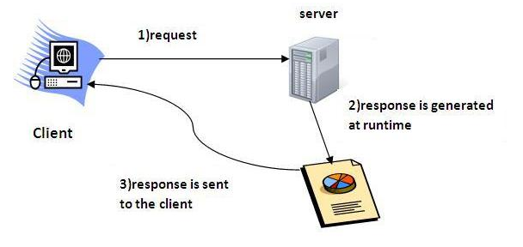
Old Servlets:
- Servlets are Java technology's answer to CGI programming.
- They are programs that run on a Web server and build Web pages.
- Building Web pages on the fly is useful (and commonly done) for a number of reasons:

- The Web page is based on data submitted by the user.
For example the results pages from search engines are generated this way
- The data changes frequently.
For example, a weather-report or news headlines page might build the page dynamically, perhaps returning a previously built page if it is still up to date.

What is CGI?
- The Common Gateway Interface (CGI) is a standard for writing programs that can interact through a Web server with a client running a Web browser.
- These programs allow a Web developer to deliver dynamic information (usually in the form of HTML) via the browser.
- A CGI program can be written in any language, including Java that can be executed by your Web server.
- Web-server receives request and translates the request into Environment Variables.
- Web-server runs CGI program
- CGI program reads the environment variables and spits out some meta-information and the data to send back to the client
- Web-server reads the results of the CGI creates a proper response for the client

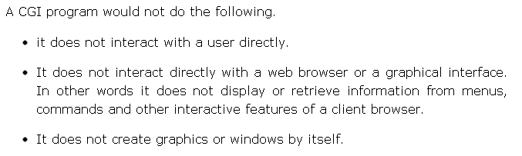

Disadvantages:
There are also disadvantages to CGI programs. One disadvantage is that CGI programs are slow since they need to form a new process for every HTTP request and the database connection must be reopened for the next instance of the program, which is quite costly.

Advantage of Servlets Over "Traditional" CGI
- Servlets are only instantiated when the client first accesses the program. All subsequent accesses are done to that instance.
- This keeps the response time of Servlets lower than that of CGI programs, which must be run once per hit.
- Servlet is instantiated only once, all accesses are put through that one object. This helps in maintaining objects like internal connection, pooling or user session tracking and lots of other features.

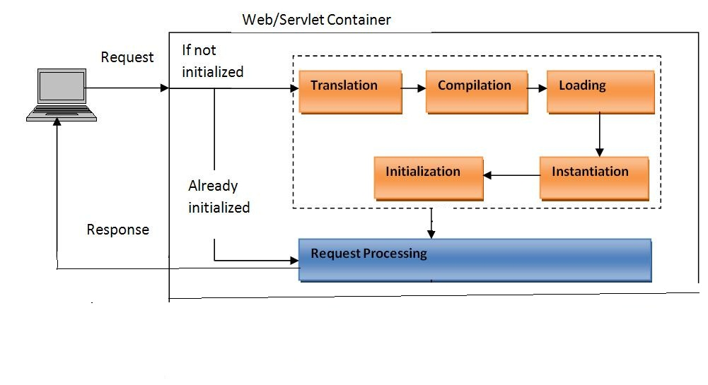
- The difference between servlet and CGI scritpt is that CGI script must be restarted every request where as servlets are pooled and reused over and over again to service many requests. This means you don't have to restart a process every time client request comes over the network.

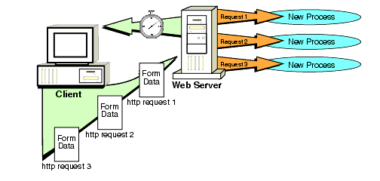

There must be some key points that must be known by the servlet programmer. Let’s first briefly discuss these points before starting the servlet. These are
- HTTP
- HTTP Request Types
- Difference between Get and Post methods
- Container
- Server
- Difference between web server and application server
- Content Type
- Introduction of XML
- Deployment

HTTP:

- Short for Hyper Text Transfer Protocol, the underlying protocol used by the World Wide Web.
- HTTP defines how messages are formatted and transmitted, and what actions Web servers and browsers should take in response to various commands.
- For example, when you enter a URL in your browser, this actually sends an HTTP command to the Web server directing it to fetch and transmit the requested Web page.
- HTTP is called a stateless protocol because each command is executed independently, without any knowledge of the commands that came before it.
- This is the main reason that it is difficult to implement Web sites that react intelligently to user input.
- HTTP clients (such as Web browsers) and servers communicate via HTTP request and response messages. The three main HTTP message types are GET, POST, and HEAD.
- HTTP utilizes TCP port 80 by default, though other ports such as 8080 can alternatively be used.

Two HTTP Request Methods: GET and POST
Two commonly used methods for a request-response between a client and server are: GET and POST.

GET - Requests data from a specified resource
POST - Submits data to be processed to a specified resource

The GET Method

Note that query strings (name/value pairs) is sent in the URL of a GET request: /test/demo_form.jsp?name1=value1&name2=value2

Some other notes on GET requests:
- GET requests can be cached
- GET requests remain in the browser history
- GET requests can be bookmarked
- GET requests have length restrictions
- GET requests should be used only to retrieve data

The POST Method

Note that query strings (name/value pairs) are sent in the HTTP message body of a POST request:
POST /test/demo_form.jsp HTTP/1.1Host: w3schools.comname1=value1&name2=value2

Some other notes on POST requests:
- POST requests are never cached
- POST requests do not remain in the browser history
- POST requests cannot be bookmarked
- POST requests have no restrictions on data length

Other HTTP Request Methods
The following table lists some other HTTP request methods:

Method | Description
HEAD | Same as GET but returns only HTTP headers and no document body
PUT | Uploads a representation of the specified URI
DELETE | Deletes the specified resource
OPTIONS | Returns the HTTP methods that the server supports
CONNECT | Converts the request connection to a transparent TCP/IP tunnel

Servlet Container:
- A servlet container is nothing but a compiled, executable program.
- The main function of the container is to load, initialize and execute servlets.
- A servlet is managed by a servlet container (referred to as Servlet Engine in prior specifications).
- The servlet container together with the web server (or application server) provides the HTTP interface to the world.
- It is also possible for a servlet container to run stand alone (without web server) or to even run on another host than the web server.
- When a request is received by the servlet container, it decides what servlet to call in accordance with a configuration file.
- The servlet Container calls the servlet's service() method and passes an instance of ServletRequest and ServletResponse.
- Depending on the request's method (mostly GET and POST), Service calls doGet() or doPost().
- These passed instances can be used by the servlet to find out who the remote user is, if and what HTTP POST parameters have been set and other characteristics.
- The servlet container is responsible for loading and instantiating the servlets and then calling init().
- A famous servlet container is tomcat.

Server:
Web Server is a machine that has a HTTPD service running. A web server is the one that handles HTTP requests and generates HTTP responses.

Servlet
A Servlet is a server-side entity for servicing HTTP requests.

Servlet Container
A Servlet Container is a sub-set of a Web Server. A Servlet Container is a separate module; it may run within the web server as a single program (called Standalone, in this case), may run as a different program, but part of the same address space (In-Process), or run in different process-spaces. Tomcat is a very popular standalone servlet container

Application Server
Tomcat is an application server, in that sense, if that is the only server used in an application. An application may use other servers, like BEA WebLogic or IBM WebSphere. These application servers provide additional services like an EJB Server, a JMS Server, a JNDI Naming Server, etc.

Difference between Application Server and Web Server in Java
- Main difference between web server and application server is support of EJB.
- In order to run EJB or host enterprise Java application (.ear) file you need an application server like JBoss, WebLogic, Web Sphere or Glassfish, while you can still run your Servlet and JSP or java web application (.war) file inside any web server like Tomcat or Jetty.

- Web Server is designed to serve HTTP Content. App Server can also serve HTTP Content but is not limited to just HTTP. It can be provided other protocol support such as RMI/RPC
- Application Server supports distributed transaction and EJB. While Web Server only supports Servlets and JSP.

- Application Server can contain web server in them. Most of App server e.g. JBoss or WAS has Servlet and JSP container.

J2EE defines three types of archives:

1. Java Archives (JAR) A JAR file encapsulates one or more Java classes, a manifest, and a descriptor. JAR files are the lowest level of archive. JAR files are used in J2EE for packaging EJBs and client-side Java Applications.
2. Web Archives (WAR) WAR files are similar to JAR files, except that they are specifically for web applications made from Servlets, JSPs, and supporting classes.
3. Enterprise Archives (EAR)”An EAR file contains all of the components that make up a particular J2EE application.

war file is web application files only.ear file is complete j2ee application file that contain all (.jar,war,client)

Content type:

The HttpServlet class requests processing methods take two parameters.
javax.servlet.http.HttpRequest
javax.servlet.http.HttpResponse

For instance, here is the signature of the HttpServlet.doGet() method:
protected void doGet(
HttpServletRequest request,
HttpServletResponse response) throws ServletException, IOException { }

The purpose of the HttpResponse object is to represent the HTTP response your web application sends back to the browser, in response to the HTTP request the browser send to your web application.

The HttpResponse object has a lot of methods
- Writing HTML
- Headers
- Content-Type
- Writing Text
- Content-Length
- Writing Binary Data

Writing HTML
To send HTML back to the browser, you have to obtain the PrintWriter from the HttpResponse object. Here is how:

PrintWriter writer = response.getWriter();
writer.write("<html><body>GET/POST response</body></html>");

Headers
Just like the request object, the HttpRequest can contain HTTP headers. Headers must be set before any data is written to the response. You set a header on the response object like this:
response.setHeader("Header-Name", "Header Value");
As you can see, a response header is a name, value pair.

Content-Type
The Content-Type header is a response header that tells the browser the type of the content you are sending back to it.
For instance, the content type for HTML is text/html. Similarly, if what you send back to the browser is plain text, you use the content type text/plain.

Here is how you set the Content-Type header on the HttpResponse object:
response.setHeader("Content-Type", "text/html");

Writing Text
You can write text back to the browser instead of HTML, like this:
response.setHeader("Content-Type", "text/plain");

PrintWriter writer = response.getWriter();
writer.write("This is just plain text");

First the Content-Type header is set to text/plain. Then a plain text string is written to the writer obtained from the response object.
Content-Length
The Content-Length header tells the browser how many bytes your servlet is sending back. If you are sending binary data back you need to set the content length header. Here is how:
response.setHeader("Content-Length", "31642");
Writing Binary Data
You can also write binary data back to the browser instead of text. For instance, you can send an image back, a PDF file or a Flash file or something like that.
Again, you will first have to set the Content-Type header to the type matching the data you are sending back.
For instance, the content type for a PNG image is image/png.

You can search for Multipurpose Internet Mail Extensions (MIME) types in your favorite search engine to find a list of mime types (content types), so you can find the mime type for the content you are sending back.
In order to write binary data back to the browser you cannot use the Writer obtained from response.getWriter(). After all, Writer's are intended for text.
Instead you have to use the OutputStream obtained from the response.getOutputStream() method. Here is how:
OutputStream outputStream = response.getOutputStream();
outputStream.write(...);

What are MIME types?
"MIME types" are used to identify the type of information that a file contains. While the file extension .html is informally understood to mean that the file is an HTML page, there is no requirement that it mean this, and many HTML pages have different file extensions.

Here are some examples of common mime types seen on the web:
Type | Common File Extension | Purpose
text/html | .html | Web Page
image/png | .png | PNG-format image
image/jpeg | .jpeg | JPEG-format image
audio/mpeg | .mp3 | MPEG Audio File
application/octet-stream | .exe | Best for downloads that should just be saved to disk

Setting the Content-type in Java:
// Response is of type javax.servlet.ServletReponse
response.setContentType("text/plain");
Setting the Content-type in C#:
// Response is of type System.Web.HttpResponse
response.ContentType = "text/plain";
Setting the Content-type in Perl/CGI:
print "Content-type:text/html";
Setting the Content-type in PHP:
<?php header('Content-type: text/html');?>

Web.xml servlet configuration:
For a Java servlet to be accessible from a browser, you must tell the servlet container what servlets to deploy, and what URL's to map the servlets to. This is done in the web.xml file of your Java web application.

Directory layout and contents of a Java web application:
In order to get a Java web server or servlet container to run your Java web application, you need to package the resources inside it (servlets, JSP's etc.) in a standardized way.

Here are the directories and files a web app should include:
- MyWebApp (dir)
  - WEB-INF (dir)
    - web.xml
    - classes (dir)
    - lib (dir)
  - index.jsp, image, html…..

The Root Directory
- The root directory of you web application can have pretty much any name you want.
- In the above example the root directory is called MyWebApp.
- Underneath the root directory, you can put all files that should be accessible in your web application.
- For instance, if your web application is mapped to the URL
http://mydomain.com/myWebApp/
... then the index.html page will be accessible at the URL
http://mydomain.com/myWebApp/index.html
- If you create any subdirectories under the root directory, and place files in these subdirectories, these will be available by the subdirectory/file path, in the web application.
- For instance, if you create a subdirectory called layout, and put a file inside it called theLayout.jsp, then you could access that file from the outside, via this URL:
http://mydomain.com/myWebApp/layout/theLayout.jsp

The WEB-INF Directory
- The WEB-INF directory is located just below the web app root directory.
- This directory is a Meta information directory.
- Files stored in here are not supposed to be accessible from a browser (although your web app can access them internally, in your code).
- Inside the WEB-INF directory there are two important directories (classes and lib, and one important file (web.xml).

web.xml
- The web.xml file contains information about the web application, which is used by the Java web server / servlet container in order to properly deploy and execute the web application.
- For instance, the web.xml contains information about which servlets a web application should deploy, and what URL's they should be mapped to.
Classes
- The classes directory contains all compiled Java classes that are part of your web application.
- The classes should be located in a directory structure matching their package structure, just like if you were to run them directly from the command line, or package them in a JAR file.
lib
- The lib directory contains all JAR files used by your web application.
- This directory most often contains any third party libraries that your application is using.
- You could, however, also put your own classes into a JAR file, and locate it here, rather than putting those classes in the classes directory.

Configuring and Mapping a Servlet
To configure a servlet in the web.xml file, you write this:

<?xml version="1.0" encoding="ISO-8859-1"?>
<!DOCTYPE web-app
PUBLIC "-//Sun Microsystems, Inc.//DTD Web Application 2.3//EN"
"http://java.sun.com/dtd/web-app_2_3.dtd">
<web-app>
<servlet>
<servlet-name>controlServlet</servlet-name>
<servlet-class>.ControlServlet</servlet-class>
</servlet>

<servlet-mapping>
<servlet-name>controlServlet</servlet-name>
<url-pattern>*.html</url-pattern>
</servlet-mapping>
</web-app>

- First you configure the servlet. This is done using the <servlet> element. Here you give the servlet a name, and writes the class name of the servlet.
- Second, you map the servlet to a URL or URL pattern. This is done in the<servlet-mapping> element. In the above example, all URL's ending in .html are sent to the servlet.

Servlet Init Parameters
You can pass parameters to a servlet from the web.xml file. The init parameters of a servlet can only be accessed by that servlet. Here is how you configure them in the web.xml file:

<servlet>
<servlet-name>controlServlet</servlet-name>
<servlet-class> ControlServlet</servlet-class>

<init-param>
<param-name>myParam</param-name>
<param-value>paramValue</param-value>
</init-param>
</servlet>

Here is how you read the init parameters from inside your servlet - in the servlets init() method:

public class SimpleServlet extends GenericServlet
{
protected String myParam = null;
public void init(ServletConfig servletConfig) throws ServletException
{
this.myParam = servletConfig.getInitParameter("myParam");
}

public void service(ServletRequest request, ServletResponse response) throws ServletException, IOException
{
response.getWriter().write("<html><body>myParam = " +this.myParam + "</body></html>");
}
}

A servlets init() method is called when the servlet container loads the servlet for the first time. No one can access the servlet until the servlet has been loaded, and theinit() method has been called successfully.
Servlet Load-on-Startup
- The <servlet> element has a sub element called <load-on-startup> which you can use to control when the servlet container should load the servlet. If you do not specify a <load-on-startup> element, the servlet container will typically load your servlet when the first request arrives for it.
- By setting a <load-on-startup> element, you can tell the servlet container to load the servlet as soon as the servlet container starts. Remember, the servlets init()method is called when the servlet is loaded.

Here is an example <load-on-startup> configuration:

<servlet>
<servlet-name>controlServlet</servlet-name>
<servlet-class> ControlServlet</servlet-class>
<init-param><param-name>container.script.static</param-name>
<param-value>/WEB-INF/container.script</param-value>
</init-param>
<load-on-startup>1</load-on-startup>
</servlet>

The number inside the <load-on-startup>1</load-on-startup> element tells the servlet container in what sequence the servlets should be loaded. The lower numbers are loaded first. If the value is negative, or unspecified, the servlet container can load the servlet at any time.

Context Parameters
You can also set some context parameters which can be read from all servlets in your application. Here is how you configure a context parameter:

<context-param>
<param-name>myParam</param-name>
<param-value>the value</param-value>
</context-param>

Here is how you access the parameter from inside an HttpServlet subclass:
String myContextParam = request.getSession().getServletContext() .getInitParameter("myParam");

Hello-app
Deployment of first application:

Run a Servlet program by deploying in web container:

Step1: set CATALINA_HOME path→C:\Tomcat 7.0
Step2: set JAVA_HOME path → C:\Program Files\Java\jdk1.6.0
Step3: check whether tomcat running successfully or not
- To run the tomcat: C:\Tomcat 7.0\bin\start-up.bat(exe) file, then tomcat runs
- Then open internet browser and type http://localhost:8080/ ( shows whether it is running or not)
Step4: write HelloWorld servlet program as like below

import java.io.*;
import javax.servlet.*;
import javax.servlet.http.*;

public class HelloWorld extends HttpServlet{
public void doGet(HttpServletRequest request,
HttpServletResponse response)
throws ServletException,IOException{
response.setContentType("text/html");
PrintWriter pw = response.getWriter();
pw.println("<html>");
pw.println("<head><title>Hello World</title></title>");
pw.println("<body>");
pw.println("<h1>Hello World</h1>");
pw.println("</body></html>");
}
}

Step5: compile the above file that generates HelloWorld.class, before compilation set the path and classpath

Path: C:\Program Files\Java\jdk1.6.0\bin;
Class path: C:\Tomcat 7.0\lib\servlet-api.jar;

Step6: create web-app hierarchy i.e,
- Hello (dir)
  - WEB-INF (dir)
    - web.xml
    - classes (dir)
    - lib (dir)
  - index.jsp

- In the above hierarchy “classes” directory should contain our HelloWorld.class file
- The web.xml file is shown below
- No index.jsp file for simple servlet program
- No need to place anything inside lib directory

Step7: creation of web.xml file

<?xml version="1.0" encoding="ISO-8859-1"?>
<!--<!DOCTYPE web-app
PUBLIC "-//Sun Microsystems, Inc.//DTD Web Application 2.3//EN"
"http://java.sun.com/dtd/web-app_2_3.dtd"> -->

<web-app>
<servlet>
<servlet-name>HelloServlet</servlet-name>
<servlet-class>HelloWorld</servlet-class>
</servlet>
<servlet-mapping>
<servlet-name>HelloServlet</servlet-name>
<url-pattern>/HelloWorld</url-pattern>
</servlet-mapping>
</web-app>

Step8: run the application from browser by giving the following url
http://localhost:8088/Hello/Helloworld

step9: You can see the output of HelloWorld java file on the browser window

Servlet Interface:
public interface Servlet

- This interface is for developing servlets.
- A servlet is a body of Java code that is loaded into and runs inside a servlet engine, such as a web server.
- It receives and responds to requests from clients.
- For example, a client may need information from a database; a servlet can be written that receives the request, gets and processes the data as needed by the client, and then returns it to the client.
- All servlets implement this interface. Servlet writers typically do this by subclassing either GenericServlet, which implements the Servlet interface, or by subclassing HttpServlet.
- The Servlet interface defines methods to initialize a servlet, to receive and respond to client requests, and to destroy a servlet and its resources.
- These are known as life-cycle methods, and are called by the network service in the following manner:
  - Servlet is created then initialized.
  - Zero or more service calls from clients are handled
  - Servlet is destroyed then garbage collected and finalized

- destroy()
Cleans up whatever resources are being held (e.g., memory, file handles, threads) and makes sure that any persistent state is synchronized with the servlet's current in-memory state.
public abstract void destroy()

- getServletConfig()
Returns a servlet config object, which contains any initialization parameters and startup configuration for this servlet.
public abstract ServletConfig getServletConfig()

- getServletInfo()
Returns a string containing information about the servlet, such as its author, version, and copyright.
public abstract String getServletInfo()

- init(ServletConfig)
Initializes the servlet.
public abstract void init(ServletConfig config) throws ServletException

- service(ServletRequest, ServletResponse)
Carries out a single request from the client.
public abstract void service(ServletRequest req, ServletResponse res) throws ServletException, IOException

Servlet Life Cycle

Creation and initialization

The container first creates the servlet instance and then executes the init() method.
init() can be called only once in its life cycle by the following ways:
- Through the ‘load-on-startup’ tag using the web.xml. This makes the servlet to be loaded and initialized when the server starts.
- For the first time only in its life cycle, just before the service() is invoked.
- Server administrator can request for the initialization of a servlet directly.

Execution of service
- Whenever a client requests for the servlet, everytime the service() method is invoked during its life cycle.
- From service() then it is branched to the doGet() or doXx..() methods for a HttpServlet. The service() method should contain the code that serves the Servlet purpose.

Destroy the servlet
- destroy() method is invoked first, then Servlet is removed from the container and then eventually garbage collected.
- destroy() method generally contains code to free any resources like jdbc connection that will not be garbage collected.

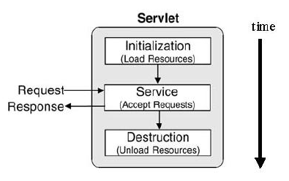

LifeOfServlet-app
Life cycle Method of a servlet program:

import java.io.IOException;
import java.io.PrintWriter;

import javax.servlet.ServletConfig;
import javax.servlet.ServletException;
import javax.servlet.GenericServlet;
import javax.servlet.ServletRequest;
import javax.servlet.ServletResponse;

public class lifec extends GenericServlet {

/**
* Constructor of the object.
*/
public lifec()
{
System.out.println("Object is created here--------->");
}
public void init(ServletConfig sc)
{
System.out.println("I am from init()---------------------->");
}
public void service(ServletRequest hreq,ServletResponse hres)throws ServletException,IOException
{
PrintWriter pw=hres.getWriter();
System.out.println("I am from service()>");
pw.println("<h2>I am from service method@@@@@@@@@@@@@@@@@@@@@@@@@@@@@@@@@@2</h2>");
pw.close();
}
public void destroy()
{

System.out.println("-------Destroy***********");
}
}

Web.xml file:
<?xml version="1.0" encoding="UTF-8"?>
<web-app version="2.5"
xmlns="http://java.sun.com/xml/ns/javaee"
xmlns:xsi="http://www.w3.org/2001/XMLSchema-instance"
xsi:schemaLocation="http://java.sun.com/xml/ns/javaee
http://java.sun.com/xml/ns/javaee/web-app_2_5.xsd">
<servlet>
<description>This is the description of my J2EE component</description>
<display-name>This is the display name of my J2EE component</display-name>
<servlet-name>lifec</servlet-name>
<servlet-class>lifec</servlet-class>
</servlet>

<servlet-mapping>
<servlet-name>lifec</servlet-name>
<url-pattern>/servlet/lifec</url-pattern>
</servlet-mapping>

</web-app>

Class javax.servlet.GenericServlet
public abstract class GenericServlet extends java.lang.Object implements Servlet, ServletConfig, java.io.Serializable

- GenericServlet implements the Servlet and ServletConfig interfaces.
- GenericServlet may be directly extended by a servlet, although it's more common to extend a protocol-specific subclass such as HttpServlet.
- GenericServlet makes writing servlets easier.
- It provides simple versions of the lifecycle methods init and destroy and of the methods in the ServletConfiginterface.
- GenericServlet also implements the log method, declared in the ServletContext interface.
- To write a generic servlet, you need only override the abstract service method.
- Generic servlet is protocal independent cannot support cookies httpsession and url writing it does not send large data
- Generic servlet can be used to handle any type of requests and responses, such as FTP, SMTP and HTTP..
- This servlet has abstract service(), while extends this genericservlet we must implemet the service method.

Constructor:
public GenericServlet()
Does nothing. All of the servlet initialization is done by one of the init methods

Methods of GenericServlet
- public String getInitParameter(String name)
Returns a String containing the value of the named initialization parameter, or null if the parameter does not exist.
- public ServletConfig getServletConfig()
Returns this servlet's ServletConfig object.
- public ServletContext getServletContext()
Returns a reference to the ServletContext in which this servlet is running.
- public java.lang.String getServletInfo()
Returns information about the servlet, such as author, version, and copyright. By default, this method returns an empty string. Override this method to have it return a meaningful value
- public void log(java.lang.String msg)
Writes the specified message to a servlet log file, prepended by the servlet's name.
- public abstract void service(ServletRequest req, ServletResponse res)
Called by the servlet container to allow the servlet to respond to a request.
- public java.lang.String getServletName()
Returns the name of this servlet instance.

Note: Apart from these method the GenericServlet class also has methods init(), destroy() that supports servlet life cycle.

This is a simple program with GenericServlet class.
import javax.servlet.*;
import java.io.*;
public class myservlet extends GenericServlet
{
public void service(ServletRequest req,ServletResponse res) throws ServletException,IOException
{
PrintWriter out=res.getWriter();
out.println("This is a simple program using generic servlet");
}
}

Web.xml file:
<web-app>
<servlet>
<servlet-name> myservlet </servlet-name>
<servlet-class> myservlet</servlet-class>
</servlet>

<servlet-mapping>
<servlet-name> myservlet </servlet-name>
<url-pattern>/ myservlet </url-pattern>
</servlet-mapping>
</web-app>

HttpServlet
- The javax.servlet.http.HttpServlet class is a slightly more advanced base class than the GenericServlet shown in the Simple Servlet example.
- The HttpServlet class reads the HTTP request, and determines if the request is an HTTP GET, POST, PUT, DELETE, HEAD etc. and calls one the corresponding method.
- To respond to e.g. HTTP GET requests only, you will extend the HttpServletclass, and override the doGet() method only. Here is an example:

public class SimpleHttpServlet extends HttpServlet
{
protected void doGet( HttpServletRequest request, HttpServletResponse response)
throws ServletException, IOException
{
response.getWriter().write("<html><body>GET response</body></html>");
}
}

- The HttpServlet class has methods you can override for each HTTP method (GET, POST etc.). Here is a list of the methods you can override:
    - doGet()
    - doPost()
    - doHead()
    - doPut()
    - doDelete()
    - doOptions()
    - doTrace()
- Most often you just want to respond to either HTTP GET or POST requests, so you just override these two methods.
- If you want to handle both GET and POST request from a given servlet, you can override both methods, and have one call the other.

public class SimpleHttpServlet extends HttpServlet
{
protected void doGet( HttpServletRequest request, HttpServletResponse response)
throws ServletException, IOException
{
doPost(request, response);
}
protected void doPost( HttpServletRequest request, HttpServletResponse response)
throws ServletException, IOException
{
response.getWriter().write("GET/POST response");
}
}

Difference between GenericServlet and HttpServlet:
GenericServlet:
- GenericServlet belongs to javax.servlet package
- GenericServlet is an abstract class which extends Object and implements Servlet, ServletConfig and java.io.Serializable interfaces.
- The direct subclass to GenericServlet is HttpServlet.It is a protocol-independent servlet.
- To write a GenericServlet you need to override abstract service() .

HttpServlet:
- HttpServlet belongs to javax.servlet.http package
- This is an abstract class which extends GenericServlet and implements java.io.Serializable
- A subclass of HttpServlet must override at least one method of doGet(), doPost(),doPut(), doDelete().

- Generic Servlet is the super class of the HttpServlet.
- Generic Servlet has init() method whereas Httpservlet doesnot have.
- Http servlet uses http protocol where as in generic servlet it does not use the protocol.
- Generic Servlet does not contain doGet() and doPost() methods,you have to provide your own implementation of doGet() and doPost() methods where as HttpServlet has got doGet() and doPost() methods which you have to override in your implemented class.
- Generic servlet is Protocol independent, HTTP Servlet is protocol dependent.
- Http servlets provides methods that support cookies, sessions etc.while generic servlets are not.

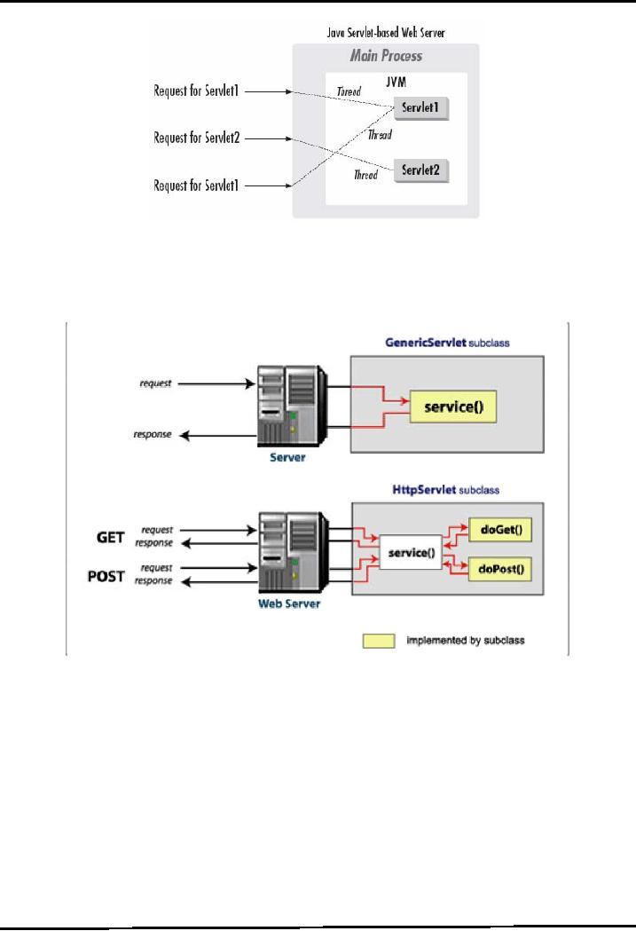

Date-app
Date servlet application:
Dateservlet.java

import java.io.IOException;
import java.io.PrintWriter;
import javax.servlet.ServletException;
import javax.servlet.http.*;
import java.io.*;
import java.util.Date;
public class Dateservlet extends HttpServlet
{
public void service(HttpServletRequest hreq,HttpServletResponse hres)throws ServletException,IOException
{
PrintWriter pw=hres.getWriter();

pw.println("----------This is a Sample Program on servlets----------");
pw.println("************************************************************");
Date d=new Date();
pw.println("<h1> Current Time is+"+d.toString()+"</h1>");
pw.close();

}
}

Web.xml:
<?xml version="1.0" encoding="UTF-8"?>
<web-app version="2.5"
xmlns="http://java.sun.com/xml/ns/javaee"
xmlns:xsi="http://www.w3.org/2001/XMLSchema-instance"
xsi:schemaLocation="http://java.sun.com/xml/ns/javaee
http://java.sun.com/xml/ns/javaee/web-app_2_5.xsd">
<servlet>
<description>This is the description of my J2EE component</description>
<display-name>This is the display name of my J2EE component</display-name>
<servlet-name>Dateservlet</servlet-name>
<servlet-class>Dateservlet</servlet-class>
</servlet>

<servlet-mapping>
<servlet-name>Dateservlet</servlet-name>
<url-pattern>/Dateservlet</url-pattern>
</servlet-mapping>
</web-app>

Taking the input from html form and pass to servlet application:
my_servletdemo:

import java.io.*;
import javax.servlet.*;
import javax.servlet.http.*;
import java.util.*;
public class my_servletdemo extends HttpServlet
{
public void doPost(HttpServletRequest req,HttpServletResponse res) throws IOException, ServletException
{
PrintWriter out = res.getWriter();
Enumeration en = req.getParameterNames();
while(en.hasMoreElements())
{
String name_recieved = (String)en.nextElement();
out.println(name_recieved+"=");
String value_recieved = req.getParameter(name_recieved);
out.println(value_recieved+"\n");
}
out.close();
}
}
Web.xml:
<?xml version="1.0" encoding="ISO-8859-1"?>
<!--<!DOCTYPE web-app
PUBLIC "-//Sun Microsystems, Inc.//DTD Web Application 2.3//EN"
"http://java.sun.com/dtd/web-app_2_3.dtd"> -->

<web-app>
<servlet>
<servlet-name>projectservlet</servlet-name>
<servlet-class>my_servletdemo</servlet-class>
</servlet>
<servlet-mapping>
<servlet-name>projectservlet</servlet-name>
<url-pattern>/my_servletdemo</url-pattern>
</servlet-mapping>
</web-app>

index.html:
<html>
<head>
<title> Student Information Form </title>
</head>
<body>
<center>
<form name = "form1" method = POST action = "my_servletdemo">
<h2> Enter student information in following fields </h2>
<table>

<tr>
<td><b> Roll Number </b></td>
<td><input type = "text" name = "Roll Number" size = "25" value=""></td>
</tr>

<tr>
<td><b> Student Name </b></td>
<td><input type = "text" name = "Name" size = "25" value=""></td>
</tr>

<tr>
<td><b> Student address </b></td>
<td><input type = "text" name = "address" size = "25" value=""></td>
</tr>

<tr>
<td><b> phone </b></td>
<td><input type = "text" name = "phone" size = "25" value=""></td>
</tr>

<tr>
<td><b> Total Marks </b></td>
<td><input type = "text" name = "Total Marks" size = "25" value=""></td>
</tr>
</table>
<input type = "submit" value = "SUBMIT">
</form>
</center>
</body>
</html>

Difference between doGet and doPost:
doGet is used when there is are requirement of sending data appended to a query string in the URL. The doGet models the GET method of Http and it is used to retrieve the info on the client from some server as a request to it. The doGet cannot be used to send too much info appended as a query stream. GET puts the form values into the URL string. GET is limited to about 256 characters (usually a browser limitation) and creates really ugly URLs.

doPost allows you to have extremely dense forms and pass that to the server without clutter or limitation in size. e.g. you obviously can't send a file from the client to the server via doGet. doPost has no limit on the amount of data you can send and because the data does not show up on the URL you can send passwords. But this does not mean that POST is truly secure. It is more secure in comparison to doGet method.

Use Log in Servlet Context
The method context.log() writes the specified message to a servlet log file. The name and type of the servlet log file is specific to the servlet container.

import java.io.IOException;
import javax.servlet.ServletConfig;
import javax.servlet.ServletContext;
import javax.servlet.ServletException;
import javax.servlet.ServletOutputStream;
import javax.servlet.http.HttpServlet;
import javax.servlet.http.HttpServletRequest;
import javax.servlet.http.HttpServletResponse;

public class LogInServlet extends HttpServlet
{
private ServletContext context;
public void init(ServletConfig config) throws ServletException {
super.init(config);
context = getServletContext();
context.log("Hello!");
}
public void doGet(HttpServletRequest req,
HttpServletResponse res)throws IOException {
ServletOutputStream out = res.getOutputStream();
context.log("Your message has been written. ");
res.setContentType("text/html");
out.println("<html><head><title>Log in ServletContext</title> </head>");
out.println("<body>Go to the tomcat-home\\logs and open the xx file to see your log entries");
out.println("</body></html>");
}
}

Web.xml:
<web-app>
<servlet>
<servlet-name>LogInServlet</servlet-name>
<servlet-class>LogInServlet</servlet-class>
</servlet>

<servlet-mapping>
<servlet-name>LogInServlet</servlet-name>
<url-pattern>/LogInServlet</url-pattern>
</servlet-mapping>
</web-app>

LOG FILE INFO:
Feb 20, 2013 12:28:14 PM org.apache.catalina.core.ApplicationContext log
INFO: Hello!
Feb 20, 2013 12:28:14 PM org.apache.catalina.core.ApplicationContext log
INFO: Your message has been written.

ServletConfig & ServletContext

ServletConfig
- This is an interface
- It is used to provide initialization information to the servlet.
- There is one servlet config for one servlet.
- It has these Methods
public java.lang.String getServletName()
public ServletContext getServletContext()
public Enumeration getInitParameterNames()
public String getInitParameter(String name)
- Servlet get its initialization information from web.xml
- Inside the <servlet> tag for the given servlet in web.xml :
- Add <init-param> tag
- For each <init-param> tag there is one <param-name> and <param-value>

<init-param>
<param-name>myName</param-name>
< param-value>myValue</param-value>
</init-param>
In the Servlet Code get this parameter value by the getInitParameter(param-name) method.
String myValue = getServletConfig().getInitParameter("myName");

Example
In the given example we are getting the name and age value from the web.xml
- It is easy to change the value in the web.xml.
- If the variable value is given in the servlet file it will require compilation every time.
- But it can be changed easily in the web.xml
- Changing in web.xml doesnot require any compilation.

- First we will create a servlet file.
- Save it as UserInfo.java
- Add the two instance variable name and age.
- Get these values in init() method

import java.io.IOException;
import java.io.PrintWriter;
import javax.servlet.ServletConfig;
import javax.servlet.ServletException;
import javax.servlet.http.HttpServlet;
import javax.servlet.http.HttpServletRequest;
import javax.servlet.http.HttpServletResponse;
public class UserInfo extends HttpServlet
{
String name;
String age;
public void init(ServletConfig config) throws ServletException
{
name = config.getInitParameter("name1");
age = config.getInitParameter("age1");
}

protected void doGet(HttpServletRequest request, HttpServletResponse response) throws ServletException, IOException
{
PrintWriter out = response.getWriter();
response.setContentType("text/html");
out.print("name is " + name);
out.print("<br>age is " + age);
}
}

- Now create web.xml file inside WEB-INF folder.
- Inside the <servlet> atg after <servlet-class>
add the <init-param> tag
then add the <param-name> and <param-value>

web.xml
<?xml version="1.0" encoding="UTF-8"?>
<web-app>
<servlet>
<servlet-name>UserInfo</servlet-name>
<servlet-class>UserInfo</servlet-class>

<init-param>
<param-name>name1</param-name>
<param-value>sohan</param-value>
</init-param>

<init-param>
<param-name>age1</param-name>
<param-value>22</param-value>
</init-param>

</servlet>

<servlet-mapping>
<servlet-name>UserInfo</servlet-name>
<url-pattern>/UserInfo</url-pattern>
</servlet-mapping>
</web-app>

Difference between ServletContext vs ServletConfig

- BothServletContext and ServletConfig are basically configuration objects which are used by servlet container to initialize various parameter of web application.
- But they have some difference in terms of scope and availability
- ServletConfig object represents or used to initialize single servlet in web application by servlet container.
- Inside deployment descriptor known as web.xml , we define Servlet initialization parameter related to that servlet inside <init-param> tag. It’s a set of name /value pair.
- Following is signature of ServletConfig interface :
- ServletContext is even more important than ServletConfig and it is one per web application, also known as Context.
- This object is common for all the servlets and they use this object to communicate with the servlet container to get the detail of whole web application or execution environment important thing to remember is, it represents a web application in single JVM .

Servlet Config | Servlet Context
Servlet config object represent single servlet | It represent whole web application running on particular JVM and common for all the servlet
It’s like local parameter associated with particular servlet | It’s like global parameter associated with whole application
It’s a name value pair defined inside the servlet section of web.xml file so it has servlet wide scope | ServletContext has application wide scope so define outside of servlet tag in web.xml file.
getServletConfig() method is used to get the config object | getServletContext() method is used to get the context object.
for example shopping cart of a user is a specific to particular user so here we can use servlet config | To get the MIME type of a file or application session related information is stored using servlet context object.

Servlet context example:

test1.java:

import javax.servlet.*;
import javax.servlet.http.*;
import java.io.*;
public class test1 extends HttpServlet
{
public void doGet(HttpServletRequest req , HttpServletResponse res) throws IOException
{
ServletConfig cfg = getServletConfig();
ServletContext sc = cfg.getServletContext();
String driver = sc. getInitParameter("driver");
String username = sc. getInitParameter("user");
String password = sc. getInitParameter("password");
String pet = cfg. getInitParameter("dog");
res.setContentType("text/html");
PrintWriter out= res.getWriter();
out.println("<br> the driver is "+driver);
out.println("<br> the user is "+ username);
out.println("<br> the password is "+ password);
out.println("<br> the config parameter value is "+ pet);
out.close();
}
}

Test2.java:

import javax.servlet.*;
import javax.servlet.http.*;
import java.io.*;
public class test2 extends HttpServlet
{
public void doGet(HttpServletRequest req , HttpServletResponse res) throws IOException
{
ServletConfig cfg = getServletConfig();
ServletContext sc = cfg.getServletContext();
String driver = sc. getInitParameter("driver");
String username = sc. getInitParameter("user");
String password = sc. getInitParameter("password");
String pet = cfg. getInitParameter("dog");
res.setContentType("text/html");
PrintWriter out= res.getWriter();
out.println("<br> the driver is "+driver);
out.println("<br> the user is "+ username);
out.println("<br> the password is "+ password);
out.println("<br> the config parameter value is "+ pet);
out.close();

}
}

Web.xml:

- <web-app>
- <servlet>
<servlet-name>test1</servlet-name>
<servlet-class>test1</servlet-class>
- <init-param>
<param-name>dog</param-name>
<param-value>lyka</param-value>
</init-param>
</servlet>
- <servlet>
<servlet-name>test2</servlet-name>
<servlet-class>test2</servlet-class>
</servlet>
- <servlet-mapping>
<servlet-name>test1</servlet-name>
<url-pattern>/test1</url-pattern>
</servlet-mapping>
- <servlet-mapping>
<servlet-name>test2</servlet-name>
<url-pattern>/test2</url-pattern>
</servlet-mapping>
- <context-param>
<param-name>driver</param-name>
<param-value>sun.jdbc.odbc.JdbcOdbcDriver</param-value>
</context-param>
- <context-param>
<param-name>user</param-name>
<param-value>hr</param-value>
</context-param>
- <context-param>
<param-name>password</param-name>
<param-value>hr</param-value>
</context-param>
</web-app>

How to develop simple servlet application through NetBeans IDE:
Step1: open netbeans IDE
Step2: from the “file” menu select “newproject”
Step3: from the “categories” choose “java web”
From the “projects” choose “webapplication”
Click on “next”
Step4: give any project name for ex: “firstservletapp”
Click on “next”, “next” and “finish”

Step5: in the source area, write the following code next to <h1> tag.

<form action=”serve” >
<input type=”text” name=”na”>
<input type=”submit” value=”clickme”>
</form>

Step6: start the tomcat server manually and run the application then you can see the output on the browser window

Step7: again go back to Netbeans IDE
Step8: In files tab(left side window), right click on current servelt application
From the new→ choose servlet
Step9: give the name “serve”. It has given in <form> action=”serve” …………………..>
Click on “next” and “finish”
Step10: in the source code delete try block in the “processRequest” method and write the following code in that area

String str;
str=request.getParameter(“na”).toString();
out.println(“welcome to servlets :”+str);
out.close();
step11: now run the application
browser will be appeared with html content
enter one string and click enter

step12: you will see the “dynamic html page” generated by “servlet”

Handling the Client Request: Form Data

- The role of form data
- Creating and submitting HTML forms
- Reading individual request parameters
- Reading the entire set of request parameters
- Handling missing and malformed data
- Dealing with incomplete form submissions

The role of form data
- Form is essential part in any web page.
- Client is interacting the server with the form.
- User sends the argument values to the server with the form fields.
- In jsp or html page we create form by the form html tag with its action and method attribute.

Creating and Submitting HTML form
- A Jsp file or Html file can contain one or more than one form.
- In the action attribute we give the servlet url or jsp file name.
- In the method we put get or post.
- It calls the doGet() and doPost()

Reading Single Values
getParameter()
- to read a request parameter you simply call the getParameter() method of HttpServletRequest , supplying case-sensitive parameter name.
- An empty string is return if parameter exist but it doesn’t have any value.
- Null is return if there was no such value.

getParameterValues()
- if same parameter name might appear in the form data more than once you should call getParameterValues() instead of getParameter()
- The return value of getParametereValues() is null for non-existent parameter names and is a non element array

Home.html:
<html>
</body>
<h2>
<form action="./RS">
First Name<input type="text" name="t1"><br>
Last Name<input type="text" name="t2"><br>
Username<input type="text" name="t3"><br>
Password<input type="password" name="t4"><br>
Gender<br>
<input type="radio" name="t5" value="M">Male<br>
<input type="radio" name="t5" value="F">Female<br>
Qualifications<br>
<input type="checkbox" name="t6" value="UG">Under Graduate<br>
<input type="checkbox" name="t6" value="G">Graduate<br>
<input type="checkbox" name="t6" value="PG">Post Graduate<br>
Country<br>
<select name="t7">
<option>India</option>
<option>UK</option>
<option>USA</option>
</select><br>
Address<textarea name="t8"></textarea>
<input type="submit" value="Register">
<input type="reset">
</form>
</h2>
</body>
</html>

RegistrationServlet.java:
import javax.servlet.*;
import java.io.*;

public class RegistrationServlet extends GenericServlet
{
public void service(ServletRequest req,ServletResponse res)
throws ServletException,IOException
{
res.setContentType("text/html");
PrintWriter out=res.getWriter();

String firstname=req.getParameter("t1");
String lastname=req.getParameter("t2");
String username=req.getParameter("t3");
String password=req.getParameter("t4");
String gender=req.getParameter("t5");
String[] qualifications=req.getParameterValues("t6");
String country=req.getParameter("t7");
String address=req.getParameter("t8");

out.println("<h2>");
out.println("First Name : "+firstname);
out.println("<br>Last Name : "+lastname);
out.println("<br>Username : "+username);
out.println("<br>Password : "+password);
out.println("<br>Gender : "+gender);
for(int i=0;i<qualifications.length;i++)
{
out.println("<br>Qualification : "+qualifications[i]);
}
out.println("<br>Country : "+country);
out.println("<br>Address : "+address);
out.println("</h2>");
}
}

Web.xml:
<web-app>
<servlet>
<servlet-name>RServlet</servlet-name>
<servlet-class>RegistrationServlet</servlet-class>
</servlet>
<servlet-mapping>
<servlet-name>RServlet</servlet-name>
<url-pattern>/RS</url-pattern>
</servlet-mapping>

<welcome-file-list>
<welcome-file>HomePage.html</welcome-file>
</welcome-file-list>
</web-app>

Inserting data into database table using servlets:

registeruser table creation in database :
create table registeruser(name varchar2(100), pass varchar2(100), email varchar2(100), country varchar2(100));

Register.java:
import java.io.*;
import java.sql.*;
import javax.servlet.ServletException;
import javax.servlet.http.*;
public class Register extends HttpServlet
{
public void doPost(HttpServletRequest request, HttpServletResponse response) throws ServletException, IOException
{
response.setContentType("text/html");
PrintWriter out = response.getWriter();

String n=request.getParameter("userName");
String p=request.getParameter("userPass");
String e=request.getParameter("userEmail");
String c=request.getParameter("userCountry");
try
{
Class.forName("sun.jdbc.odbc.JdbcOdbcDriver");
Connection con=DriverManager.getConnection("jdbc:odbc:mydsn","hr","hr");
PreparedStatement ps=con.prepareStatement("insert into registeruser values(?,?,?,?)");
ps.setString(1,n);
ps.setString(2,p);
ps.setString(3,e);
ps.setString(4,c);

int i=ps.executeUpdate();
if(i>0)
out.print("You are successfully registered...");
}catch (Exception e2)
{
System.out.println(e2);
}
out.close();
}
}

web.xml:
<?xml version="1.0" encoding="UTF-8"?>
<web-app version="2.5"
xmlns="http://java.sun.com/xml/ns/javaee"
xmlns:xsi="http://www.w3.org/2001/XMLSchema-instance"
xsi:schemaLocation="http://java.sun.com/xml/ns/javaee
http://java.sun.com/xml/ns/javaee/web-app_2_5.xsd">
<servlet>
<servlet-name>Register</servlet-name>
<servlet-class>Register</servlet-class>
</servlet>

<servlet-mapping>
<servlet-name>Register</servlet-name>
<url-pattern>/servlet/Register</url-pattern>
</servlet-mapping>
<welcome-file-list>
<welcome-file>register.html</welcome-file>
</welcome-file-list>
</web-app>

register.html:
<html>
<body>
<form action="servlet/Register" method="post">

Name:<input type="text" name="userName"/><br/><br/>
Password:<input type="password" name="userPass"/><br/><br/>
Email Id:<input type="text" name="userEmail"/><br/><br/>
Country:
<select name="userCountry">
<option>India</option>
<option>Pakistan</option>
<option>other</option>
</select>

<br/><br/>
<input type="submit" value="register"/>

</form>
</body>
</html>

RequestDispatcher: (servelt collabaration)

A RequestDispatcher object can forward a client's request to a resource or include the resource itself in the response back to the client. A resource can be another servlet, or an HTML file, or a JSP file, etc.

Methods:
- Public void forward(ServletRequest request, ServletResponse response) throws ServletException, java.io.IOException: Forwars a request from a servlet to another resource(servlet, jsp file or html file) on the server.

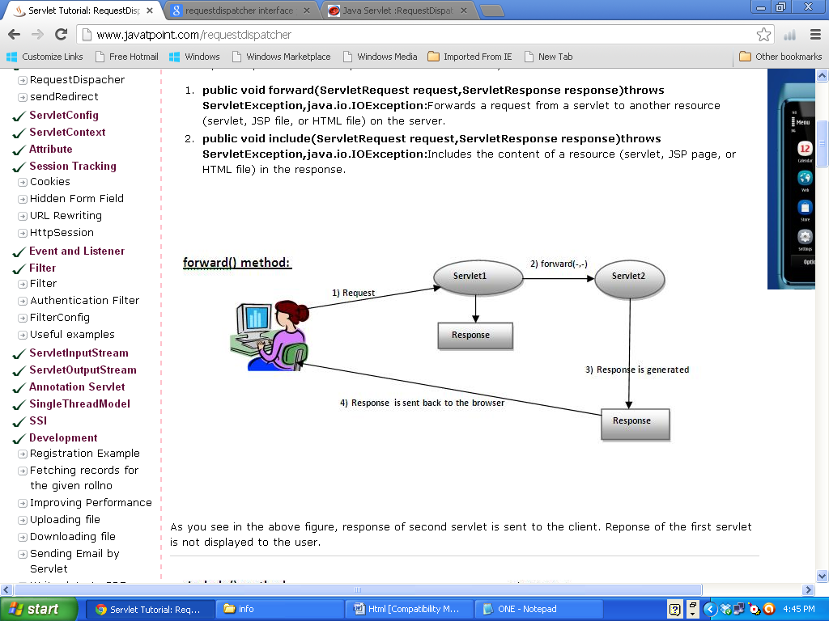

- Public void include(ServletRequest request, ServletResponse response) throws ServletException, java.io.IOException: includes the content of a resource(servlet, jsp file or html file) in the response.

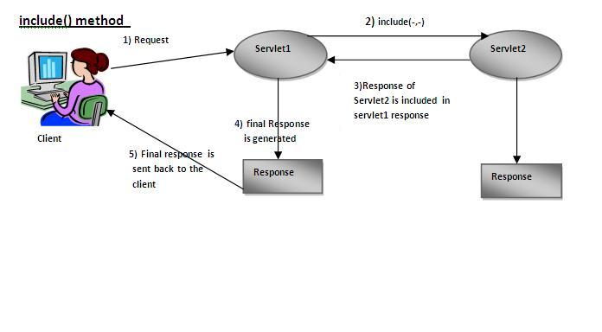
For constructing a RequestDispatcher object, you can use either
ServletRequest.getRequestDispatcher() method
(or)
ServletContext.getRequestDispatcher() method.

- They both do the same thing, but impose slightly different constraints on the argument path.
- For the former, it looks for the resource in the same webapp to which the invoking servlet belongs and the pathname specified can be relative to invoking servlet.
- For the latter, the pathname must begin with '/' and is interpreted relative to the root of the webapp.
- To illustrate, suppose you want Servlet_A to invoke Servlet_B.
- If they are both in the same directory, you could accomplish this by incorporating the following code fragment in either theservice method or the doGet method of Servlet_A:

RequestDispatcher dispatcher = getRequestDispatcher("Servlet_B");
dispatcher.forward( request, response );

- where request, of type HttpServletRequest, is the first parameter of the enclosing servicemethod (or the doGet method) and response, of type HttpServletResponse, the second. You could accomplish the same by
RequestDispatcher dispatcher=getServletContext().getRequestDispatcher( "/servlet/Servlet_B" );
dispatcher.forward( request, response );

Example of RequestDispatcher interface:
In this example, we are validating the password entered by the user. If password is Servlet, it will forward the request to the WelcomeServlet, otherwise will show an error message: sorry username and password error!. In this program, we are checking for hardcoded information.

Index.html file for getting input from the user
Login.java file is a servlet class for processing the response. If password is servlet, it will forward the request to the welcome servlet.
WelcomeServlet.java file is a servlet class for displaying the welcome message.
Web.xml file is a deployment descriptor file that contains the information about the servlet.

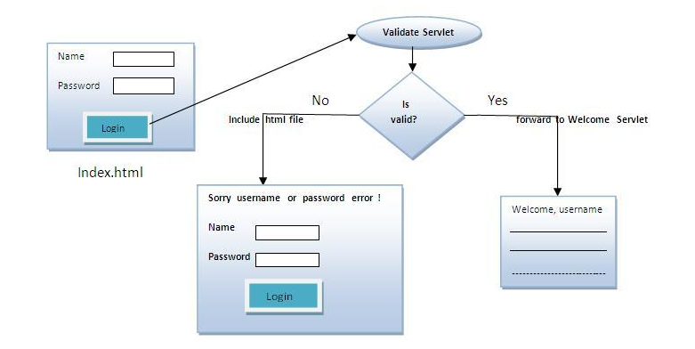

Simple.java:
import java.io.IOException;
import java.io.PrintWriter;
import javax.servlet.*;
import javax.servlet.http.*;
public class Simple extends HttpServlet
{
public void doGet(HttpServletRequest request, HttpServletResponse response)throws ServletException, IOException
{
response.setContentType("text/html");
PrintWriter out = response.getWriter();
String p=request.getParameter("userPass");
if(p.equals("srinivas"))
{
RequestDispatcher rd=request.getRequestDispatcher("welcome");
rd.forward(request, response);
}
else
{
out.print("Sorry username or password error!");
RequestDispatcher rd=request.getRequestDispatcher("login.html");
rd.include(request, response);
}
}
}

WelcomeServlet.java:
import java.io.IOException;
import java.io.PrintWriter;
import javax.servlet.ServletException;
import javax.servlet.http.HttpServlet;
import javax.servlet.http.HttpServletRequest;
import javax.servlet.http.HttpServletResponse;
public class WelcomeServlet extends HttpServlet
{
public void doGet(HttpServletRequest request, HttpServletResponse response) throws ServletException, IOException
{
response.setContentType("text/html");
PrintWriter out = response.getWriter();
String n=request.getParameter("userName");
out.print("Welcome "+n);
}
}

Web.xml:
<?xml version="1.0" encoding="UTF-8"?>
<web-app version="2.5"
xmlns="http://java.sun.com/xml/ns/javaee"
xmlns:xsi="http://www.w3.org/2001/XMLSchema-instance"
xsi:schemaLocation="http://java.sun.com/xml/ns/javaee
http://java.sun.com/xml/ns/javaee/web-app_2_5.xsd">
<servlet>
<servlet-name>Simple</servlet-name>
<servlet-class>Simple</servlet-class>
</servlet>
<servlet>
<servlet-name>WelcomeServlet</servlet-name>
<servlet-class>WelcomeServlet</servlet-class>
</servlet>

<servlet-mapping>
<servlet-name>Simple</servlet-name>
<url-pattern>/go</url-pattern>
</servlet-mapping>
<servlet-mapping>
<servlet-name>WelcomeServlet</servlet-name>
<url-pattern>/welcome</url-pattern>
</servlet-mapping>
<welcome-file-list>
<welcome-file>login.html</welcome-file>
</welcome-file-list>
</web-app>

login.html:

<form action="go" method="get">
Name:<input type="text" name="userName"/><br/>
Password:<input type="password" name="userPass"/><br/>
<input type="submit" value="login"/>
</form>

Example:

Default.html:
<html>
<body>
<h2> Calculation Form</h2>
<form action="/CalculateServlet">
<table>
<tr>
<td>Input First number :</td>
<td><input type="Text" name="num1" size="20" tabindex="1"></td>
</tr>

<tr>
<td>Input Second Number :</td>
<td><input type="text" name="num2" size="20" tabindex="1"></td>
</tr>

<tr>
<td><input type="Submit" value="Add"></td>
<td><input type="reset" value="Reset"></td>
</tr>
</table>

</form>
</body>
</html>

CalculateServlet:
import java.io.*;
import java.net.*;
import javax.servlet.*;
import javax.servlet.http.*;
public class CalculateServlet extends HttpServlet
{
protected void doGet(HttpServletRequest request, HttpServletResponse response)throws ServletException, IOException {
response.setContentType("text/html;charset=UTF-8");
PrintWriter out = response.getWriter();
int n1=Integer.parseInt(request.getParameter("num1"));
int n2=Integer.parseInt(request.getParameter("num2"));
int result=n1+n2;
request.setAttribute("result",new Integer(result));
ServletContext contx=getServletContext();
RequestDispatcher reqDisp=contx.getRequestDispatcher("/DisplayServlet");
reqDisp.forward(request, response);
}
}

DisplayServlet:
import java.io.*;
import java.net.*;
import javax.servlet.*;
import javax.servlet.http.*;
public class DisplayServlet extends HttpServlet
{
protected void doGet(HttpServletRequest request,HttpServletResponse response)throws ServletException, IOException
{
response.setContentType("text/html");
PrintWriter out = response.getWriter();
Integer res=(Integer)request.getAttribute("result");
out.println("The result of the calculation is : "+res.toString());
}
}

web.xml:
<web-app>
<servlet>
<servlet-name>CalculateServlet</servlet-name>
<servlet-class>CalculateServlet</servlet-class>
</servlet>

<servlet>
<servlet-name>DisplayServlet</servlet-name>
<servlet-class>DisplayServlet</servlet-class>
</servlet>

<servlet-mapping>
<servlet-name>CalculateServlet</servlet-name>
<url-pattern>/CalculateServlet</url-pattern>
</servlet-mapping>

<servlet-mapping>
<servlet-name>DisplayServlet</servlet-name>
<url-pattern>/DisplayServlet</url-pattern>
</servlet-mapping>
</web-app>

Difference between the two getRequestDispatcher methods
The difference between ServletRequest.getRequestDispatcher(String path) and ServletContext.getRequestDispatcher(String path) is that the former can accept a relative path as well whereas the latter can accept paths relative to the current context root only.
If the path starts with a '/' in the getRequestDispatcher(String path) of theServletRequest interface then it's interpreted as being relative to the current context root otherwise it'll be a relative to the request of the calling servlet. Whereas, the path of the getRequestDispatcher(String path) of theServletContext interface must start with '/' only - being relative to the current context root.
Another difference between the two is that path of thegetRequestDispatche(String path) of the ServletRequest interface cannot extend outside the current servlet context whereasgetRequestDispatcher(String path) of the ServletContext can use thegetContext(String uripath) method to obtain RequestDispatcher for resources in foreign contexts.

We can give relative URL when we use ServletRequest and not while using ServletContext.

If u call request Dispatcher on servletRequest objects it performs servlet chaining b/w source servlet and destination program when they reside in the same web application.
if u call requestDispatcher on servletContext object it performs servlet chaining b/w source servlet and destination program when they reside in two different web application of same server but not when they reside in the two different web application of different servers

The servletRequest's getRequestDispatcher() can take a relative path while ServletContext's getRequestDispatcher() can not(can only take relative to the current context's root).

For example
with ServletrRequest both
-> request.getRequestDispatcher("./jsp/jsppage.jsp") - evaluated relative to the path of the request
-> request.getRequestDispatcher("/jsp/jsppage.jsp") - evaluated relative to the root
are all valid

with ServletContext only
-> context.getRequestDispatcher("/jsp/jsppage.jsp") is valid
but not context.getRequestDispatcher("./jsp/jsppage.jsp").
that is it can not evaluate a path other than context root.

As said in Javadoc servletContext's requestDispatcher must begin with a "/" and is interpreted as relative to the current context root.

response.sendRedirect(URL)
- Sends a response back to the browser that says, in effect, “I can’t handle this request; you should go to this URL instead.”

Difference between SendRedirect() and Forward() in JSP Servlet:
SendRedirect ():
This method is declared in HttpServletResponse Interface.

Singanature: void sendRedirect (String URL)

- This method is used to redirect client request to some other location for further processing.
- The new location is available on different server or different context.
- Our web container handles this and transfers the request using browser, and this request is visible in browser as a new request.
- Some time this is also called as client side redirect.
Forward ():
This method is declared in RequestDispatcher Interface.

Signature: forward (ServletRequest request, ServletResponse response)

- This method is used to pass the request to another resource for futher processing within the same server, another resource could be any servlet, and jsp page any kind of file.
- This process is taken care by web container.
- When we call forward method, request is sent to another resource without the client being informed.
- Which resource will handle the request; it has been mention on requestDispatcher object.
- We can get this object by two ways either using ServletContext or Request.
- This is also called server side redirect.

RequestDispatcher rd = request.getRequestDispatcher("pathToResource");
rd.forward(request, response);
[Or]
RequestDispatcher rd = servletContext.getRequestDispatcher("/pathToResource");
rd.forward(request, response);
Difference between SendRedirect and Forward
Now let’s see some difference between these two methods of servlet API in tabular format.

Forward() | SendRediret()
When we use forward method request is transfer to other resource within the same server for further processing. | In case of sendRedirect request is transfer to another resource to different domain or different server for futher processing.
In case of forward Web container handle all process internally and client or browser is not involved. | When you use SendRedirect container transfers the request to client or browser so url given inside the sendRedirect method is visible as a new request to the client.
When forward is called on requestdispather object we pass request and response object so our old request object is present on new resource which is going to process our request | In case of SendRedirect call, old request and response object is lost because it’s treated as new request by the browser.
Visually we are not able to see the forwarded address, its is transparent | In address bar we are able to see the new redirected address it’s not transparent.
Using forward () method is faster then send redirect. | SendRedirect is slower because one extra round trip is required to complete the new request and old request object is lost.Two browser request requird.
When we redirect using forward and we want to use same data in new resource, we can use request.setAttribute() as we have request object available. | But in sendRedirect if we want to use we have to store the data in session or pass along with the URL.
Login.html:

<!DOCTYPE HTML PUBLIC "-//W3C//DTD HTML 4.0 Transitional//EN">
<html>
<head>
<title>New Page 1</title>
</head>

<body>
<form method="POST" action="./SendRedirectServlet">
<p>Enter UserName <input type="text" name="username" size="20"></p>
<p>Enter Password <input type="password" name="password" size="20"></p>
<p><input type="submit" value="Submit"></p>
</form>
</body>
</html>

SendRedirectServlet:
import java.io.*;
import javax.servlet.*;
import javax.servlet.http.*;
public class SendRedirectServlet extends HttpServlet
{
protected void doPost(HttpServletRequest request, HttpServletResponse response) throws ServletException, IOException
{
response.setContentType("text/html");
PrintWriter out = response.getWriter();
String name = request.getParameter("username");
String password = request.getParameter("password");
if(name.equals("srinivas")&& password.equals("srinivas"))
{
response.sendRedirect("http://www.google.com");
}
else
{
out.println("Your UserName or Password is incorrect");
}
}
}

LoginServlet:
import java.io.*;
import javax.servlet.*;
import javax.servlet.http.*;
public class LoginServlet extends HttpServlet
{
protected void service(HttpServletRequest request, HttpServletResponse response) throws ServletException, IOException
{
PrintWriter out = response.getWriter();
out.println("Welcome to naresh technologies ");
}
}

Web.xml:
<web-app>
<servlet>
<servlet-name>controller</servlet-name>
<servlet-class>SendRedirectServlet</servlet-class>
</servlet>

<servlet-mapping>
<servlet-name>controller</servlet-name>
<url-pattern>/SendRedirectServlet</url-pattern>
</servlet-mapping>

<servlet>
<servlet-name>LoginSrv</servlet-name>
<servlet-class>LoginServlet</servlet-class>
</servlet>

<servlet-mapping>
<servlet-name>LoginSrv</servlet-name>
<url-pattern>/LoginServlet</url-pattern>
</servlet-mapping>
</web-app>

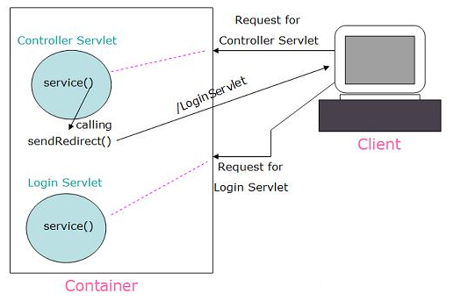

Cookies

- HTTP Cookies are little pieces of data that a web application can store on the client machine of users visiting the web application. Typically up to 4 kilo bytes of data.
- You can write cookies using the HttpServletResponse object like this:
Syntax
public Cookie(java.lang.String name,java.lang.String value)
name - Sring specifying the name of the cookie
value - String specifying the value of the cookie

response.addCookie(cookie);

As you can see, the cookie is identified by a name, "myCookie", and has a value, "myCookieValue". Thus, you can add many different cookies with different identifies (names). It's a bit like a Hashtable.
- Whenever the the browser accesses the web application it submits the cookies stored on the client machine to the web application. Only cookies stored by the accessed web application are submitted. Cookies from other web applications are not submitted.
- You can read the cookies via the HttpServletRequest like this:
Cookie [] cookies = request.getCookies();
- Now you can iterate through the array of cookies and find the cookies you need.

Cookie Settings
- A cookie has various settings you can modify.
- For instance, you can set the cookie expiration, which tell the browser how long time it should store the cookie on the client.

Overview of Cookies
Cookies are small bits of textual information that a Web server sends to a browser and that the browser returns unchanged when visiting the same Web site or domain later. By having the server read information it sent the client previously, the site can provide visitors with a number of conveniences:

Identifying a user during an e-commerce session: Many on-line stores use a "shopping cart" metaphor in which the user selects an item, adds it to his shopping cart, then continues shopping. Since the HTTP connection is closed after each page is sent, when the user selects a new item for his cart, how does the store know that he is the same user that put the previous item in his cart? Cookies are a good way of accomplishing this. In fact, this is so useful that servlets have an API specifically for this, and servlet authors don't need to manipulate cookies directly to make use of it. This is discussed in the tutorial section on Session Tracking.

Avoiding username and password: Many large sites require you to register in order to use their services, but it is inconvenient to remember the username and password. Cookies are a good alternative for low-security sites. When a user registers, a cookie is sent with a unique user ID. When the client reconnects at a later date, the user ID is returned; the server looks it up, determines it belongs to a registered user, and doesn't require an explicit username and password.

Focusing advertising: The search engines charge their customers much more for displaying "random" ads than "directed" ads. That is, if you do a search on "Java Servlets", a search site can charge much more for an ad for a Servlet development environment than an ad for an on-line travel agent. On the other hand, if the search had been "Bali Hotels", the situation would be reversed. The problem is that they have to show a random ad when you first arrive and haven't yet performed a search, as well as when you search on something that doesn't match any ad categories. Cookies let them remember "Oh, that's the person who was searching for such and such previously" and display an appropriate (read "high priced") ad instead of a random (read "cheap") one.

Points to Remember
- A browser accepts 20 cookies per client and 300 cookies total.
- The size of each cookie limited to 4KB

Creating Cookie object
- You can create cookie by Cookie constructor, which takes two strings Cookie name and cookie value.
- Neither the name nor value should contain white spaces or any of these symbols.
[],(),=“/ ? @ : ;
Cookie c1=new Cookie(“userid”,”a123”);
Setting Maximum age
C1.setMaxAge(60*60*24*7) //one week
Adding cookies
response.addCookie(c1);

Reading and Specifying Cookie Attributes
Before adding the cookie to the outgoing headers, you can look up or set attributes of the cookie. Here's a summary:
getComment/setComment
Gets/sets a comment associated with this cookie.

getDomain/setDomain
Gets/sets the domain to which cookie applies. Normally, cookies are returned only to the exact hostname that sent them. You can use this method to instruct the browser to return them to other hosts within the same domain. Note that the domain should start with a dot (e.g. .prenhall.com), and must contain two dots for non-country domains like .com, .edu, and .gov, and three dots for country domains like .co.uk and .edu.es.
getMaxAge/setMaxAge
public void setMaxAge(int expiry)
- Gets/sets how much time (in seconds) should elapse before the cookie expires.
- If you don't set this, the cookie will last only for the current session (i.e. until the user quits the browser), and will not be stored on disk.
- A positive value indicates that the cookie will expire after that many seconds have passed. Note that the value is the maximum age when the cookie will expire, not the cookie's current age.
- A negative value means that the cookie is not stored persistently and will be deleted when the Web browser exits. A zero value causes the cookie to be deleted.
public int getMaxAge()
returns the maximum age of the cookie, specified in seconds,By default, -1 indicating the cookie will persist until browser shutdown

getName/setName
Gets/sets the name of the cookie. The name and the value are the two pieces you virtually always care about. Since the getCookies method of HttpServletRequest returns an array of Cookie objects, it is common to loop down this array until you have a particular name, then check the value with getValue
public void setValue(java.lang.String newValue)
public java.lang.String getValue()

getPath/setPath
Gets/sets the path to which this cookie applies. If you don't specify a path, the cookie is returned for all URLs in the same directory as the current page as well as all subdirectories. This method can be used to specify something more general. For example, someCookie.setPath("/") specifies that all pages on the server should receive the cookie. Note that the path specified must include the current directory.
public void setPath(java.lang.String uri)
public java.lang.String getPath()

getSecure/setSecure
Gets/sets the boolean value indicating whether the cookie should only be sent over encrypted (i.e. SSL) connections.

getValue/setValue
Gets/sets the value associated with the cookie. Again, the name and the value are the two parts of a cookie that you almost always care about, although in a few cases a name is used as a boolean flag, and its value is ignored (i.e the existence of the name means true).
public void setValue(java.lang.String newValue)
public java.lang.String getValue()

getVersion/setVersion
Gets/sets the cookie protocol version this cookie complies with. Version 0, the default, adheres to the original Netscape specification
public void setVersion(int v)
public int getVersion()

Getting the Value of a Cookie with a Specified Name
String color=CookieUtilities.getCookieValue(request,”color”,”black”);
String font=CookieUtilities.getCookieValue(request,”font”,”Arial”);

CookieDemo.java:
import java.io.IOException;
import java.io.PrintWriter;
import javax.servlet.http.Cookie;
import javax.servlet.http.HttpServlet;
import javax.servlet.http.HttpServletRequest;
import javax.servlet.http.HttpServletResponse;

public class CookieDemo extends HttpServlet
{
public void doGet(HttpServletRequest request, HttpServletResponse response) throws IOException
{
response.setContentType("text/html");
PrintWriter pw = response.getWriter();
Cookie cookie = new Cookie("url","myservlet dot com");
cookie.setMaxAge(60*60); //1 hour
response.addCookie(cookie);
pw.println("Cookies created");
}
}

Web.xml:

<?xml version="1.0" encoding="UTF-8"?>
<web-app id="WebApp_ID" version="2.4" xmlns="http://java.sun.com/xml/ns/j2ee"
xmlns:xsi="http://www.w3.org/2001/XMLSchema-instance"
xsi:schemaLocation="http://java.sun.com/xml/ns/j2ee
http://java.sun.com/xml/ns/j2ee/web-app_2_4.xsd">
<servlet>
<servlet-name>ServletName</servlet-name>
<servlet-class>CookieDemo</servlet-class>
</servlet>

<servlet-mapping>
<servlet-name>ServletName</servlet-name>
<url-pattern>/Demo</url-pattern>
</servlet-mapping>

</web-app>

For Google chrome browser, go like this;
- Right click on the page and choose; Inspect element.
- Go to Resources tab.
- Scroll down to Cookies, you will find your site there, just click on it to see all the cookies related to your site.

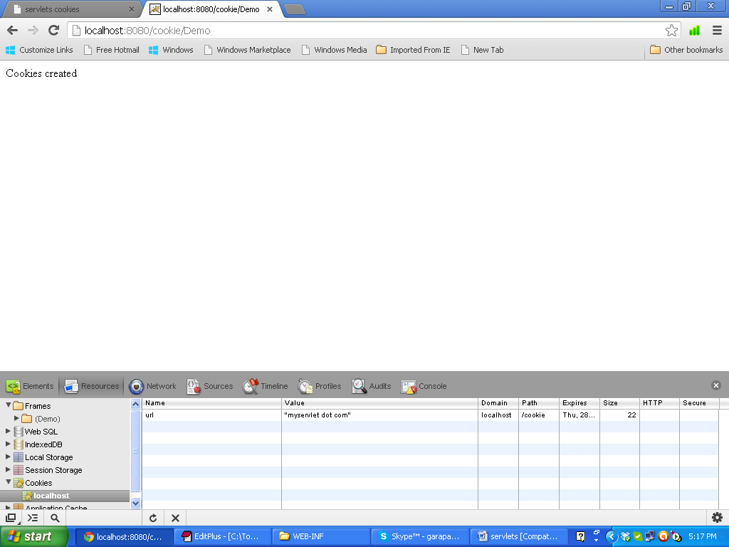

Cookie1.java:
import java.io.IOException;
import java.io.PrintWriter;
import javax.servlet.ServletException;
import javax.servlet.http.Cookie;
import javax.servlet.http.HttpServlet;
import javax.servlet.http.HttpServletRequest;
import javax.servlet.http.HttpServletResponse;

public class Cookie1 extends HttpServlet
{
private static final long serialVersionUID = 1L;
protected void doGet(HttpServletRequest request, HttpServletResponse response) throws ServletException, IOException
{
Cookie c1 = new Cookie("emp1", "e001");
Cookie c2 = new Cookie("emp2", "e002");
Cookie c3 = new Cookie("emp3", "e003");

response.addCookie(c1);
response.addCookie(c2);
response.addCookie(c3);

response.getWriter().print("cookie added");
}
}

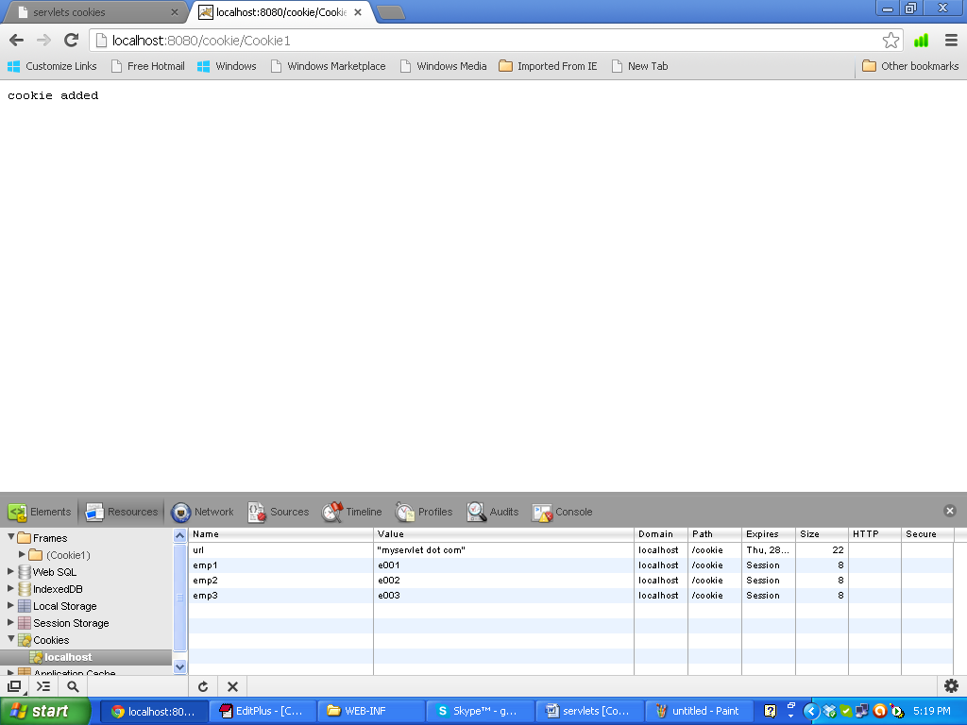

Cookie2.java:

import java.io.IOException;
import java.io.PrintWriter;

import javax.servlet.ServletException;
import javax.servlet.http.Cookie;
import javax.servlet.http.HttpServlet;
import javax.servlet.http.HttpServletRequest;
import javax.servlet.http.HttpServletResponse;

public class Cookie2 extends HttpServlet
{
private static final long serialVersionUID = 1L;
protected void doGet(HttpServletRequest request,HttpServletResponse response) throws
ServletException, IOException
{
response.setContentType("text/html");
PrintWriter out = response.getWriter();
Cookie cookie[] = request.getCookies();
out.print("<br><br>Name-----Value<br>");
for (int i = 0; i < cookie.length; i++)
{
out.print("<br>" + cookie[i].getName() + "-----"+ cookie[i].getValue());
}
}
}
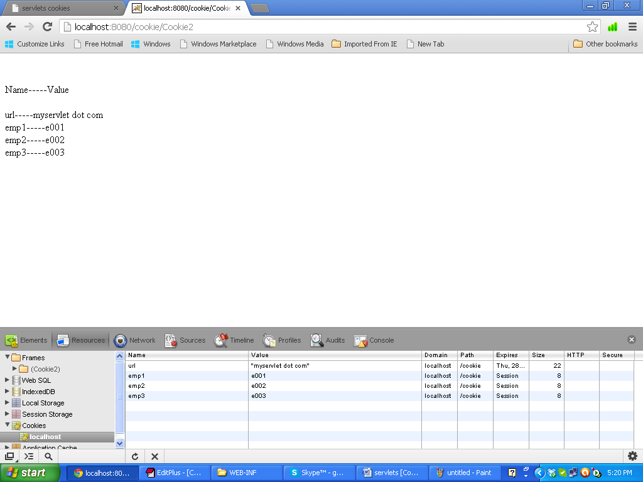

CustomerCookie.java:

import java.io.IOException;
import java.io.PrintWriter;

import javax.servlet.ServletException;
import javax.servlet.http.Cookie;
import javax.servlet.http.HttpServlet;
import javax.servlet.http.HttpServletRequest;
import javax.servlet.http.HttpServletResponse;

public class CustomerCookie extends HttpServlet
{
private static final long serialVersionUID = 1L;
protected void doGet(HttpServletRequest request,
HttpServletResponse response) throws ServletException, IOException
{
Cookie c[] = new Cookie[3];
String cname[] = { "cust1", "cust2", "cust3" };
String cval[] = { "c101", "c102", "c103" };
int age[] = { 10, -10, 0 };
for (int i = 0; i < c.length; i++)
{
c[i] = new Cookie(cname[i], cval[i]);
c[i].setMaxAge(age[i]);
response.addCookie(c[i]);
}
response.getWriter().print("Three customer cookie added");
}
}

Output
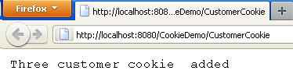
Three cookies added first.....!
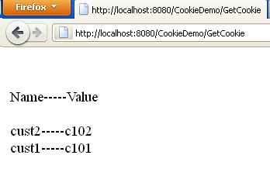
Third cookie whose Maxage set to 0, destroy instantly..
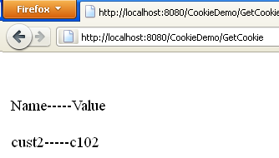
And cookie whose Maxage was set to 10 destroy after 10 sec.
Finally the cookie whose maxage set to negative will remain there..!

Web.xml for above four classes:

<web-app>
<servlet>
<servlet-name>ServletName</servlet-name>
<servlet-class>CookieDemo</servlet-class>
</servlet>
<servlet-mapping>
<servlet-name>ServletName</servlet-name>
<url-pattern>/Demo</url-pattern>
</servlet-mapping>
<servlet>
<servlet-name>CustomerCookie</servlet-name>
<servlet-class>CustomerCookie</servlet-class>
</servlet>
<servlet-mapping>
<servlet-name>CustomerCookie</servlet-name>
<url-pattern>/CustomerCookie</url-pattern>
</servlet-mapping>

<servlet>
<servlet-name>Cookie1</servlet-name>
<servlet-class>Cookie1</servlet-class>
</servlet>
<servlet-mapping>
<servlet-name>Cookie1</servlet-name>
<url-pattern>/Cookie1</url-pattern>
</servlet-mapping>

<servlet>
<servlet-name>Cookie2</servlet-name>
<servlet-class>Cookie2</servlet-class>
</servlet>
<servlet-mapping>
<servlet-name>Cookie2</servlet-name>
<url-pattern>/Cookie2</url-pattern>
</servlet-mapping>
</web-app>

Session Tracking

What is a session?
A session is a conversation between the server and a client. A session is a series of continuous request and response.

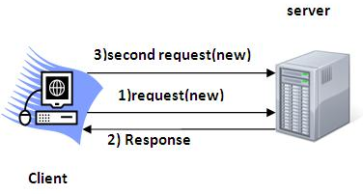

Why should a session be maintained?
When there is a series of continuous request and response from a same client to a server, the server cannot identify from which client it is getting requests because HTTP is a stateless protocol.

When there is a need to maintain the conversational state, session tracking is needed. For example, in a shopping cart application a client keeps on adding items into his cart using multiple requests. When every request is made, the server should identify in which client’s cart the item is to be added. So in this scenario, there is a certain need for session tracking.

Solution is, when a client makes a request it should introduce itself by providing unique identifier every time. There are four different methods to achieve this.

Session tracking methods:
- Cookies
- Hidden fields
- URL rewriting
- Session tracking API

The first four methods are traditionally used for session tracking in all the server-side technologies. The session tracking API method is provided by the underlying technology (java servlet or PHP or likewise). Session tracking API is built on top of the first four methods.

1.Cookies
Cookies are the mostly used technology for session tracking. Cookie is a key value pair of information, sent by the server to the browser. This should be saved by the browser in its space in the client computer. Whenever the browser sends a request to that server it sends the cookie along with it. Then the server can identify the client using the cookie.

In java, following is the source code snippet to create a cookie:
Cookie cookie = new Cookie(“userID”, “7456″);
res.addCookie(cookie);

Session tracking is easy to implement and maintain using the cookies. Disadvantage is that, the users can opt to disable cookies using their browser preferences. In such case, the browser will not save the cookie at client computer and session tracking fails.

Example of using Cookies:
In this example, we are storing the name of the user in the cookie object and accessing it in another servlet. As we know well that session corresponds to the particular user. So if you access it from too many browsers with different values, you will get the different value.

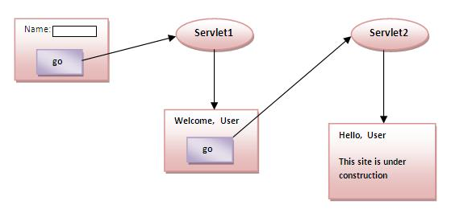

index.html:
<form action="servlet1" method="post">
Name:<input type="text" name="userName"/><br/>
<input type="submit" value="go"/>
</form>

FirstServlet.java:

import java.io.*;
import javax.servlet.*;
import javax.servlet.http.*;
public class FirstServlet extends HttpServlet
{
public void doPost(HttpServletRequest request, HttpServletResponse response)
{
try
{
response.setContentType("text/html");
PrintWriter out = response.getWriter();
String n=request.getParameter("userName");
out.print("Welcome "+n);
Cookie ck=new Cookie("uname",n);//creating cookie object
response.addCookie(ck);//adding cookie in the response
//creating submit button
out.print("<form action='servlet2' method='post'>");
out.print("<input type='submit' value='go'>");
out.print("</form>");
out.close();
}catch(Exception e){System.out.println(e);}
}
}

SecondServlet.java:

import java.io.*;
import javax.servlet.*;
import javax.servlet.http.*;

public class SecondServlet extends HttpServlet
{
public void doPost(HttpServletRequest request, HttpServletResponse response)
{
try
{
response.setContentType("text/html");
PrintWriter out = response.getWriter();
Cookie ck[]=request.getCookies();
out.print("Hello "+ck[0].getValue());
out.close();
}catch(Exception e){System.out.println(e);}
}
}

Web.xml:
<?xml version="1.0" encoding="UTF-8"?>
<web-app version="2.5"
xmlns="http://java.sun.com/xml/ns/javaee"
xmlns:xsi="http://www.w3.org/2001/XMLSchema-instance"
xsi:schemaLocation="http://java.sun.com/xml/ns/javaee
http://java.sun.com/xml/ns/javaee/web-app_2_5.xsd">
<servlet>
<description>This is the description of my J2EE component</description>
<display-name>This is the display name of my J2EE component</display-name>
<servlet-name>Servlet1</servlet-name>
<servlet-class>FirstServlet</servlet-class>
</servlet>
<servlet>
<description>This is the description of my J2EE component</description>
<display-name>This is the display name of my J2EE component</display-name>
<servlet-name>SecondServlet</servlet-name>
<servlet-class>SecondServlet</servlet-class>
</servlet>

<servlet-mapping>
<servlet-name>Servlet1</servlet-name>
<url-pattern>/servlet1</url-pattern>
</servlet-mapping>
<servlet-mapping>
<servlet-name>SecondServlet</servlet-name>
<url-pattern>/servlet2</url-pattern>
</servlet-mapping>
<welcome-file-list>
<welcome-file>index.html</welcome-file>
</welcome-file-list>
</web-app>

Advantages:
- Simplest technique of maintain the state.
- Cookies are maintained at client side

Disadvantages:
- It will not work if cookie is disabled from the browser.
- Only textual information can be set in Cookie object.

- Hidden Fields
In case of Hidden Form Field an invisible text field is used for maintaining the state of a user. In such case, we store the information in the hidden field and get it from another servlet. This approach is better if we have to submit form in all the pages and we don’t want to depend on the browser.

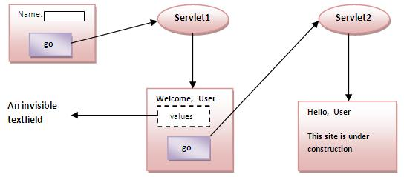

Advantages:
- It will always work whether cookie is disabled or not

Disadvantages
- It is maintained at server side.
- Extra form submission is required on each page.
- Only textual information can be used.

<INPUT TYPE=”hidden” NAME=”technology” VALUE=”servlet”>

- We uses hidden box in html to hide the session information from client.
- We cannot use this type of session for secure data because when a client views the source code of the html page the session information can be view by all.
<input type =”hidden” name =”session” value=”sessionid”/>/
- In servlet to get session information:
String value = request.getParameter(“session”);
- One way to support anonymous session tracking is to use hidden form fields. As the name implies, these are fields added to an HTML form that are not displayed in the client’s browser. They are sent back to the server when the form that contains them is submitted.

- Hidden form field is a way of session tracking so that you can save the information in client browser itself. For that you can use hidden field for securing fields.
So at the time of page display, no one can see these fields. When client submit the form, the browser also transfer these hidden value to the server with other fields.
Example application:
Index.html:
<!DOCTYPE HTML PUBLIC "-//W3C//DTD HTML 4.0 Transitional//EN">
<HTML>
<HEAD>
<TITLE> hiddenform </TITLE>
</HEAD>

<BODY>
<center>
<h2>Click on Submit to check hidden field </h2>
<form action="HiddenFieldServlet" method="post">
<input type="hidden" name="name" value="Roseindia">
<input type="hidden" name="location" value="New Delhi">
<input type="submit" value="Submit"></form>
</center>
</BODY>
</HTML>

HiddenFieldServlet.java:
import java.io.IOException;
import java.io.PrintWriter;
import javax.servlet.ServletException;
import javax.servlet.http.HttpServlet;
import javax.servlet.http.HttpServletRequest;
import javax.servlet.http.HttpServletResponse;

public class HiddenFieldServlet extends HttpServlet
{
protected void doPost(HttpServletRequest request,HttpServletResponse response) throws ServletException, IOException
{
response.setContentType("text/html");
PrintWriter out = response.getWriter();
out.println("<html>");
out.println("<body>");
out.println("<center>");
String name = request.getParameter("name");
String location = request.getParameter("location");
out.println("<b>Company Name : </b>" + name);
out.println("<br><b>Locaion : </b>" + location);
out.println("</center>");
out.println("</body>");
out.println("</html>");
}
}

Web.xml:
<?xml version="1.0" encoding="UTF-8"?>
<web-app version="3.0" xmlns="http://java.sun.com/xml/ns/javaee" xmlns:xsi="http://www.w3.org/2001/XMLSchema-instance" xsi:schemaLocation="http://java.sun.com/xml/ns/javaee http://java.sun.com/xml/ns/javaee/web-app_3_0.xsd">
<servlet>
<servlet-name>HiddenFieldServlet</servlet-name>
<servlet-class>HiddenFieldServlet</servlet-class>
</servlet>
<servlet-mapping>
<servlet-name>HiddenFieldServlet</servlet-name>
<url-pattern>/HiddenFieldServlet</url-pattern>
</servlet-mapping>
</web-app>

3. URL Rewriting
In URL rewriting, we append a token or identifier to the URL of the next Servlet or the next resource. We can send parameter name/value pairs using the following format:

url? name1=value1&name2=value2&??

A name and value is separated using an equal = sign, a parameter name/value pair is separated from another parameter using the ampersand (&). When the user click the hyperlink. The parameter name/value pairs will be passed to the server. From a Servlet, we can use getParameter() method to obtain a parameter value.

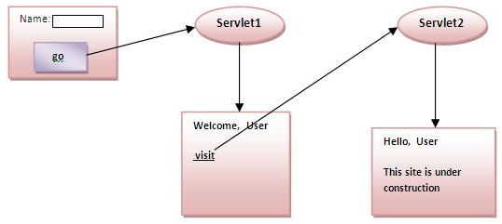

Advantages:
- It will always work whether cookie is disabled or not (browser independant).
- Extra form submission is not required on each page.

Disadvantages:
- It will work only with links
- It can send only textual information

Example application:
Index.html:
<form action="go" method="get">
Name:<input type="text" name="uname"/><br/>
<input type="submit" value="go"/>
</form>

FirstServlet.java:
import java.io.*;
import javax.servlet.*;
import javax.servlet.http.*;
public class FirstServlet extends HttpServlet
{
public void doGet(HttpServletRequest request, HttpServletResponse response)
{
try
{
response.setContentType("text/html");
PrintWriter out = response.getWriter();
String n=request.getParameter("userName");
out.print("Welcome "+n);
//appending the username in the query string
out.print("<a href='servlet2?uname="+n+"'>visit</a>");
out.close();
}catch(Exception e)
{
System.out.println(e);
}
}
}

SecondServlet.java:
import java.io.*;
import javax.servlet.*;
import javax.servlet.http.*;
public class SecondServlet extends HttpServlet
{
public void doGet(HttpServletRequest request, HttpServletResponse response)
{
try
{
response.setContentType("text/html");
PrintWriter out = response.getWriter();
//getting value from the query string
String n=request.getParameter("uname");
out.print("Hello "+n);
out.close();
}catch(Exception e)
{
System.out.println(e);
}
}
}

Web.xml:

<?xml version="1.0" encoding="UTF-8"?>
<web-app version="2.5"
xmlns="http://java.sun.com/xml/ns/javaee"
xmlns:xsi="http://www.w3.org/2001/XMLSchema-instance"
xsi:schemaLocation="http://java.sun.com/xml/ns/javaee
http://java.sun.com/xml/ns/javaee/web-app_2_5.xsd">
<servlet>
<description>This is the description of my J2EE component</description>
<display-name>This is the display name of my J2EE component</display-name>
<servlet-name>Servlet1</servlet-name>
<servlet-class>FirstServlet1</servlet-class>
</servlet>
<servlet>
<description>This is the description of my J2EE component</description>
<display-name>This is the display name of my J2EE component</display-name>
<servlet-name>SecondServlet</servlet-name>
<servlet-class>SecondServlet</servlet-class>
</servlet>

<servlet-mapping>
<servlet-name>Servlet1</servlet-name>
<url-pattern>/go</url-pattern>
</servlet-mapping>
<servlet-mapping>
<servlet-name>SecondServlet</servlet-name>
<url-pattern>/welcome</url-pattern>
</servlet-mapping>
<welcome-file-list>
<welcome-file>index.html</welcome-file>
</welcome-file-list>
</web-app>

URL-rewriting vs URL-encoding in Servlet JSP:

- Main difference between URL-rewriting and URL-encoding is that URL-rewriting is a technique to maintain user session if cookies are not enabled on client browser or browser doesn't support cookies.
- URL-encoding is a way to pass string to server containing special characters by converting special characterslike space into some other characters like +.
- People often confuse between URL encoding and URL rewriting because of there names which sounds quite similar for new guys but functionality wise they are totally different to each other.
- Also servlet encodeURL() method adds more confusion because its sounds like its used for URL Encoding but indeed used for URL Rewriting.
- This is also a very popular servlet and JSP interview question

- java.servlet.http.HttpServletResponse methods encodeURL(String url) and encodeRedirectURL(String URL) is used to encode SesssionID on URL to support URL-rewriting.
- Don’t confuse with name encodeURL() because it doesn't do URL encoding instead it embeds sessionID in url if necessary.
- In order to implement URL-rewriting in JSP you can use use JSTL core tags. All URLs passed to it, will automatically be URL-rewriting if browser doesn't support cookies.
- While java.net.URLEncoder.encode() and java.net.URLDecoder.decode()is used to perform URL Encoding and decoding which replace special character from String to another character.
- This method uses default encoding of system and also deprecated instead of this you can use java.net.URLEncoder.encode(String URL, String encoding) which allows you to specify encoding as per W3C UTF-8 encoding should be used to encode URL in web application.
- In URL rewriting session id is appended to URL and in case of URL-encoding special character replaced by another character.

4. Session tracking API
In such case, container creates a session id for each user. The container uses this id to identify the particular user. An object of HttpSession can be used to perform two tasks.

- Bind objects
- View and manipulate information about a session, such as the session identifier, creation time, and last accessed time.

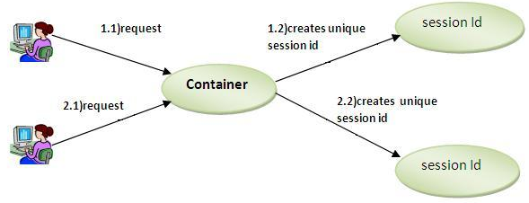

HttpServletRequest interface provides two methods to get the object of HttpSession:

Public HttpSession getSession(): Returns the current session associated with this request, or if the request does not have a seesion, creates one.

Public HttpSession getSession(Boolean create) : Returns the current HttpSession associated with this request or, if there is no current session and creates is true, returns a new session.

Methods:

public String getId(): returns a string containing the unique identifier value.

public longCreationTime(): returns the time when this session was created, measure in milliseconds since midnight January 1, 1970 GMT.

public long getLastAccessedTime(): returns the last time the client sent a request associated with this session as the number of milliseconds since midnight January 1 1970 GMT.

public void invalidate(): invalidates this session then unbinds any objects bound to it.

Example:
- A servlet should not use instance variables to maintain client state information (class variable), because clients accessing that servlet in parallel might overwrite the shared instance variables. Servlets should maintain client state information inHttpSession objects.
- When the user selects a language from the document SessionSelectLanguage.html and presses Submit, method doPost is invoked.
- The example uses method getSession of interface HttpServletRequest to obtain the HttpSession object for the client.
- If the server has an existing HttpSession object for the client from a previous request, method getSession returns thatHttpSession object.
- Otherwise, the true argument to method getSession indicates that the servlet should create a unique new HttpSessionobject for the client.
- A false argument would cause method getSession to return null if the HttpSession object for the client did not already exist. Using a false argument could help determine whether a client has logged into a Web application.
- Like a cookie, an HttpSession object can store name/value pairs. In session terminology, these are called attributes, and they are placed into an HttpSession object with method setAttribute. The example uses setAttribute to put the language and the corresponding recommended book’s ISBN number into the HttpSession object.
- One of the primary benefits of using HttpSession objects rather than cookies is that HttpSession objects can store any object (not just Strings) as the value of an attribute. This allows Java programmers flexibility in determining the type of state information they wish to maintain for clients of their Web applications.
- If an attribute with a particular name already exists when setAttribute is called, the object associated with that attribute name is replaced.
- Name/value pairs added to an HttpSession object with setAttribute remain available until the client’s current browsing session ends or until the session is invalidated explicitly by a call to the HttpSession object’s invalidate method. Also, if the servlet container is restarted, these attributes may be lost.
- After the values are added to the HttpSession object, the servlet sends an HTML document to the client.
- The HTML document sent to the client in response to a post request includes a hyperlink that invokes method doGet. The method obtains the HttpSession
object for the client with method getSession. We do not want to make any recommendations if the client does not have an existing HttpSession object. So,
this call to getSession uses a false argument. Thus, getSession returns an HttpSession object only if one already exists for the client.
Web-app: Sessions

Index.html:
<?xml version = "1.0"?>
<!DOCTYPE html PUBLIC "-//W3C//DTD XHTML 1.0 Strict//EN"
"http://www.w3.org/TR/xhtml1/DTD/xhtml1-strict.dtd">
<html xmlns = "http://www.w3.org/1999/xhtml">
<head>
<title>Using Sessions</title>
</head>
<body>
<form action = "sessions" method = "post">
<p>Select a programming language:</p>
<p>
<input type = "radio" name = "language" value = "C" />C <br />
<input type = "radio" name = "language" value = "C++" />C++ <br />
<input type = "radio" name = "language" value = "Java" checked = "checked" />Java<br />
<input type = "radio" name = "language" value = "VB6" />VB 6
</p>
<p><input type = "submit" value = "Submit" /></p>
</form>
</body>
</html>

SessionServlet.java:
import javax.servlet.*;
import javax.servlet.http.*;
import java.io.*;
import java.util.*;
public class SessionServlet extends HttpServlet
{
private final Map books = new HashMap();
public void init()
{
books.put( "C", "0130895725" );
books.put( "C++", "0130895717" );
books.put( "Java", "0130125075" );
books.put( "VB6", "0134569555" );
}
protected void doPost( HttpServletRequest request, HttpServletResponse response ) throws ServletException, IOException
{
String language = request.getParameter( "language" );
HttpSession session = request.getSession( true );
session.setAttribute( language, books.get( language ) );
response.setContentType( "text/html" );
PrintWriter out = response.getWriter();
out.println("<html>");
out.println( "<head>" );
out.println( "<title>Welcome to Sessions</title>" );
out.println( "</head>" );
out.println( "<body>" );
out.println( "<p>Welcome to Sessions! You selected " + language + ".</p>" );
out.println( "<p>Your unique session ID is: " + session.getId() + "<br />" );
out.println( "This " + ( session.isNew() ? "is" : "is not" ) + " a new session<br />" );
out.println( "The session was created at: " + new Date( session.getCreationTime() ) + "<br />" );
out.println( "You last accessed the session at: " +new Date( session.getLastAccessedTime() ) + "<br />" );
out.println( "The maximum inactive interval is: " + session.getMaxInactiveInterval() + " seconds</p>" );
out.println( "<p><a href = " + "\"index.html\">" +"Click here to choose another language</a></p>" );
out.println( "</body>" );
out.println( "</html>" );
out.close(); // close stream
}
}

Web.xml:
<?xml version="1.0" encoding="ISO-8859-1"?>
<!--<!DOCTYPE web-app
PUBLIC "-//Sun Microsystems, Inc.//DTD Web Application 2.3//EN"
"http://java.sun.com/dtd/web-app_2_3.dtd"> -->

<web-app>
<servlet>
<servlet-name>sessions</servlet-name>
<servlet-class>SessionServlet</servlet-class>
</servlet>
<servlet-mapping>
<servlet-name>sessions</servlet-name>
<url-pattern>/sessions</url-pattern>
</servlet-mapping>
</web-app>

Example of using HttpSession:
In this example, we are setting the attribute in the session scope in one servlet and getting that value from the session scope in another servlet. To set the attribute in the session scope, we have used the setAttribute() method of HttpSession interface and to get the attribute, we have used the getAttribute method.

Index.html:
<form action="servlet1">
Name:<input type="text" name="userName"/><br/>
<input type="submit" value="go"/>
</form>

FirstServlet.java:
import java.io.*;
import javax.servlet.*;
import javax.servlet.http.*;
public class FirstServlet extends HttpServlet
{
public void doGet(HttpServletRequest request, HttpServletResponse response)
{
try
{
response.setContentType("text/html");
PrintWriter out = response.getWriter();
String n=request.getParameter("userName");
out.print("Welcome "+n);
HttpSession session=request.getSession();
session.setAttribute("uname",n);
out.print("<a href='servlet2'>visit</a>");
out.close();
}catch(Exception e)
{
System.out.println(e);
}
}
}

SecondServlet.java:
import java.io.*;
import javax.servlet.*;
import javax.servlet.http.*;
public class SecondServlet extends HttpServlet
{
public void doGet(HttpServletRequest request, HttpServletResponse response)
{
try
{
response.setContentType("text/html");
PrintWriter out = response.getWriter();
HttpSession session=request.getSession(false);
String n=(String)session.getAttribute("uname");
out.print("Hello "+n);
out.close();
}catch(Exception e){System.out.println(e);}
}
}

Web.xml:
<web-app>

<servlet>
<servlet-name>s1</servlet-name>
<servlet-class>FirstServlet</servlet-class>
</servlet>

<servlet-mapping>
<servlet-name>s1</servlet-name>
<url-pattern>/servlet1</url-pattern>
</servlet-mapping>

<servlet>
<servlet-name>s2</servlet-name>
<servlet-class>SecondServlet</servlet-class>
</servlet>

<servlet-mapping>
<servlet-name>s2</servlet-name>
<url-pattern>/servlet2</url-pattern>
</servlet-mapping>

</web-app>

Event and Listener in Servlet:
- Changing the state of an object is known as event.
- We can perform some important tasks at the occurrence of these exceptions, such as counting total and current logged-in users, creating tables of the database at time of deploying the project, creating database connection object etc.
- Interface for receiving notification events about requests coming into and going out of scope of a web application.
- A ServletRequest is defined as coming into scope of a web application when it is about to enter the first servlet or filter of the web application, and as going out of scope as it exits the last servlet or the first filter in the chain.
- In order to receive these notification events, the implementation class must be declared in the deployment descriptor of the web application, annotated withWebListener, or registered via one of the addListener methods defined on ServletContext.

Event handlers:
Events:

- servlet context events (ServletContextListener):
  - initialize
  - destroy
- servlet context attribute events (ServletContextAttributeListener):
  - set
  - add
  - remove

- session events (HttpSessionListener):
  - create
  - invalidate
  - time out
- session attribute events (HttpSessionAttributeListener):
  - set
  - add
  - remove

There are many Event classes and Listener interfaces in the javax.servlet and javax.servelt.http packages.

The event classes are
- ServletRequestEvent
- ServletContextEvent
- ServletRequestAttributeEvent
- ServletContextAttributeEvent
- HttpSessionEvent

Evnet interfaces
- ServletRequestListener
- ServletRequestAttributeListener
- ServletContextListener
- ServletContextAttributeListener
- HttpSessionListener
- HttpSessionAttributeListener
ServletContextEvent and ServeletContextListener:
- The ServletcontextEvent in notified when web application is deployed on the server
- If you want to perform some action at the time of deploying the web application such as creating database connection, creating all the tables of the project etc. you need to implement ServletContextListener interface and provide the implementation of its methods.

Constructor:
ServletContextEvent(ServletContext e)

Method of ServeltContextEvent:
Public ServletContext getServletContext(): returns instance of ServletContext.

Methods of ServletContextListener interface
Public void contextInitialized(ServletContextEvent e): is invoked when application is deployed on the server.
Public void contextDestroyed(ServeltContextEvent e): is invoked when application is undeployed from the server.

Implementations of the following interface receive notifications about changes to the servlet context of the web application they are part of. To receive notification events, the implementation class must be configured in the deployment descriptor for the web application. All ServletContextListeners are notified of context initialization before any filter or servlet in the web application is initialized. All servlets and filters have been destroyed before any ServletContextListeners are notified of context destruction.

package javax.servlet;
public interface ServletContextListener extends java.util.EventListener
{
public void contextInitialized(ServletContextEvent sce);
public void contextDestroyed(ServletContextEvent sce);
}

This is the event class for notifications about changes to the servlet context of a web application:
package javax.servlet;
public class ServletContextEvent extends java.util.EventObject
{
public ServletContext getServletContext();
}

Example Servlet:

SetDriver.java

public class SetDriver
{
String driver;
String url;
String username;
String password;
public SetDriver() {}
public SetDriver(String d,String u,String user,String pass)
{
driver=d;
url=u;
username=user;
password=pass;
}
}

CreateConnection.java

import javax.servlet.*;
public class CreateConnection implements ServletContextListener
{
public void contextInitialized(ServletContextEvent event)
{
ServletContext ctx=event.getServletContext();
String dname=ctx.getInitParameter("driver");
String urladd=ctx.getInitParameter("url");
String uname=ctx.getInitParameter("username");
String pass=ctx.getInitParameter("password");
SetDriver con=new SetDriver(dname,urladd,uname,pass);
ctx.setAttribute("ConnectionDesc",con);
System.out.println("Context initialized");
}
public void contextDestroyed(ServletContextEvent event)
{
System.out.println("Context destroyed");
}
}

FetchData.java

import java.io.*;
import java.sql.*;
import javax.servlet.*;
import javax.servlet.http.*;

public class FetchData extends HttpServlet
{
public void doGet(HttpServletRequest req, HttpServletResponse res) throws ServletException, IOException {
PrintWriter out = res.getWriter();
SetDriver cn = (SetDriver) getServletContext().getAttribute("ConnectionDesc");
if (cn == null)
{
out.println("<html><body><b> Connection not possible</b>");
}
else
{
try
{
Class.forName(cn.driver);
Connection con = DriverManager.getConnection(cn.url, cn.username, cn.password);
Statement stmt = con.createStatement();
ResultSet rs = stmt.executeQuery("select * from studentrecord");
out.println("<html><body bgcolor=yellow>");
out.println("<br><b>Student Details</b><br><table border=1>");
while (rs.next())
{
out.println("<tr><td>" + rs.getInt(1) + "</td><td>"+ rs.getString(2) + "</td>");
}
out.println("</table>");
out.println("</body></html>");
con.close();
} catch (Exception e) {
System.out.println(e);
}
}
}
}

Web.xml:

<web-app>

<servlet>
<servlet-name>FetchData</servlet-name>
<servlet-class>FetchData</servlet-class>
</servlet>

<servlet-mapping>
<servlet-name>FetchData</servlet-name>
<url-pattern>/servlet/FetchData</url-pattern>
</servlet-mapping>

<listener>
<listener-class>CreateConnection</listener-class>
</listener>

<context-param>
<param-name>driver</param-name>
<param-value>sun.jdbc.odbc.JdbcOdbcDriver</param-value>
</context-param>

<context-param>
<param-name>url</param-name>
<param-value>jdbc:odbc:mydsn</param-value>
</context-param>

<context-param>
<param-name>username</param-name>
<param-value>hr</param-value>
</context-param>

<context-param>
<param-name>password</param-name>
<param-value>hr</param-value>
</context-param>

</web-app>

Database table:

Sql>create table studentrecord(sno number(6), sname varchar2(100));
Table created…

Sql>commit;

Sql>insert into studentrecord values(1001,’raam’);
Row created…..
Sql>insert into studentrecord values(1002,’robert’);
Row created….
Sql>insert into studentrecord values(1003,’rahim’);
Row created….

Sql>commit;

When do I use HttpSessionListener?
- The HttpSessionListener interface is used to monitor when sessions are created and destroyed on the application server. Its best practical use would be to track session use statistics for a server.
- To receive notification events, the implementation class must be configured in the deployment descriptor for the web application.
- This entry points the server to a class that will be called when a session is created or destroyed. The entry required is simple. All you need is a listener and listener-class element in the following format.
- The listener-class element must be a fully qualified class name.

<listener>
<listener-class>mypackage.MySessionListener</listener-class>
</listener>

The HttpSessionListener interface has two methods:
- public void sessionCreated(HttpSessionEvent se) : Notification that a session was created.
- public void sessionDestroyed(HttpSessionEvent se) : Notification that a session is about to be invalidated.
Filter:
- When the servlet container calls a method in a servlet on behalf of the client, the HTTP request that the client sent is, by default, passed directly to the servlet.
- The response that the servlet generates is, by default, passed directly back to the client, with its content unmodified by the container.
- So, normally, the servlet must process the request and generate as much of the response as the application requires.
- But there are many cases where some preprocessing of the request for servlets would be useful.
- In addition, it is sometimes useful to modify the response from a class of servlets. One example is encryption.
- A servlet, or a group of servlets in an application, might generate response data that is sensitive and should not go out over the network in clear-text form, especially when the connection has been made using a non-secure protocol such as HTTP.
- A filter can encrypt the responses. Of course, in this case the client must be able to decrypt the responses.
- A common case for a filter is where you want to apply pre-processing or post-processing to requests and responses for a group of servlets, not just a single servlet.
- If you need to modify the request or response for just one servlet, there is no need to create a filter--just do what is required directly in the servlet itself.
- A filter is an object that is used to perform filtering tasks such as conversion, log maintain, compression, encryption and decryption, input validation etc.
- A filter is invoked at the preprocessing and post processing of a request.
- It is pluggable, i.e. its entry is defined in the web.xml file, if we remove the entry of filter from the web.xml file, filter will be removed automatically and we don’t need to change the Servlet. So it will be easier to maintain the web application.
- Note that filters are not servlets. They do not implement and override HttpServlet methods such as doGet() or doPost(). Rather, a filter implements the methods of the javax.servlet.Filter interface. The methods are:
- init()
- destroy()
- doFilter()

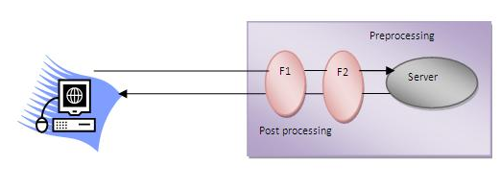
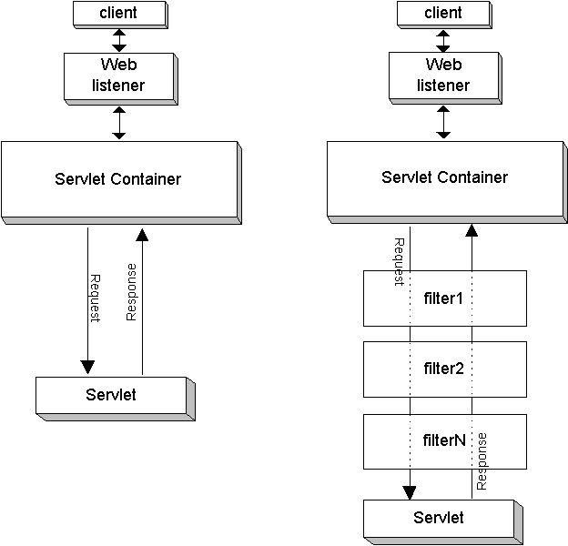

Usage of filter:
- Recording all incoming requests
- Logs the IP addresses of the computers from which the request originate
- Conversion
- Data compression
- Encryption and decryption
- Input validation etc.

Advantages
- Filter is pluggable
- One filter doesn’t have dependency onto another resource.

Filter API
Like servlet, filter has its own API. The javax.servlet package contains the three interfaces of Filter API
- Filter
- FilterChain
- FilterConfig

Filter interface:
For creating any filter, you must implement the Filter interface; Filter interface provides the life cycle methods for a filter.

Public void init(FilterConfig config): init() method is invoked only once it is used to initialize the filter.
Public void doFilter(HttpServletRequest request, HttpServletResponse response, FilterChain chain): doFilter() method is invoked every time when user request to any resource, to which the filter is mapped. It is used to perform filtering tasks.
Public void destroy(): this is invoked only once when filter is taken out of the service.

FilterChain interface
The object of FilterChain is responsible to invoke the next filter or resource in the chain. This object is passed in the doFilter method of Filter interface. The FilterChain interface contains only one method:

Public void doFilter (HttpServletRequest request, HttpServletResponse response): doFilter passes the control to the next filter or resource.

Authentication Filter:
We can perform authentication in filter. Here, we are going to check to password given by the user in filter class, if given password is admin, it will forward the request to the WelcomeAdmin Servlet otherwise it will display error message.

FilterConfig:
An object of FilterConfig is created by the web container. This object can be used to get the configuration information from the web.xml file.

Methods:
Public void init(FilterConfig config): invoked once used to initialize the filter.

Public String getInitParameter(String parameterName): returns the parameter value for the specified parameter name.

Public java.util.Enumeration getInitParameterNames(): returns an enumeration containing all the parameter names.

Public ServletContext getServletContext(): returns the ServletContext object.

Index.html:
<form action="servlet1">
Name:<input type="text" name="name"/><br/>
Password:<input type="password" name="password"/><br/>
<input type="submit" value="login">
</form>

AdminServlet.java:
import java.io.IOException;
import java.io.PrintWriter;
import javax.servlet.ServletException;
import javax.servlet.http.HttpServlet;
import javax.servlet.http.HttpServletRequest;
import javax.servlet.http.HttpServletResponse;

public class AdminServlet extends HttpServlet
{
public void doGet(HttpServletRequest request, HttpServletResponse response) throws ServletException, IOException
{
response.setContentType("text/html");
PrintWriter out = response.getWriter();
out.print("welcome ADMIN");
out.close();
}
}

MyFilter.java:
import java.io.IOException;
import java.io.PrintWriter;
import javax.servlet.*;

public class MyFilter implements Filter
{

public void init(FilterConfig arg0) throws ServletException {}

public void doFilter(ServletRequest req, ServletResponse resp, FilterChain chain) throws IOException, ServletException
{
PrintWriter out=resp.getWriter();
String password=req.getParameter("password");
if(password.equals("admin"))
{
chain.doFilter(req, resp);//sends request to next resource
}
else
{
out.println("username or password error!");
RequestDispatcher rd=req.getRequestDispatcher("index.html");
rd.include(req, resp);
}
}
public void destroy() {}
}

Web.xml;
<?xml version="1.0" encoding="UTF-8"?>
<web-app version="2.5"
xmlns="http://java.sun.com/xml/ns/javaee"
xmlns:xsi="http://www.w3.org/2001/XMLSchema-instance"
xsi:schemaLocation="http://java.sun.com/xml/ns/javaee
http://java.sun.com/xml/ns/javaee/web-app_2_5.xsd">
<servlet>
<servlet-name>AdminServlet</servlet-name>
<servlet-class>AdminServlet</servlet-class>
</servlet>

<servlet-mapping>
<servlet-name>AdminServlet</servlet-name>
<url-pattern>/servlet1</url-pattern>
</servlet-mapping>

<filter>
<filter-name>f1</filter-name>
<filter-class>MyFilter</filter-class>
</filter>
<filter-mapping>
<filter-name>f1</filter-name>
<url-pattern>/servlet1</url-pattern>
</filter-mapping>

</web-app>

Example of counting number of visitors for a single page

import java.io.IOException;
import java.io.PrintWriter;
import javax.servlet.*;

public class MyFilter implements Filter
{
static int count=0;
public void init(FilterConfig arg0) throws ServletException {}

public void doFilter(ServletRequest req, ServletResponse resp, FilterChain chain) throws IOException, ServletException
{
PrintWriter out=resp.getWriter();
chain.doFilter(req,resp);

out.print("<br/>Total visitors"+(++count));
out.close();
}
public void destroy() {}
}

Total time to respond in filter:

import java.io.IOException;
import java.io.PrintWriter;
import javax.servlet.*;

public class MyFilter implements Filter
{
static int count=0;
public void init(FilterConfig arg0) throws ServletException {}

public void doFilter(ServletRequest req, ServletResponse resp, FilterChain chain) throws IOException, ServletException
{
PrintWriter out=resp.getWriter();

long before=System.currentTimeMillis();
chain.doFilter(req,resp);
long after=System.currentTimeMillis();
out.print("<br/>Total time to respond :"+(after-before)+" milli seconds");
out.close();
}
public void destroy() {}
}

ServletInputStream class
This class provides stream to read binary data such as image etc. from the request object. It is an abstract class.
The getInputStream() method of ServletRequest interface returns the instance of ServletInputStream class. So can be get as:
ServletInputStream sin=request.getInputStream();

Methods:

public int readLine(byte[] buffer, int offset, int length) throws IOException

Reads a line from the POST data.
Parameters:
buffer - buffer to hold the line data
offset - offset into the buffer to start
length - maximum number of bytes to read.
Returns:
number of bytes read or -1 on the end of line.

ServletOutputStream class
This class provides a stream to write binary data into the response. It is an abstract class.
The getOutputStream() method of ServletResponse interface returns the instance of ServletOutputStream class. It may be get as:
ServletOutputStream out=response.getOutputStream();

Methods of ServletOutputStream class provides print() and println() methods that are overloaded.
- void print(boolean b)
- void print(char c)
- void print(int i)
- void print(long l)
- void print(flaot f)
- void println(boolean b)
- void println(char c)
- void println(int i)
- void println(long l)
- void println(flaot f)

Example servlet:

Index.html:
<a href="servlet1">click for photo</a>

DisplayImage.java:
import java.io.*;
import javax.servlet.*;
import javax.servlet.http.*;

public class DisplayImage extends HttpServlet
{
public void doGet(HttpServletRequest request,HttpServletResponse response) throws IOException
{
response.setContentType("image/jpeg");
ServletOutputStream out;
out = response.getOutputStream();
FileInputStream fin = new FileInputStream("C:\\Tomcat 7.0\\webapps\\imageinservlet\\cute.jpg");
BufferedInputStream bin = new BufferedInputStream(fin);
BufferedOutputStream bout = new BufferedOutputStream(out);
int ch =0; ;
while((ch=bin.read())!=-1)
{
bout.write(ch);
}
bin.close();
fin.close();
bout.close();
out.close();
}
}

Web.xml:

<?xml version="1.0" encoding="UTF-8"?>
<web-app version="2.5"
xmlns="http://java.sun.com/xml/ns/javaee"
xmlns:xsi="http://www.w3.org/2001/XMLSchema-instance"
xsi:schemaLocation="http://java.sun.com/xml/ns/javaee
http://java.sun.com/xml/ns/javaee/web-app_2_5.xsd">
<servlet>
<servlet-name>DisplayImage</servlet-name>
<servlet-class>DisplayImage</servlet-class>
</servlet>

<servlet-mapping>
<servlet-name>DisplayImage</servlet-name>
<url-pattern>/servlet1</url-pattern>
</servlet-mapping>

</web-app>

How to run first servelt application:
http://www.youtube.com/watch?v=4ouOAwoWIHg

How to build simple Servlet application through net beans
http://www.youtube.com/watch?v=vBJKcLxX21M

