class FirstApplication

{

public static void main(String[] args)

{

System.out.println("Hello World!");

}

}

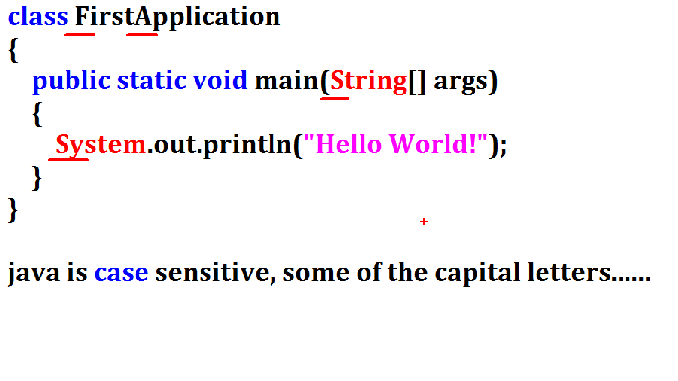

class :

1) Java application is nothing but creating objects to communicate.

2) To define object, model(class) is required.

3) Hence in java application every instruction must be placed inside the class.

4) Using class, we are implementing Encapsulation(protect).

class Identity : (FirstApplication)

1) Every application is a set of class files.

2) In java application, every class should be uniquely identified.

3) JVM executes a specific class using its identity only.

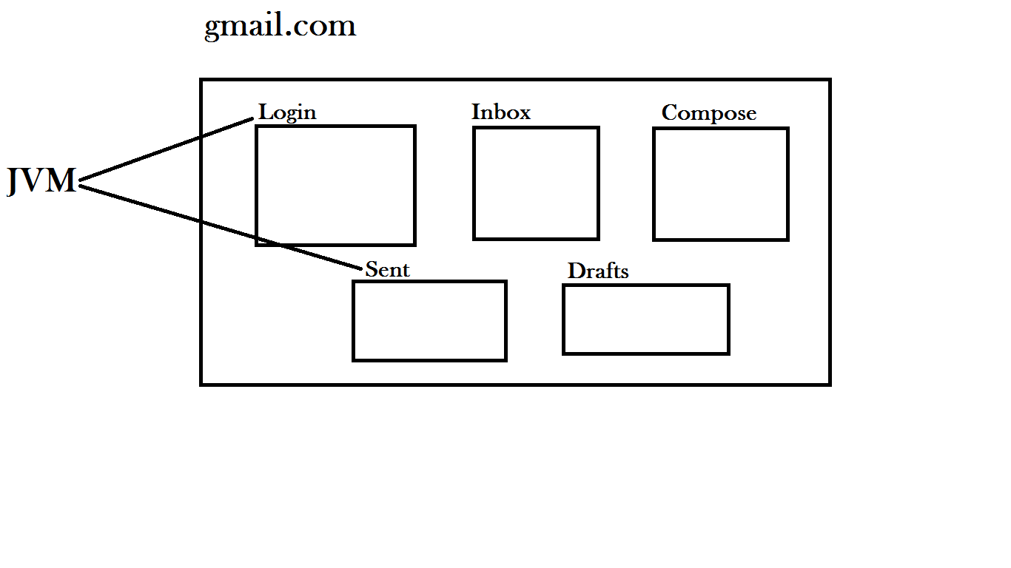

Ques : Why java class name starts with capital letter ?

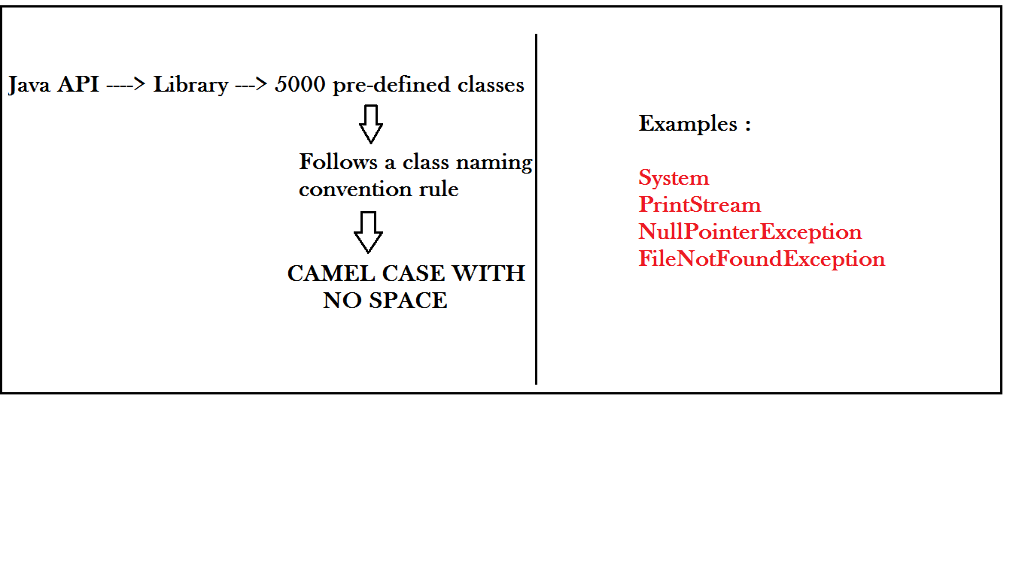

1) API is having 5000 classes

2) Description about these classes will not be available along with JDK installation.

3) Oracle company provided documentation about these classes as a OFFICIAL WEBSITE

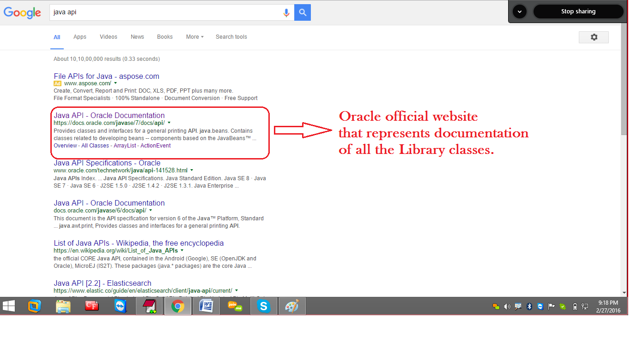

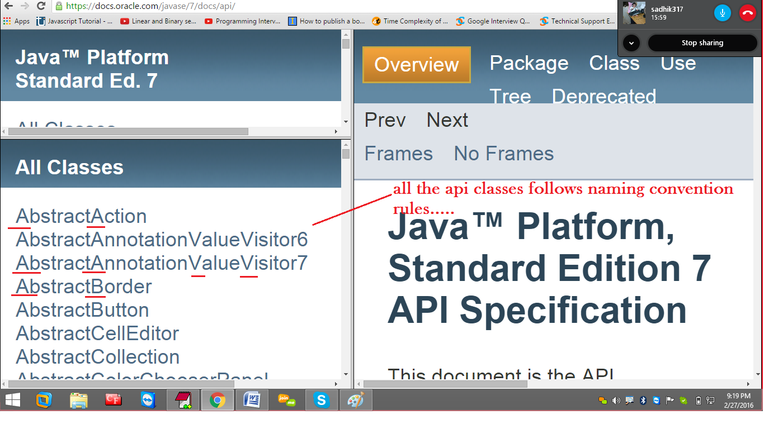

Note :

While using pre-defined library classes, it is mandatory to follow the rules of naming conventions.

But in case of user defined classes, it is optional.

Ques : what are the problems when we don’t follow the rules of naming conventions?

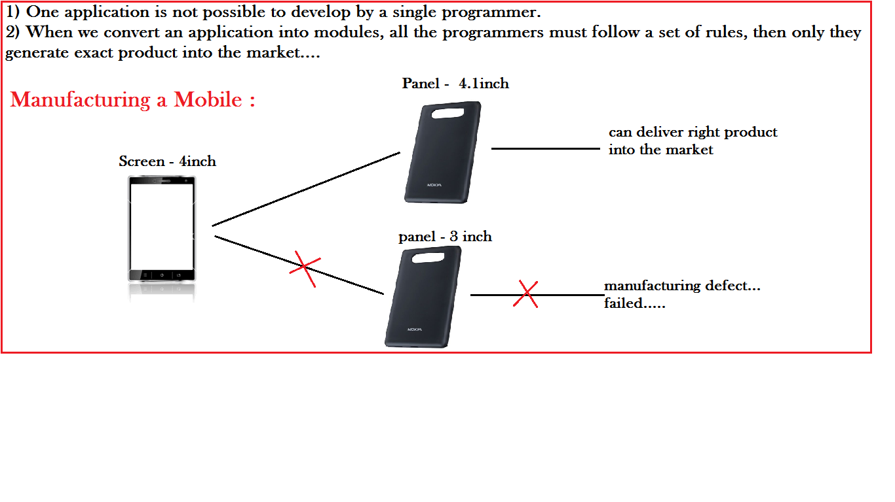

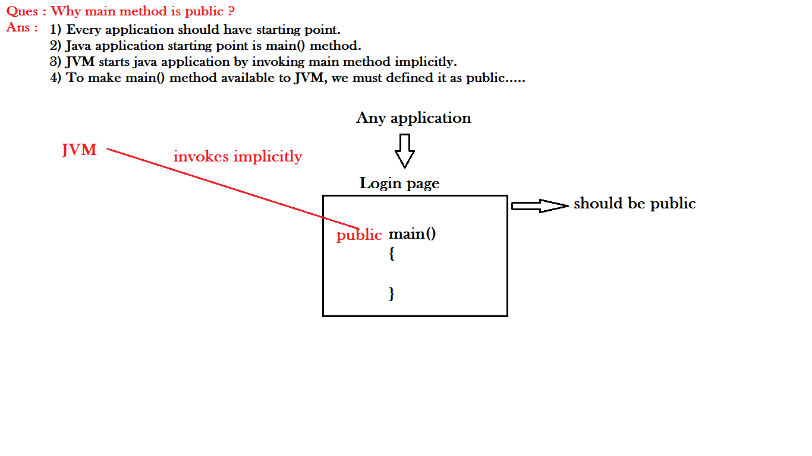

Ques : Why main method is static ?

Ans :

1) In java common functionality of Object must be defined as static.

2) main( ) method is the common starting point of every java application.

3) we can't put restrictions to access "Login page".

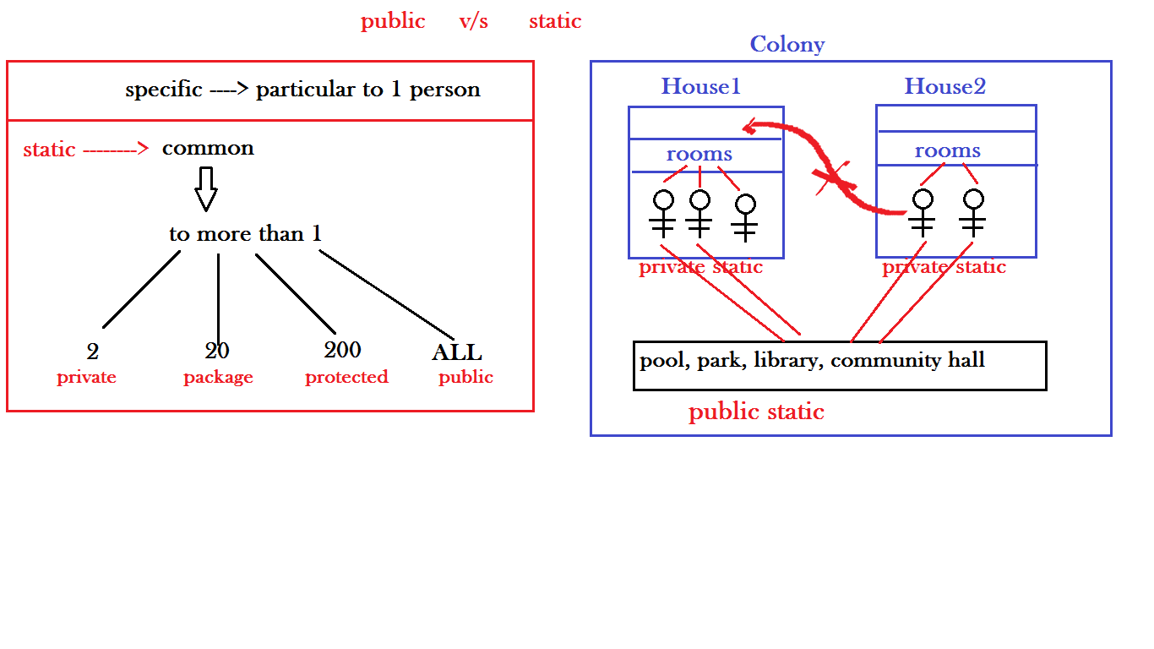

Ques : Why main method is void ?

Ans : main() method is not returning anything to JVM.

Hence it is void.

Method naming conventions :

MIXED CASE WITH NO SPACE

Examples :

next( )

println( )

nextFlot( );

getAccountNumber();

getAccountHolderName( );

getAccountHolderHouseAddress();

