Professional Summary:

- 11+ years of IT experience in analysis, design, development, documentation, implementing and testing of software systems in Java, J2EE technologies
- Full -stack developer with expertise in Java using Spring, Spring Boot, RESTful API, React js, Java Script and SQL.
- Having experience in developing Microservices using Spring Boot, Netflix OSS (Zuul, Eureka, Hystrix) and followed domain driven design.
- Experience in using build/deploy tools such as Jenkins, Docker, OpenShift and Azure Cloud.

Technical Skills:

Programming Languages : Java , J2EE , JavaScript
Framework : Spring, Spring Boot, Hibernate, Struts 1.2
Server : Inautilius, Apache Tomcat 9
Database : Oracle, SQL server
Testing : Junit, Mockito
IDE/Tools : STS, Eclipse, Putty, Visual Studio
Version Control Tools : Gitlab, SVN, Azure Repository
Web Technologies : JavaScript , HTML, CSS
Cloud Platform : Azure
CI/CD tools : Jenkins, SonarQube
Business Domain : Banking and Financial Services, Insurance

IT Experience:
- Capgemini, Hyderabad as a Sr Consultant from April-2019 to November-2021

Project Profile:

1. Project Title : Remote Closing
Organization : Capgemini
Client : MetLife Japan
Technologies : Java 11, Rest APIs, Spring Boot, Hibernate, React js, Azure DevOps
Database : SQL server
Duration : Jan2021- Nov2021

Description:

Agents’ role is burdened by increased complexity of business. They used to carry bundles of applications. If any flaw is detected in the application, they had to reach customers to collect information again. Such problems of collecting data again and again is tedious, time consuming and costly. Solving the problem over and over is costly. MetLife wanted a solution that can be configured in different markets. They devised a plan to develop the application first for Japan with a thought that this application can be used later in other geographies as well.

Responsibilities:

- Worked in agile framework as an individual contributor Responsibilities include - Interaction with Business team in story grooming, reviewing story/acceptance criteria.
- Implemented Rest API’s using Spring Boot
- Implemented React js components
- Writing Mockito testcases
- SonarQube and Veracode issues fixing.
- Deploying the Docker Images in Azure cloud
- Responsible for Goal setting, Performance reviews for all direct reports.

2. Project Title : SCI
Organization : Capgemini
Client : SCB Singapore
Technologies : Java 8, Spring Boot, Restful Service, Kafka, Open Shift
Database : Oracle
Duration : April 2019- December 2020

Description:

Single Client Identifier System is the Bank's golden source for entity clients (CIB, CB and Business Clients). SCI captures demographics and details like approved limits, CDD Risk Rating etc. For the entity clients. Each entity is identified by a unique identification number called as SCI LEID.SCI profile is created based on an approved CDD or Creditmate BCA and counterparty profiles are created based on request from Business. LEID's have a main profile that captures data applicable for the entity across all locations are captured and a sub profile which is location specific.

Responsibilities:
- Worked in agile framework as an individual contributor Responsibilities include - Interaction with Business team in story grooming, reviewing story/acceptance criteria.
- Implemented REST Microservices using spring boot
- Implemented Hysterix a Latency and Fault Tolerance system for Distributed Systems
- Accountable for Setting up the DevOps environment in coordination with Dev Ops team.
- Deploying the Docker Images in Open Shift
- Used spring config server for centralized configuration
- Responsible for Goal setting, Performance reviews for all direct reports.

- Inautix Technologies India Pvt. Ltd (BNY Mellon) Chennai as Applications Developer/Lead from April 2013 to Jan 2019

Project Profile:

1. Project Title : Client On Boarding
Organization : Inautix Technologies India Pvt Ltd (BNY Mellon)
Client : Pershing LLC / BNY Mellon
Technologies : Java, Spring MVC, Oracle,
Server : Inautilius
Database : Oracle Exadata
Duration : January 2018 to January 2019

Description:

Client on Boarding is Pershing product. The key modules in this product include Client Search, E-Delivery, Household, Account Holder and Business party. The purpose of COB is to be simplifying the account opening process and giving better user experience. Prepopulate the information in account opening process.

- Analysis and Implementation of enhancements and new features.
- Involved in deployment and maintenance.
- Production support
- Application monitoring in all phases of QA, UAT, XAT and Production
- Mentoring new joinees on the application

2. Project Title : AccountService
Organization : Inautix Technologies India Pvt Ltd
Client : Pershing LLC / Bank of New York Mellon
Technologies : Java, Struts, Jsp
Server : Inautilius
Database : Oracle Exadata
Duration : April 2013 to December 2017

Description:

Account Services is front end application. The key modules in this product include Replicate, e-delivery, Household, DOL, CDD and Business party.
The purpose of Account service application is to open the different types of Retail, Retirement and COD accounts. The key modules in this product include the Account Maintenance, Workflow and Account Profile settings.

Responsibilities:

- Analysis and Implementation of enhancements and new features.
- Production Support and Incidents Support
- Disaster recovery Support

- Hexaware Chennai as a Sr Software Engineer from Mar 2011 to Mar 2013

Project Title : Electronic Toll Collection
Organization : Hexaware Chennai
Client : ACS
Technologies : Java, Struts, Jsp, JavaScript
Server : Tomcat
Database : Oracle
Duration : Mar 2011 to Mar 2013

Description:

ETC is an application which automates the Toll collection system. It allows Toll user to register to an Agent, so that he can pass through the Tollgates, without paying. It would be automatically deducted from his credit. It also keeps track of any Violations. ETC uses various technologies to automate the collection of tolls as a vehicle passes through an ETC lane, without requiring the driver to manually pay cash or deposit tokens.

Responsibilities:

- Analysis and Implementation of enhancements and new features.
- Writing Junit testcases
- Production Support and Incidents Support

- Mastek Mumbai as a Software Engineer from May 2010 to Mar 2011

Project Title : Core Elixir
Organization : Mastek Mumbai
Client : Capita
Technologies : Java, Struts, JForm Designer
Server : OC4J
Database : Oracle
Duration : May 2010 to Mar 2011

Description:

Core Elixir is one in the Mastek's suite of insurance products. This product is built on Enterprise Service Bus (ESB) framework, which implements Service Oriented Architecture. This solution framework collaborates with existing systems of insurance carriers to deliver benefits in increasing sales and service efficiency, creating branding for every independent partner etc. The key modules in the product include New Business, Underwriting, Products, Claims and Servicing. The product has admin, reports and other miscellaneous features

Responsibilities:

- Implementation of backend code.
- Writing Junit testcases

EDUCATION

Master of Computer Applications
Nagarjuna University

Certifications:

IBM Cloud Technical Advocate v3

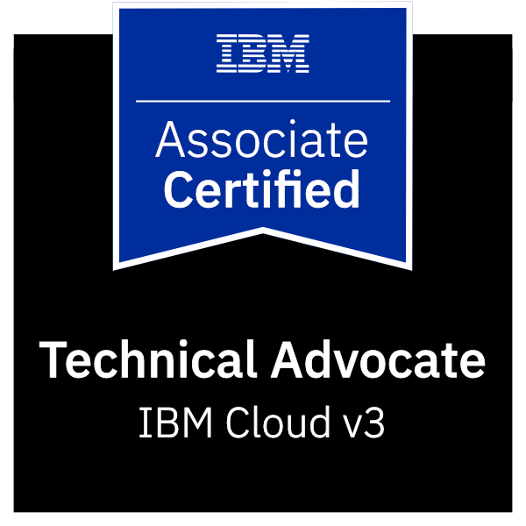

IBM Cloud Financial Services v1.

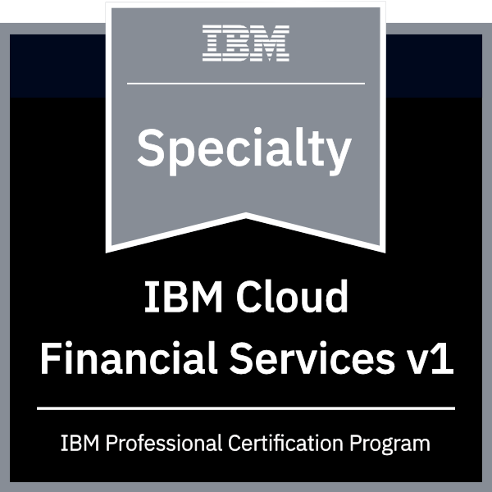

Microsoft Certified Azure Fundamentals

