

**Senior Consultant**

*Capgemini, Hyderabad, India / April 2019 – November 2021*

* Designed and developed an application using Spring Boot, Rest API and Java 11.
* Created reusable components using React JS.
* Developing Kafka Producer and Consumer
* Wrote unit tests to test all the desired functionality using Mockito.
* Creating Docker images and Deploying in Azure.
* Coordinates the cross-functional and/or cross-segment teams.

**Email:** [subbabny@gmail.com](mailto:subbabny@gmail.com)

**Phone:** +919962589250

**Address:** Flat 216, Sai Keerthi Prime, Chandanagar, Hyderabad - 500050

**CONTACT**

**EXPERIENCE**

Subbareddy Annapureddy

Full-stack Developer

**PROFESSIONAL SUMMARY**



Highly experienced, solutions-oriented professional with 14+ years of remarkable background in overseeing all aspects of the Software Development Life Cycle, from extensive analysis and design through execution and maintenance. Proficient in utilizing a wide variety of programs and tools to provide high-quality and cost-effective applications/systems to boost organizational efficiency and productivity.

**SKILLS**



Programming Languages: Java 8, Java 11 and J2ee

Frameworks: Spring MVC, Spring Boot, Spring Data JPA, Spring Cloud and Hibernate.

MQ: Kafka, RabbitMQ

Frontend: Html5, CSS, JavaScript, React JS and Redux

Data base: Oracle, My SQL, PostgreSQL

No SQL: MongoDB

DevOps: Git, Jenkins, SonarQube Docker, K8s and OpenShift

Cloud: AWS, Azure and IBM Cloud.

Other: SOLID Principles, Java design patterns and Microservices design patterns

Domain: Banking and Financial Services, Insurance

**Senior System Analyst**

*IBM, Hyderabad, India / December 2021 - Present*

* Designed and developed an application using Spring Boot with Microservices, Rest API, Java 11, Kafka and Apache Camel.
* Wrote unit tests to test all the desired functionality using Mockito.
* Involved in requirements gathering and requirements analysis and participated client meetings.
* Mentoring the team members in understanding the process & modifying requirements.
* CI/CD pipeline build and deploy in OpenShift.

**Technical Lead**

*BNY Mellon, Chennai, India / April 2013 – January 2019*

* Designed and developed an application using Java 8, Spring MVC and Hibernate.
* Wrote unit tests to test all the desired functionality using Mockito.
* Lead large, complex projects to achieve key business objectives.
* Influences senior leadership to adopt new ideas, products, and/or approaches.
* Coordinates the cross-functional and/or cross-segment teams.



**EDUCATION**



**Master of Computer Applications**

Acharya Nagarjuna University, Andhra Pradesh - 522510

**Senior Software Engineer**

*Hexaware, Chennai, India / March 2011 – March 2013*

* Analysis and Implementation of enhancements and new features.
* Wrote unit tests to test all the desired functionality using Junit.
* Designed and developed frontend application using Html, CSS and JavaScript.
* Production support and Incident’s support.

**Certifications**



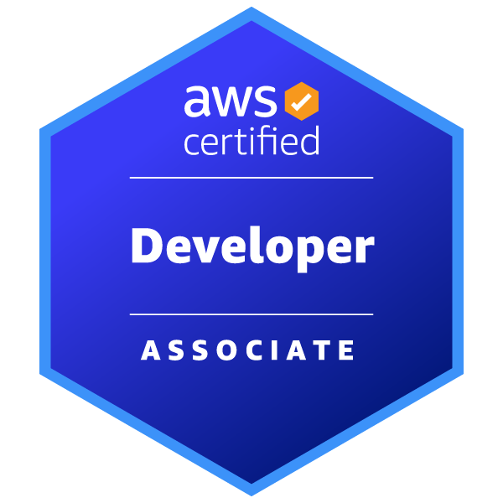



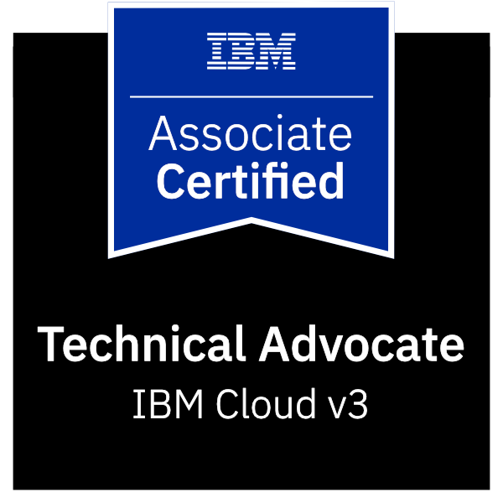

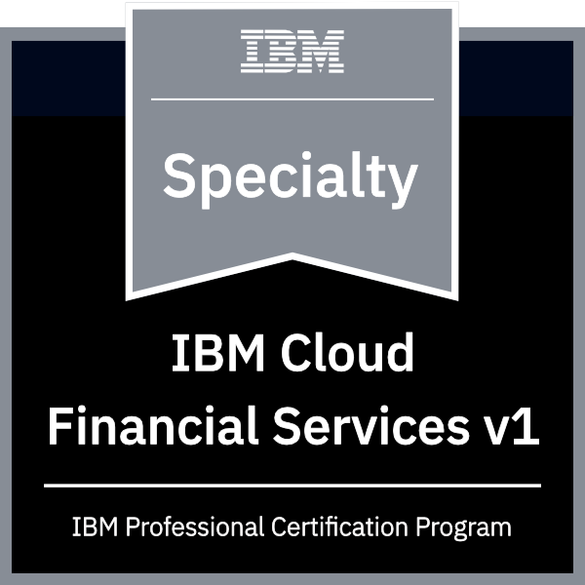

**Software Engineer**

*Mastek, Mumbai, India / May 2010 – March 2011*

* Coded backend services using Java and Rest API.
* Wrote unit tests to test all the desired functionality using Junit.
* Designed and developed frontend application using Html, CSS and JavaScript.

**Software Engineer**

*L&T Infotech, Mumbai, India / February 2008 – April 2010*

* Developed backed application using Java and Struts 1.2.
* Wrote unit tests to test all the desired functionality using Junit.