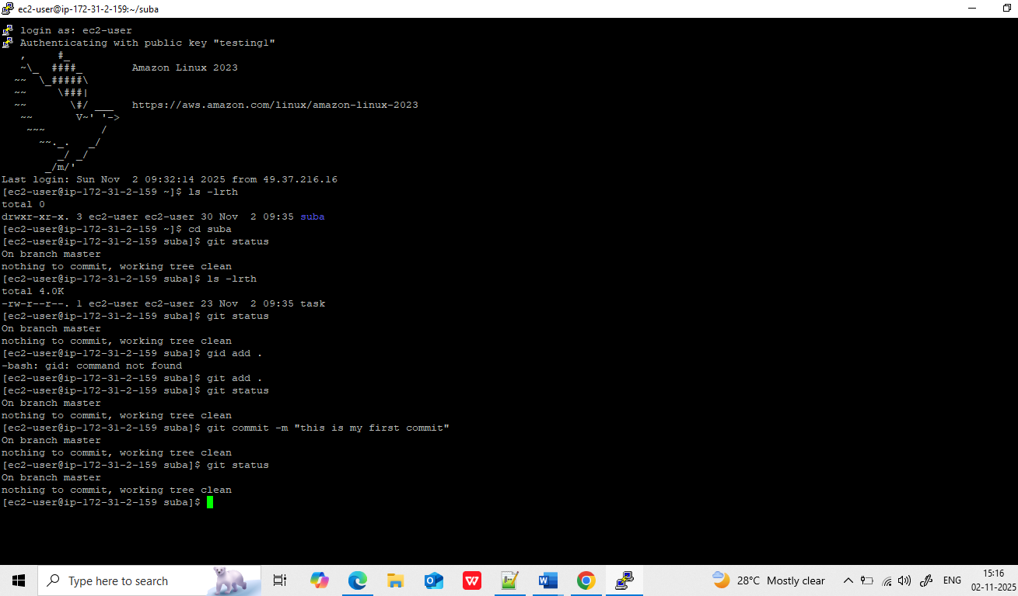

- Directory create suba
- Under directory initialixe git git init
- File create test1.txt
- Git add to move my file into stagig area
- Git commit – to move my file from staging to local repository
- Git repository create In git hub
- Git remote add origin url
- Existing repository – git remote origin url
- Origin variable name

Global user congig –name “git username”
Global -user config email – “gmal”

Git push orign master
It prompts your git user id an dpat token
After provided pat token
File will be pushed from local to remote .

Conflicts:

https://github.com/subbasri17/Git-task.git

doubt :
git remote origin https://github.com/subbasri17/Git-task.git-- error

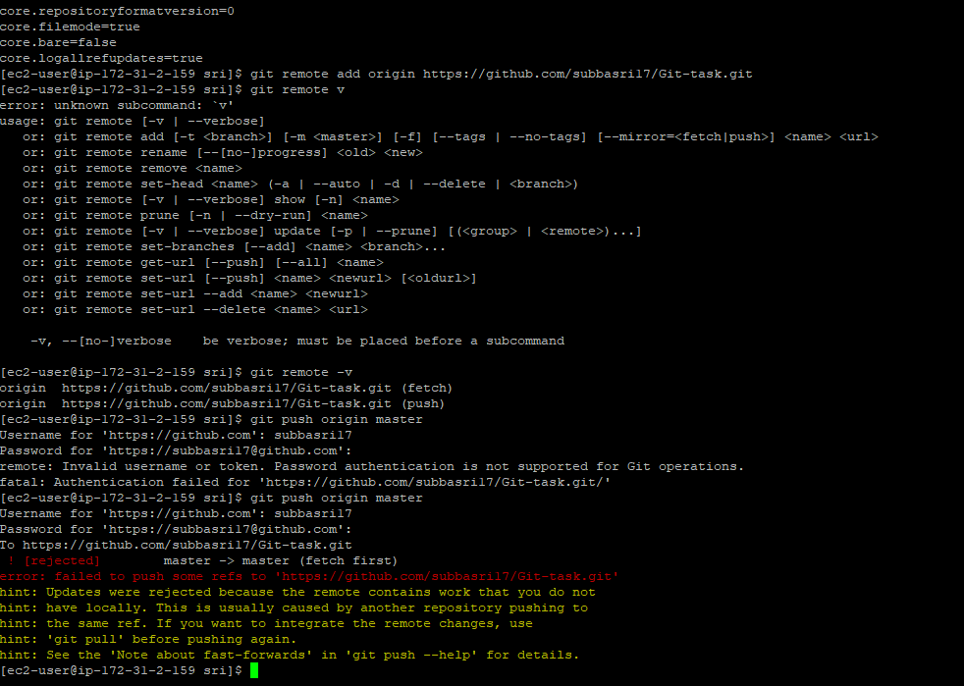

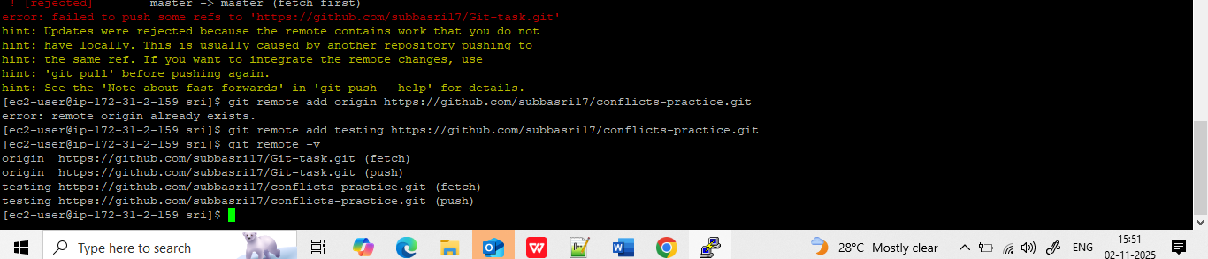

[ec2-user@ip-172-31-2-159 shiv]$ git config pull.ff true
[ec2-user@ip-172-31-2-159 shiv]$ git pull https://github.com/subbasri17/conflicts-practice.git
From https://github.com/subbasri17/conflicts-practic

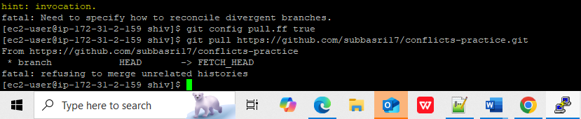

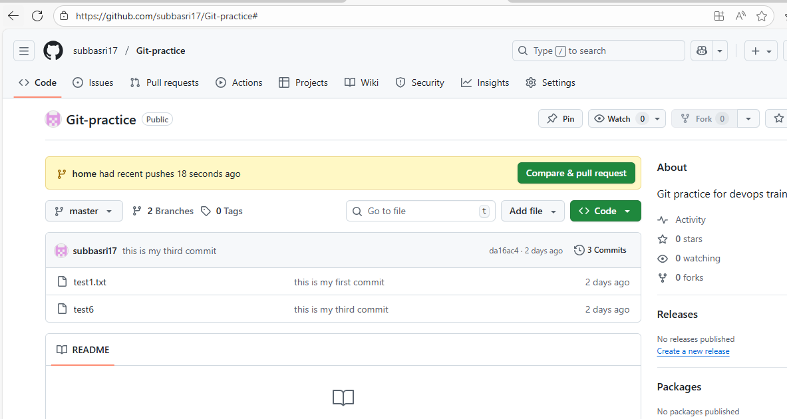

1st conflict:
I am in one directory and am trying to pull other directory:

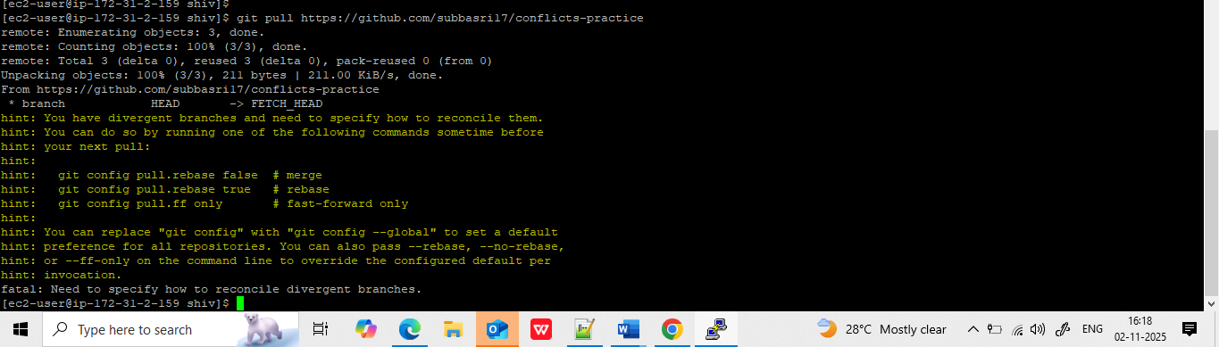

fatal: Need to specify how to reconcile divergent branches.
[ec2-user@ip-172-31-2-159 shiv]$ git config pull.ff true
[ec2-user@ip-172-31-2-159 shiv]$ git pull https://github.com/subbasri17/conflicts-practice.git
From https://github.com/subbasri17/conflicts-practice
* branch HEAD -> FETCH_HEAD
fatal: refusing to merge unrelated histories
[ec2-user@ip-172-31-2-159 shiv]$ fatal: refusing to merge unrelated histories
-bash: fatal:: command not found
[ec2-user@ip-172-31-2-159 shiv]$ git config pull.rebase false
[ec2-user@ip-172-31-2-159 shiv]$ git pull https://github.com/subbasri17/conflicts-practice.git
From https://github.com/subbasri17/conflicts-practice
* branch HEAD -> FETCH_HEAD
fatal: refusing to merge unrelated histories
[ec2-user@ip-172-31-2-159 shiv]$ git config pull.rebase true
[ec2-user@ip-172-31-2-159 shiv]$ git pull https://github.com/subbasri17/conflicts-practice.git
From https://github.com/subbasri17/conflicts-practice
* branch HEAD -> FETCH_HEAD
Successfully rebased and updated refs/heads/home.

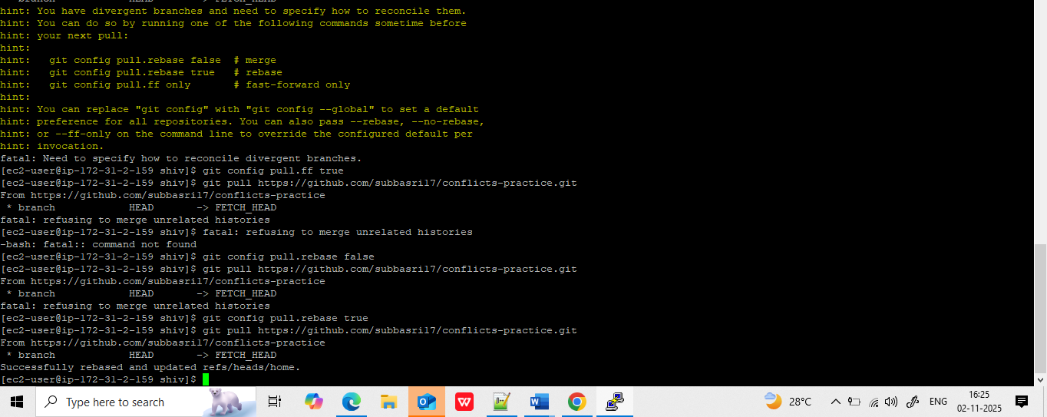

Basically we are trying to get the source code from one repository to other repository by using pull command.
When we try to use pull, you will get a below errors, while trying 3 options. Rebase is worked for me

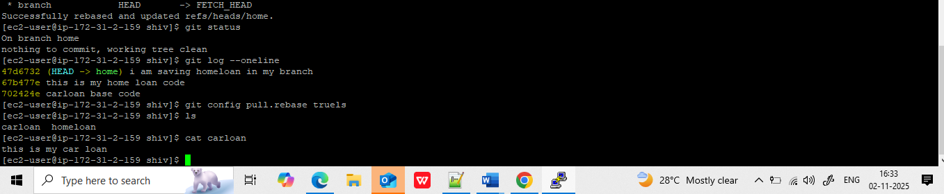

Pulling can do twice:
Cloning , and pulling.
We can merge by using below command to merge:
git pull origin master --allow-unrelated-histories

trying to pull

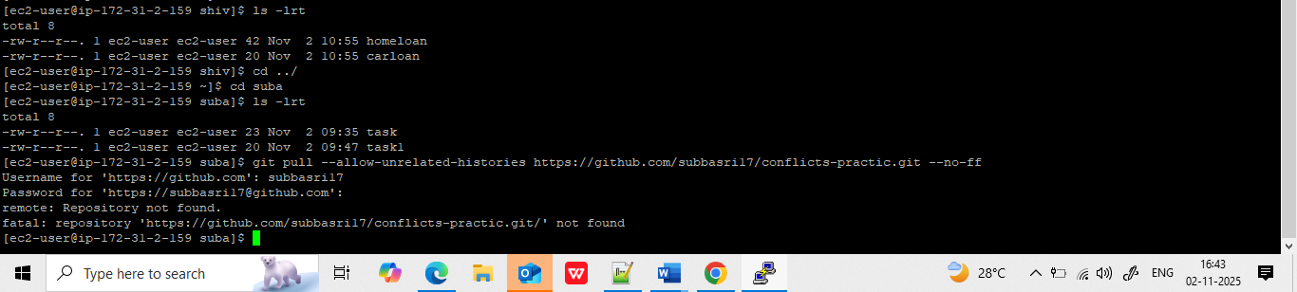

Same repository :
Two different user trying to push the differnent source code in the same branch.
Try to pull which source code

Extra task given by mentor :
Actually I have created another directory and push carloan code to the same repository to the master repository I got the below error
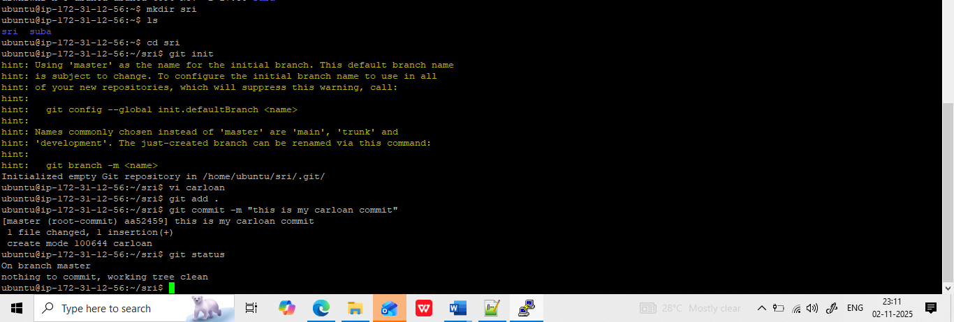

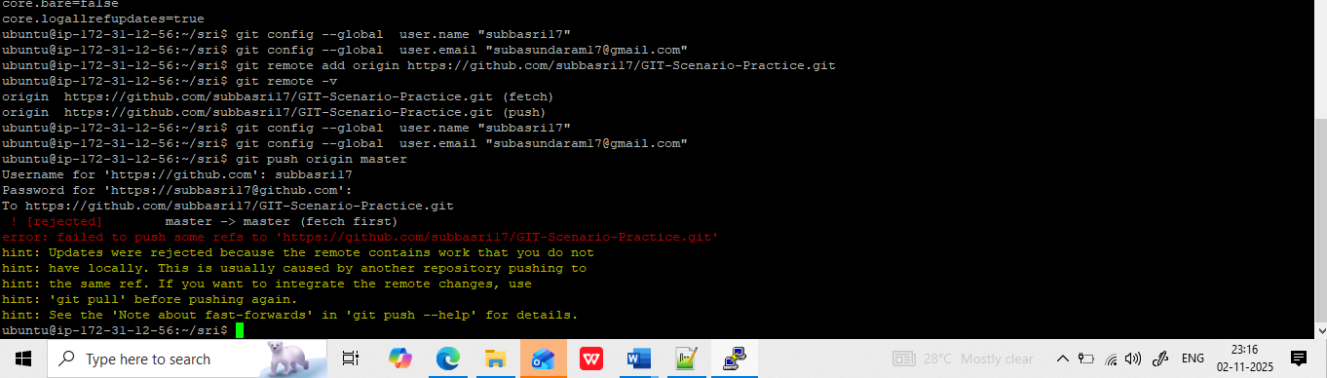

I tried different methods but cannot do i.
So what I do, I create a new branch in sri directory , and then pushed in a new branch

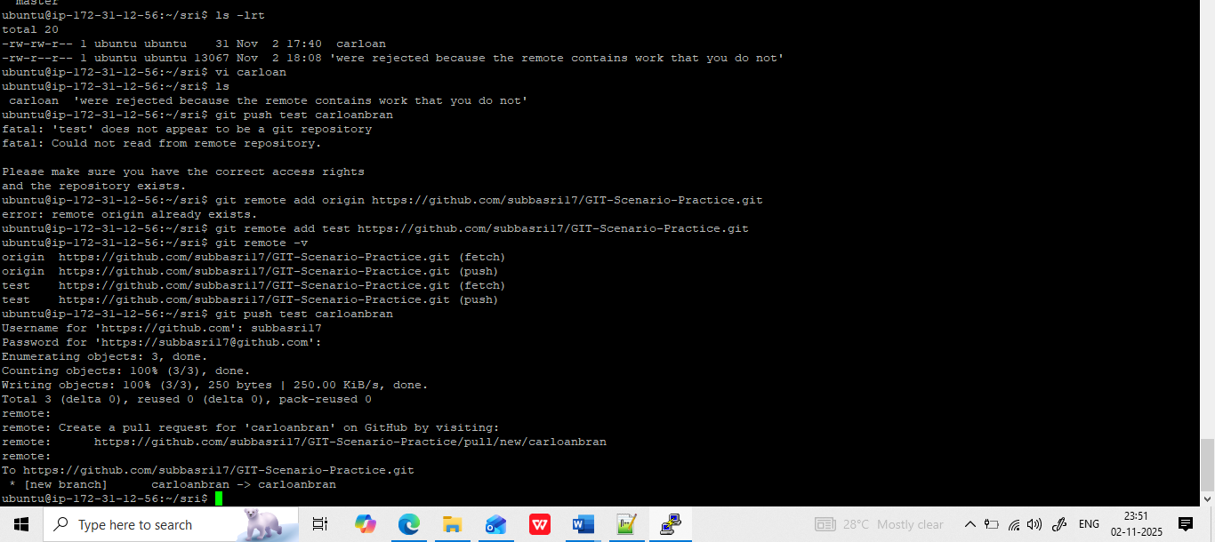

I tried to git pull the simply repository, ia m getting the below error.
Branches · subbasri17/GIT-Scenario-Practice

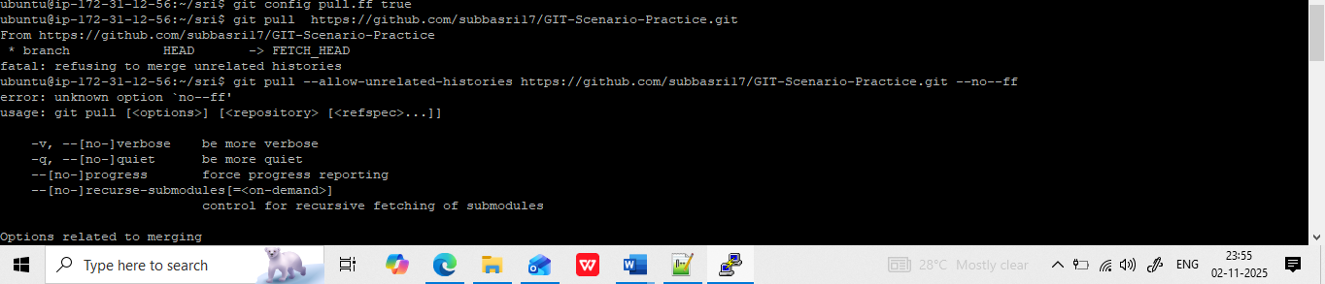

I tried to push the same name source code in the below repository, already that repository has same name file home loan, so I got below error. So I clone the git repository and could see another home loan file, I juts do some changesand pushing again./
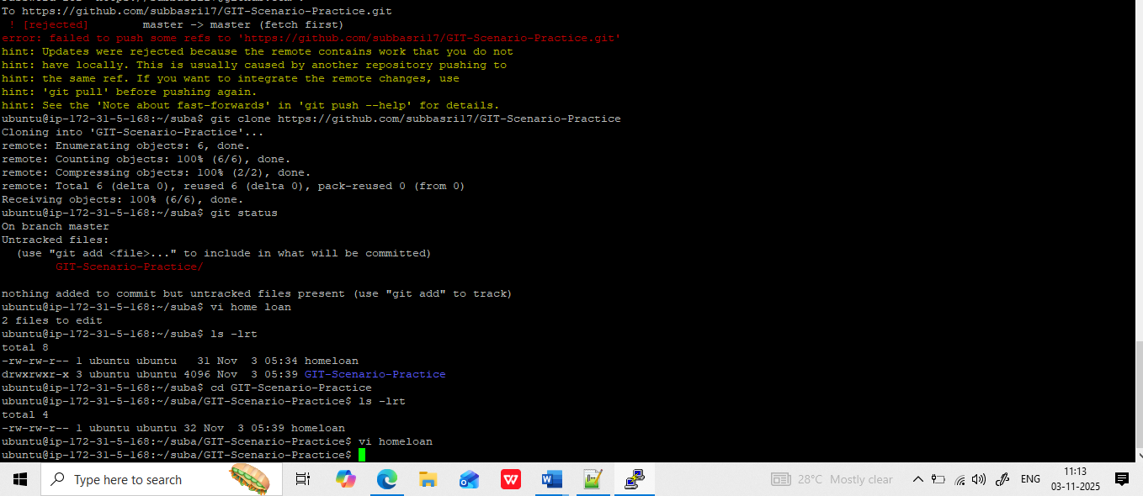

After clone, I tried to add repository again to push the code, but it showed below error.

Without adding remote add and config, I just directly push the file, and able to push it.
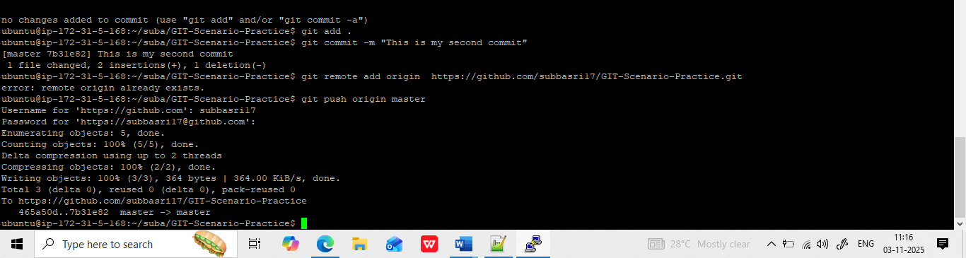

What I am suspect :
Master branch has only one file and the feature has multiple file. We should not add other different file name in the master branch.
If any anymodification, we can clone and push.

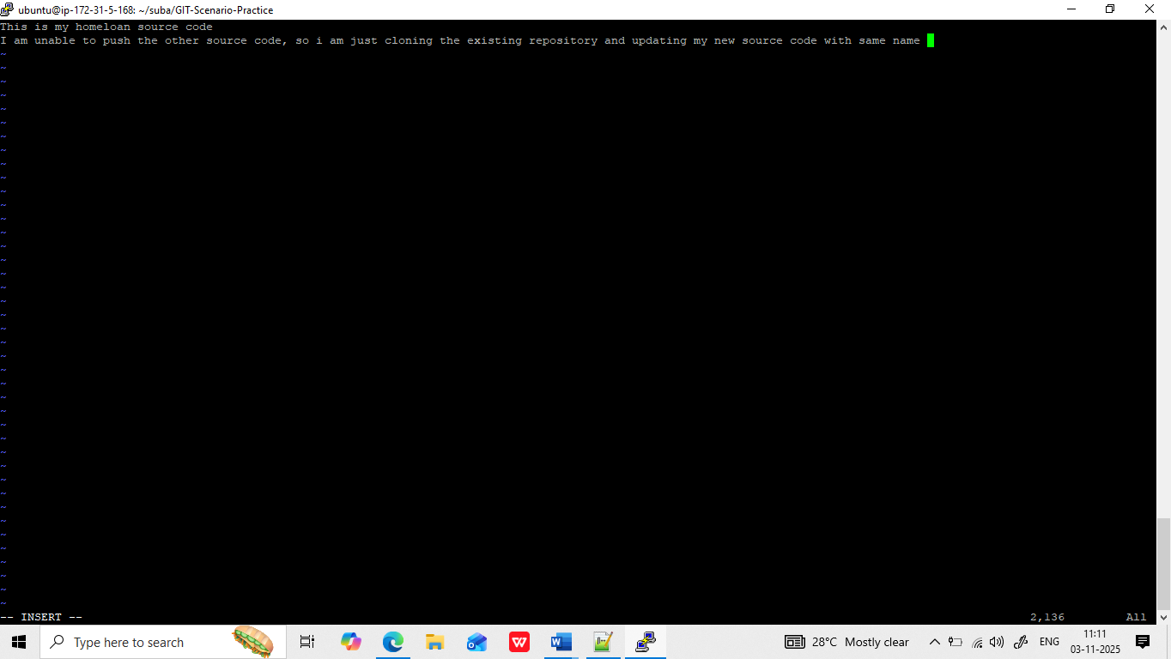

If I want to add a branch on git hb.
- I cloned the repository
- git clone https://github.com/subbasri17/GIT-Scenario-Practice.git
- cd that cloned repository
- create my branch
- go that branch , file commit an dchnages.
- Add that branch to remote
- Pushes the branch to remote

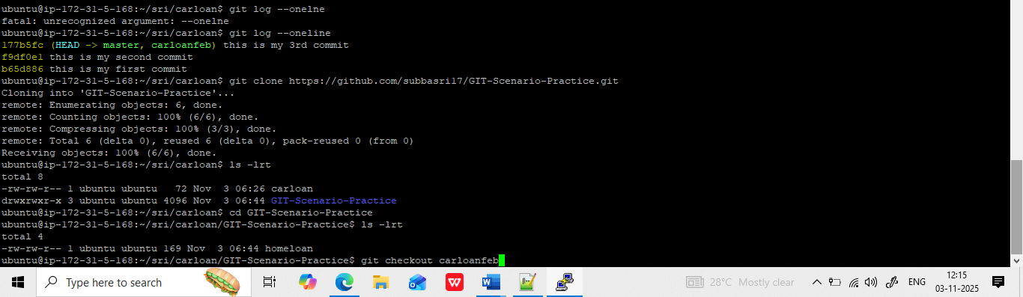
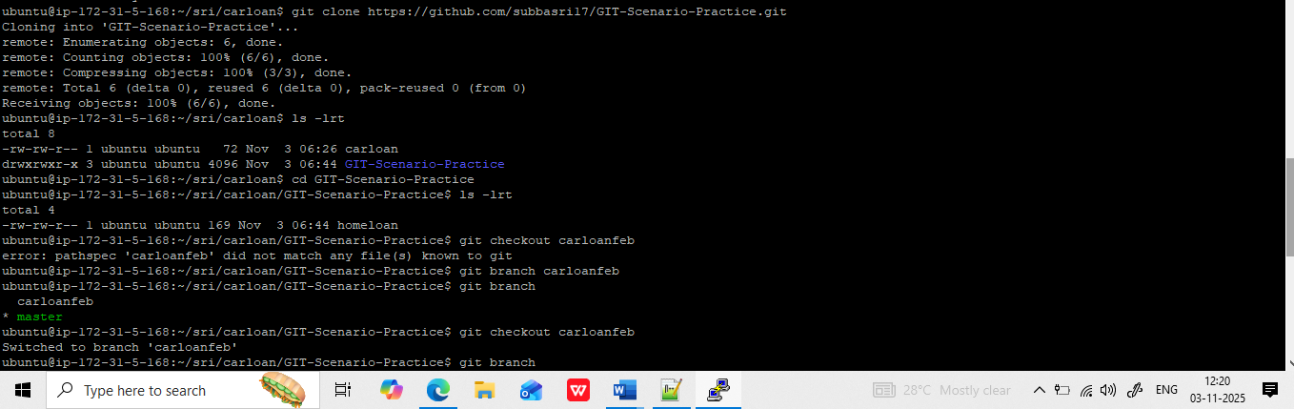
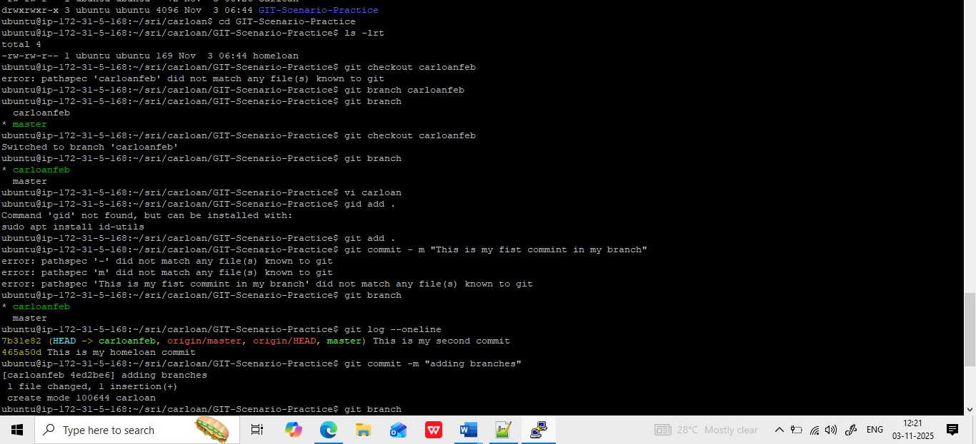
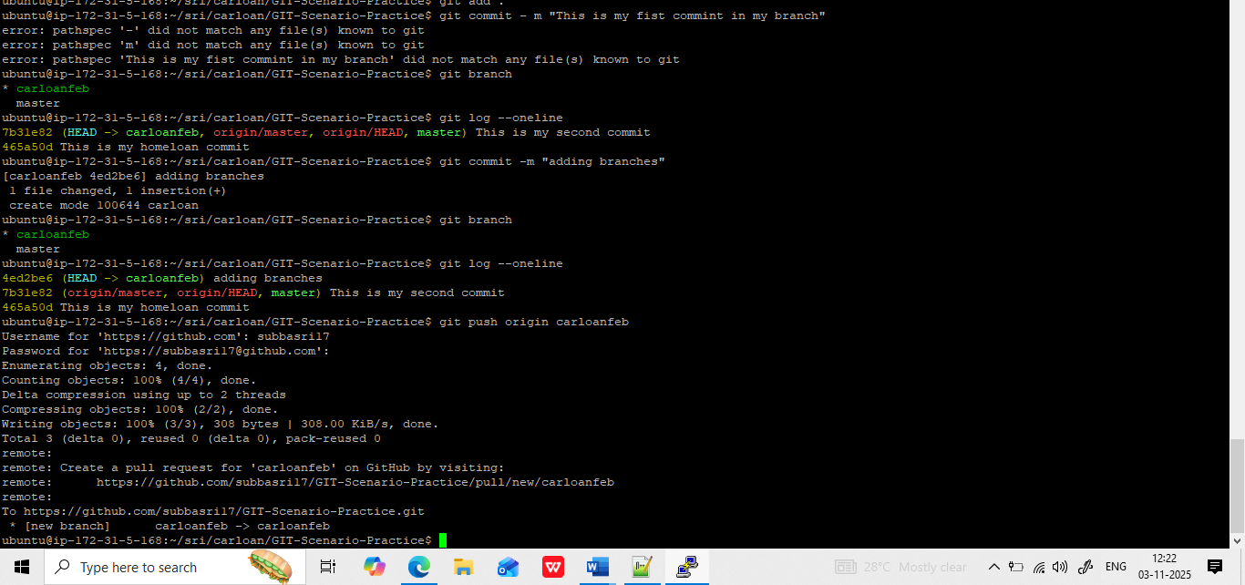

Pull – ihave a doubt:

