**Task Description:**

1. Create a S3 bucket, with no public access and upload files to the bucket & view the logs using cloud watch for the uploaded files.

S3 bucket created : [738-13830-8153](https://ap-south-1.console.aws.amazon.com/s3/buckets/738-13830-8153?region=ap-south-1&bucketType=general) with no public access.

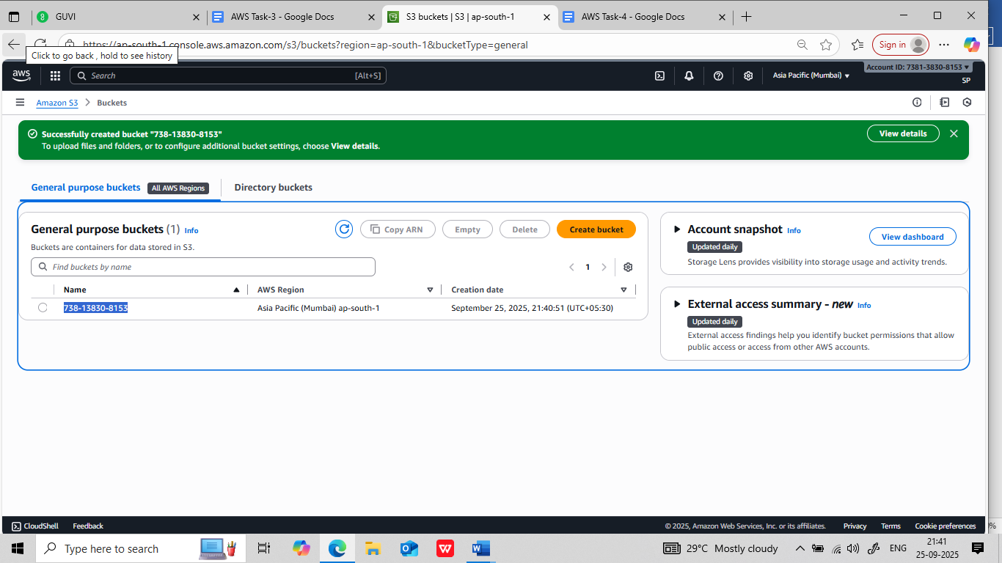

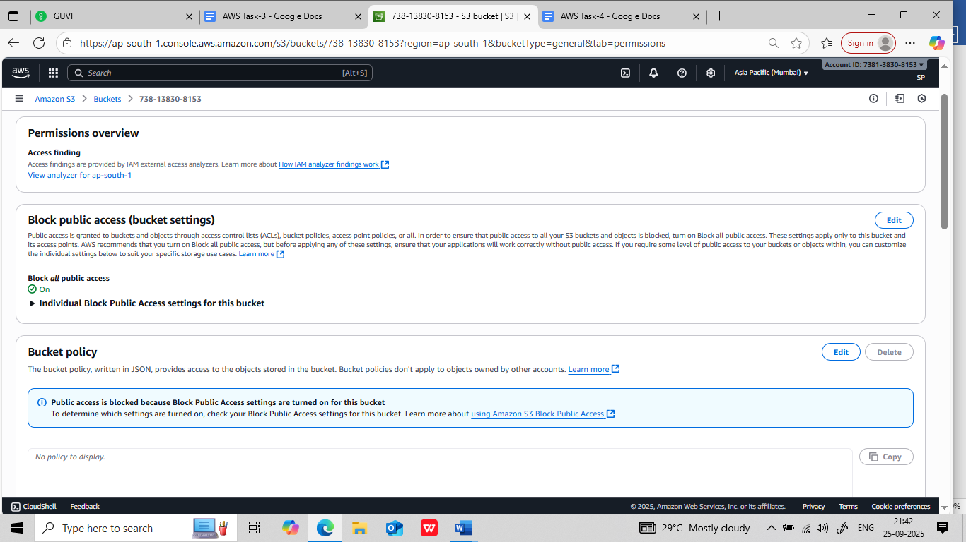

Upload files to the bucket and versioning the bucket:

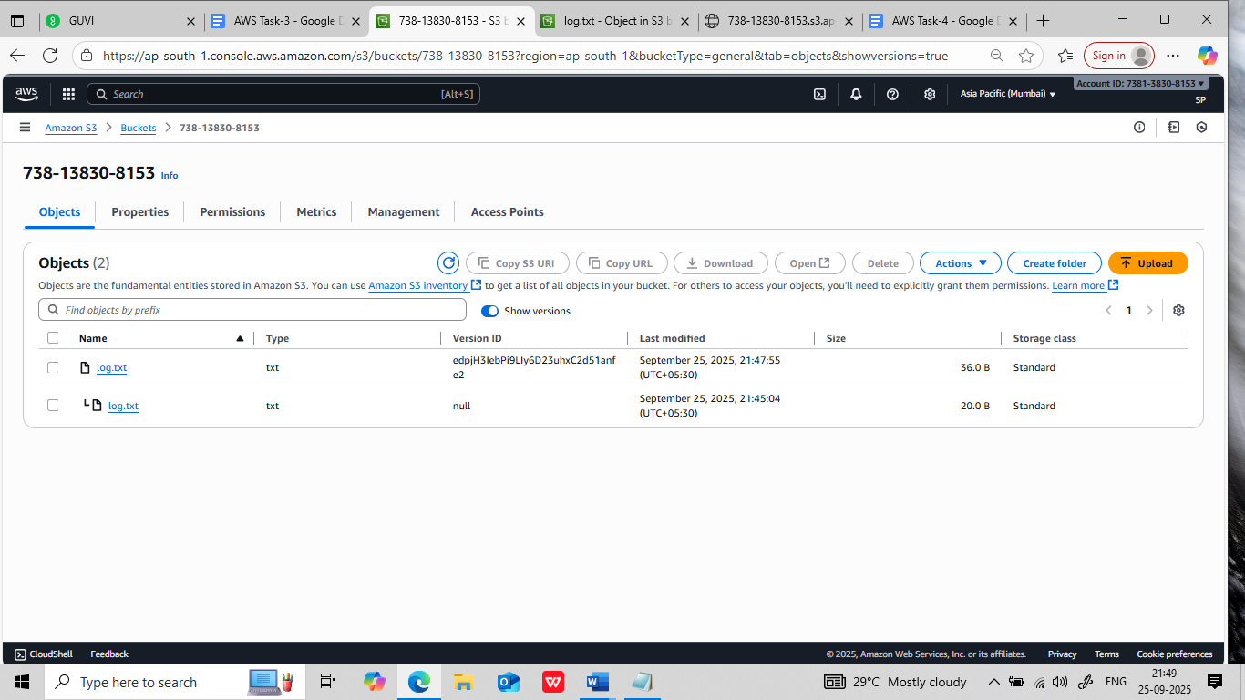

Cloud watch concept is not yet covered by the mentor.

1. Launch two ec2-instances and connect it to a application load balancer, where the output traffic from the server must be an load balancer IP address :

Two instances created:

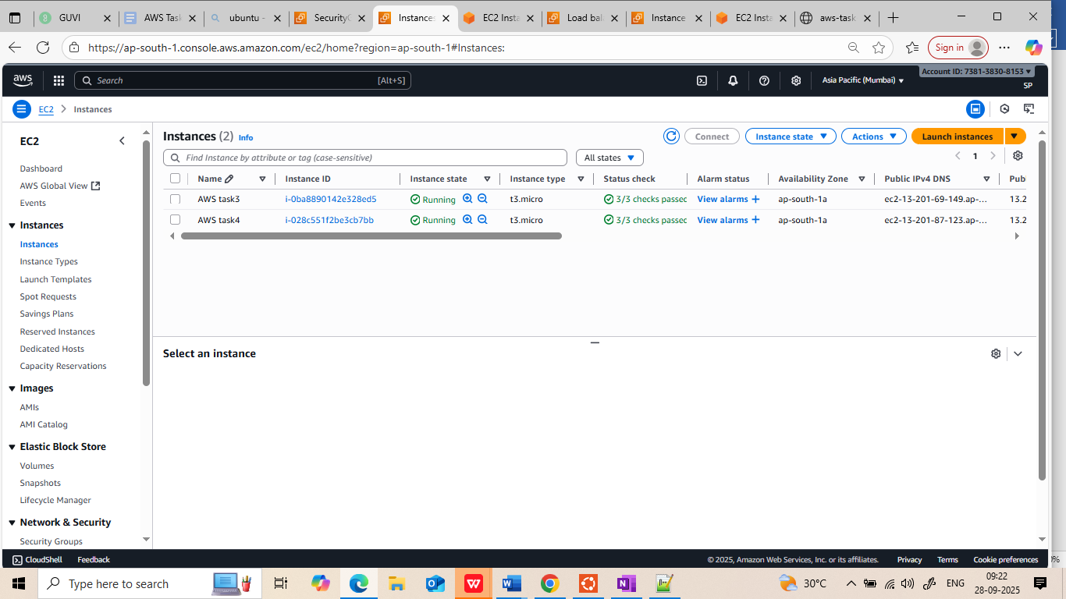

Webserver nginx installed on both instances:

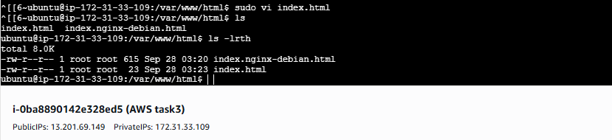

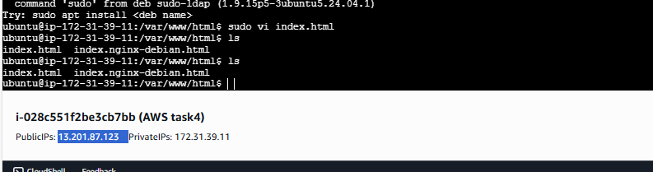

Creating application load balancer:   
**Load balancer : AWS-task-lb,**

**Target grp 1 – attached two instances allowed outside traffic.**

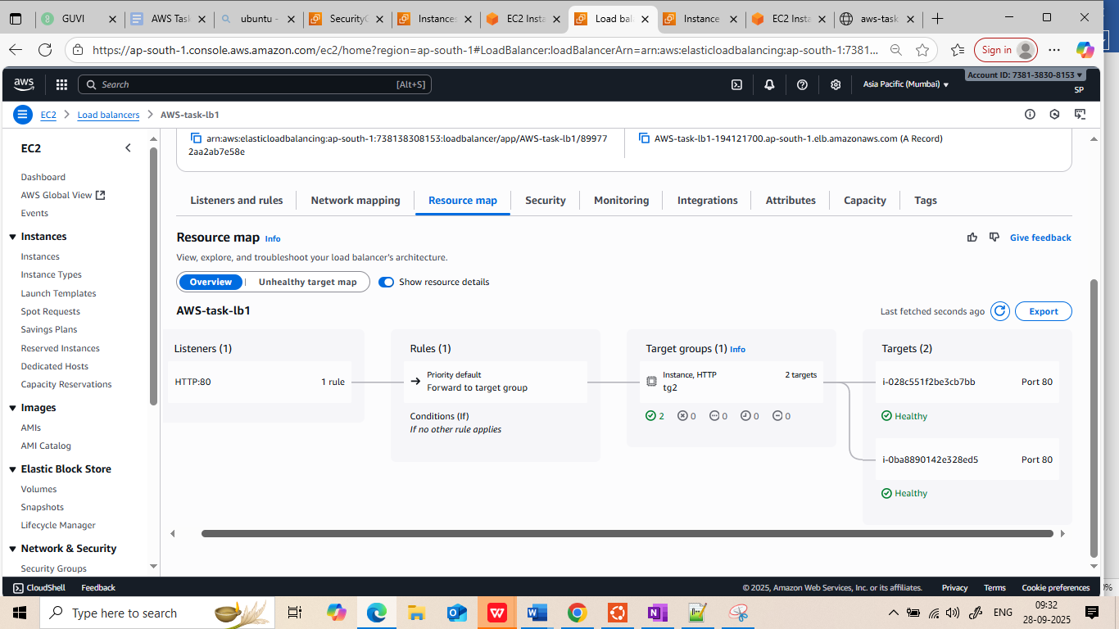

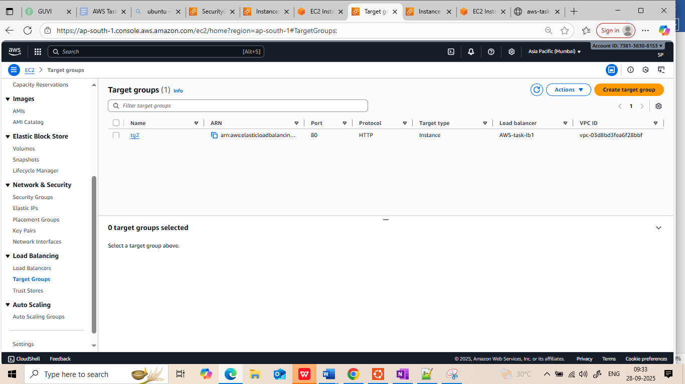

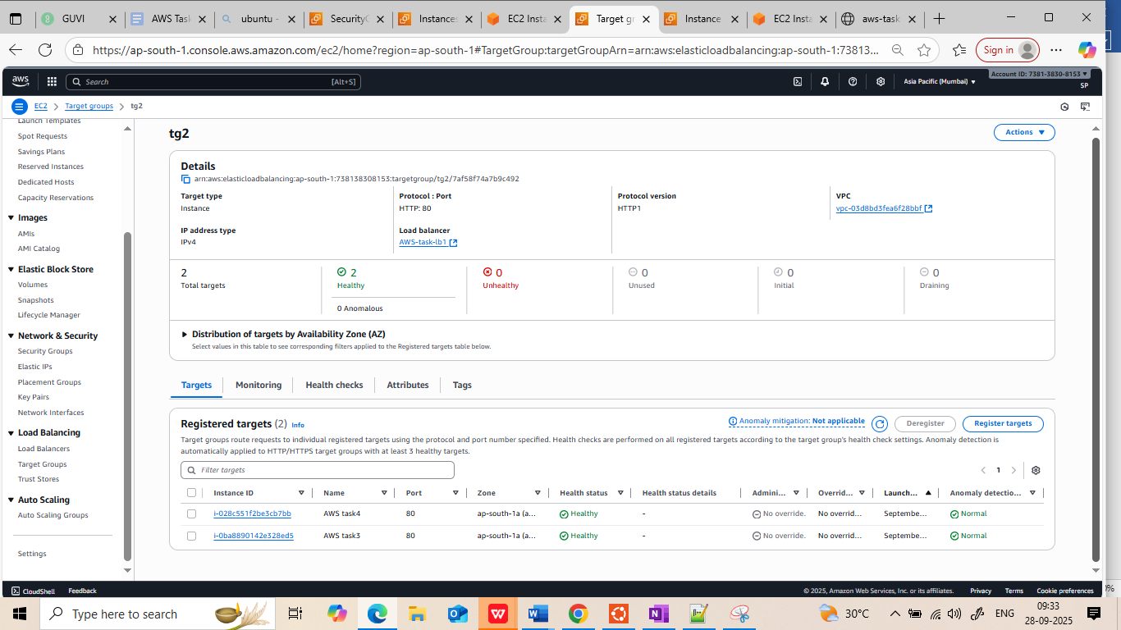

Load balancer DNS name:

[aws-task-lb1-194121700.ap-south-1.elb.amazonaws.com](http://aws-task-lb1-194121700.ap-south-1.elb.amazonaws.com/)

First Hit:

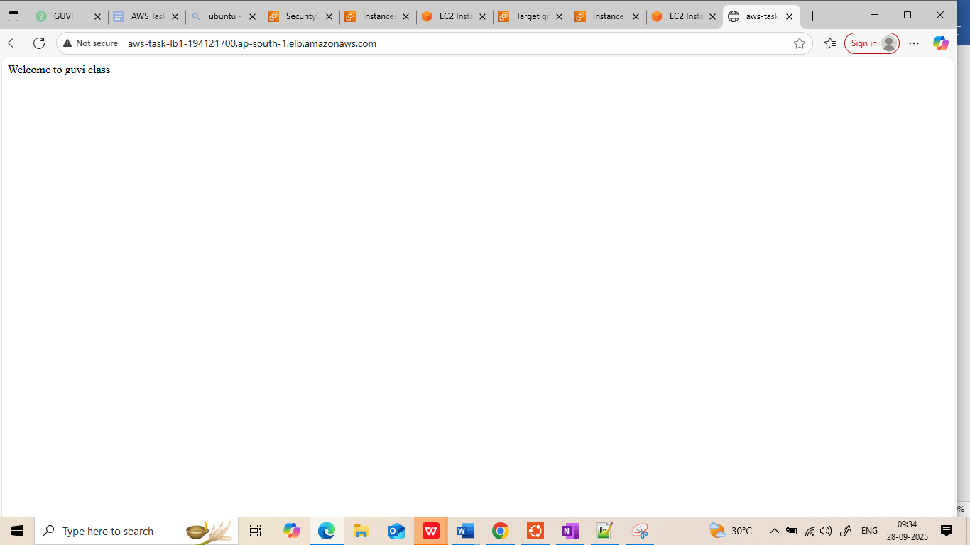

Second hit :

