TOURISM WEBSITE — PROJECT REPORT
Greater Hyderabad
City of Pearls — A Multi-Page Tourism Website
Built with HTML5 & CSS3 | 11 Pages | 8 Stylesheets | No Framework
Prepared by
[ Your Name ]
Web Development Project — HTML5 · CSS3 · Responsive Design

Table of Contents
1. Introduction 3
1.1 Purpose of This Report 3
2. Project Objectives 3
3. Technology Stack 3
4. Site Structure 4
5. Design System 5
5.1 Colour Palette 5
5.2 Typography 5
5.3 Shared Scales 5
6. CSS Architecture 6
6.1 Component Library 6
7. Animation System 7
7.1 Keyframes (17 total) 7
7.2 The Homepage Gallery Carousel 7
7.3 Accessibility 7
8. Responsive Design Strategy 8
9. Website Screenshots 9
9.1 Home Page 9
9.2 All Places — Listing Page 9
9.3 Why Visit Hyderabad 10
9.4 Shopping — Malls & Centres 10
9.5 Gallery — Explore Through Photos 11
9.6 About — History Timeline 11
9.7 About — Our Story 12
10. Challenges Faced 13
11. Learnings & Outcomes 14
12. Conclusion & Future Scope 15

1. Introduction
“Greater Hyderabad” is a complete, front-end-only tourism website built to present Hyderabad — the “City of Pearls” — as a travel destination. The site covers the city's heritage monuments, temples, parks, museums, cuisine, shopping and culture across 11 interconnected HTML pages, all styled by a shared design system built from 8 separate CSS files.
The project was built with plain HTML5 and CSS3 only — there is no back end, no build tool, and almost no JavaScript. It is a fully static, hand-crafted website, making it a strong demonstration of core web-design fundamentals: semantic markup, CSS architecture, responsive layout, and advanced CSS animation, all without relying on a framework.

1.1 Purpose of This Report
This report documents the goals, structure, design system, and technical implementation of the website, along with the challenges encountered during development and the key lessons learned. It is intended to accompany the project submission and the presentation deck.

2. Project Objectives
- Showcase the destination — present Hyderabad's monuments, culture, food and shopping in a visually rich, card-based format that inspires travel.
- Multi-page navigation — build one consistent navbar repeated identically across all 11 pages so visitors can move seamlessly between categories.
- Visual storytelling — use hero sections, photo galleries, an animated carousel and a historical timeline to bring the city to life.
- Consistent design system — apply one shared set of colours, fonts, shadows and spacing tokens across every page and every component.
- Responsive, accessible design — ensure the site adapts cleanly from large desktop monitors down to small mobile phones.

3. Technology Stack
Technology | Role in the Project
HTML5 | Semantic page structure across all 11 pages — <nav>, <section>, <article>, <footer>
CSS3 | All visual styling, layout (Flexbox & Grid), animation and responsive behaviour
CSS Custom Properties | A single :root token system for colours, fonts, radii, shadows and transitions
CSS Grid & Flexbox | Card grids, footer columns, navbar layout, filter bars and form rows
CSS Keyframe Animation | 17 reusable keyframes powering entrances, hovers and the homepage carousel
Google Fonts | Playfair Display (headings), Poppins (body text), Inter (navigation & UI)
Vanilla JavaScript | A single 6-line script that rotates the homepage's hero emblem image

Notably, two pieces of “app-like” interactivity — the mobile navigation menu and the gallery's category filter — are built entirely with CSS, using the native :checked pseudo-class on hidden checkbox/radio inputs, without any JavaScript at all.

4. Site Structure
The website consists of 11 pages that all share an identical layout skeleton: Navbar → Hero → Breadcrumb → Content Sections → Newsletter → Footer.
Page | File | Content
Home | index.html | Hero, featured destinations, why-visit, top attractions, gallery carousel, testimonials
Places | places.html | Master directory of 100+ tourist destinations with a category filter bar
Heritage | heritage.html | Forts, palaces and historic monuments
Temples | temples.html | Sacred sites and places of worship
Parks | parks.html | Gardens, lakes and green spaces
Museums | museums.html | Art, history and cultural collections
Food | food.html | Hyderabadi cuisine and where to find it
Shopping | shopping.html | Bazaars, malls and local crafts
Gallery | gallery.html | Filterable photo gallery with a CSS-only category filter
About | about.html | City history timeline, transport options and seasonal weather
Contact | contact.html | Enquiry form, sticky info card and emergency numbers

5. Design System
Every colour, font, shadow, radius and transition used across the 8 CSS files is defined once as a CSS custom property in :root, then reused everywhere with var(--token) — this is what keeps 11 separate pages feeling like one cohesive product.

5.1 Colour Palette
Token | Hex | Usage
--primary | #8B0000 | Deep maroon — primary brand colour (heritage / royal theme)
--secondary | #FFD700 | Gold accent — Nizami / royal highlight
--accent | #008080 | Teal — secondary badges and category accents
--bg | #FFF8F0 | Warm cream page background
--dark / --gray | #222222 / #6b6b6b | Body text and secondary text tones

5.2 Typography
Font | Token | Usage
Playfair Display | --font-head | Headings — an editorial serif that carries the heritage theme
Poppins | --font-body | Body copy across all pages
Inter | --font-ui | Navigation links, labels, buttons and UI chrome

5.3 Shared Scales
- Corner radius: 6px / 12px / 20px / 32px — a 4-step rounding scale (--radius-sm to --radius-xl)
- Shadow elevation: 4 escalating box-shadow presets (--shadow-sm to --shadow-xl)
- Transition: one shared easing curve — all 0.35s cubic-bezier(0.4, 0, 0.2, 1) — used on nearly every hover effect sitewide

6. CSS Architecture
Rather than one large stylesheet, the CSS is deliberately split by responsibility across 8 files, loaded in a fixed order on every page so later files can safely override earlier ones.
File | Lines | Role
style.css | 1,366 | Foundation — reset, design tokens, navbar, footer, buttons, badges
responsive.css | 2,448 | Every @media breakpoint for every other file — always loaded last
home.css | 1,302 | Home-page-only sections: hero, featured grid, carousel, testimonials
cards.css | 755 | Every reusable listing/detail card used across category pages
contact.css | 616 | Contact page: hero, form, info card, emergency grid
gallery.css | 423 | Gallery masonry grid, hover tilt effect, CSS-only filter system
animation.css | 452 | Every @keyframes definition and animation utility class
about.css | 187 | About page: timeline, transport cards, weather cards

Loading order on every page: style.css → page-specific CSS → cards.css → animation.css → responsive.css. This mirrors a lightweight ITCSS/SMACSS layering (foundation → layout → components → motion → overrides), achieved with plain CSS and load order rather than a preprocessor.

6.1 Component Library
Component | Description
Buttons | .btn-primary / -secondary / -outline / -white — shared pill shape and hover-flash overlay
Badges | .badge-primary / -accent / -gold — tinted pill labels marking category on cards
Cards | 4 families: Place Card, Horizontal Detail Card, Shopping Card, Food Detail Card
Forms | Consistent input/textarea/select styling with a maroon focus ring
Navbar | Fixed, frosted-glass blur, animated underline, checkbox-driven mobile menu
Footer | 4-column grid: brand & socials, quick links, categories, contact info

7. Animation System
All motion on the site is centralised in one file, animation.css, split into keyframes, entrance/utility classes, and hover-interaction classes.

7.1 Keyframes (17 total)
Family | Keyframes
Fade / Entrance | fadeIn, fadeInUp, fadeInDown, fadeInLeft, fadeInRight, scaleIn, slideUp
Continuous / Ambient | float, pulse, glow, rotateSlow, spin, bounce, scrollDot
Sweep / Loading | shimmer, gradientShift, underlineExpand

7.2 The Homepage Gallery Carousel
The most technically advanced piece of CSS in the project is the homepage's auto-rotating 7-photo carousel — built with zero JavaScript. All 7 photo cards run the exact same 15.4-second keyframe animation, but each one is started at a different negative animation-delay (a 2.2-second step apart). A negative delay tells the browser to treat the animation as already partway through, so at any instant the 7 cards are all sampling different points of one shared timeline — which is what makes them look like independent objects orbiting a stage.
The keyframe itself defines a centre-front slot and three receding slots on each side; cards shrink, fade and rotate outward as they move from centre, and the invisible jump from far-right back to far-left is timed to happen exactly when the card is smallest and faintest, disguising the loop.

7.3 Accessibility
A single @media (prefers-reduced-motion: reduce) rule collapses every animation and transition duration to 0.01ms sitewide, respecting users who have disabled motion at the operating-system level.

8. Responsive Design Strategy
All breakpoint logic lives in responsive.css — at 2,448 lines, the single largest file in the project — loaded last on every page so its overrides always win.
Breakpoint | Purpose
≥ 1400px | Extra-large desktop refinements
1200px – 1399px | Large desktop band
≤ 1199px | Small-desktop / large-tablet — grids drop a column
≤ 1023px | Tablet — 2-column grids, stacked contact layout
≤ 767px | Mobile — hamburger nav takes over, single-column grids
≤ 575px | Small phones — reduced padding and font sizes
≤ 374px | Very small phones — final safety-net tightening

This is a desktop-first approach — base rules assume desktop widths, and the majority of queries use max-width to progressively simplify the layout downward, with only the top two bands using min-width for extra polish on very large screens.

9. Website Screenshots

9.1 Home Page
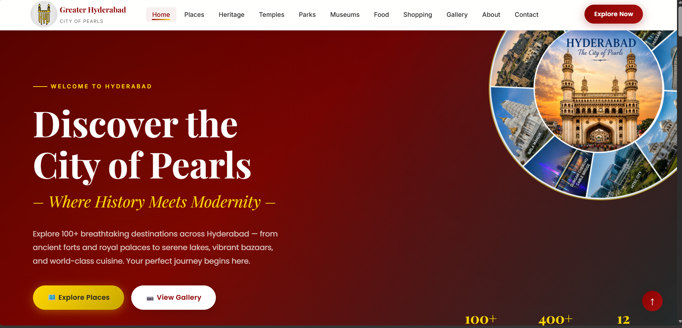
Hero banner with rotating emblem, stats bar and dual call-to-action buttons

9.2 All Places — Listing Page
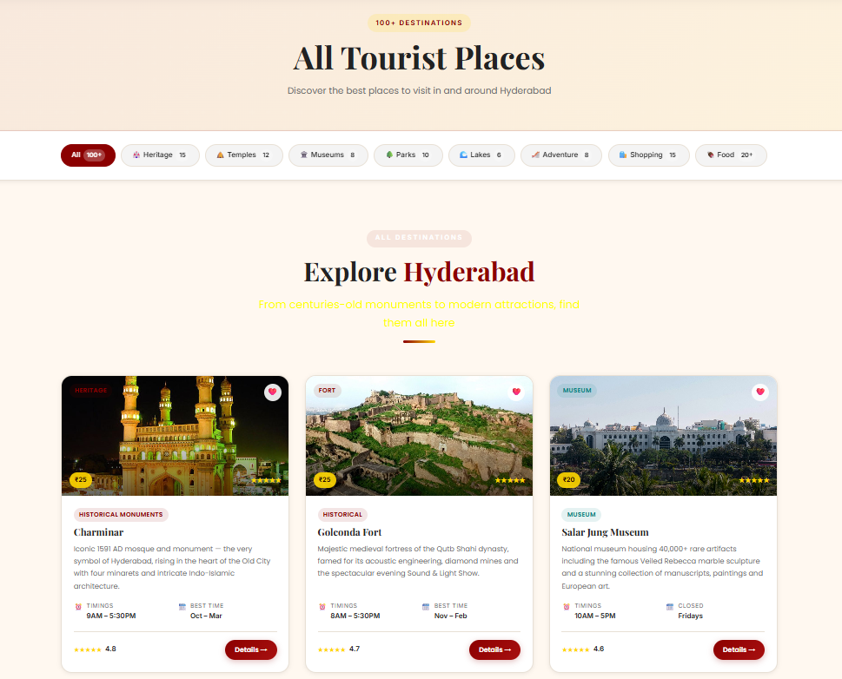
Filter bar plus a grid of destination cards with ratings, timings and entry fees

9.3 Why Visit Hyderabad
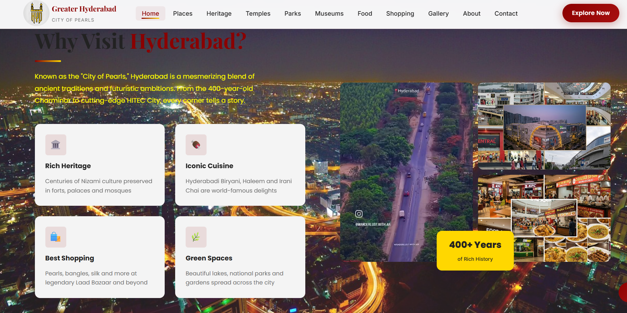
Feature tiles, an image collage and a floating “400+ Years” badge on the homepage

9.4 Shopping — Malls & Centres
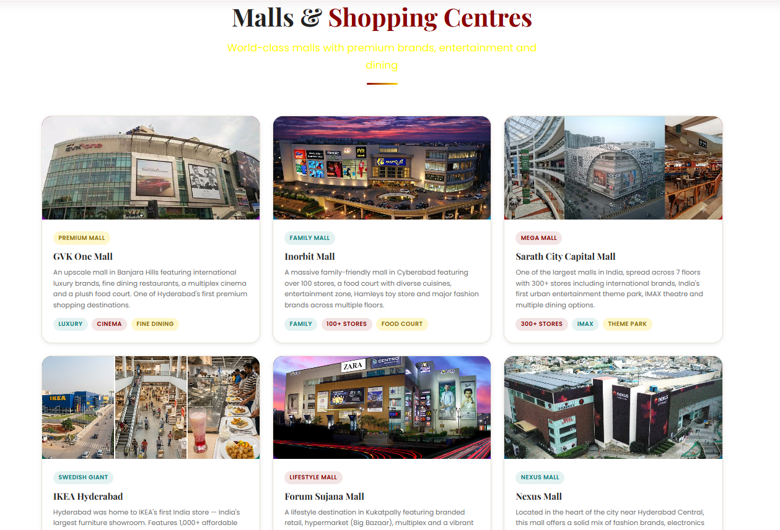
Shop-card grid with tagged highlights such as Luxury, Family Mall and IMAX

9.5 Gallery — Explore Through Photos
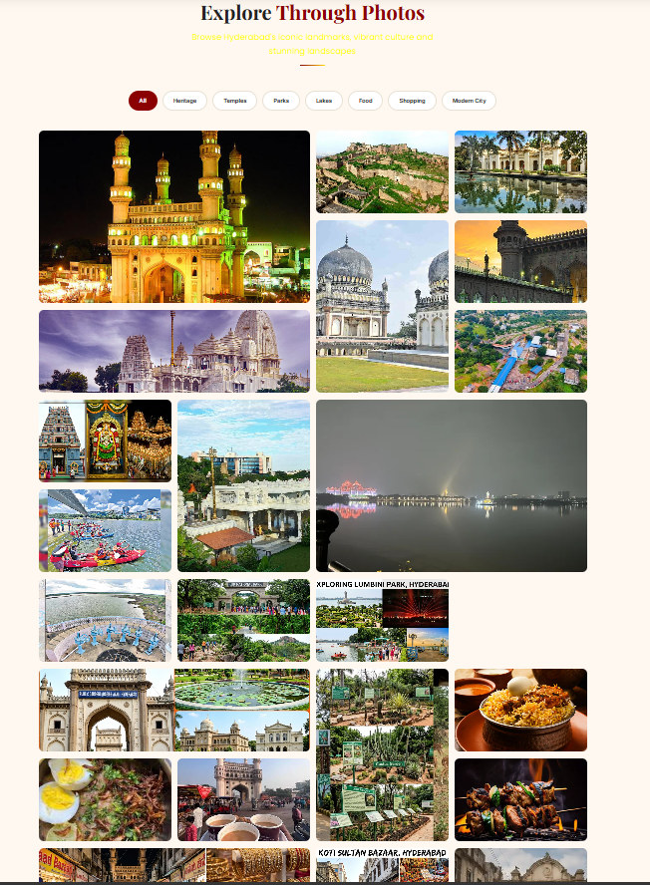
CSS-only category filters above a responsive photo masonry grid

9.6 About — History Timeline
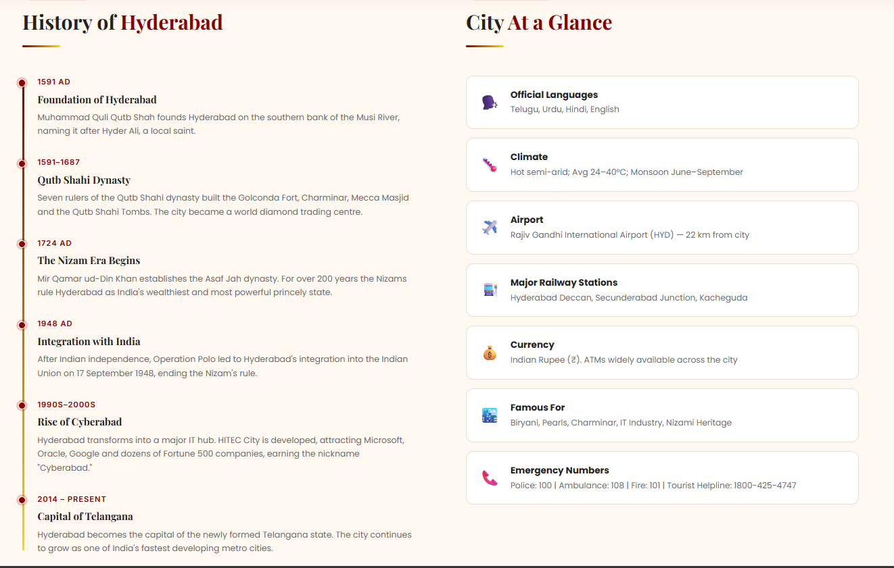
A vertical timeline of Hyderabad's history beside a “City at a Glance” fact panel

9.7 About — Our Story
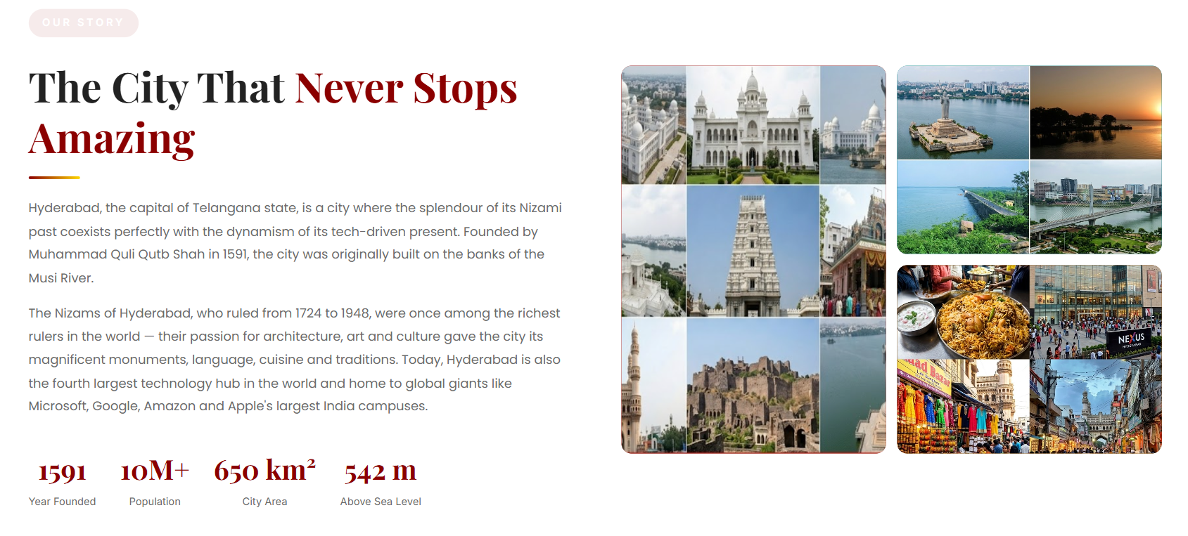
City narrative and key statistics beside a photo collage of Hyderabad's landmarks

10. Challenges Faced

Carousel Animation Math
Getting the 7-card gallery carousel to loop seamlessly required precise keyframe percentages and negative animation-delay staggering so that all 7 cards appear to move independently while sharing one animation timeline.

Consistency Across 8 Stylesheets
Keeping colours, spacing and typography identical across style.css, home.css, cards.css, about.css, contact.css, gallery.css, animation.css and responsive.css required strict discipline around the shared design-token system.

CSS-Only Interactivity
Building a fully working mobile navigation menu and gallery category filter using only the :checked pseudo-class and sibling combinators, without any JavaScript, took careful planning of the HTML structure so the CSS selectors could reach the elements they needed to affect.

Cross-Page Consistency
Repeating the navbar and footer identically across all 11 separate HTML files, with no shared template engine or build step, meant every structural change had to be applied by hand to each file.

11. Learnings & Outcomes

CSS Architecture
Learned to split stylesheets by responsibility — foundation, layout, components, motion and responsive overrides — for a codebase that stays maintainable even without a preprocessor or build tool.

Advanced Animation Techniques
Gained hands-on experience with CSS keyframes, animation-delay staggering, and 3D perspective hover effects, and learned how to disguise animation “seams” by timing them to occur when an element is least visible.

Responsive Design Strategy
Practised building a full breakpoint system covering everything from large desktop monitors down to small mobile phones, all centralised in one dedicated stylesheet.

Component-Based Thinking
Built a reusable card library and a design-token system that scales cleanly across 11 pages, reinforcing the value of designing components once and reusing them everywhere.

12. Conclusion & Future Scope

Successful Project Completion
All 11 pages meet the planned structure, navigation and visual-design goals set out at the start of the project, delivering a cohesive, visually consistent tourism website using only HTML5 and CSS3.

A Strong, Reusable Foundation
The design-token and component system is clean enough to extend with new pages or categories with minimal additional CSS, making the site a solid base for future development.

Future Scope
- Add a real backend to process the contact form and store enquiries
- Introduce JavaScript-powered search and dynamic filtering across the Places page
- Connect a CMS so tourist places, prices and images can be managed without editing HTML directly
- Add user accounts, reviews, and a wishlist feature building on the existing (currently decorative) heart-icon UI
— End of Report —

