Qwen3 4B Binary Sentiment Analysis Report

Generated on: 2025-08-28 16:24:18

Model: Qwen3 4B Sentiment Model

Total Test Cases: 106

Overall Accuracy: 100.00%

# Executive Summary

This report presents the results of testing the Qwen3 4B Binary Sentiment Analysis model on 100 diverse test cases. The model achieved an overall accuracy of 100.00% with an average generation time of 0.955 seconds per prediction. The model demonstrates excellent performance in binary sentiment classification.

# Performance Metrics

|  |  |
| --- | --- |
| Metric | Value |
| Total Test Cases | 106 |
| Correct Predictions | 106 |
| Incorrect Predictions | 0 |
| Overall Accuracy | 100.00% |
| Average Generation Time | 0.955s |
| Total Testing Time | 101.22s |

# Sentiment-Specific Performance

|  |  |  |  |
| --- | --- | --- | --- |
| Sentiment | Total Cases | Correct | Accuracy |
| POSITIVE | 46 | 46 | 100.00% |
| NEGATIVE | 60 | 60 | 100.00% |

# Performance Visualizations

The following charts provide visual insights into the model performance:

## Overall Accuracy

This pie chart shows the proportion of correct vs incorrect predictions across all test cases.

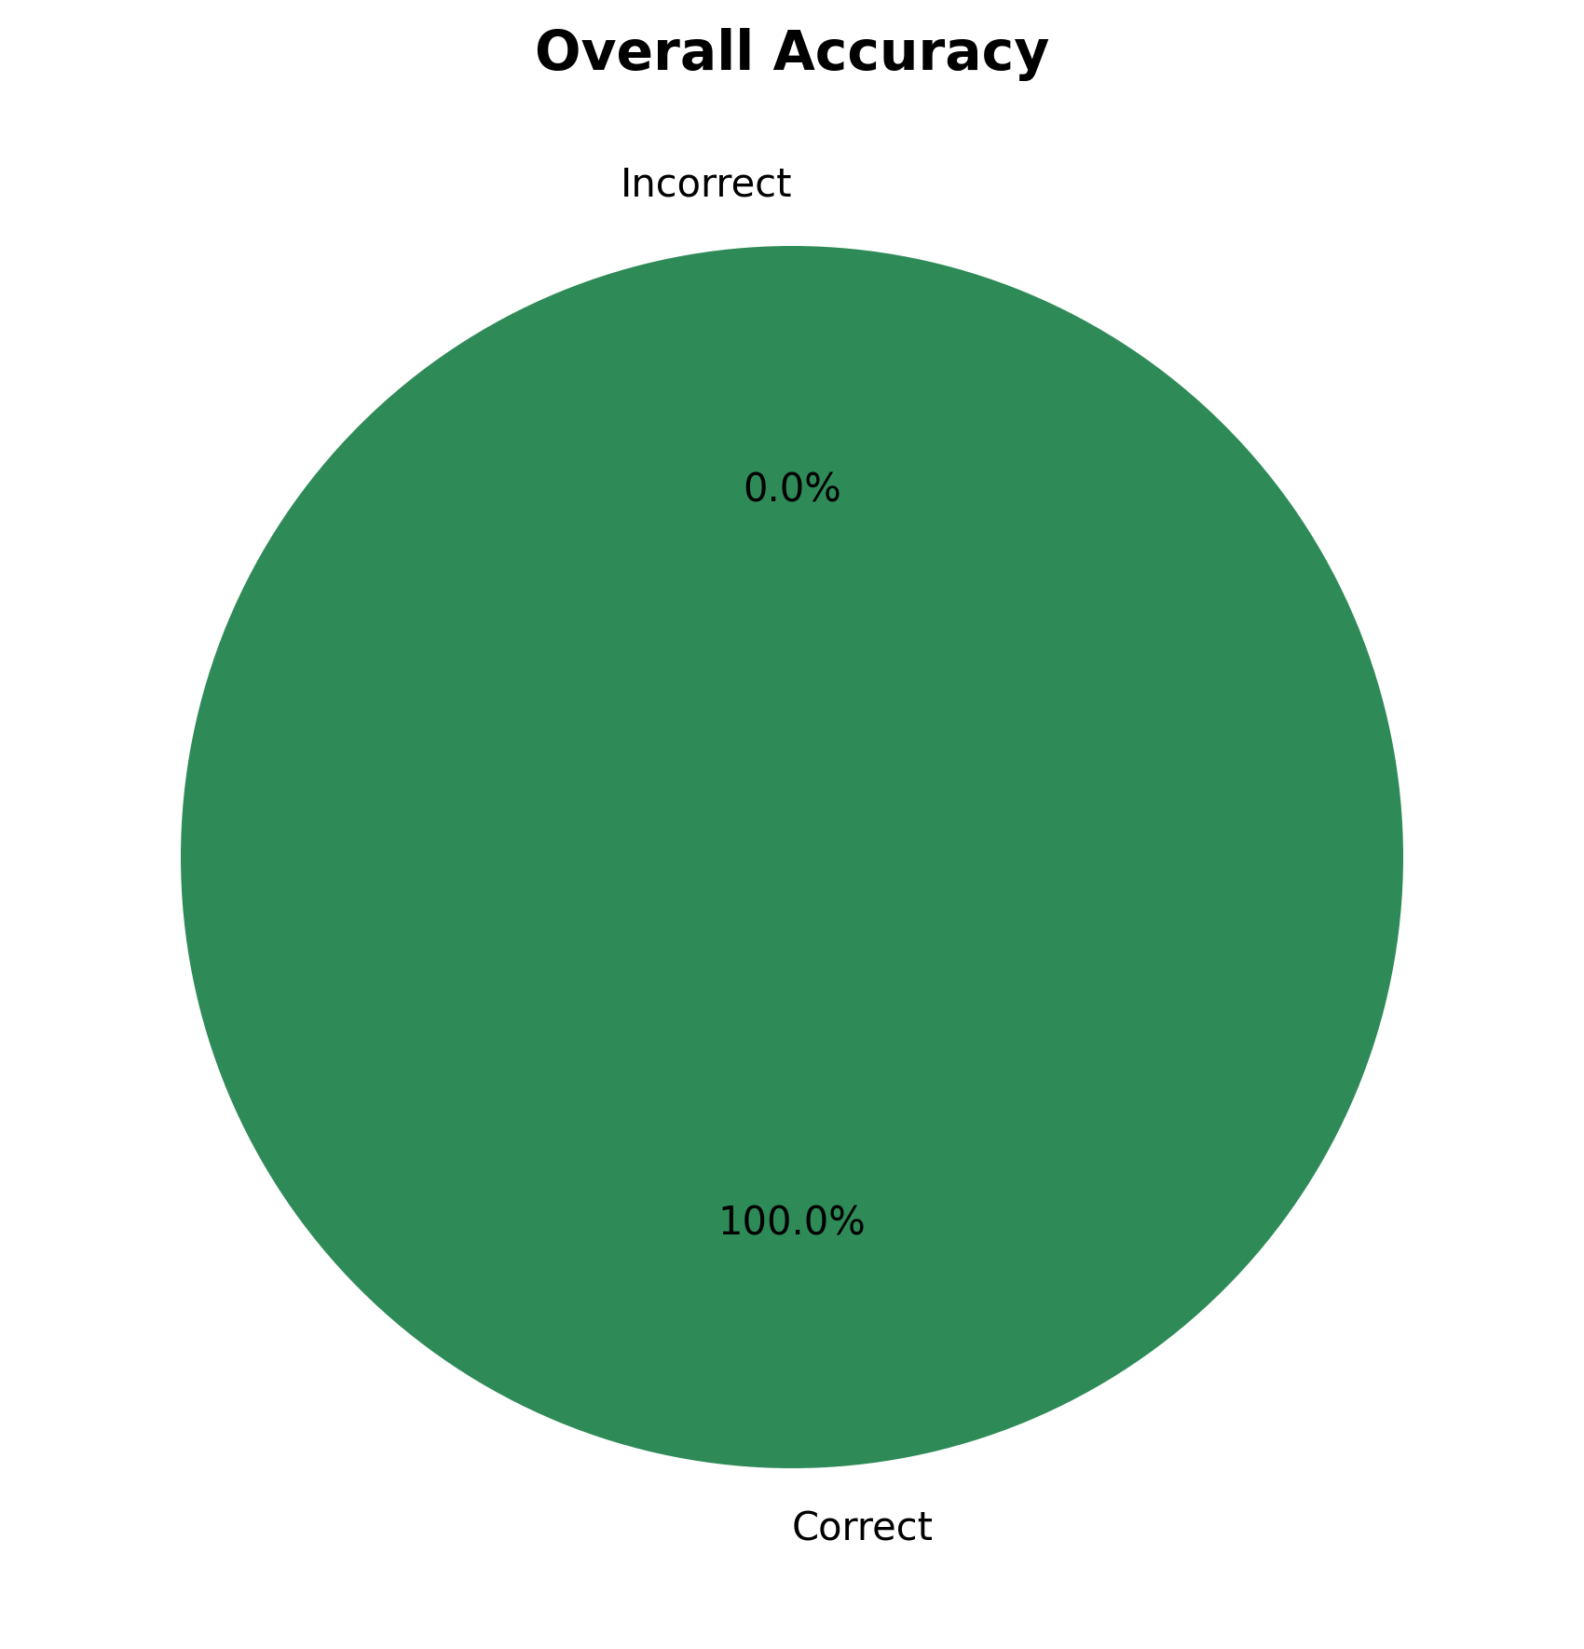

## Test Cases Distribution

This bar chart shows the distribution of test cases between positive and negative sentiment categories.

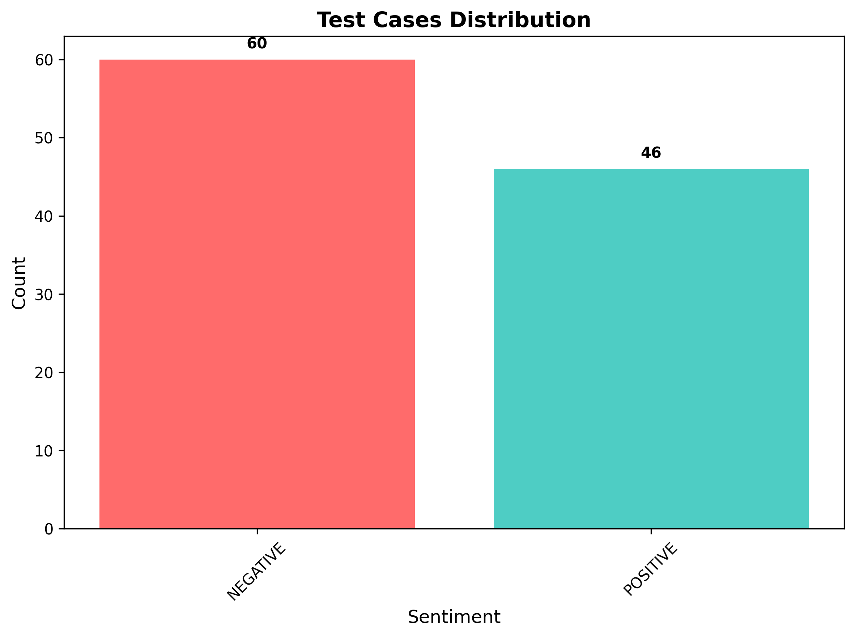

## Accuracy by Sentiment

This bar chart compares the accuracy achieved for positive vs negative sentiment classification.

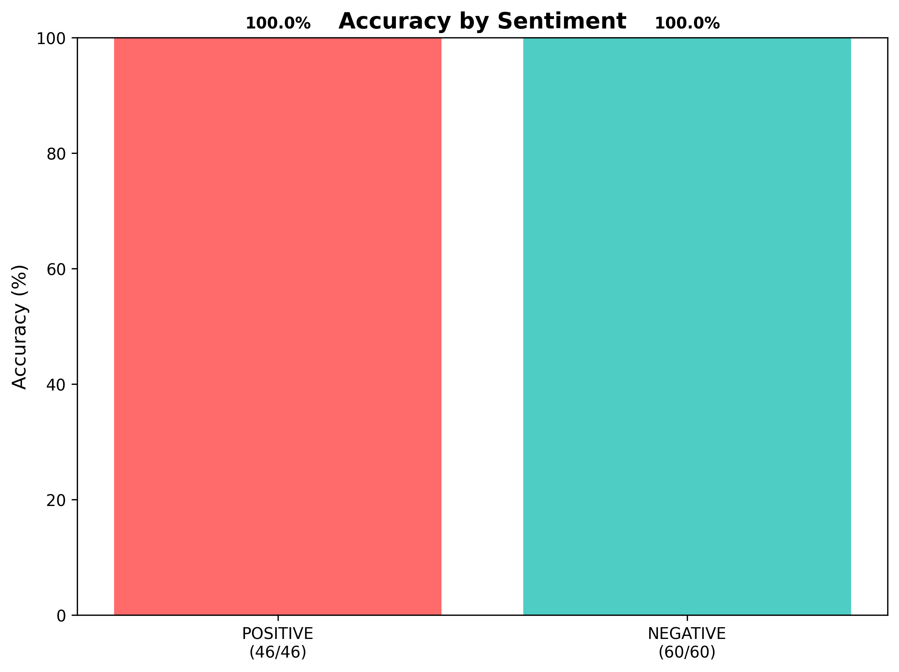

## Generation Time Distribution

This histogram shows the distribution of response generation times across all test cases.

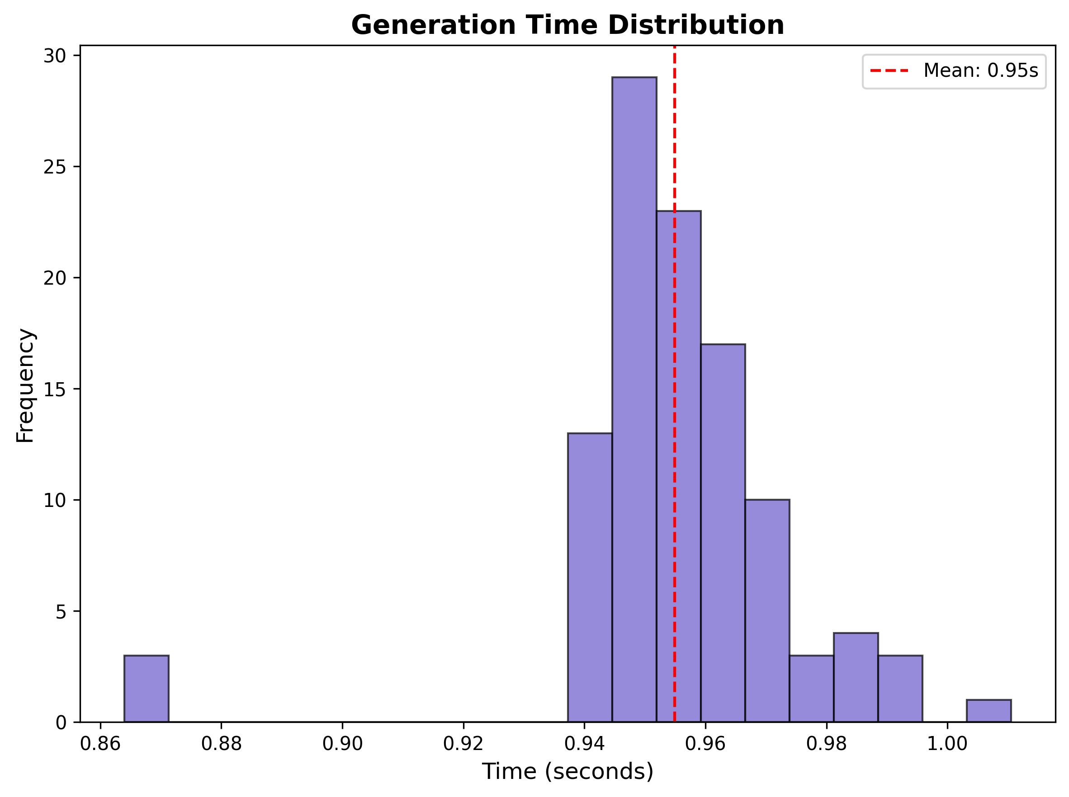

## Cumulative Accuracy Trend

This line chart shows how the cumulative accuracy improves as more test cases are processed.

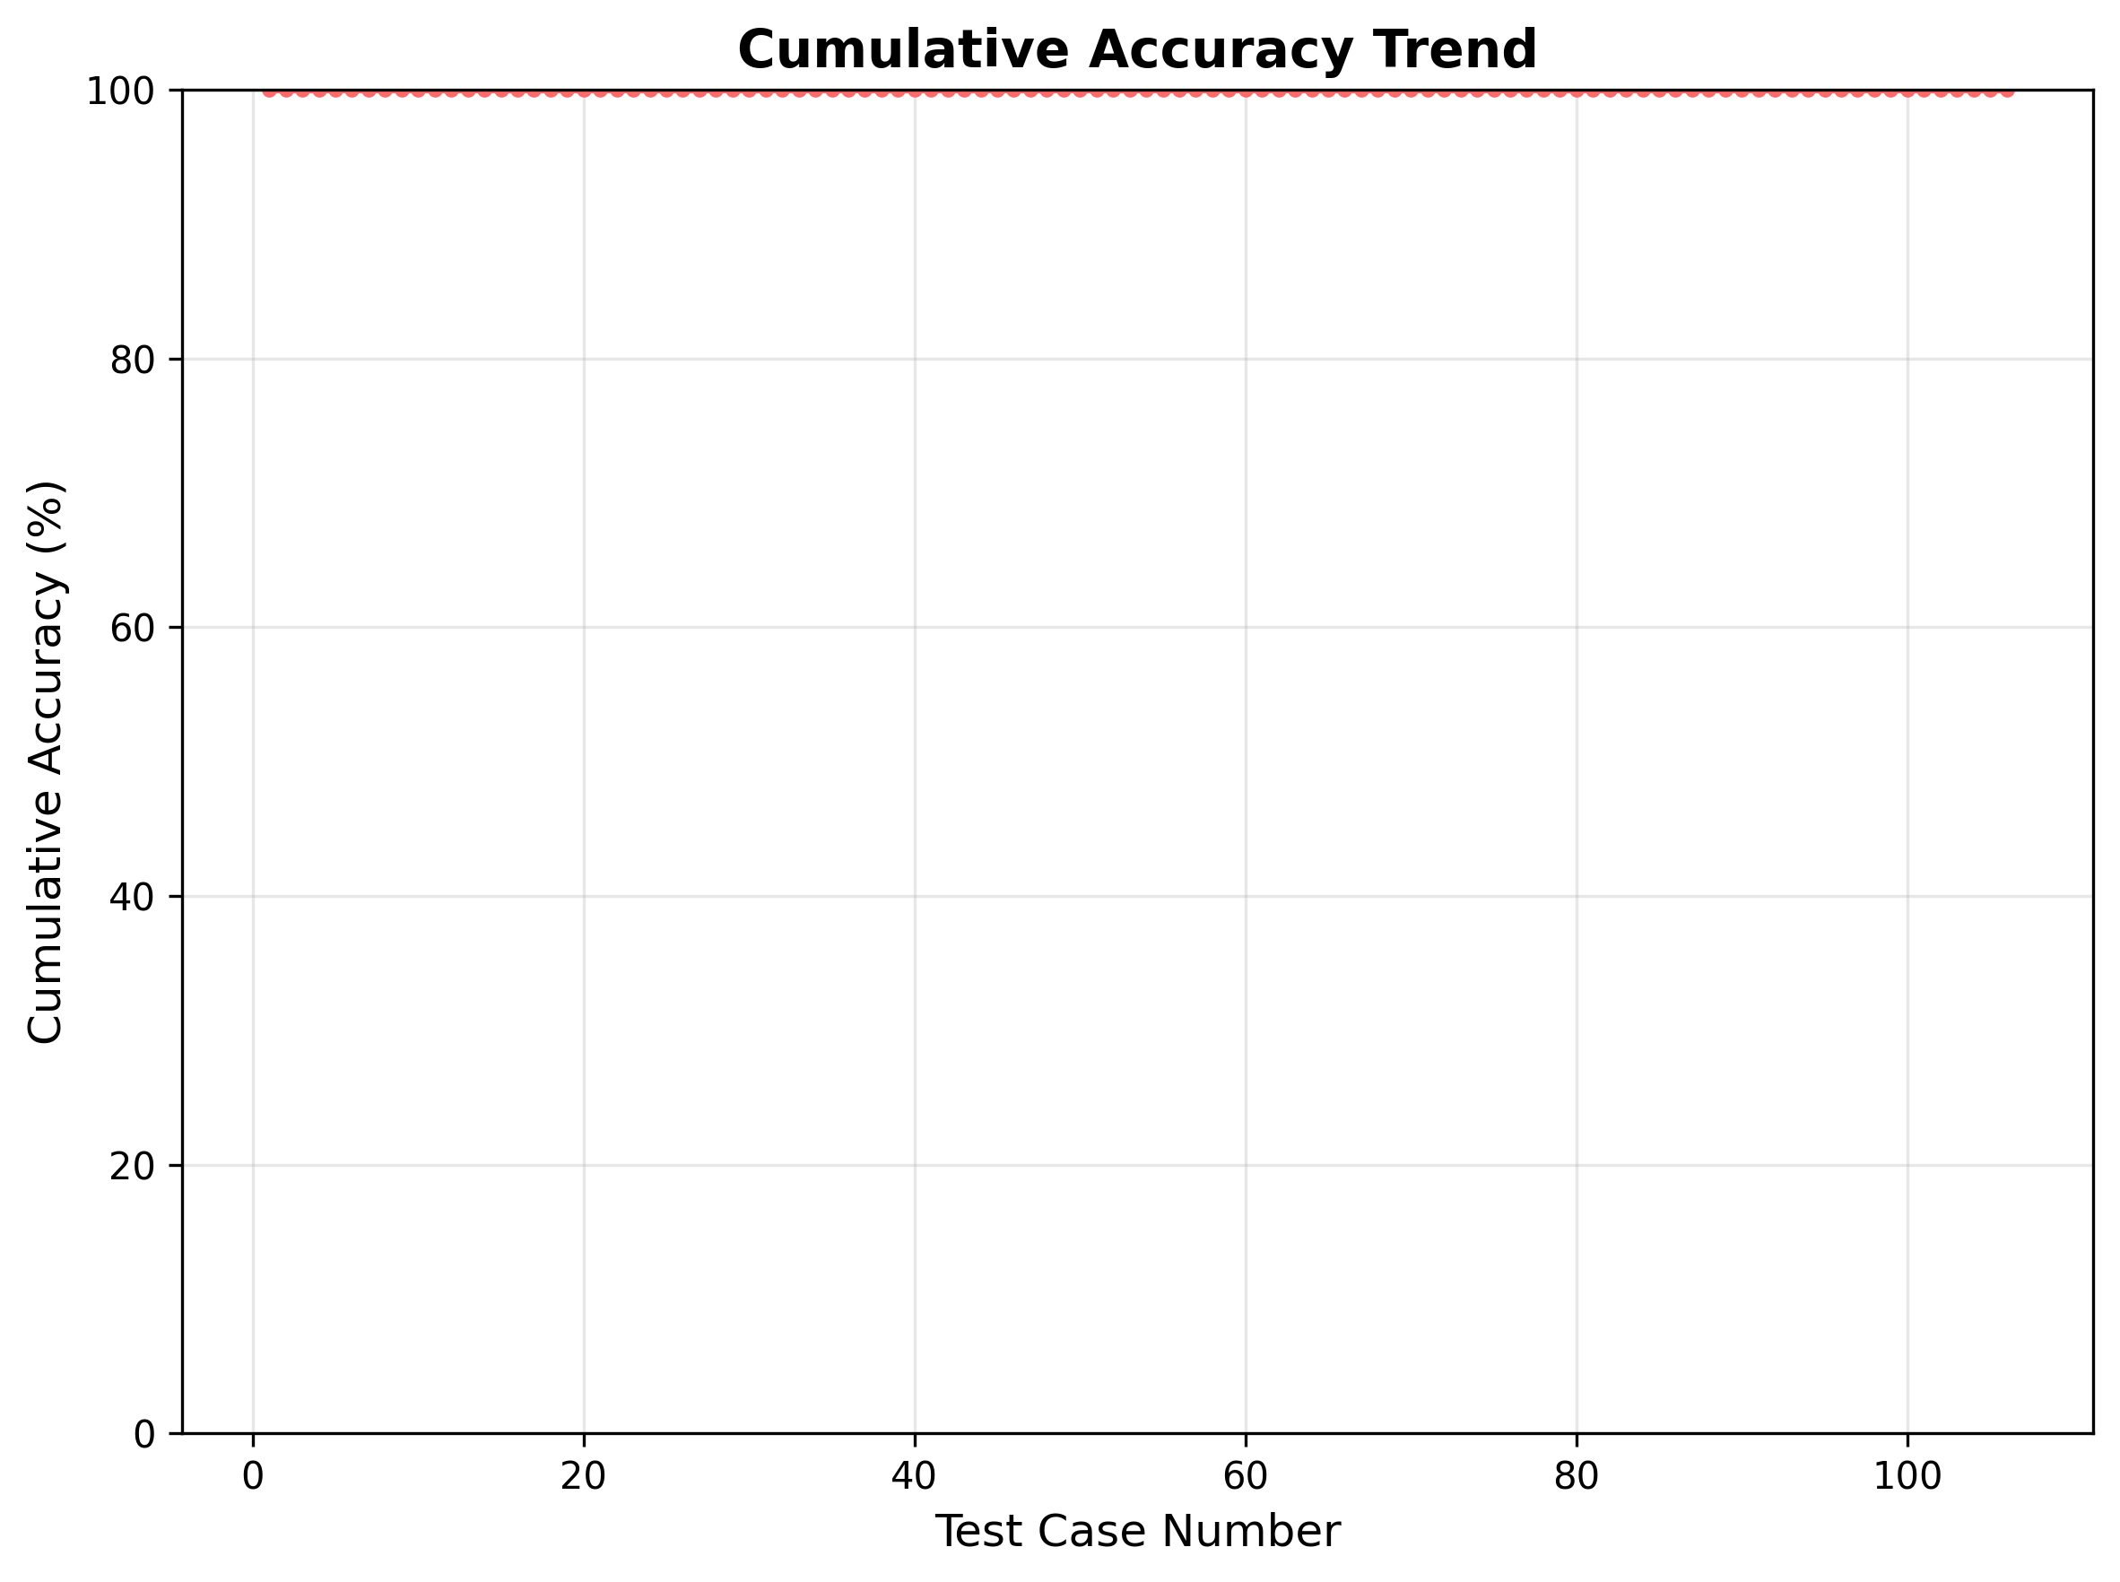

## Confusion Matrix

This heatmap shows the detailed breakdown of predictions vs actual sentiment labels.

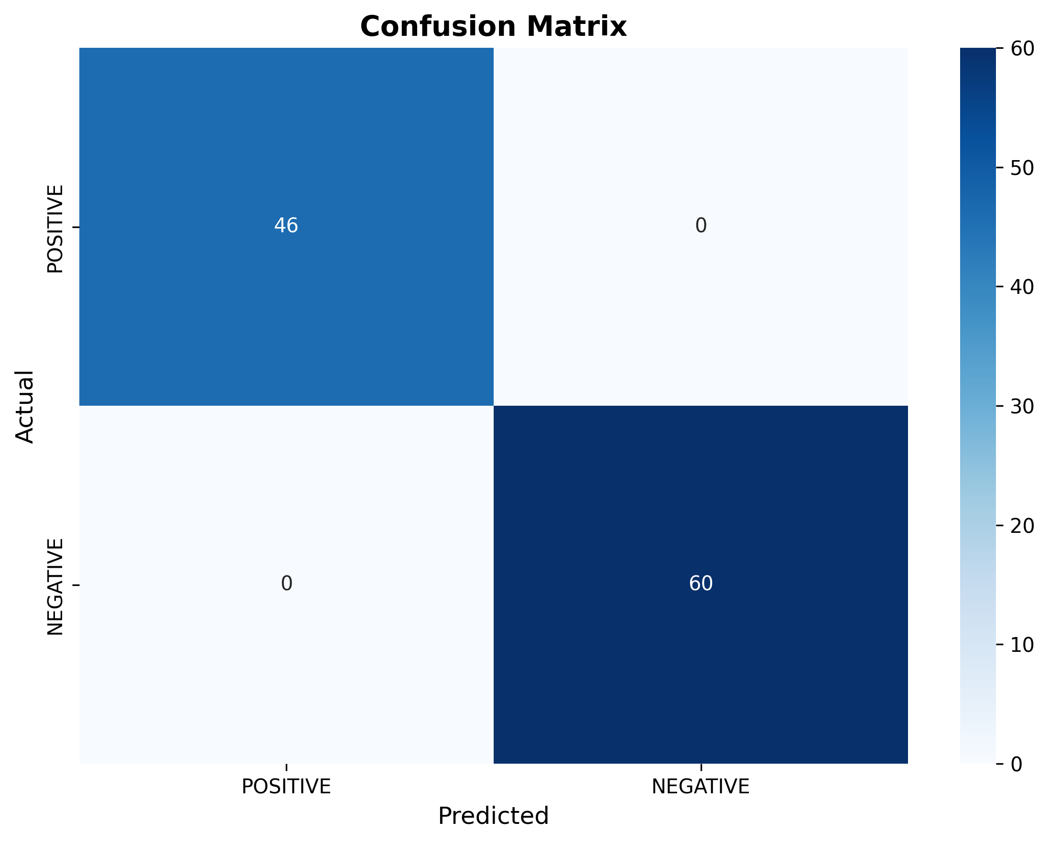

# Detailed Test Cases Results

Below are the detailed results for all test cases, including the input text, expected sentiment, predicted sentiment, and whether the prediction was correct.

|  |  |  |  |  |
| --- | --- | --- | --- | --- |
| Case # | Input Text | Expected | Predicted | Result |
| 1 | I absolutely love this product! It's amazing and exceeded all my expectations. | POSITIVE | POSITIVE | ✅ Correct |
| 2 | I'm so happy with my purchase. Best decision ever! | POSITIVE | POSITIVE | ✅ Correct |
| 3 | This book is incredible! I couldn't put it down. | POSITIVE | POSITIVE | ✅ Correct |
| 4 | The concert was absolutely breathtaking. Pure magic! | POSITIVE | POSITIVE | ✅ Correct |
| 5 | I'm thrilled with the results. Everything went perfectly. | POSITIVE | POSITIVE | ✅ Correct |
| 6 | I'm delighted with the quality and performance. | POSITIVE | POSITIVE | ✅ Correct |
| 7 | This is exactly what I was looking for. Perfect! | POSITIVE | POSITIVE | ✅ Correct |
| 8 | I'm overjoyed with the outcome. It's fantastic! | POSITIVE | POSITIVE | ✅ Correct |
| 9 | The food here is delicious and the atmosphere is great. | POSITIVE | POSITIVE | ✅ Correct |
| 10 | I'm very satisfied with this purchase. Great value! | POSITIVE | POSITIVE | ✅ Correct |
| 11 | This product works flawlessly. I'm impressed! | POSITIVE | POSITIVE | ✅ Correct |
| 12 | I'm grateful for this opportunity. It's wonderful! | POSITIVE | POSITIVE | ✅ Correct |
| 13 | I'm excited about this new feature. It's brilliant! | POSITIVE | POSITIVE | ✅ Correct |
| 14 | This solution is perfect for my needs. Love it! | POSITIVE | POSITIVE | ✅ Correct |
| 15 | I'm amazed by the quality and attention to detail. | POSITIVE | POSITIVE | ✅ Correct |
| 16 | This exceeded my expectations in every way. | POSITIVE | POSITIVE | ✅ Correct |
| 17 | I'm very pleased with the results. Outstanding! | POSITIVE | POSITIVE | ✅ Correct |
| 18 | This is a game-changer. I'm ecstatic! | POSITIVE | POSITIVE | ✅ Correct |
| 19 | I'm grateful for such a wonderful experience. | POSITIVE | POSITIVE | ✅ Correct |
| 20 | This product is a dream come true. Amazing! | POSITIVE | POSITIVE | ✅ Correct |
| 21 | I'm blown away by the performance. Incredible! | POSITIVE | POSITIVE | ✅ Correct |
| 22 | This is the best thing I've ever purchased. | POSITIVE | POSITIVE | ✅ Correct |
| 23 | I had an amazing time with my family yesterday. | POSITIVE | POSITIVE | ✅ Correct |
| 24 | I'm so excited about my upcoming vacation! | POSITIVE | POSITIVE | ✅ Correct |
| 25 | I love spending time with my friends and family. | POSITIVE | POSITIVE | ✅ Correct |
| 26 | This book changed my perspective on life. | POSITIVE | POSITIVE | ✅ Correct |
| 27 | I'm grateful for all the wonderful people in my life. | POSITIVE | POSITIVE | ✅ Correct |
| 28 | I'm so proud of my child's achievements. | POSITIVE | POSITIVE | ✅ Correct |
| 29 | This coffee is the best I've ever tasted. | POSITIVE | POSITIVE | ✅ Correct |
| 30 | I love the feeling of accomplishment after hard work. | POSITIVE | POSITIVE | ✅ Correct |
| 31 | The flowers in my garden are blooming beautifully. | POSITIVE | POSITIVE | ✅ Correct |
| 32 | I'm excited about learning new skills. | POSITIVE | POSITIVE | ✅ Correct |
| 33 | This movie made me laugh and cry with joy. | POSITIVE | POSITIVE | ✅ Correct |
| 34 | I'm so happy to see my old friends again. | POSITIVE | POSITIVE | ✅ Correct |
| 35 | This experience was life-changing in the best way. | POSITIVE | POSITIVE | ✅ Correct |
| 36 | I love the creativity and innovation here. | POSITIVE | POSITIVE | ✅ Correct |
| 37 | The customer service exceeded all expectations. | POSITIVE | POSITIVE | ✅ Correct |
| 38 | I'm grateful for this beautiful day. | POSITIVE | POSITIVE | ✅ Correct |
| 39 | This product solved all my problems perfectly. | POSITIVE | POSITIVE | ✅ Correct |
| 40 | I love the positive energy in this room. | POSITIVE | POSITIVE | ✅ Correct |
| 41 | The performance was absolutely spectacular. | POSITIVE | POSITIVE | ✅ Correct |
| 42 | I'm so excited about the future possibilities. | POSITIVE | POSITIVE | ✅ Correct |
| 43 | This place has the most amazing atmosphere. | POSITIVE | POSITIVE | ✅ Correct |
| 44 | I love how everything turned out perfectly. | POSITIVE | POSITIVE | ✅ Correct |
| 45 | The food here is like heaven on earth. | POSITIVE | POSITIVE | ✅ Correct |
| 46 | I'm so grateful for this wonderful opportunity. | POSITIVE | POSITIVE | ✅ Correct |
| 47 | I absolutely hate this product. It's terrible and a waste of money. | NEGATIVE | NEGATIVE | ✅ Correct |
| 48 | This movie was awful. The acting was terrible and the plot made no sense. | NEGATIVE | NEGATIVE | ✅ Correct |
| 49 | The service here is horrible. Never coming back! | NEGATIVE | NEGATIVE | ✅ Correct |
| 50 | I'm extremely disappointed with this purchase. Worst decision ever. | NEGATIVE | NEGATIVE | ✅ Correct |
| 51 | This book is terrible. I couldn't finish it. | NEGATIVE | NEGATIVE | ✅ Correct |
| 52 | The concert was a complete disaster. Waste of time and money. | NEGATIVE | NEGATIVE | ✅ Correct |
| 53 | I'm furious with the results. Everything went wrong. | NEGATIVE | NEGATIVE | ✅ Correct |
| 54 | This experience was terrible and I want to forget it. | NEGATIVE | NEGATIVE | ✅ Correct |
| 55 | I'm disgusted with the quality and performance. | NEGATIVE | NEGATIVE | ✅ Correct |
| 56 | This is the opposite of what I wanted. Terrible! | NEGATIVE | NEGATIVE | ✅ Correct |
| 57 | I'm devastated by the outcome. It's horrible! | NEGATIVE | NEGATIVE | ✅ Correct |
| 58 | The food here is disgusting and the atmosphere is awful. | NEGATIVE | NEGATIVE | ✅ Correct |
| 59 | I'm very unsatisfied with this purchase. Poor value! | NEGATIVE | NEGATIVE | ✅ Correct |
| 60 | This product is completely broken. I'm furious! | NEGATIVE | NEGATIVE | ✅ Correct |
| 61 | I'm angry about this situation. It's terrible! | NEGATIVE | NEGATIVE | ✅ Correct |
| 62 | The customer support was useless and unhelpful. | NEGATIVE | NEGATIVE | ✅ Correct |
| 63 | I'm frustrated with this feature. It's broken! | NEGATIVE | NEGATIVE | ✅ Correct |
| 64 | This solution is completely wrong for my needs. Hate it! | NEGATIVE | NEGATIVE | ✅ Correct |
| 65 | I'm appalled by the poor quality and lack of care. | NEGATIVE | NEGATIVE | ✅ Correct |
| 66 | This failed to meet even my lowest expectations. | NEGATIVE | NEGATIVE | ✅ Correct |
| 67 | I'm very upset with the results. Disappointing! | NEGATIVE | NEGATIVE | ✅ Correct |
| 68 | This is a complete failure. I'm devastated! | NEGATIVE | NEGATIVE | ✅ Correct |
| 69 | I'm furious about such a terrible experience. | NEGATIVE | NEGATIVE | ✅ Correct |
| 70 | This product is a nightmare. Awful! | NEGATIVE | NEGATIVE | ✅ Correct |
| 71 | I'm shocked by the poor performance. Terrible! | NEGATIVE | NEGATIVE | ✅ Correct |
| 72 | This is the worst thing I've ever purchased. | NEGATIVE | NEGATIVE | ✅ Correct |
| 73 | I'm so frustrated with this terrible service. | NEGATIVE | NEGATIVE | ✅ Correct |
| 74 | This experience was completely ruined by poor management. | NEGATIVE | NEGATIVE | ✅ Correct |
| 75 | I hate how everything went wrong today. | NEGATIVE | NEGATIVE | ✅ Correct |
| 76 | The food was cold and tasteless. Disgusting! | NEGATIVE | NEGATIVE | ✅ Correct |
| 77 | I'm extremely angry about this situation. | NEGATIVE | NEGATIVE | ✅ Correct |
| 78 | This product is a complete waste of money. | NEGATIVE | NEGATIVE | ✅ Correct |
| 79 | The customer service was absolutely terrible. | NEGATIVE | NEGATIVE | ✅ Correct |
| 80 | I hate dealing with incompetent people. | NEGATIVE | NEGATIVE | ✅ Correct |
| 81 | This is the most frustrating experience ever. | NEGATIVE | NEGATIVE | ✅ Correct |
| 82 | I'm furious about the lack of communication. | NEGATIVE | NEGATIVE | ✅ Correct |
| 83 | The weather is terrible and ruining my plans. | NEGATIVE | NEGATIVE | ✅ Correct |
| 84 | I'm so upset about what happened yesterday. | NEGATIVE | NEGATIVE | ✅ Correct |
| 85 | This place has the worst atmosphere imaginable. | NEGATIVE | NEGATIVE | ✅ Correct |
| 86 | I hate how nothing ever goes right for me. | NEGATIVE | NEGATIVE | ✅ Correct |
| 87 | The food here is absolutely disgusting. | NEGATIVE | NEGATIVE | ✅ Correct |
| 88 | I'm devastated by this terrible news. | NEGATIVE | NEGATIVE | ✅ Correct |
| 89 | This product broke after one day. Useless! | NEGATIVE | NEGATIVE | ✅ Correct |
| 90 | I'm so angry about this terrible decision. | NEGATIVE | NEGATIVE | ✅ Correct |
| 91 | The service was slow and unprofessional. | NEGATIVE | NEGATIVE | ✅ Correct |
| 92 | I hate how expensive everything is becoming. | NEGATIVE | NEGATIVE | ✅ Correct |
| 93 | This experience was completely ruined. | NEGATIVE | NEGATIVE | ✅ Correct |
| 94 | I'm furious about the poor customer service. | NEGATIVE | NEGATIVE | ✅ Correct |
| 95 | The quality is absolutely terrible. | NEGATIVE | NEGATIVE | ✅ Correct |
| 96 | I hate dealing with these problems. | NEGATIVE | NEGATIVE | ✅ Correct |
| 97 | This is the most disappointing purchase ever. | NEGATIVE | NEGATIVE | ✅ Correct |
| 98 | I'm so frustrated with this terrible company. | NEGATIVE | NEGATIVE | ✅ Correct |
| 99 | The food was cold and the service was slow. | NEGATIVE | NEGATIVE | ✅ Correct |
| 100 | I hate how nothing works properly anymore. | NEGATIVE | NEGATIVE | ✅ Correct |
| 101 | This product is completely worthless. | NEGATIVE | NEGATIVE | ✅ Correct |
| 102 | I'm so angry about this terrible situation. | NEGATIVE | NEGATIVE | ✅ Correct |
| 103 | The experience was absolutely horrible. | NEGATIVE | NEGATIVE | ✅ Correct |
| 104 | I hate how everything is so expensive. | NEGATIVE | NEGATIVE | ✅ Correct |
| 105 | This is the worst service I've ever received. | NEGATIVE | NEGATIVE | ✅ Correct |
| 106 | I'm devastated by this terrible outcome. | NEGATIVE | NEGATIVE | ✅ Correct |

# Error Analysis

No errors found! All predictions were correct.

# Recommendations

The model is performing excellently and is ready for production use.