**Pricing**

**Scenario – Cost analysis**:

1. **AWS Standard Pricing:**

**CloudFront Pricing:**

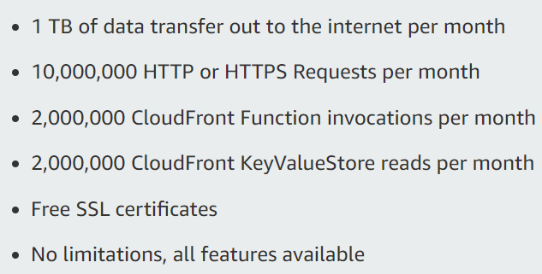

**Regional Data Transfer Out to Internet (per GB):**

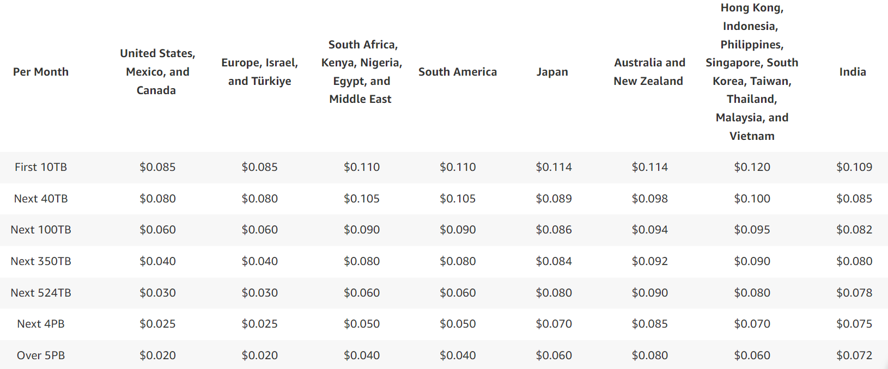

**Regional Data Transfer Out to Origin (per GB):**

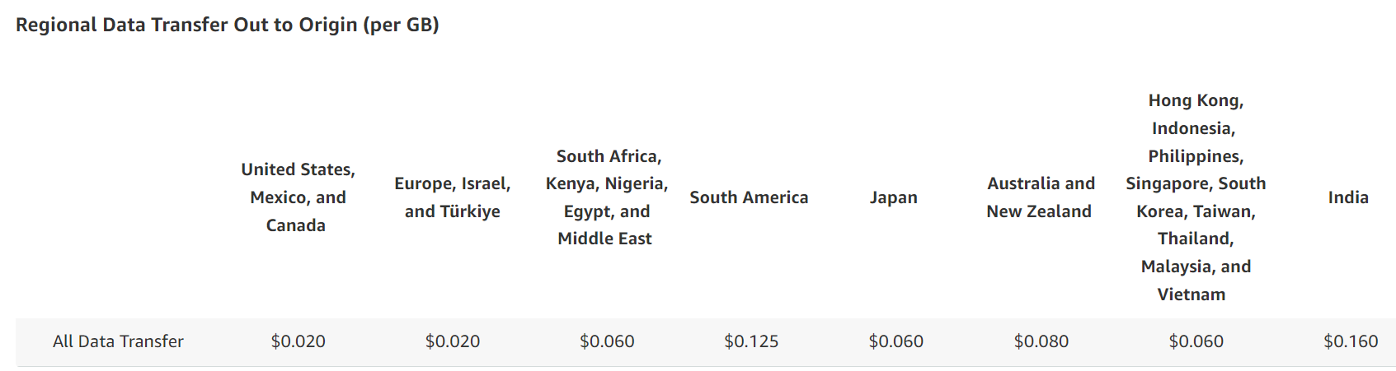

**Price Class:**

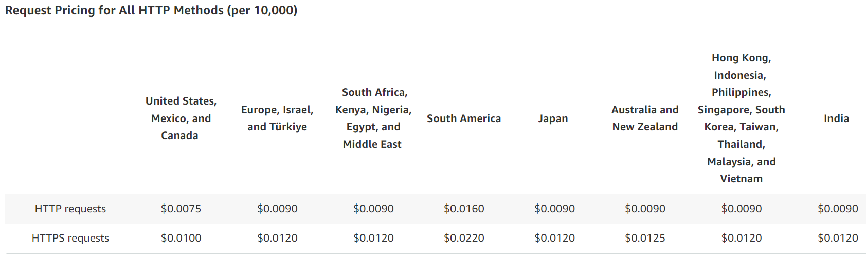

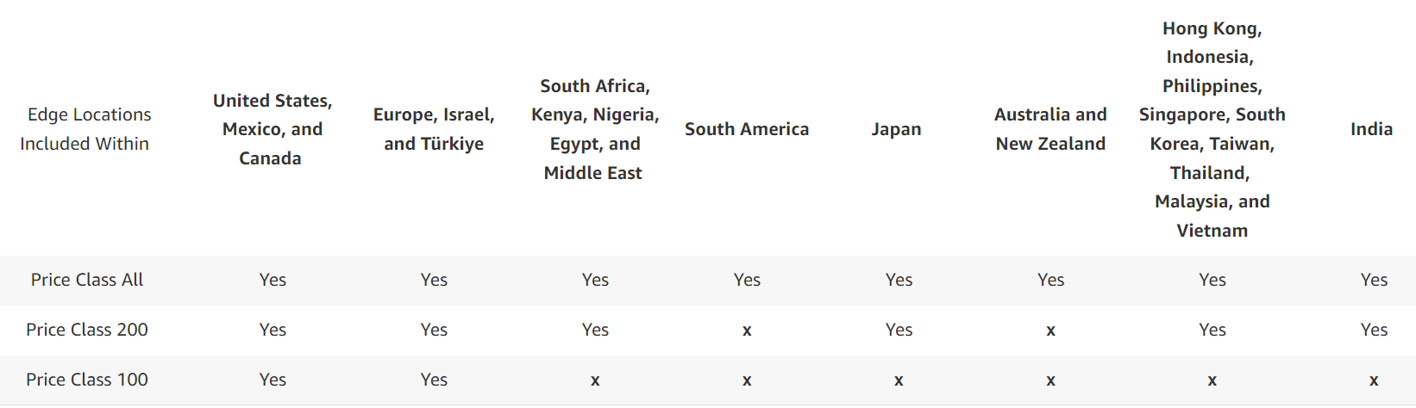

*Note: If you are using an AWS origin like S3, data transferred from origin to CloudFront edge locations will be free of charge.*

**Ex1**:

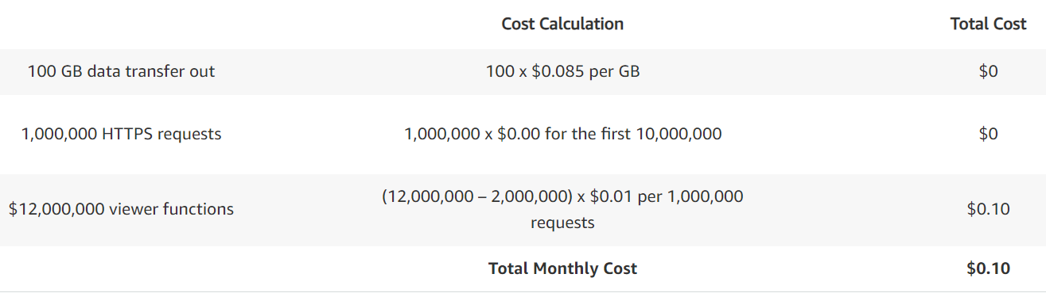

**Ex2**:

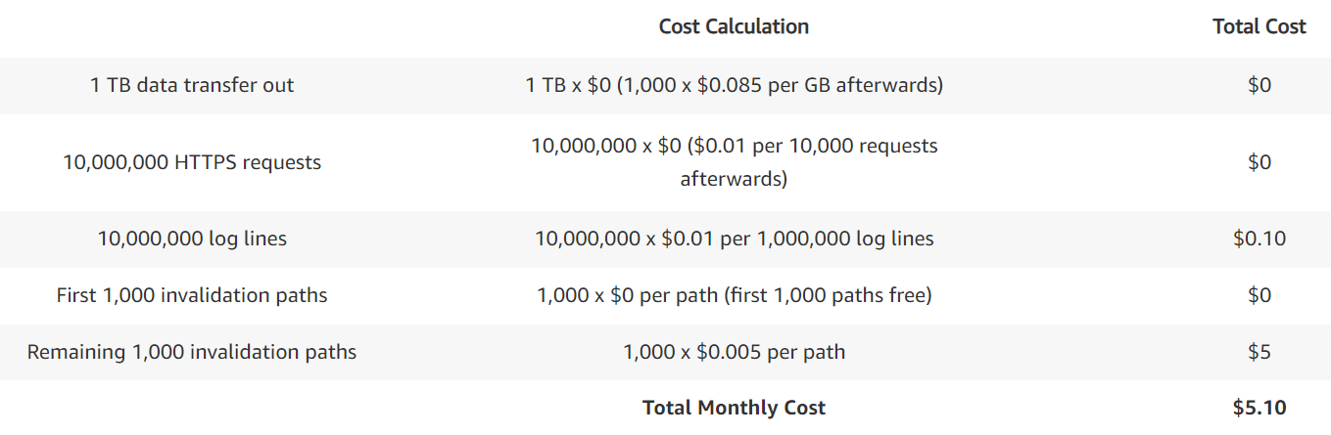

**Ex3**:

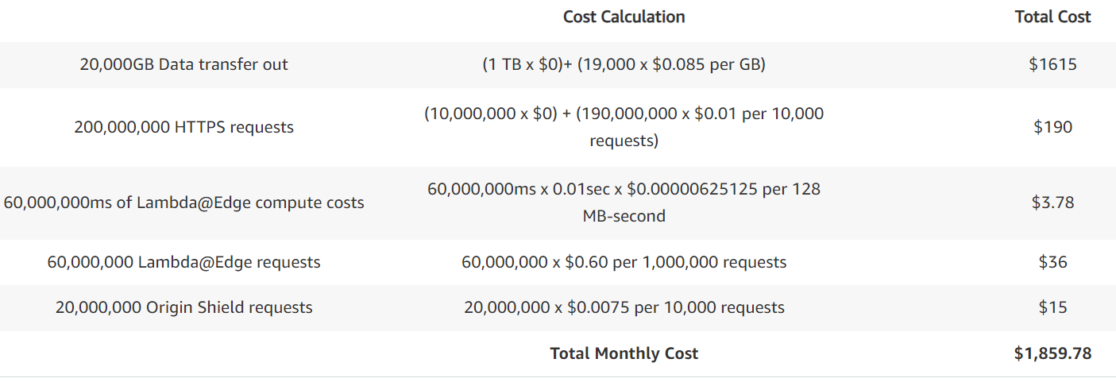

1. **Lambda@Edge:**

**Cost for 1000000 requests, 1000GB data transfer out for (CloudFront + Lambda@Edge):**

Calculating the cost for 1,000,000 requests and 1,000 GB of data transfer out involves considering the pricing models for both **CloudFront and Lambda@Edge**.

**CloudFront Pricing:**

1. **Data Transfer Out**: The pricing varies by region and starts at around $0.085 per GB for the first 10 TB in many regions. Assuming an average of $0.085 per GB:
   * **Cost for 1,000 GB**: 1,000 GB * $0.085/GB = $85
2. **Requests**: CloudFront charges for the number of requests made. Assuming the standard rate of $0.0075 per 10,000 requests:
   * **Cost for 1,000,000 requests**: 1,000,000 requests / 10,000 * $0.0075 = $0.75

**Lambda@Edge Pricing:**

1. **Execution Time**: Lambda@Edge charges based on the number of requests and the duration of each request.
   * **Execution Cost**: This depends on the complexity of your function and the time it takes to execute.
2. **Data Transfer Out**: Lambda@Edge executions incur additional data transfer costs when they interact with other AWS services like DynamoDB or S3.

**Total Cost Estimate:**

To estimate the total cost for 1,000,000 requests and 1,000 GB data transfer out, assuming basic Lambda@Edge usage (without additional AWS service interaction):

* **CloudFront**:
  + Data Transfer Out: $85
  + Requests: $0.75
  + **Total CloudFront Cost**: $85 + $0.75 = $85.75
* **Lambda@Edge**:
  + Execution Time Cost: This varies depending on the complexity and duration of your functions. A rough estimate might be around $0.20 per million requests (assuming very basic functions).
  + Data Transfer Out: Assuming minimal additional data transfer cost, let's estimate around $5 (this can vary significantly depending on actual use).
* **Total Lambda@Edge Cost**: $0.20 (execution) + $5 (data transfer) = $5.20

**Overall Total Cost:**

* **Total Cost (CloudFront + Lambda@Edge)**:
  + CloudFront: $85.75
  + Lambda@Edge: $5.20
  + **Grand Total**: $85.75 + $5.20 = **$90.95**

These are rough estimates and actual costs can vary based on the specifics of your usage, AWS region, and any additional services or features utilized.

1. **CloudFront function + KVS:**

Calculating the cost for 1,000,000 requests and 1,000 GB of data transfer out for CloudFront with KVS (Key-Value Store) involves considering the pricing for CloudFront itself, as KVS storage within CloudFront Functions is not separately billed but rather integrated into the CloudFront pricing model.

**CloudFront Pricing:**

1. **Data Transfer Out**: The pricing varies by region. Assuming an average of $0.085 per GB for the first 10 TB:
   * **Cost for 1,000 GB**: 1,000 GB * $0.085/GB = $85
2. **Requests**: CloudFront charges for the number of requests made. Assuming the standard rate of $0.0075 per 10,000 requests:
   * **Cost for 1,000,000 requests**: 1,000,000 requests / 10,000 * $0.0075 = $0.75
3. **CloudFront Functions (with KVS)**:
   * There are no additional charges for using the KVS within CloudFront Functions as it's part of the CloudFront pricing structure.

**Total Cost Estimate:**

To estimate the total cost for 1,000,000 requests and 1,000 GB data transfer out using CloudFront with KVS:

* **CloudFront**:
  + Data Transfer Out: $85
  + Requests: $0.75
  + **Total CloudFront Cost**: $85 + $0.75 = $85.75

**Summary:**

* **Total Cost (CloudFront with KVS)**: **$85.75**

This estimate provides a straightforward cost calculation for using CloudFront with KVS for your specified workload. It's important to note that actual costs can vary based on your AWS region, any additional features or services utilized, and specific traffic patterns.

1. **Comparison:**

**Comparison L@E and CloudFront KVS:**

* **Lambda@Edge**: Focuses on execution based on requests and duration. Ideal for dynamically modifying content or responding to specific events.
* **CloudFront KVS**: Primarily used for storing and retrieving small amounts of data with associated costs for requests and data transfer out.

**Cost Effectiveness:**

* **Lambda@Edge** may be more cost-effective for scenarios requiring dynamic content modification or complex logic execution closer to end-users.
* **CloudFront KVS** is cost-effective for caching small, frequently accessed data (e.g., API responses, session data) without incurring standard storage costs.

**Considerations:**

* **Usage Patterns**: Tailor your choice based on how frequently functions need to execute and data needs to be retrieved.
* **Performance Requirements**: Evaluate if Lambda@Edge functions' performance benefits outweigh their costs compared to using CloudFront KVS for simpler caching needs.

Both services can complement each other depending on your application's architecture and performance requirements. It's advisable to simulate costs using the AWS Pricing Calculator or review detailed pricing on the AWS website to match specific usage scenarios and optimize costs effectively.

1. **AWS Pricing Calculator:**

<https://calculator.aws/#/createCalculator/CloudFront>

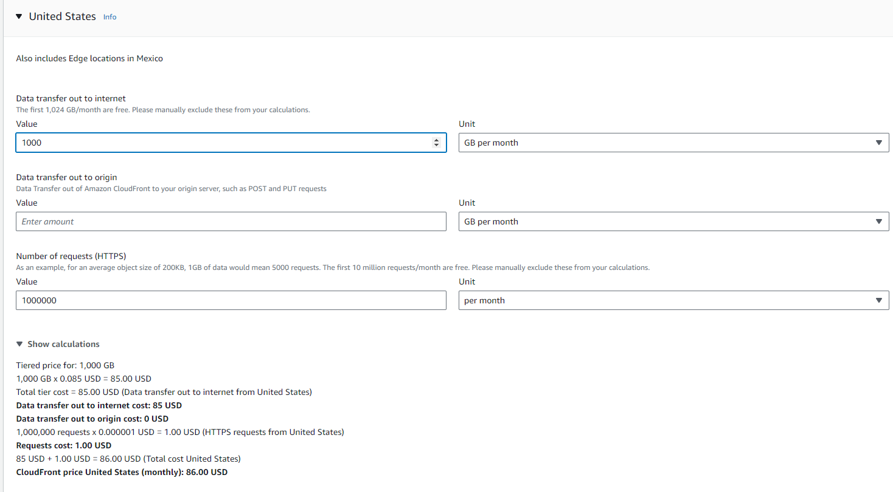

<https://calculator.aws/#/createCalculator/Lambda>

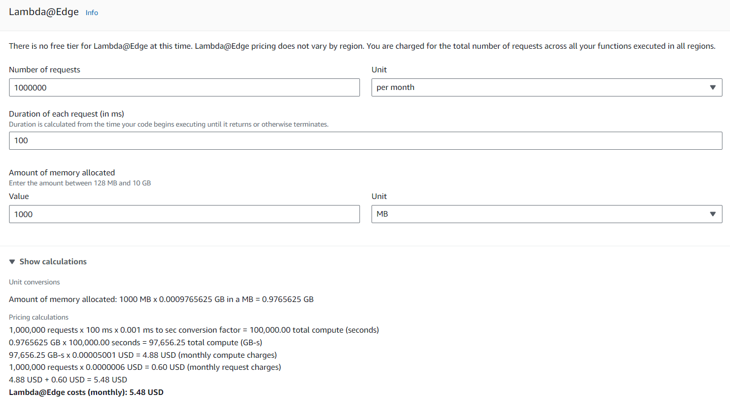

1. **Appendix**:

<https://aws.amazon.com/cloudfront/pricing/>

<https://calculator.aws/#/estimate>

<https://calculator.aws/#/createCalculator/CloudFront>

<https://aws.amazon.com/blogs/aws/introducing-cloudfront-functions-run-your-code-at-the-edge-with-low-latency-at-any-scale/>

<https://docs.aws.amazon.com/AmazonCloudFront/latest/DeveloperGuide/cloudfront-limits.html#limits-keyvaluestores>

<https://docs.aws.amazon.com/AmazonCloudFront/latest/DeveloperGuide/cloudfront-limits.html#limits-lambda-at-edge>