# Spring Boot & Swagger UI

## Design, Build, and Document APIs in the Cloud with SwaggerHub



**Introduction about swagger UI:**

Swagger is one of the most popular specifications for REST APIs for a number of reasons:

* Swagger generates an interactive API console for people to quickly learn about and try the API.
* Swagger generates the client SDK code needed for implementations on various platforms.
* The Swagger file can be auto-generated from code annotations on a lot of different platforms.
* Swagger has a strong community with helpful contributors.

The Swagger spec provides a way to describe your API using a specific JSON or YAML schema that outlines the names, order, and other details of the API.

You can code this Swagger file by hand in a text editor, or you can auto-generate it from annotations in your source code. Different tools can consume the Swagger file to generate the interactive API documentation.

Note: The interactive API documentation generated by the Swagger file is minimal. It shows the resources, parameters, requests, and responses. However, it’s not going to provide any other detail about how your API works.

Now let’s implement in sample project

I am giving sample on one spring boot application with embedded derby database with swagger-ui

Step to be follow:

1. Develop one sample curd application ,with all the layer like controller, service, and persistence layer
2. Below am providing my controller class with 4 Rest methods i.e GET, POST, PUT, DELETE

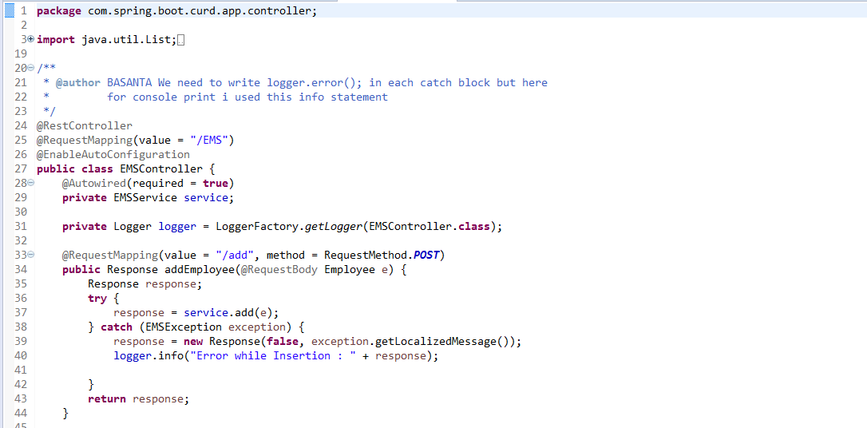

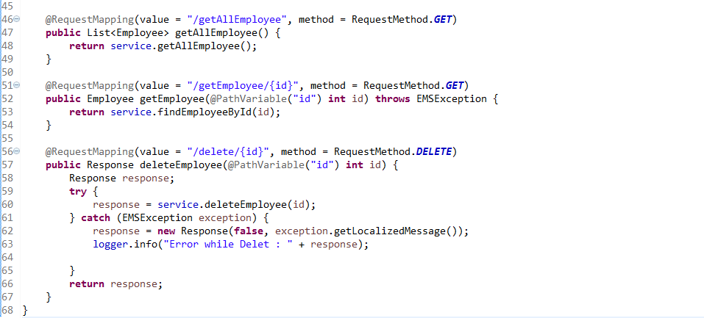

So for this Rest controller I want to generate API structure using swagger

3. Add swagger UI dependency in pom.xml to enable swagger features

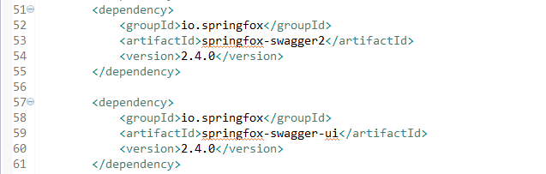

1. Then next step to write one configuration class , where we need to specify our API information like created by , Organization, Email , contact Details, License and all
2. Again this configuration class we need to specify for which method of Controller you want to generate API-Documents as below

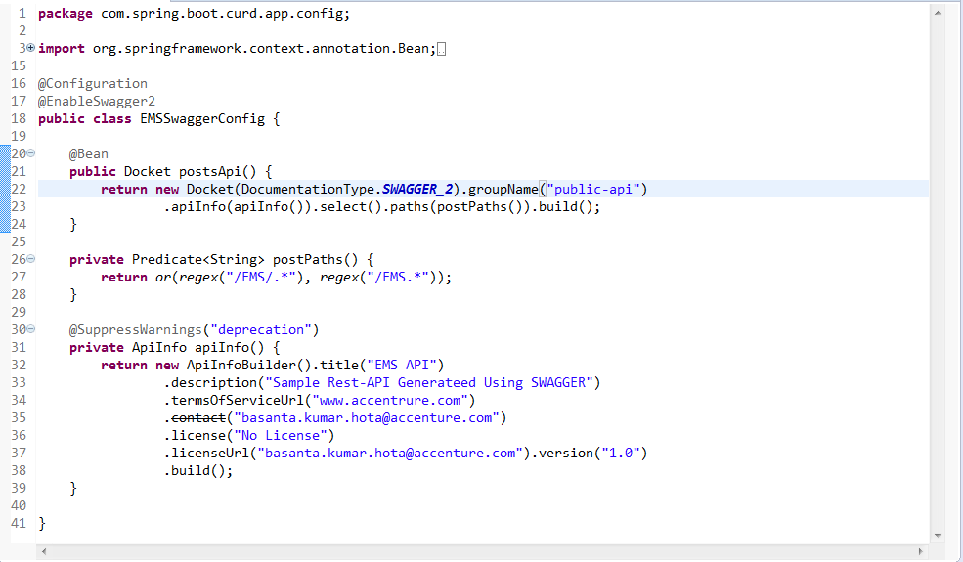

1. So now swagger is enable and auto configure by spring boot as I mention @EnableSwagger2
2. Now run your spring-boot application ,if it run success then hit the below url

<http://localhost:port/swagger-ui.html>

Then it will generate API structure as below, based on your controller method structure

1. Home page

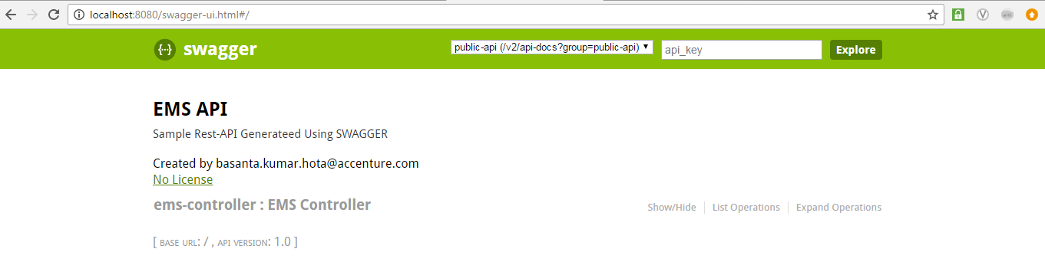

2. API-INFO

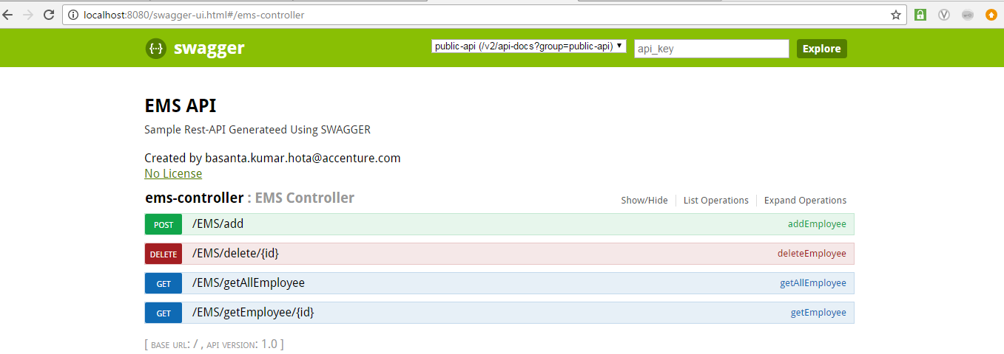

3. Specific API, where we can directly Test our Application without using POST-MAN, SOAPUI, and Advance Rest client

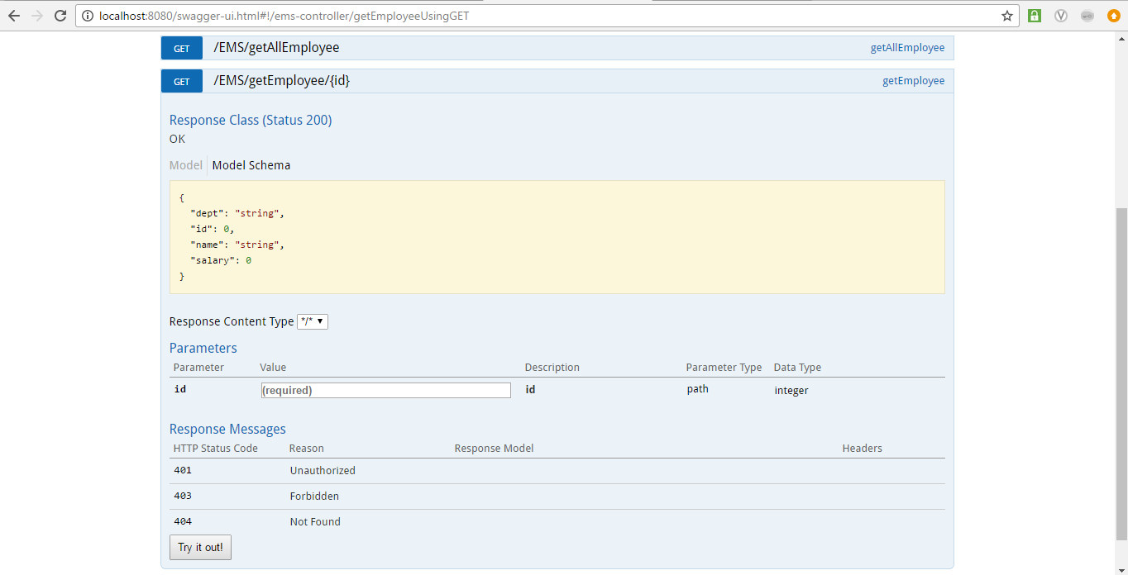

This is all about Enable swagger in our Rest based web application to generate Rest API with less burden.