IoT Based Air Quality Monitoring System

A Project report submitted in partial fulfillment Of the requirements for the degree of B.E Electronics And Communication Engineering

By

P. Subbulakshmi(513221106326)

Under the supervision of
Hod & Professor Department of
Electronics And Communication
Engineering

IoT Air Quality Monitoring System
IoT (Internet of Things) has become an integral part of our lives and it has already made an impact in various sectors, including the environment. Air pollution is a severe problem that has been affecting our planet for years. Therefore, there is a need for a reliable and efficient air pollution monitoring system to protect ourselves from its hazardous effects. An IoT-based air pollution monitoring system is an ideal solution that can provide real-time data and insights about the air quality in a particular area.
An IoT based air pollution monitoring system consists of several hardware and software components that work together to collect and process data. The hardware components include sensors, microcontrollers, and communication modules. The software components consist of a cloud platform, a mobile application, and a web-based dashboard.
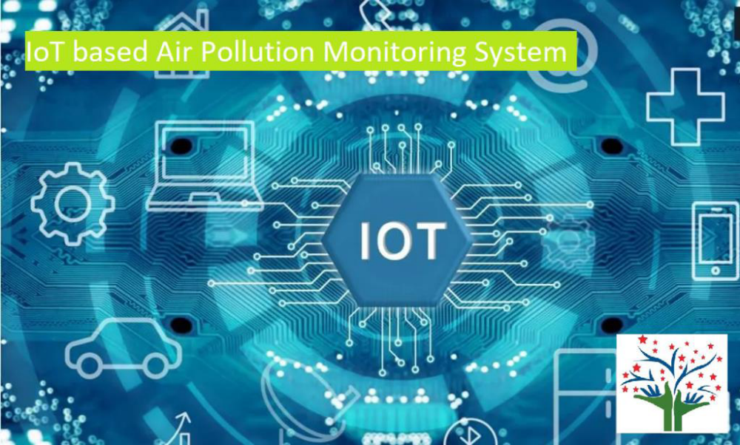

IoT based Air Pollution Monitoring System – Perfect Pollucon Services
The IoT-based air pollution monitoring system provides several benefits over traditional air pollution monitoring systems. It can collect real-time data from multiple locations, which then analyzed to identify the sources of pollution. It helps to take necessary measures to reduce it.
The system can also alert the users if the air quality reaches a dangerous level, allowing them to take precautions to protect themselves.
IoT Monitoring System components
IoT-based air pollution monitoring systems comprise several components that work together to collect and analyze air quality data. The components include:
1.Sensors: Sensors are the primary components of IoT-based air pollution monitoring systems. They measure various air quality parameters such as particulate matter, carbon monoxide, sulfur dioxide, and nitrogen oxides. The sensors can be classified into two categories: physical and chemical sensors. Physical sensors measure parameters such as temperature, humidity, and pressure, while chemical sensors measure air pollutants.
2.Microcontroller: The microcontroller is the brain of IoT-based air pollution monitoring systems. It receives data from the sensors, processes it, and sends it to the cloud server. The microcontroller is usually a microprocessor such as Arduino, Raspberry Pi, or similar devices.
3.CommunicationModule: The communication module is responsible for transmitting data from the microcontroller to the cloud server. Communication modules can use various wireless technologies such as Wi-Fi, Bluetooth, or cellular networks.
4.CloudServer: The cloud server is a centralized platform for storing, analyzing, and sharing air quality data. It collects data from the communication module and stores it in a database. The cloud server also provides web and mobile applications for users to access the data.
5.PowerSupply: IoT-based air pollution monitoring systems require a power supply to operate. In case of permanent installations external power supply is provided and batteries are provided for portable devices.
6.Enclosure: The enclosure is the outer covering that protects the components from environmental factors such as dust, water, and temperature.
def on_connect(data_iot, user, events):
print(“connected with code” + str(events))
Usage of Monitoring System
The IoT-based air pollution monitoring system can be used in various settings, including residential, industrial, and urban areas. It can also be integrated with existing air pollution monitoring systems to enhance their capabilities. The system can provide valuable data to government agencies, researchers, and the public to make informed decisions about air pollution.
How does IoT reduce air pollution?
IoT (Internet of Things) plays a crucial role in reducing air pollution through its ability to collect real-time data and enable smart decision-making. IoT devices, such as air quality sensors, can monitor pollutant levels in various environments, including cities, industries, and homes.
This data can be analyzed to identify pollution sources, implement targeted mitigation strategies, and track the effectiveness of pollution control measures. IoT-enabled smart city solutions optimize transportation, waste management, and energy consumption, reducing emissions and improving air quality.
Furthermore, IoT-based personal air quality monitors empower individuals to make informed choices and avoid high-pollution areas. By leveraging IoT technology, we can proactively address air pollution, create sustainable solutions, and promote healthier environments for present and future generations.
How IoT Based Air and Sound Pollution Monitoring System is Implemented?
An IoT-based air and sound pollution monitoring system is implemented using a network of sensors, connectivity technologies, and data analytics platforms. Air quality sensors are deployed in strategic locations to measure pollutant levels such as particulate matter, gases, and volatile organic compounds (VOCs). Sound sensors capture noise levels and patterns in the environment.
These sensors are connected to a central data management system through wireless or wired communication protocols. The collected data is then processed and analyzed in real-time, leveraging cloud-based analytics platforms. Users can access the monitoring system through web or mobile applications, which provide visualizations, alerts, and historical data.
This allows authorities, environmental agencies, and individuals to monitor pollution levels, identify hotspots, and take necessary actions for pollution control and mitigation. The system can also integrate with existing infrastructure such as smart city platforms or industrial monitoring systems to provide a comprehensive view of environmental conditions and enable effective decision-making.
IoT Based Air Pollution Monitoring System Using NodeMCU
An IoT-based air pollution monitoring system using NodeMCU is a compact and cost-effective solution. NodeMCU, an open-source development board, can be integrated with air quality sensors to collect pollutant data.
This data can then be transmitted to a cloud-based platform for real-time monitoring and analysis, enabling proactive pollution control measures. The system offers a scalable and efficient approach to monitor air quality using IoT technology.

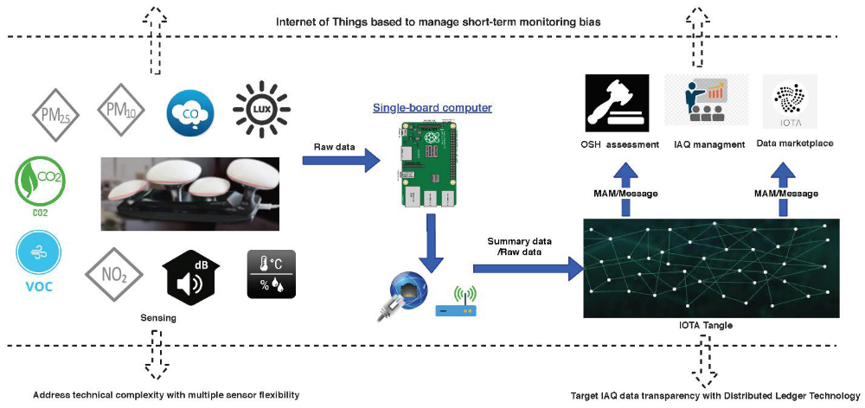
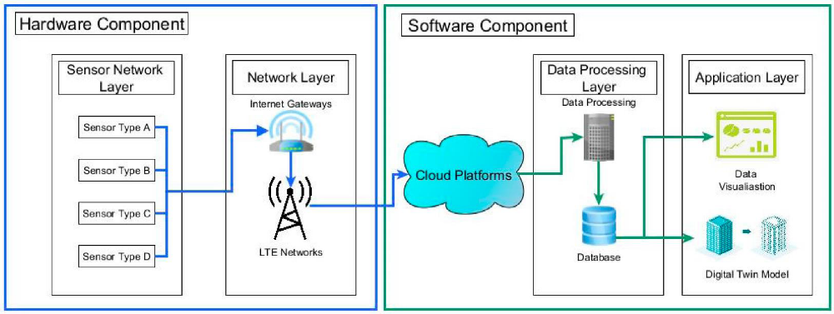
PROGRAM
import paho.mqtt.client as mqtt
#Callback
for received data from server

data = mqtt.Client()
Data.on_connect = on_connect
Data.on_message = on_message
data.loop_forever()

