FinalProjectPhase1

2023-06-18

## Subbu Subramanian

# Analysis of Homes sold Above median value in Ames, Iowa:

## Libraries and Data

#Loading Libraries and reading the csv file  
library(tidyverse)

## ── Attaching core tidyverse packages ──────────────────────── tidyverse 2.0.0 ──  
## ✔ dplyr 1.1.2 ✔ readr 2.1.4  
## ✔ forcats 1.0.0 ✔ stringr 1.5.0  
## ✔ ggplot2 3.4.2 ✔ tibble 3.2.1  
## ✔ lubridate 1.9.2 ✔ tidyr 1.3.0  
## ✔ purrr 1.0.1   
## ── Conflicts ────────────────────────────────────────── tidyverse_conflicts() ──  
## ✖ dplyr::filter() masks stats::filter()  
## ✖ dplyr::lag() masks stats::lag()  
## ℹ Use the conflicted package (<http://conflicted.r-lib.org/>) to force all conflicts to become errors

library(tidymodels)

## ── Attaching packages ────────────────────────────────────── tidymodels 1.1.0 ──  
## ✔ broom 1.0.4 ✔ rsample 1.1.1  
## ✔ dials 1.2.0 ✔ tune 1.1.1  
## ✔ infer 1.0.4 ✔ workflows 1.1.3  
## ✔ modeldata 1.1.0 ✔ workflowsets 1.0.1  
## ✔ parsnip 1.1.0 ✔ yardstick 1.2.0  
## ✔ recipes 1.0.6   
## ── Conflicts ───────────────────────────────────────── tidymodels_conflicts() ──  
## ✖ scales::discard() masks purrr::discard()  
## ✖ dplyr::filter() masks stats::filter()  
## ✖ recipes::fixed() masks stringr::fixed()  
## ✖ dplyr::lag() masks stats::lag()  
## ✖ yardstick::spec() masks readr::spec()  
## ✖ recipes::step() masks stats::step()  
## • Learn how to get started at https://www.tidymodels.org/start/

library(GGally)

## Registered S3 method overwritten by 'GGally':  
## method from   
## +.gg ggplot2

library(ggcorrplot)  
HomeSales = read_csv("ames_student-1-2.csv")

## Rows: 2053 Columns: 81  
## ── Column specification ────────────────────────────────────────────────────────  
## Delimiter: ","  
## chr (47): MS_SubClass, MS_Zoning, Street, Alley, Lot_Shape, Land_Contour, Ut...  
## dbl (34): Lot_Frontage, Lot_Area, Year_Built, Year_Remod_Add, Mas_Vnr_Area, ...  
##   
## ℹ Use `spec()` to retrieve the full column specification for this data.  
## ℹ Specify the column types or set `show_col_types = FALSE` to quiet this message.

## Initial Analysis

#initial Analysis of the given data  
summary(HomeSales)

## MS_SubClass MS_Zoning Lot_Frontage Lot_Area   
## Length:2053 Length:2053 Min. : 0.00 Min. : 1300   
## Class :character Class :character 1st Qu.: 43.00 1st Qu.: 7500   
## Mode :character Mode :character Median : 62.00 Median : 9548   
## Mean : 57.38 Mean : 10258   
## 3rd Qu.: 78.00 3rd Qu.: 11600   
## Max. :313.00 Max. :215245   
## Street Alley Lot_Shape Land_Contour   
## Length:2053 Length:2053 Length:2053 Length:2053   
## Class :character Class :character Class :character Class :character   
## Mode :character Mode :character Mode :character Mode :character   
##   
##   
##   
## Utilities Lot_Config Land_Slope Neighborhood   
## Length:2053 Length:2053 Length:2053 Length:2053   
## Class :character Class :character Class :character Class :character   
## Mode :character Mode :character Mode :character Mode :character   
##   
##   
##   
## Condition_1 Condition_2 Bldg_Type House_Style   
## Length:2053 Length:2053 Length:2053 Length:2053   
## Class :character Class :character Class :character Class :character   
## Mode :character Mode :character Mode :character Mode :character   
##   
##   
##   
## Overall_Qual Overall_Cond Year_Built Year_Remod_Add  
## Length:2053 Length:2053 Min. :1875 Min. :1950   
## Class :character Class :character 1st Qu.:1953 1st Qu.:1965   
## Mode :character Mode :character Median :1972 Median :1993   
## Mean :1971 Mean :1984   
## 3rd Qu.:2000 3rd Qu.:2004   
## Max. :2010 Max. :2010   
## Roof_Style Roof_Matl Exterior_1st Exterior_2nd   
## Length:2053 Length:2053 Length:2053 Length:2053   
## Class :character Class :character Class :character Class :character   
## Mode :character Mode :character Mode :character Mode :character   
##   
##   
##   
## Mas_Vnr_Type Mas_Vnr_Area Exter_Qual Exter_Cond   
## Length:2053 Min. : 0.0 Length:2053 Length:2053   
## Class :character 1st Qu.: 0.0 Class :character Class :character   
## Mode :character Median : 0.0 Mode :character Mode :character   
## Mean : 103.8   
## 3rd Qu.: 164.0   
## Max. :1600.0   
## Foundation Bsmt_Qual Bsmt_Cond Bsmt_Exposure   
## Length:2053 Length:2053 Length:2053 Length:2053   
## Class :character Class :character Class :character Class :character   
## Mode :character Mode :character Mode :character Mode :character   
##   
##   
##   
## BsmtFin_Type_1 BsmtFin_SF_1 BsmtFin_Type_2 BsmtFin_SF_2   
## Length:2053 Min. :1.00 Length:2053 Min. : 0.00   
## Class :character 1st Qu.:3.00 Class :character 1st Qu.: 0.00   
## Mode :character Median :3.00 Mode :character Median : 0.00   
## Mean :4.21 Mean : 52.57   
## 3rd Qu.:7.00 3rd Qu.: 0.00   
## Max. :7.00 Max. :1526.00   
## Bsmt_Unf_SF Total_Bsmt_SF Heating Heating_QC   
## Min. : 0.0 Min. : 0 Length:2053 Length:2053   
## 1st Qu.: 226.0 1st Qu.: 793 Class :character Class :character   
## Median : 460.0 Median : 988 Mode :character Mode :character   
## Mean : 561.2 Mean :1055   
## 3rd Qu.: 801.0 3rd Qu.:1304   
## Max. :2336.0 Max. :5095   
## Central_Air Electrical First_Flr_SF Second_Flr_SF   
## Length:2053 Length:2053 Min. : 432 Min. : 0.0   
## Class :character Class :character 1st Qu.: 882 1st Qu.: 0.0   
## Mode :character Mode :character Median :1088 Median : 0.0   
## Mean :1168 Mean : 326.1   
## 3rd Qu.:1402 3rd Qu.: 701.0   
## Max. :5095 Max. :1862.0   
## Low_Qual_Fin_SF Gr_Liv_Area Bsmt_Full_Bath Bsmt_Half_Bath   
## Min. : 0.000 Min. : 480 Min. :0.0000 Min. :0.00000   
## 1st Qu.: 0.000 1st Qu.:1137 1st Qu.:0.0000 1st Qu.:0.00000   
## Median : 0.000 Median :1447 Median :0.0000 Median :0.00000   
## Mean : 4.973 Mean :1499 Mean :0.4301 Mean :0.05796   
## 3rd Qu.: 0.000 3rd Qu.:1737 3rd Qu.:1.0000 3rd Qu.:0.00000   
## Max. :1064.000 Max. :5095 Max. :3.0000 Max. :2.00000   
## Full_Bath Half_Bath Bedroom_AbvGr Kitchen_AbvGr   
## Min. :0.000 Min. :0.0000 Min. :0.000 Min. :1.000   
## 1st Qu.:1.000 1st Qu.:0.0000 1st Qu.:2.000 1st Qu.:1.000   
## Median :2.000 Median :0.0000 Median :3.000 Median :1.000   
## Mean :1.564 Mean :0.3751 Mean :2.855 Mean :1.047   
## 3rd Qu.:2.000 3rd Qu.:1.0000 3rd Qu.:3.000 3rd Qu.:1.000   
## Max. :4.000 Max. :2.0000 Max. :6.000 Max. :3.000   
## Kitchen_Qual TotRms_AbvGrd Functional Fireplaces   
## Length:2053 Min. : 3.000 Length:2053 Min. :0.000   
## Class :character 1st Qu.: 5.000 Class :character 1st Qu.:0.000   
## Mode :character Median : 6.000 Mode :character Median :1.000   
## Mean : 6.442 Mean :0.603   
## 3rd Qu.: 7.000 3rd Qu.:1.000   
## Max. :15.000 Max. :4.000   
## Fireplace_Qu Garage_Type Garage_Finish Garage_Cars   
## Length:2053 Length:2053 Length:2053 Min. :0.000   
## Class :character Class :character Class :character 1st Qu.:1.000   
## Mode :character Mode :character Mode :character Median :2.000   
## Mean :1.774   
## 3rd Qu.:2.000   
## Max. :5.000   
## Garage_Area Garage_Qual Garage_Cond Paved_Drive   
## Min. : 0 Length:2053 Length:2053 Length:2053   
## 1st Qu.: 320 Class :character Class :character Class :character   
## Median : 478 Mode :character Mode :character Mode :character   
## Mean : 472   
## 3rd Qu.: 576   
## Max. :1488   
## Wood_Deck_SF Open_Porch_SF Enclosed_Porch Three_season_porch  
## Min. : 0.00 Min. : 0.00 Min. : 0.00 Min. : 0.000   
## 1st Qu.: 0.00 1st Qu.: 0.00 1st Qu.: 0.00 1st Qu.: 0.000   
## Median : 0.00 Median : 27.00 Median : 0.00 Median : 0.000   
## Mean : 93.52 Mean : 48.17 Mean : 23.02 Mean : 2.799   
## 3rd Qu.: 168.00 3rd Qu.: 72.00 3rd Qu.: 0.00 3rd Qu.: 0.000   
## Max. :1424.00 Max. :742.00 Max. :584.00 Max. :407.000   
## Screen_Porch Pool_Area Pool_QC Fence   
## Min. : 0.00 Min. : 0.000 Length:2053 Length:2053   
## 1st Qu.: 0.00 1st Qu.: 0.000 Class :character Class :character   
## Median : 0.00 Median : 0.000 Mode :character Mode :character   
## Mean : 16.68 Mean : 1.339   
## 3rd Qu.: 0.00 3rd Qu.: 0.000   
## Max. :576.00 Max. :800.000   
## Misc_Feature Misc_Val Mo_Sold Year_Sold   
## Length:2053 Min. : 0.00 Min. : 1.000 Min. :2006   
## Class :character 1st Qu.: 0.00 1st Qu.: 4.000 1st Qu.:2007   
## Mode :character Median : 0.00 Median : 6.000 Median :2008   
## Mean : 60.12 Mean : 6.189 Mean :2008   
## 3rd Qu.: 0.00 3rd Qu.: 8.000 3rd Qu.:2009   
## Max. :17000.00 Max. :12.000 Max. :2010   
## Sale_Type Sale_Condition Longitude Latitude   
## Length:2053 Length:2053 Min. :-93.69 Min. :41.99   
## Class :character Class :character 1st Qu.:-93.66 1st Qu.:42.02   
## Mode :character Mode :character Median :-93.64 Median :42.03   
## Mean :-93.64 Mean :42.03   
## 3rd Qu.:-93.62 3rd Qu.:42.05   
## Max. :-93.58 Max. :42.06   
## Above_Median   
## Length:2053   
## Class :character   
## Mode :character   
##   
##   
##

## Data Wrangling

# Data Wrangling to remove the insignificant columns and factoring them as needed  
HomeSales2 = HomeSales %>%  
 select(MS_Zoning, Lot_Area, Neighborhood, Bldg_Type, Year_Built, Year_Remod_Add, Gr_Liv_Area, TotRms_AbvGrd, Garage_Cars,Above_Median) %>% mutate(Neighborhood = as_factor(Neighborhood)) %>% mutate(MS_Zoning = as_factor(MS_Zoning)) %>% mutate(Bldg_Type = as_factor(Bldg_Type)) %>% mutate(Above_Median = as_factor(Above_Median)) %>% filter(Above_Median == "Yes")

## Second Level Analysis

#Summarizing for Second Level Analysis  
summary(HomeSales2)

## MS_Zoning Lot_Area Neighborhood  
## Residential_Low_Density :919 Min. : 2117 College_Creek :134   
## Residential_High_Density : 6 1st Qu.: 8738 Somerset :110   
## Floating_Village_Residential: 79 Median : 10437 Gilbert :106   
## Residential_Medium_Density : 39 Mean : 11829 Northridge_Heights:104   
## C_all : 0 3rd Qu.: 12837 Northwest_Ames : 76   
## A_agr : 0 Max. :215245 North_Ames : 72   
## I_all : 0 (Other) :441   
## Bldg_Type Year_Built Year_Remod_Add Gr_Liv_Area TotRms_AbvGrd   
## OneFam :905 Min. :1879 Min. :1950 Min. : 964 Min. : 4.00   
## TwnhsE :100 1st Qu.:1977 1st Qu.:1991 1st Qu.:1456 1st Qu.: 6.00   
## Twnhs : 19 Median :1999 Median :2000 Median :1672 Median : 7.00   
## Duplex : 13 Mean :1988 Mean :1995 Mean :1770 Mean : 7.01   
## TwoFmCon: 6 3rd Qu.:2005 3rd Qu.:2006 3rd Qu.:1984 3rd Qu.: 8.00   
## Max. :2010 Max. :2010 Max. :5095 Max. :15.00   
##   
## Garage_Cars Above_Median  
## Min. :0.000 Yes:1043   
## 1st Qu.:2.000 No : 0   
## Median :2.000   
## Mean :2.193   
## 3rd Qu.:2.000   
## Max. :4.000   
##

## Plot Analysis across different Variables

#Analyzing Above median sold homes based on Zones  
ggplot(HomeSales2, aes(x=MS_Zoning, fill = Above_Median)) + geom_bar() + theme_bw() +  
theme(axis.text.x = element_text(angle = 90,  
 vjust = 0.5,  
 hjust = 0.5))

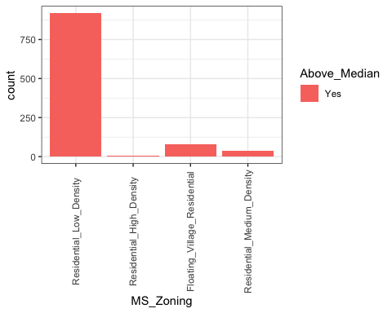

#Analyzing Above median sold homes based on Lot Area  
ggplot(HomeSales2, aes(x=Lot_Area, fill = Above_Median)) + geom_bar() + theme_bw() +  
theme(axis.text.x = element_text(angle = 90,  
 vjust = 0.5,  
 hjust = 0.5))

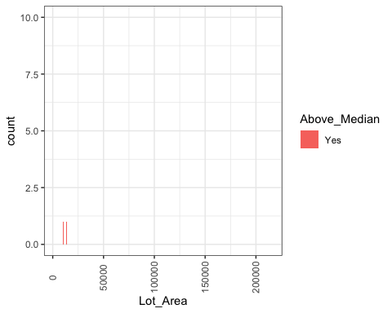

#Analyzing Above median sold homes based on Neighborhood  
ggplot(HomeSales2, aes(x=Neighborhood, fill = Above_Median)) + geom_bar() + theme_bw() +  
theme(axis.text.x = element_text(angle = 90,  
 vjust = 0.5,  
 hjust = 0.5))

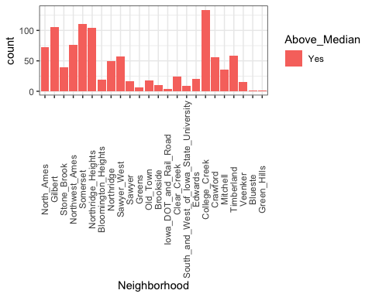

#Analyzing Above median sold homes based on the Type of Buildings  
ggplot(HomeSales2, aes(x=Bldg_Type, fill = Above_Median)) + geom_bar() + theme_bw() +  
theme(axis.text.x = element_text(angle = 90,  
 vjust = 0.5,  
 hjust = 0.5))

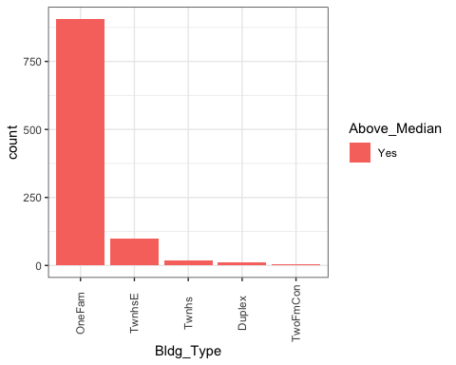

#Analyzing Above median sold homes based on Built year  
ggplot(HomeSales2, aes(x=Year_Built, fill = Above_Median)) + geom_bar() + theme_bw() +  
theme(axis.text.x = element_text(angle = 90,  
 vjust = 0.5,  
 hjust = 0.5))

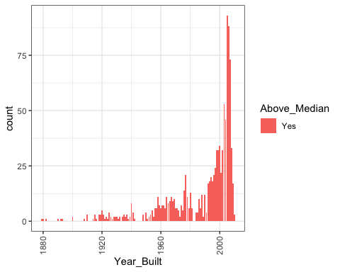

#Analyzing Above median sold homes based on Remodeled year   
ggplot(HomeSales2, aes(x=Year_Remod_Add, fill = Above_Median)) + geom_bar() + theme_bw() +  
theme(axis.text.x = element_text(angle = 90,  
 vjust = 0.5,  
 hjust = 0.5))

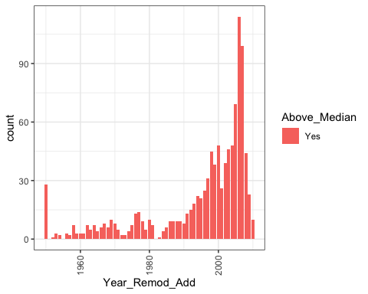

#Analyzing Above median sold homes based on Living Area  
ggplot(HomeSales2, aes(x=Gr_Liv_Area, fill = Above_Median)) + geom_bar() + theme_bw() +  
theme(axis.text.x = element_text(angle = 90,  
 vjust = 0.5,  
 hjust = 0.5))

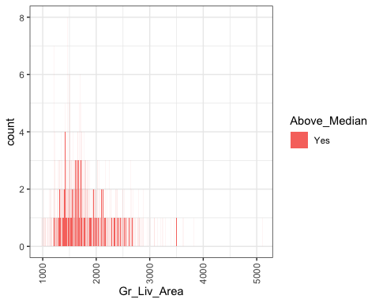

#Analyzing Above median sold homes based on Total number of Rooms above Ground  
ggplot(HomeSales2, aes(x=TotRms_AbvGrd, fill = Above_Median)) + geom_bar() + theme_bw() +  
theme(axis.text.x = element_text(angle = 90,  
 vjust = 0.5,  
 hjust = 0.5))

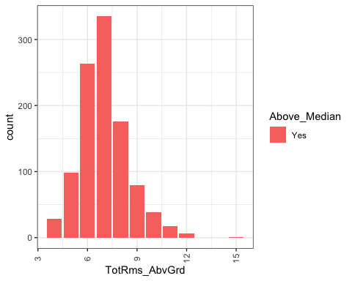

#Analyzing Above median sold homes based on the Garage Car capacity  
ggplot(HomeSales2, aes(x=Garage_Cars, fill = Above_Median)) + geom_bar() + theme_bw() +  
theme(axis.text.x = element_text(angle = 90,  
 vjust = 0.5,  
 hjust = 0.5))

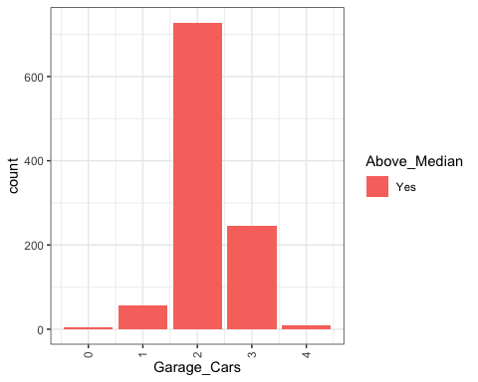

## Finalizing

#As evident from the analysis so far, College Creek neighborhood has the highest number of homes sold above median price. So filtering the other factors which aid the above median value of the homes that are sold in College Creek  
  
HomeSales3 = HomeSales2 %>% filter(Neighborhood == "College_Creek")  
   
summary(HomeSales3)

## MS_Zoning Lot_Area Neighborhood  
## Residential_Low_Density :134 Min. : 6762 College_Creek :134   
## Residential_High_Density : 0 1st Qu.: 8817 North_Ames : 0   
## Floating_Village_Residential: 0 Median :10142 Gilbert : 0   
## Residential_Medium_Density : 0 Mean :10408 Stone_Brook : 0   
## C_all : 0 3rd Qu.:11418 Northwest_Ames: 0   
## A_agr : 0 Max. :21533 Somerset : 0   
## I_all : 0 (Other) : 0   
## Bldg_Type Year_Built Year_Remod_Add Gr_Liv_Area TotRms_AbvGrd   
## OneFam :134 Min. :1975 Min. :1977 Min. :1009 Min. : 5.000   
## TwnhsE : 0 1st Qu.:1999 1st Qu.:2000 1st Qu.:1479 1st Qu.: 6.000   
## Twnhs : 0 Median :2002 Median :2003 Median :1661 Median : 7.000   
## Duplex : 0 Mean :2002 Mean :2002 Mean :1660 Mean : 6.791   
## TwoFmCon: 0 3rd Qu.:2005 3rd Qu.:2006 3rd Qu.:1797 3rd Qu.: 7.000   
## Max. :2010 Max. :2010 Max. :2574 Max. :10.000   
##   
## Garage_Cars Above_Median  
## Min. :2.000 Yes:134   
## 1st Qu.:2.000 No : 0   
## Median :2.000   
## Mean :2.201   
## 3rd Qu.:2.000   
## Max. :3.000   
##

## Summary of the Analysis

Highest number Homes in College Creek neighborhood are the ones which are sold above median value. These above median value homes are all of One Family homes with a Low Density Residential Zoning. They all have been built on a median lot area of 10142 sq.ft with a median living area of 1661 sq.ft. All of these homes are either mostly built after 2002 or remodeled after 2003. Two car garages are a minimum for these homes and they have a median of 7 rooms abouve ground level.