# Module 3 - Assignment 3

# Subramanian, Subbu

# More Practice with Plots

library(tidyverse)

## ── Attaching packages ─────────────────────────────────────── tidyverse 1.3.2 ──  
## ✔ ggplot2 3.3.6 ✔ purrr 0.3.4  
## ✔ tibble 3.1.7 ✔ dplyr 1.0.9  
## ✔ tidyr 1.2.0 ✔ stringr 1.4.0  
## ✔ readr 2.1.2 ✔ forcats 0.5.1  
## ── Conflicts ────────────────────────────────────────── tidyverse_conflicts() ──  
## ✖ dplyr::filter() masks stats::filter()  
## ✖ dplyr::lag() masks stats::lag()

GOOG <- read_csv("GOOG.csv")

## Rows: 253 Columns: 7  
## ── Column specification ────────────────────────────────────────────────────────  
## Delimiter: ","  
## dbl (6): Open, High, Low, Close, Adj Close, Volume  
## date (1): Date  
##   
## ℹ Use `spec()` to retrieve the full column specification for this data.  
## ℹ Specify the column types or set `show_col_types = FALSE` to quiet this message.

## Google Stock Price Plots

The following is an analysis of Google’s stock price from October of 2019 to October of 2020. This will include a scatter, line, bar, histogram and boxplot. All the plots represent the closing price on the dates listed on the x-axis.

library(tidyverse)  
ggplot(data=GOOG,aes(x=Date,y=Close)) +  
 geom_point()

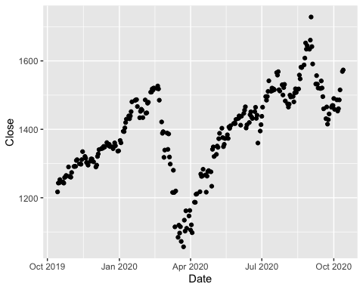

ggplot(data=GOOG,aes(x=Date,y=Close)) +  
 geom_line()

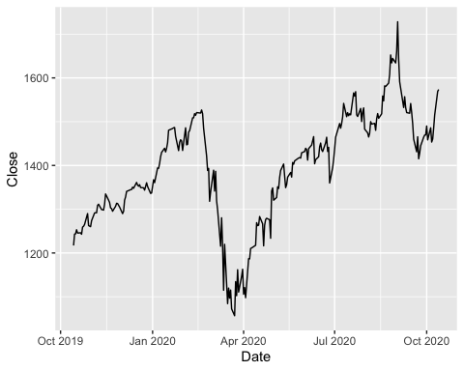

ggplot(data=GOOG,aes(x=Date,y=Close)) +  
 geom_col()

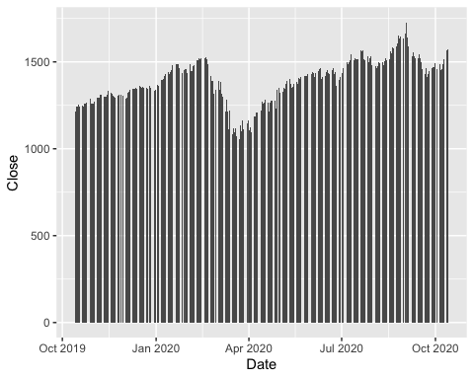

ggplot(data=GOOG,aes(x=Close)) +  
 geom_histogram()

## `stat_bin()` using `bins = 30`. Pick better value with `binwidth`.

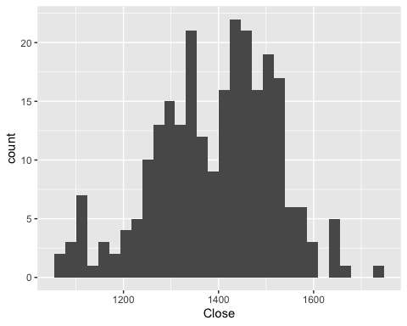

ggplot(data=GOOG,aes(x=Close)) +  
 geom_boxplot()

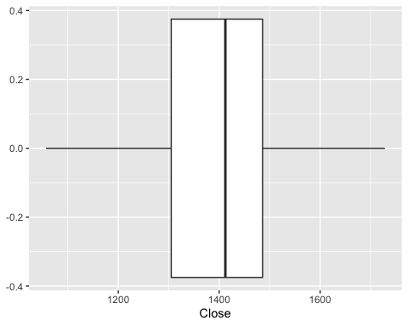

ggplot(data=GOOG,aes(x=Date,y=Close)) +  
 geom_line() +  
 geom_point()

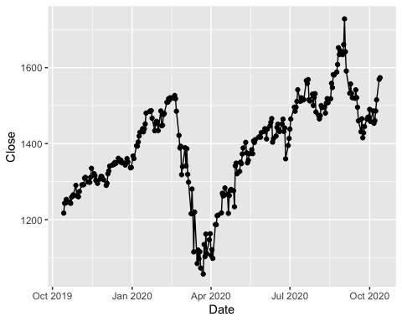

You have created many different plots of the same data but some are more helpful than others. Based on the plots you created, which one do you find most useful and why?

The one I find useful is the line plot/line plot with points, because it is very easy to read the trend and peak points for the provided fiscal year through these plots. Whereas, the other plots are not really saying anything fruitful about the data.

## Google Stock Daily Price Comparisons

library(tidyverse)  
  
ggplot(GOOG) +  
 geom_line(aes(x=Date,y=High,color="High")) +  
 geom_line(aes(x=Date,y=Low,color="Low"))

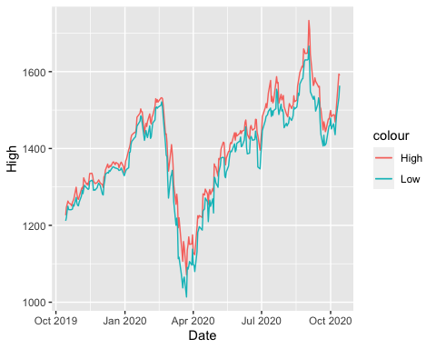

ggplot(GOOG) +  
 geom_line(aes(x=Date,y=Open,color="Open")) +  
 geom_line(aes(x=Date,y=Close,color="Close"))

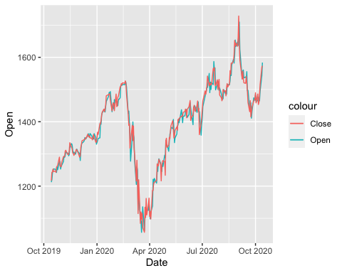

ggplot(data=GOOG,aes(x=Date,y=Close)) +  
 geom_area(color="black",fill="blue",alpha=.2)

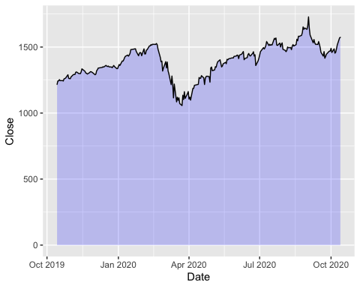

ggplot(data=GOOG,aes(x=Date,y=Open)) +  
 geom_area(color="blue",fill="green",alpha=.10)

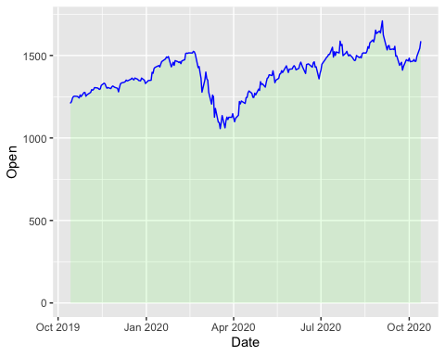

MayPrice<-subset(GOOG, Date > "2020-04-30" & Date < "2020-06-01")  
  
ggplot(MayPrice, aes(x=Date,y=Close)) +  
 geom_point() +  
 geom_text(aes(label = round(Close)), size=3, vjust=-1)

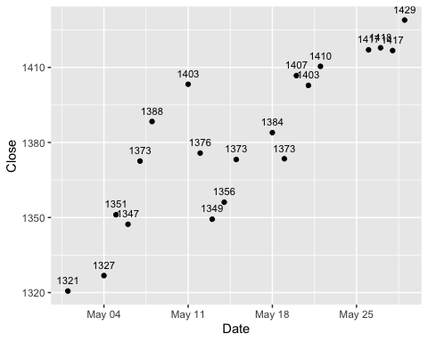

AprilPrice<-subset(GOOG, Date > "2020-03-31" & Date < "2020-05-01")  
  
ggplot(AprilPrice, aes(x=Date,y=Open)) +  
 geom_point() +  
 geom_text(aes(label = round(Open)), size=2, vjust=1.5)

