# Module 4 - Assignment 1

# Subramanian, Subbu

# Data Transformation

library(tidyverse)

## ── Attaching packages ─────────────────────────────────────── tidyverse 1.3.2 ──  
## ✔ ggplot2 3.3.6 ✔ purrr 0.3.4  
## ✔ tibble 3.1.7 ✔ dplyr 1.0.9  
## ✔ tidyr 1.2.0 ✔ stringr 1.4.0  
## ✔ readr 2.1.2 ✔ forcats 0.5.1  
## ── Conflicts ────────────────────────────────────────── tidyverse_conflicts() ──  
## ✖ dplyr::filter() masks stats::filter()  
## ✖ dplyr::lag() masks stats::lag()

state_income <- read_csv("state_income.csv")

## Warning: One or more parsing issues, see `problems()` for details

## Rows: 32526 Columns: 18  
## ── Column specification ────────────────────────────────────────────────────────  
## Delimiter: ","  
## chr (7): State_Name, State_ab, County, City, Place, Type, Primary  
## dbl (11): id, State_Code, Zip_Code, Area_Code, ALand, AWater, Lat, Lon, Mean...  
##   
## ℹ Use `spec()` to retrieve the full column specification for this data.  
## ℹ Specify the column types or set `show_col_types = FALSE` to quiet this message.

## State Incomes:

I will be creating a subset of data from the file and will be using the below variables for the analysis,

1.) State_Name 2.) State_ab 3.) County 4.) City 5.) Type 6.) ALand 7.) Mean 8.) Median 9.) Stdev

State_income2<-select(state_income,State_Name,State_ab,County,City,Type,ALand,Mean,Median,Stdev)  
select(State_income2,State_ab,everything())

## # A tibble: 32,526 × 9  
## State_ab State_Name County City Type ALand Mean Median Stdev  
## <chr> <chr> <chr> <chr> <chr> <dbl> <dbl> <dbl> <dbl>  
## 1 AL Alabama Mobile County Chickas… City 1.09e7 38773 30506 33101  
## 2 AL Alabama Barbour County Louisvi… City 2.61e7 37725 19528 43789  
## 3 AL Alabama Shelby County Columbi… City 4.48e7 54606 31930 57348  
## 4 AL Alabama Mobile County Satsuma City 3.69e7 63919 52814 47707  
## 5 AL Alabama Mobile County Dauphin… Town 1.62e7 77948 67225 54270  
## 6 AL Alabama Cullman County Cullman Town 8.91e6 50715 42643 35886  
## 7 AL Alabama Escambia County East Br… City 8.83e6 33737 23610 28256  
## 8 AL Alabama Elmore County Coosada Town 1.02e7 46319 40242 38941  
## 9 AL Alabama Morgan County Eva Town 1.05e7 57994 39591 47235  
## 10 AL Alabama Talladega County Sylacau… CDP 4.52e7 54807 41712 51359  
## # … with 32,516 more rows

head(State_income2,10)

## # A tibble: 10 × 9  
## State_Name State_ab County City Type ALand Mean Median Stdev  
## <chr> <chr> <chr> <chr> <chr> <dbl> <dbl> <dbl> <dbl>  
## 1 Alabama AL Mobile County Chickas… City 1.09e7 38773 30506 33101  
## 2 Alabama AL Barbour County Louisvi… City 2.61e7 37725 19528 43789  
## 3 Alabama AL Shelby County Columbi… City 4.48e7 54606 31930 57348  
## 4 Alabama AL Mobile County Satsuma City 3.69e7 63919 52814 47707  
## 5 Alabama AL Mobile County Dauphin… Town 1.62e7 77948 67225 54270  
## 6 Alabama AL Cullman County Cullman Town 8.91e6 50715 42643 35886  
## 7 Alabama AL Escambia County East Br… City 8.83e6 33737 23610 28256  
## 8 Alabama AL Elmore County Coosada Town 1.02e7 46319 40242 38941  
## 9 Alabama AL Morgan County Eva Town 1.05e7 57994 39591 47235  
## 10 Alabama AL Talladega County Sylacau… CDP 4.52e7 54807 41712 51359

State_income2<-rename(State_income2,SquareArea=ALand,MeanIncome=Mean,IncomeMedian=Median,IncomeStDev=Stdev)  
head(State_income2,10)

## # A tibble: 10 × 9  
## State_Name State_ab County City Type SquareArea MeanIncome IncomeMedian  
## <chr> <chr> <chr> <chr> <chr> <dbl> <dbl> <dbl>  
## 1 Alabama AL Mobile Co… Chic… City 10894952 38773 30506  
## 2 Alabama AL Barbour C… Loui… City 26070325 37725 19528  
## 3 Alabama AL Shelby Co… Colu… City 44835274 54606 31930  
## 4 Alabama AL Mobile Co… Sats… City 36878729 63919 52814  
## 5 Alabama AL Mobile Co… Daup… Town 16204185 77948 67225  
## 6 Alabama AL Cullman C… Cull… Town 8913021 50715 42643  
## 7 Alabama AL Escambia … East… City 8826252 33737 23610  
## 8 Alabama AL Elmore Co… Coos… Town 10222339 46319 40242  
## 9 Alabama AL Morgan Co… Eva Town 10544874 57994 39591  
## 10 Alabama AL Talladega… Syla… CDP 45178321 54807 41712  
## # … with 1 more variable: IncomeStDev <dbl>

NC_income<-filter(State_income2,State_Name=="North Carolina")  
head(NC_income,10)

## # A tibble: 10 × 9  
## State_Name State_ab County City Type SquareArea MeanIncome IncomeMedian  
## <chr> <chr> <chr> <chr> <chr> <dbl> <dbl> <dbl>  
## 1 North Carolina NC Alama… Elon CDP 3515396 89973 300000  
## 2 North Carolina NC Johns… Wend… Town 23956770 67438 300000  
## 3 North Carolina NC Samps… Sted… Town 1353212 43538 25196  
## 4 North Carolina NC Hende… Hend… CDP 2625120 38120 31430  
## 5 North Carolina NC Beauf… Pine… Town 4121722 30468 17951  
## 6 North Carolina NC Davie… Clem… Town 5903422 97561 80720  
## 7 North Carolina NC Blade… Blad… Town 5737410 38588 20838  
## 8 North Carolina NC Samps… Clin… CDP 8562785 34778 23603  
## 9 North Carolina NC Lee C… Broa… Town 3350431 60384 52298  
## 10 North Carolina NC Guilf… Burl… City 75533002 54337 300000  
## # … with 1 more variable: IncomeStDev <dbl>

## NC Incomes:

I will be using the NC_income dataset to create summaries of the incomes within North Carolina including summaries by county, city and type.

NC_income<-arrange(NC_income,County)  
head(NC_income,10)

## # A tibble: 10 × 9  
## State_Name State_ab County City Type SquareArea MeanIncome IncomeMedian  
## <chr> <chr> <chr> <chr> <chr> <dbl> <dbl> <dbl>  
## 1 North Carolina NC Alama… Elon CDP 3515396 89973 300000  
## 2 North Carolina NC Alama… Meba… City 23213152 67397 55632  
## 3 North Carolina NC Alama… Hend… Track 12734435 57073 41022  
## 4 North Carolina NC Alama… Ahos… Track 199246026 54071 42038  
## 5 North Carolina NC Alama… Red … Track 93319263 30673 20786  
## 6 North Carolina NC Alama… Stat… Track 10829691 40174 27569  
## 7 North Carolina NC Alama… Supp… Track 29875162 45625 32324  
## 8 North Carolina NC Alama… Stat… Track 37718022 55177 48504  
## 9 North Carolina NC Alama… Moor… Track 13853696 106274 83085  
## 10 North Carolina NC Alama… Moor… Track 7037037 93463 79991  
## # … with 1 more variable: IncomeStDev <dbl>

summary1 <- group_by(NC_income,County)  
summary1 <- summarise (summary1, mean= mean(MeanIncome))  
summary2 <- NC_income %>%  
group_by(City) %>%  
summarise (mean = mean(MeanIncome))

Summary 1 Dataset provides the mean income for every county in North Carolina

Summary 2 Dataset provides the mean income for every city in North Carolina

summary3 <- NC_income %>%  
group_by(Type) %>%  
summarise (mean = mean(MeanIncome))  
head(summary3,10)

## # A tibble: 5 × 2  
## Type mean  
## <chr> <dbl>  
## 1 CDP 45853.  
## 2 City 55884.  
## 3 Town 53116.  
## 4 Track 58381.  
## 5 Village 0

## Income Visualization

ggplot(data=summary1,aes(x=County,y=mean,label=County)) +  
geom_point() +  
 labs(title = "County Income Data",   
 y = "Income") +  
theme(axis.text.x = element_text(angle = 90,vjust =0.5, hjust=1))

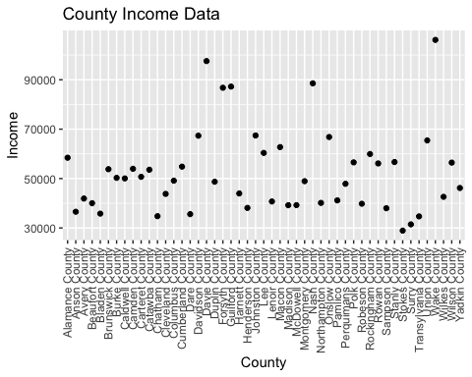

* County with the largest average Income : Wake County
* County with the lowest average income : Stokes County
* County with the second lowest income : Surry County

AvgStateIncome <- group_by(State_income2,State_ab)  
AvgStateIncome <- summarise (AvgStateIncome, mean= mean(MeanIncome))  
AvgStateIncome <-filter(AvgStateIncome,grepl("N",State_ab))  
ggplot(data=AvgStateIncome,aes(x=State_ab,y=mean)) +  
geom_point() +  
 labs(title = "State Income Data",   
 y = "Income") +  
theme(axis.text.x = element_text(angle = 90,vjust =0.5, hjust=1))

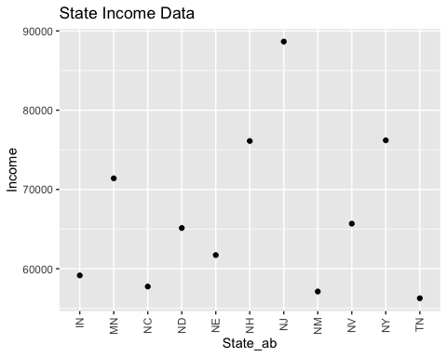

* State with the largest average Income : NJ
* State with the lowest average income : TN